Laboratory work 8
Solving systems of linear equations by Kramer’s method
ISU (US) – 23 – 1, subgroup 2
Kamarayev Timur
Variant 11
System of linear equation:
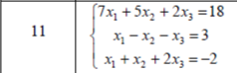

1. SMath Studio
- Open SMath Studion program
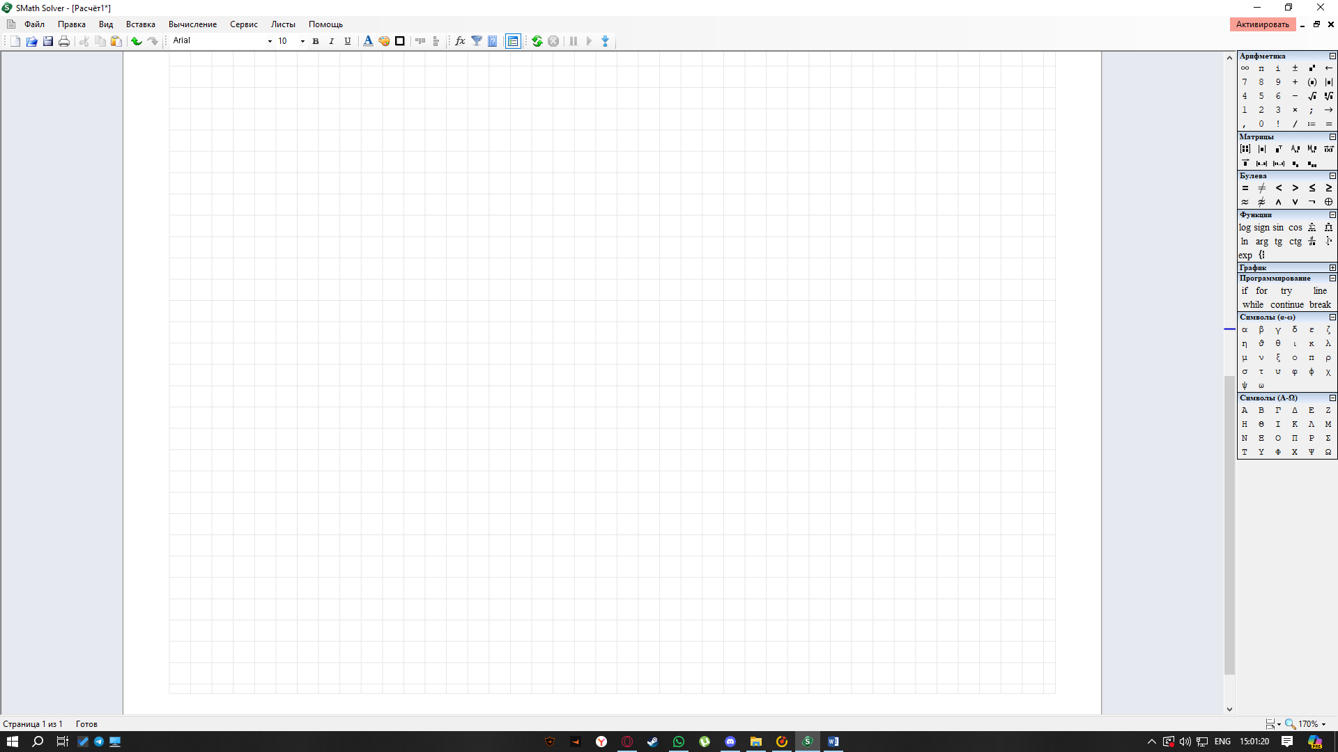
- Implement System of linear equation in matrix form
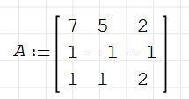
- Find its determinant
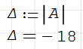
- Let's calculate the auxiliary determinants by replacing the first, second and third columns with a column of free coefficients
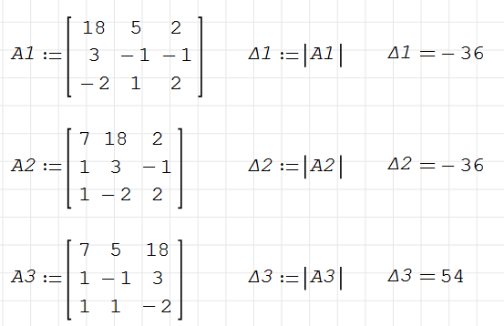
- Now find the X - es
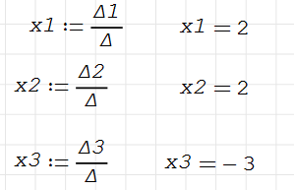
ANSWER IS {(2;2;-3)}
2. Manual solution
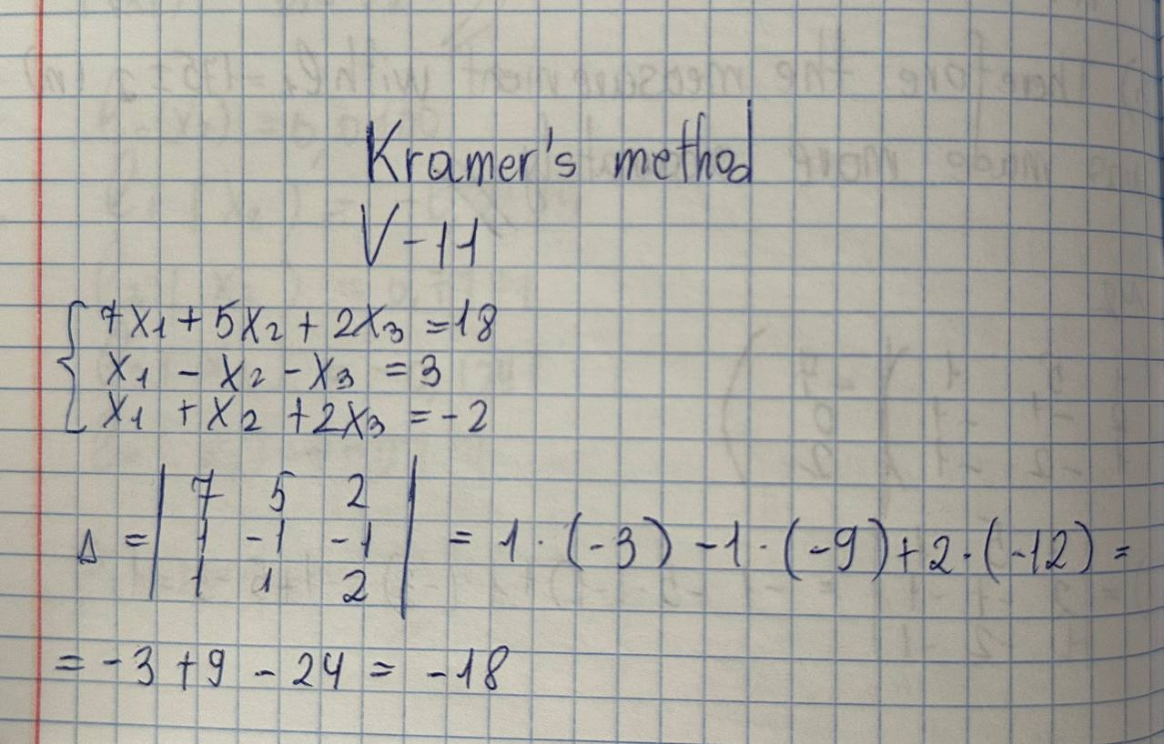
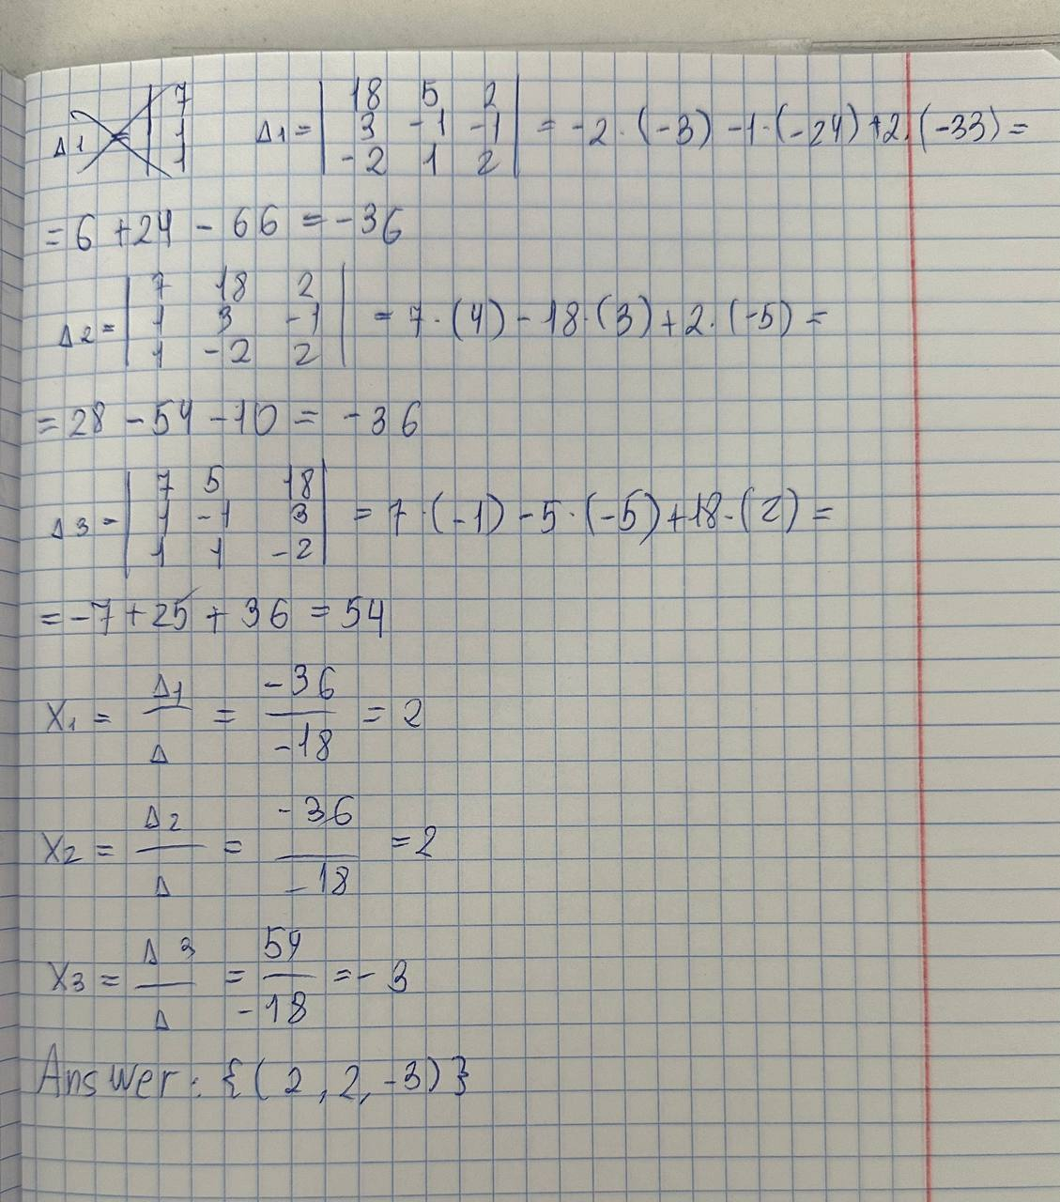
RESULT:
The answers are the same. Using SMath Studio to solve systems of linear equations using the Cramer method is effective

