Written by student ISU-US-24-1 Zhantassova Adina
Laboratory Work Report
Approximate solutions of nonlinear algebraic equations
(bisection, newton, chord method)
Objective
The objective of this lab is to explore key numerical methods for solving nonlinear equations using SMath Studio and Excel. The focus is on three approaches: the Bisection Method, Newton’s Method, and the Chord Method. Additionally, a comparison is made between the results obtained from different computational tools.
Answers to Self-Control Questions

- What are the ways to study the function?
  - Analyzing the function’s domain and range
  - Finding critical points (derivatives, extrema)
  - Studying asymptotes and limits
  - Investigating concavity and inflection points
  - Graphing the function for visualization
- What methods are used to find the roots of the equation?
  - Analytical methods (factoring, quadratic formula, algebraic manipulation)
  - Graphical methods (plotting the function and identifying intersections with the x-axis)
  - Numerical methods (Bisection Method, Newton’s Method, Chord/Secant Method, Fixed-Point Iteration)
- What is the root separation procedure used for?
  - The root separation procedure helps identify intervals where a function changes sign, indicating the presence of roots. This step is crucial before applying numerical methods like bisection to ensure that a root exists within a specific interval.
- What is the essence of the dichotomy method?
  - The Dichotomy (Bisection) Method is a numerical technique that iteratively narrows down the interval containing a root by checking the sign change in the function. The interval is halved in each step until the desired accuracy is reached.
- What is the essence of the Newton, Chord method?
  - Newton’s Method: Uses the function’s derivative to iteratively approximate the root, converging quickly if the initial guess is close enough.
  - Chord Method (Secant Method): Uses two initial points to approximate the root without requiring derivatives, making it more flexible but sometimes less stable than Newton’s Method.
- Criteria for stopping the iterative process.
  - The absolute or relative error falls below a predefined tolerance level
  - The function value at the estimated root is sufficiently close to zero
  - A maximum number of iterations is reached
  - Consecutive approximations remain unchanged within a certain precision
- What is the difference between numerical and analytical finding of the roots of an equation?
  - Analytical methods provide exact solutions using algebraic manipulations and formulas. They work best for simpler equations but may not be feasible for complex equations.
  - Numerical methods provide approximate solutions through iterative calculations, making them useful for equations that cannot be solved algebraically.

Tools Used:
- SMath Studio Online
- Microsoft Excel
- Computer with internet access
Findings
- The Bisection Method was stable but slower in reaching the root.
- Newton’s Method showed faster convergence due to its use of derivatives but required a well-chosen initial guess.
- The Chord Method worked effectively but was sensitive to the initial points selected.
- Results from SMath Studio and Excel were consistent, with Excel providing better visualization options.
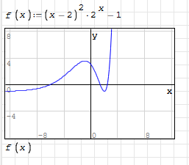
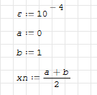
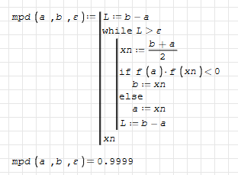
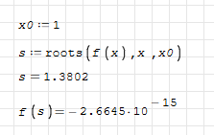

Analysis
This experiment highlighted how different numerical methods can approximate solutions to nonlinear equations. The Bisection Method is reliable but slow. Newton’s Method is efficient but relies on differentiation and a good starting point. The Chord Method serves as a useful alternative but requires two initial values. Results from both SMath Studio and Excel aligned with theoretical expectations, confirming their effectiveness for numerical problem-solving.

Conclusion
To sum up, this lab provided practical experience in solving nonlinear equations using various numerical techniques. The comparison between SMath Studio and Excel demonstrated that both tools are valuable for iterative calculations—Excel excels in visualization, while SMath Studio offers a structured mathematical approach. Understanding these methods is essential for solving numerical problems in real-world applications.

