Laboratory work №8
Solving systems of linear equations by Kramer’s method
Ayazhanova Dilnaz
ISM-23-1
Subgroup - 1
Solve a system of linear algebraic equations using Kramer’s method:
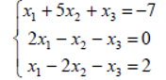
- Open and launch the SMath Studio.

- Enter the matrix A, made up of the coefficients of the system.
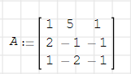
- Calculate its determinant.
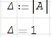
- A1 is obtained from matrix A by replacing the 1st column with a column of free members of the system.
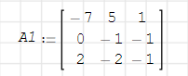
- Matrix A2 is obtained from matrix A by replacing the 2nd column with a column of free members of the system.
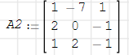
- Matrix A3 is obtained from matrix A by replacing the 3rd column with a column of free members of the system.
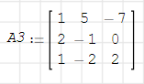
- Calculate the determinants of these matrices.
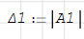,
,
- Enter the received values.
,
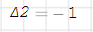,
- Find a solution to the system using the formulas.
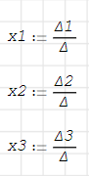
- Display the values .
,
,
The answer is a triple of numbers (-1, -1, -1).
Conclusion: In order to improve the accuracy of my solutions for linear equation systems, I have implemented Kramer's matrix method, which involves using determinants to solve for each variable. To assist with the calculations, I have been utilizing the robust and user-friendly SMath Studio application. This combination has proven to be highly effective in producing precise and reliable results for complex linear equations.

