LABORATORY WORK No. 4
APPROXIMATE SOLUTIONS OF NONLINEAR ALGEBRAIC EQUATIONS (BISECTION, NEWTON, CHORD METHOD)

Purpose: to study the basic methods of approximate solution of nonlinear equations using the Smath Studio application, as well as in the Excel environment.
Questions for self-control
1. What are the ways to study the function?
2. What methods are used to find the roots of the equation?
3. What is the root separation procedure used for?
4. What is the essence of the dichotomy method?
5. What is the essence of the Newton, Chord method?
6. Criteria for stopping the iterative process.
7. What is the difference between numerical and analytical finding of the roots of an equation?

Individual tasks
Find approximate solutions of nonlinear algebraic equations. Separate the roots of a given equation. If there are several roots, then refine one of them using the methods of half division, Newton, chords in the Smath Studio environment, using programming elements, built-in functions, as well as in the Excel environment. Compare the results obtained in different environments.
Table 1– Job options
Option | Equation | Option | Equation
1 |  | 14
2 |  | 15
3 |  | 16
4 |  | 17
5 |  | 18
6 |  | 19
7 |  | 20
8 |  | 21
9
10
11
12
13

Methodological recommendations:
Find the root of the equation $$x^{3}+4x-3=0$$
Laboratory work No. 4
Solving a nonlinear equation by bisection method

1) In the Smath Studio application
We will find solutions to the equations using approximate methods using the basic elements of programming, namely cyclic operators. The presence and number of roots of the equation are determined graphically, isolating the roots, specifying them by approximate methods.

1. Setting the function.
2. Consider the method of half division.
2.1. Calculate the length of the segment on which the root is specified, as the difference between the ends of the segment.
2.2. Using the while loop, the root is specified. We find the middle of the segment and, using conditional transition operators, choose from the two halves the half at the ends of which the function has different signs.
2.3. The cycle is repeated until the length of the segment under study is greater than the specified number ε.
Listing the program in SMath Studio:
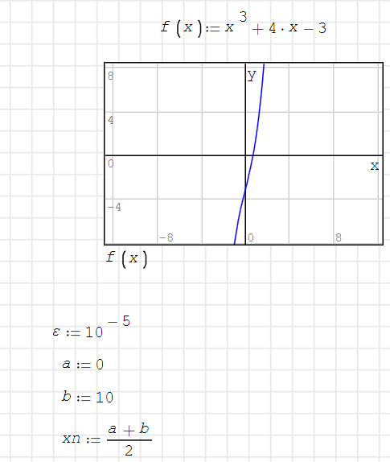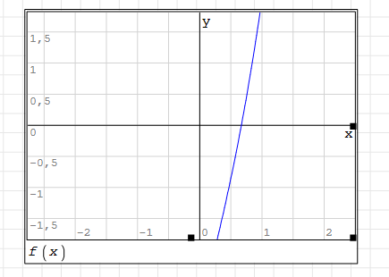
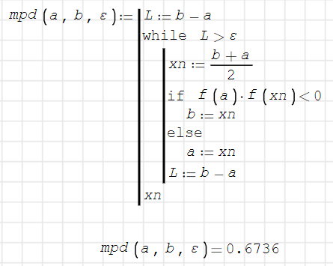
2) In the Smath Studio application, using the built-in function
To solve one nonlinear equation with one unknown, the Smath Studio system has a built-in function, which, depending on the type of problem, can have either two or three arguments: root(f(x); x) or root (f(x); x;a), where f(x) is a scalar function defining the initial nonlinear equation; x is the scalar variable with respect to which the equation is solved, and is the initial approximation of the variable x.
Decision:
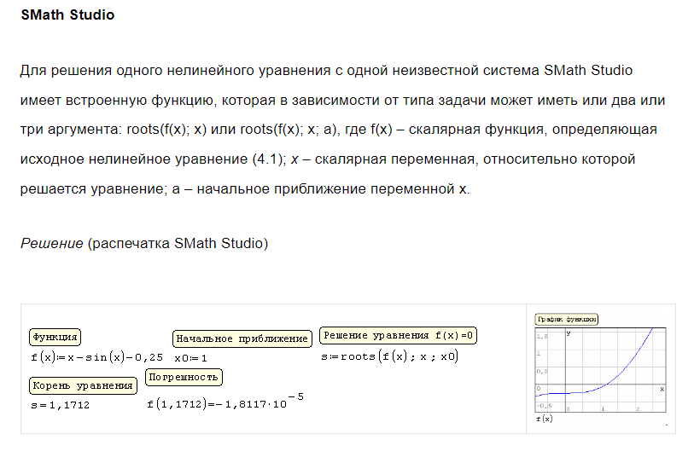
using the built-in functions of the Smath Studio math package.
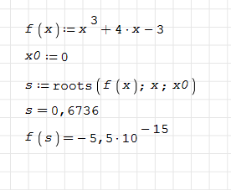
3) The bisection method algorithm shown in this flowchart was implemented in the Office Excel program: in the Excel environment
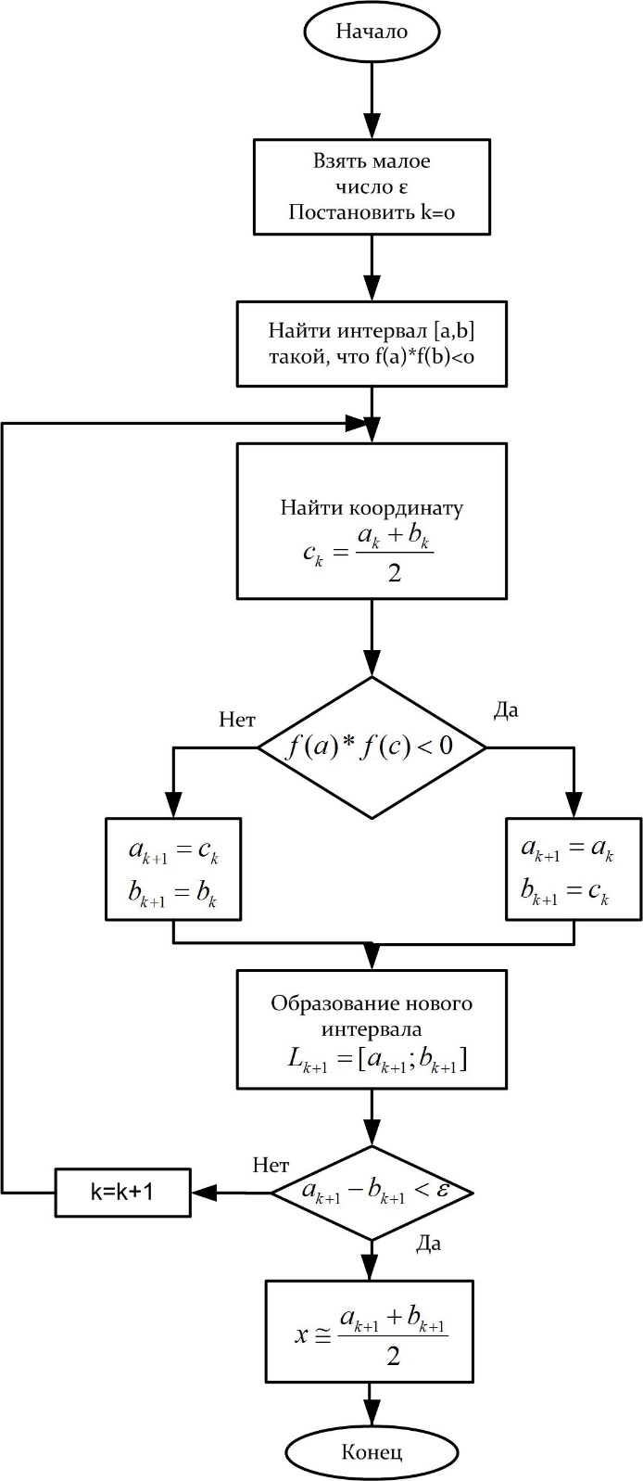
When performing iterations with the choice of the initial interval [0;1], ε=0.0001, the following results were obtained:
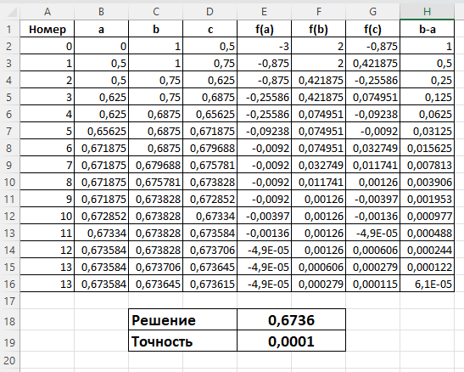
Steps for creating a table:
1) Filling the first row with column names
3) Cells B2 and C2 contain values describing the interval
4) Cell D2 contains the arithmetic mean of cells B2 and C2.
5) Cells E2, F2, G2 contain the values of functions with an argument equal to the values in cells B2, C2 and D2, respectively.
6) in cell H2 is the difference between the values of a and b of the current iteration. This value plays the role of accuracy
7) Cell B3 contains the condition: if the product of the function values with arguments equal to the values a and c from the previous iteration is less than 0, then the value of this cell is equal to the value a(B2) from the previous iteration, otherwise - the value c(D2) from the previous iteration
8) Cell C3 contains the condition: if the product of the function values with arguments equal to the values a and c from the previous iteration is less than 0, then the value of this cell is equal to the value c from the previous iteration, otherwise - the value b from the previous iteration
9) The values of the remaining cells are extended from the second line
10) The lines are extended until the precision value (column H) is less than the pre-set value
