Lecture 9 Civil and Political Confrontation (1917-1920s)
The main topics of the lecture:
1) The October revolution of 1917 and establishment of Soviet power in Kazakhstan.
2) The Civil War (1918-1920) and War Communism policy.
3) Formation of Kazakh Autonomous Soviet republic.
4) New economic policy (NEP) in Kazakhstan.

- The October revolution of 1917 and establishment of Soviet power in Kazakhstan

The October Revolution, commonly referred to as Red October, the October Uprising, or the Bolshevik Revolution, was a seizure of state power instrumental in the larger Russian Revolution of 1917. It took place with an armed insurrection in Petrograd on October 25, 1917.
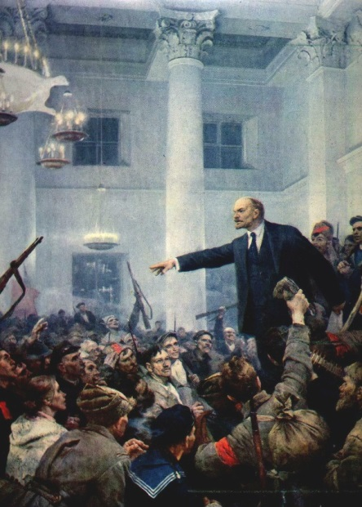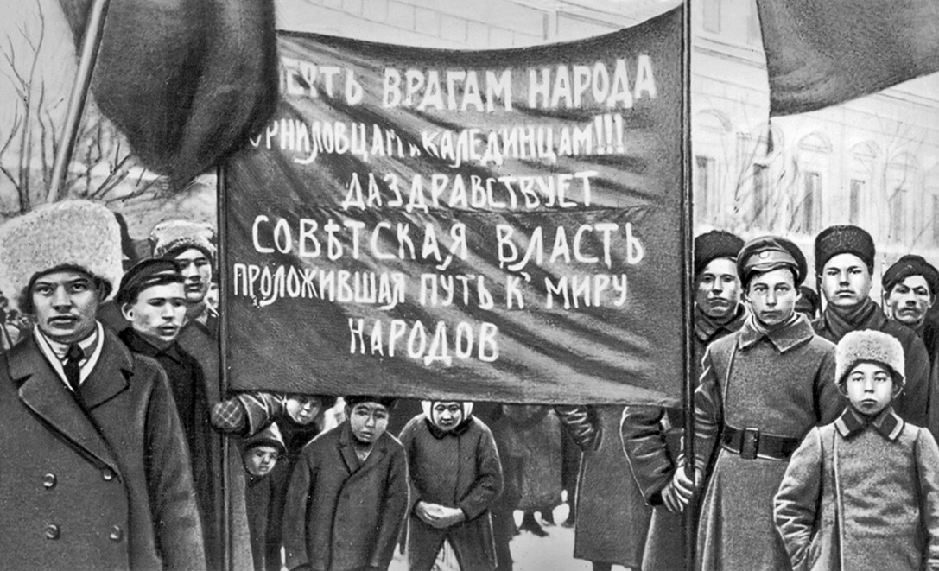
It followed and capitalized on the February Revolution of the same year, which overthrew the Tsarist autocracy and resulted in a provisional government after a transfer of power proclaimed by Grand Duke Michael, brother of Tsar Nicolas II, who declined to take power after the Tsar, stepped down. During this time, urban workers began to organize into councils wherein revolutionaries criticized the provisional government and its actions. The October Revolution in Petrograd overthrew the provisional government and gave the power to the local soviets. The Bolshevik party was heavily supported by the soviets. After the Congress of Soviets, now the governing body had its second session, it elected members of the Bolsheviks and other leftist groups such as the Left Socialist Revolutionaries to key positions within the new state of affairs. This immediately initiated the establishment of the Russian Socialist Federative Soviet Republic, the world’s first self-proclaimed socialist state.
The revolution was led by the Bolsheviks, who used their influence in the Petrograd Soviet to organize the armed forces. Bolshevik Red Guards forces under the Military Revolutionary Committee began the takeover of government buildings on October 24, 1917. The following day, the Winter Palace (the seat of the Provisional government located in Petrograd, then capital of Russia), was captured.
The regional congress of democratic organizations and Soviets of soldiers', workers' and peasants' deputies on November 15-22, 1917 in Tashkent "allocated the new regional authority in the person of the Council of People's Commissars of Turkestan krai". There was not a single representative of the Muslim population in the 14-member Council of People's Commissars. From October 1917 to March 1918. Soviets established power throughout Russia. In the Kazakh steppe, Soviet power was primarily established in the cities and towns along the railroads. In October, 1917 the power passed into the hands of the Perovsk (Kzyl-Orda) Soviet of Workers' and Soldiers' Deputies. In November the power of the Soviets was established in the towns of Aulie-Ata and Chernyaev. Cossack officer corps led by Ataman A. I. Dutov, the government of Alash-Orda, SRs and Mensheviks united against the Soviet power. In Bukeyev Horde the Soviet power was proclaimed on December 2, 1917. In December 1917, with the support of the food squad of Baltic sailors, workers and soldiers of Kustanai took power. In January 1918. Kustanai Congress of Soviets decided to establish Soviet power in the county, L.I.Taran was elected chairman of the county executive committee. In January 1918 the Soviet power was established in Aktobe and Orenburg. At the beginning of 1918. Soviet power won in Irgiz and Turgay counties, where a prominent role was played by A. Imanov, M. Kiselev, O. Asauov. At the end of January, 1918, with the support of the detachment of the Red Guard, Pavlodar Soviet took the power into its own hands. On the night of February 16 to 17, 1918 the power in Semipalatinsk went into the hands of the local Soviet, which predetermined the establishment of the Soviet power in Ust-Kamenogorsk, Karkaralinsk, Zaisan. In January 1918 under difficult conditions the Soviet power was established in Uralsk. In March 1918 the Regional Congress of Soviets decided to transfer the power in the Urals region in the hands of the Executive Committee of the Regional Council and the dissolution of the Cossack Voivod Government and the Government of the Alash Orda. However, due to the lack of armed forces the Council was unable to implement this decision. On the night of March 28 to 29 the counterrevolution managed to make a coup. Members of the executive committee were arrested. The Soviet power in Uralsk was finally established during the Civil War. On the night of 2 to 3 March 1918, as a result of an armed uprising in Verny, Soviet power was whitewashed. During March 1918. Soviet power prevailed in the entire Semirechenskaya oblast.
Ideology and the first reforms of the Soviet government.
The October Revolution was led by Vladimir Lenin and was based upon Lenin’s writing on the ideas of Karl Marx, a political ideology often known as Marxism-Leninism. Marxist-Leninists espouse a wide array of views depending on their understanding of Marxism and Leninism, but generally support the idea of a vanguard party, one-party state, proletarian state-dominance over the economy, internationalism, opposition to bourgeois democracy, and opposition to capitalism. The October Revolution marked the beginning of the spread of communism in the 20th century. It was far less sporadic than the revolution of February and came about as the result of deliberate planning and coordinated activity to that end.
The first two main documents of Soviet power: the decree on land and the decree on peace.
The first reforms of the Soviet government are following.
- Creation of new state structure
- All-Russian Central Executive Committee, the highest legislative, administrative and supervisory body of state power in Russia.
- The Council of People's Commissars, the highest executive authority of the government of the Soviet Union. The chairman of this council was thus the head of government.
- Replacing Russia’s short-lived provisional parliamentary government with government by soviets, local councils elected by bodies of workers and peasants.
- Defense bodies of the republic. The Soviet government gave priority in the state-building to creation of the bodies of protection of the revolution. On October 28, 1917 the People's Commissariat of Internal Affairs created workers' militia (militsia) to fight with criminals. On November 22nd the Council of People's Commissars issued the decree about the court, which abolished the old judicial system and proclaimed the principles of the Soviet court
- 7 (20) December 1917 on Lenin's initiative the Sovnarkom created the All-Russian Extraordinary Commission against counterrevolution and sabotage (VChK).
- Creation of regular armed forces. 15 (28) January 1918. SNK adopted a decree on the organization of the Workers and Peasants Red Army (Red Army).

- Constitution of the RSFSR of 1918. The Soviet power system fixed in the Constitution had four main features: class inclusiveness; unity of power - legislative, executive and judicial; deputies' responsibility before electors; subordination to the ruling party. The transformations were of class character, were aimed at establishing and strengthening the dictatorship of proletariat, development of creative potential of the working and exploited masses.

- In the social sphere the Soviet government paid primary attention to the national question. The "Declaration of the Rights of the Peoples of Russia" (November 2, 1917), the appeal "To all the Working Muslims of Russia and the East" (November 22, 1917) and other state decrees declared equal rights of both citizens regardless of national-religious differences and the peoples of Russia, including their right to secede. The decrees of VTsIK and SNK of December 16 and 18, 1917 gave a start to emancipation of women and their equalization with men rights.

- In economic sphere the major direction of the policy of the Soviet state was the struggle with financial, industrial and trade capital. It was expressed in the establishment of the workers control in the production. Nationalization of industry and banks.
- The Civil War (1918-1920) and War Communism policy

On May 25, 1918 the revolt of the Czechoslovak Corps began White Legionnaires captured Petropavlovsk, Kokshetav, Akmolinsk, Omsk, Pavlodar, Semipalatinsk, Kustanai. Ataman A. Dutov in June 1918 occupied Orenburg and cut the railroad connecting Kazakhstan with Central Russia. Against the Soviet authorities opposed the government of Alash-Orda, officially recognized the White Guard Siberian government. In November 1918. Admiral Kolchak proclaimed himself as ruler of Russia; he led the white movement in the eastern part of the country. British troops arrived in Iran and the Trans-Caspian region in March 1918, defeating the Soviet of Urals, the White Cossacks seized Uralsk. Special Purpose Squad twice tried to release the city. In November 1918. The Second Separate Steppe Corps of the Siberian White Army began an operation in the Semirechie direction to capture Tashkent. At the end of 1918 a division of Ataman Annenkov was transferred to the Semirechie front, the Soviets created military units called "Muslim", the formation of national military units was initially based on the principle of voluntariness. In 1920 in Turkestan, the first forced recruitment of the indigenous population was announced. By the end of 1920 37 military units had been formed on the territory of Bukeyev, Ural and Turgai regions. The formation of the military units was carried out by the extraordinary commissar of the Steppe region A. Dzhangildin, the military commissar of the Turgai district A. Imanov, head of the political department of the Kazakh horse brigade B. Karataev, commanders and commissars T. Aliyev, S. Argancheev, B. Almanov, D. Janshev, M. Masanchi, A. Rozybakiyev, U. Isayev, A. Urazbayeva. Military operations on the fronts in Kazakhstan were closely linked with the military operations on the Eastern Front.
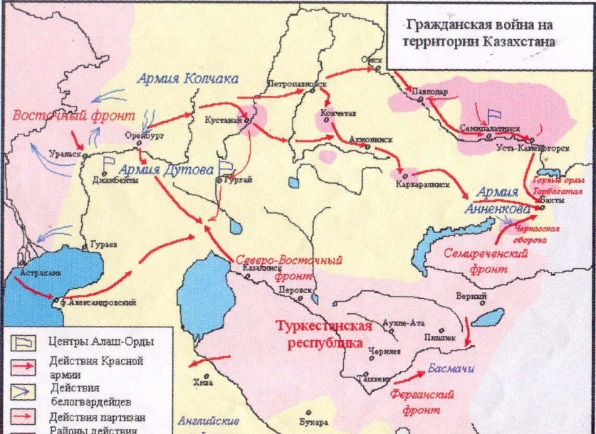
Kazakhstan in the period of Civil War (1918-1920)
In January 1919 the Red Army liberated Orenburg and Uralsk. The connection of the Soviet Russia with Kazakhstan and Central Asia was restored. The peasants who revolted in the rear of Kolchak in April 1919 took Kustanai by storm. However they failed to gain a foothold in the city, and Kolchak's detachments captured Kustanai again. The defeat of Kolchak troops in Kazakhstan was entrusted to the Northern and Southern groups of the Eastern Front. The Southern Group under the command of M.V. Frunze liberated Ufa in June 1919. In July, the Kazakh cavalry brigade together with the 25th Chapayev Division took part in the defeat of the White Guard troops besieging Uralsk. In summer of 1919 the troops of the Eastern Front drove Kolchak beyond the Urals. The First Army of the Turkestan Front launched an offensive in the direction of Aktyubinsk against the main force of the Orenburg counterrevolution - the Southern Army of the Kolchak troops. From the Aral Sea the advancing troops were supported by units of the Aktyubinsk Front Finding themselves in the grip. The Southern Army of the Kolchakists was forced to capitulate. In September 1919, at the Mugodzharskaya station of the Orenburg-Tashkent railroad the First Army joined up with the units of the Aktyubinsk front. Turkestan was again connected to Central Russia. On January 5, 1920 the troops of Turkestan front took Guriev, and the Ural Front was eliminated. In autumn 1919 the liberation of the Northern, and then eastern Kazakhstan from the Kolchak's troops was started by the Fifth Army of the Eastern Front (commander M.N. Tukhachevsky). Petropavlovsk and Akmolinsk were released. In November the Military-Revolutionary Committee restored Soviet power in Semipalatinsk. By the end of March 1920 the northern part of Semipalatinsk region was free of White Guards, Semirechenskaya front was liquidated. In June 1920 an anti-Soviet rebellion broke out in Verny.
War Communism
Lenin did not favour moving toward a socialist economy after October, because the Bolsheviks lacked the necessary economic skills. He preferred state capitalism, with capitalist managers staying in place but supervised by the workforce. But the Civil War caused the Bolsheviks to adopt a more severe economic policy known as War Communism.
The core of war communism policy.
- The Bolsheviks took control of factories, mines, workshops and railways.
- Grain was taken from the peasants using force.
- Nationalization of all industries.
- The Bolsheviks took control of the banks.
- Food was rationed to deal with shortages.
- Private enterprise banned.

- Formation of Kazakh Autonomous Soviet republic
The Decree on the “Formation of Kirghiz [Kazakh] Soviet Socialist Autonomous Republic” was signed by the chairman of Council of People’s Commissars Vladimir Lenin and Chairman of the Central Executive Committee Mikhail Kalinin in 26 August 1920. According to the Decree, the Kazakh Autonomous Republic was formed as a part of RSFSR and consisted of following administrative units within their borders in 1917: the Semipalatinsk oblast consisting of Pavlodar, Semipalatinsk, Ust-Kamenogorsk, Zaysan, Karkaralinsk uezds; the Akmolinsk oblast consisting of Atbasar, Akmolinsk, Kokchetav, Petropavlovsk and a part of Omsk uezds; the Uralsk oblast consisting of Uralsk, Lbishensk, Temirsk, Gur’ev; the Turgay oblasts consisting of Kustanay, Aktyubinsk, Irgiz, Turgay uezds; Mangishlak uezd of Transcaspian oblast 4th and 5th volosts of Krasnovodsk uezd of Transcaspian oblast; Sinomrsk volost, Bokei Orda, 1th and 2th primorskiy okrugs of Astrakhan gubernia. All these territories belonged to Kazakhstan nowadays. Orenburg was not mentioned in the decree, however, Orenburg with its neighbor territories was included in the Kazakh ASSR in October 1920. It also was declared as its capital. According to official data of autumn 1920, the territory of Kirghiz (Kazakh) Autonomous Republic was 1 871 239 square versts (2129000 square kilometers), the population numbered 5046000, 46.6% Kazakhs. Reducing Kazakhs on 12% can be explained the fact that southern territories of Kazakhstan were parts of Turkestan ASSR in that time.
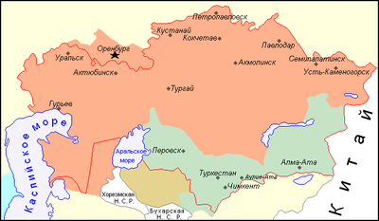
Kazakh Autonomous Soviet Republic

The First Constituent Congress of Soviets of KASSR took place in Orenburg (October 1920). There were 273 delegates represented all regions of recently formed Kirghiz (Kazakh) Autonomous Soviet Socialist Republic and 6 delegates of Altay Gubernia. 197 delegates were the members of Russian Communist Party of Bolsheviks; the rest delegates were non-Party men. The Congress prepared and adopted the appeals: to all Autonomous republics and oblasts of the Russian Soviet Federation; to all working- people of Kazakh Autonomous Soviet Socialist Republic.
The congress also approved the Declaration of Rights of Working People of Kirghiz (Kazakh) ASSR. According to the Declaration “Territory of Kirghiz Krai is proclaimed the Republic of Soviets of workers, working Kirghiz people’s, peasants’, Cossack s’ and Red Army men’s deputies.”
Civil institutions of government were created instead of Kazrevkom. At its closing meeting on October 12, 1920 the Congress elected the Supreme legislative power KASSR - the Central Executive Committee of KASSR, and selected its members S. Mendeshev (Chairman), S. Seifullin, V. A. Radus-Zen’kovich, A., Dzhangildin, I. A. Akulov, I. F. Kiselev, B. Almanov, A. Dosov, G. A. Korostelev P.I. Struppe. Thus, all organizational structures and governmental institutions of Kazakh Soviet Socialist Autonomous Republic were created; KASSR became one of the Republic of Russian Soviet Federative Socialist Republic.
According to the Decree about formation of Kirghiz (Kazakh) Autonomous Soviet Socialist Republic, the governmental bodies of KASSR were local Councils of deputies, the Central Executive Committee and Council of People's Commissars of KASSR. Twelve people’s commissars were established: 1) Internal Affairs with the Office of posts and telegraphs; 2) Justice; 3) Education; 4) Health; 5) Social security; 6) Agriculture; 7) Food; 8) Finance; (9) the Council of national economy; 10) the Workers' and Peasants' Inspectorate; 11) Labour; 12) Railways.
It should be noted that majority of the Central governmental bodies of the Autonomous Republic were directly subordinated to the Central Power bodies of the RSFSR. For example, the highest military authority (the Kirghiz Military Committee) was subordinated to the Zavolzhsky military district. Furthermore, according to the article 6 of the Decree of the People's Commissariats of food, Finance, communications, Rabkrin, Council of Agriculture, the Department of posts and telegraphs, the Kirghiz (Kazakh) Bureau of statistics, the Kirghiz (Kazakh) Emergency Commission remained subordinated to the “corresponding People's Commissars of the RSFSR “with purpose of unity of financial and economic policy of the RSFSR”. As to financing issues, according to article 8 of the Decree KASSR “all necessary finances and technical means were supplied by the funds of the RSFSR.” In addition, it was forbidden for the KASSR to have political or economic contacts with foreign countries. Article 9 of the Decree stated: “Foreign affairs and external trade remain entirely under the jurisdiction of the Central governmental bodies of the RSFSR.” The decree paid also significant attention to national rights of KASSR. According to the Decree, all nations were declared equal, each nation had an equal right to use the mother tongue in all public institutions and at school.
A striking proof of national equality and a change in the attitude of the new government towards the local population was the introduction of Kazakh language along with Russian in official documents. In addition, civil servants of KASSR were required to study Kazakh language, the compulsory study of the Kazakh language was also introduced into local Soviet Party schools.
The fundamental rights of the residents of the Kazakh Autonomous Soviet Socialist Republic were introduced in the Declaration of Rights of Working People of Kirghiz (Kazakh) ASSR. The Declaration had a class-oriented character. All power in the Autonomous Republic “should belong entirely and exclusively to working people.” According to article 2 of the Declaration among the categories of the population, deprived of the right to vote, were “servants and agents of the former police, the persons employing hired labour for profit, and living on unearned income.” In addition, article 4 of the Declaration stated the necessity to continue the class struggle and to build a socialist society through the struggle with the exploiters. To achieve this goal the Declaration prescribed a policy of expropriating of the means of production, eliminating private property and transferring it to the disposal of the state. KASSR’s citizens were guaranteed the right to free education and healthcare, men and women were declared to have equal rights. The main priority in gender policy was an accelerated emancipation of Kazakh women because they were believed an oppressed category of population without equal rights with men. To work was declared the duty of every citizen of the Autonomous Republic, RSFSR’s labor code was introduced in KASSR. Unified with other regions of RSFSR the legal system and proceedings were declared. 5 and 6 article of the Declaration emphasized the impossibility of economic and military separation of the KASSR from the Russian Soviet Federative Socialist Republic and all economic and military organs of the Republic declared to be controlled by the Central Government of RSFSR.

- New economic policy (NEP) in Kazakhstan

The New Economic Policy (NEP), introduced by Lenin at the Tenth Party Congress in March 1921, represented a major departure from the party’s previous approach to running the country. During the civil war, the Soviet state had assumed responsibility for acquiring and redistributing grain and other foodstuffs from the countryside, administering both small- and large-scale industry, and a myriad of other economic activities. Subsequently dubbed (by Lenin) “War Communism,” this approach actually was extended in the course of 1920, even after the defeat of the last of the Whites. Many have claimed that War Communism reflected a “great leap forward” mentality among the Bolsheviks, but desperation to overcome shortages of all kinds, and particularly food, seems a more likely motive. In any case, in the context of continuing urban depopulation, strikes by disgruntled workers, peasant unrest, and open rebellion among the soldiers and sailors stationed on Kronstadt Island, Lenin resolved to reverse direction.

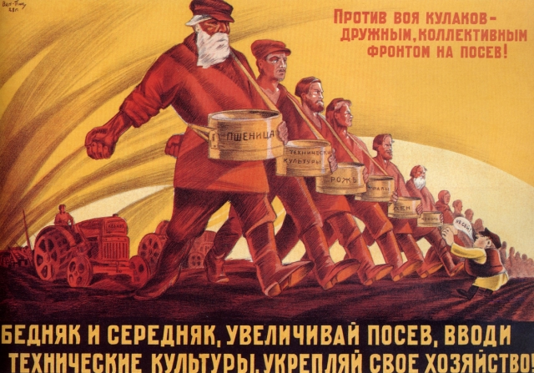
A sample of the state propaganda in the period of NEP

The peculiarity of NEP was the introduction of a tax-in-kind, set at levels considerably below those of previous requisition quotas, which permitted peasants to dispose of their food surpluses on the open market. This concession to market forces soon led to the denationalization of small-scale industry and services; the establishment of trusts for supplying, financing, and marketing the products of large-scale industry; the stabilization of the currency; and other measures, including the granting of concessions to foreign investors, all of which were designed to reestablish the link (smychka) between town and country. Referring to NEP as a retreat of the state to the “commanding heights of the economy” (large-scale industry, banking, foreign commerce), Lenin insisted that it had to be pursued “seriously and for a long time.”
The new economic policy yielded results by the mid-1920s. By 1925 the national economy was largely restored. Difficulties and successes of the NEP:

In the area of agriculture:
- Changes in tax policy. With the introduction of the Prodnalog there were favorable conditions in the life of the peasantry;
- Semi-pastoral farms with 6 or less cattle were exempted from the tax;
- On January 1, 1924 a cash tax was imposed;
- The brunt of the taxes fell on the farms of the kulaks and bays. Thus, in 1926-1927 in nomadic and semi-nomadic areas, 8% of the Bays farms paid 54.8% of the tax;
- Expenditure of funds collected from taxes went for defense; for the development of education; for all-round support of agriculture; and for the development of large-scale industry.
- Credit policy for agriculture: An agricultural credit society (Kazselhozkredit) was established to organize the rehabilitation of agriculture; The nomadic population was given loans on concessional terms for the period of 3-5 years; The state practiced to give seeds on credit; Farm machines and implements were given on credit. In 1924-1925 Kazakhstan cooperatives and communes purchased 415 tractors.
- The credit, seed loans, taxes and other means of economic regulation strengthened the connection of the state with the working peasantry, restoration of productive forces, growth of labor activity of the aul and village workers.
- The cooperative movement of the village:The initial form of cooperation was the Koshchi union, peasant committees (peasant committees) with their public plots, with shares, with their monetary and material funds and a collective form of management. small enterprises - mills, bakeries, canteens, creameries, slaughterhouses, brickyards, etc.
Successes of the NEP in agriculture:
The sowing area of the Kazakh ASSR increased from 2.1 million hectares in 1924 to 4 million hectares in 1928. In fact, the sowing area in the republic in 1928 reached the level of 1913. (4.4 million hectares);
The number of livestock increased in 1924-1928 from 24.8 million to 41 million. (in 1922 it decreased to 12.2 million heads); The number of peasant farms increased in those years from 737,000 to 1,333,000;
On the basis of economic growth there was further stratification of the peasants: the halving of the halftime peasant farms. In 1928. Three-fourths of the aul and village were the middle-aged. The number (from 6.6% to 14.8%) of kulak-bays farms more than doubled. Thus, the NEP proved to be the "miracle" that mobilized the potential of the sharua and migrant peasantry to accelerate the recovery of the agriculture that had been set back by wars, famine, and devastation.
In the field of industry:
The Kazakh Central Council of National Economy united 8 trusts - Kozhmehtrest, Kazrybtrest, Iletsksol, Pavlodarsol, Akzhol-gold, Kazspirt and two enterprises - the santonin plant and the Kargaly cloth factory;
The provincial council was in charge of local enterprises - milleries, wineries, artels, etc. Some of them were rented out;
By the decree of the CEC of the USSR from November 12, 1923. A part of them was leased out; by a decree of the Central Executive Committee of the USSR on November 12, 1923, three trusts of Soviet importance began operating in Kazakhstan: Embaneft (the oil fields of the Ural-Emba district of Western Kazakhstan), Altaypolymetal (the Ridder polymetallic enterprises) and the Ekibastuz coal mines
Difficulties of the NEP in the industry:
- The all-union trusts deducted a considerable amount from their revenues to the republic's budget. For example, 5% of revenues from the oil production of the Emba oil fields were allocated to the regional budget of the Kazakh ASSR;
- The super concentration of industry and the monopoly of the Soviet trusts and later the People's Commissariat and departments, which was extremely necessary during the restoration of industry and the formation of national defense capabilities, later turned into a system;
- An orderly style of leadership was formed. Politics played a dominant role;
- Widespread creation of trusts played a negative role in the rational distribution of productive forces in the regions, defined for many years the raw nature of economic development of Kazakhstan.

