Solving systems of linear equations by the inverse matrix method
Task: solve a system of linear algebraic equations using the inverse matrix method.
Provide the results of both the manual solution and the solution implemented in Smath Studio in the report.
Purpose: to explore the main features of the Smath Studio application for finding solutions to systems of linear equations.
Questions for self-control
1. What is called a system of linear equations?
2. What is the solution of a system of linear equations?
3. Matrix notation of a system of linear equations?
4. Why do I need to find the determinant of the coefficient matrix?
The course of a solution:
1) Write down a system of linear algebraic equations in matrix form .
2) Find the determinant of the matrix of the system Δ=detA and conclude that there is a solution.
3) Solve the system in matrix form: .
4) Check the correctness of the solution.
5) Solve the system in a matrix way
Table
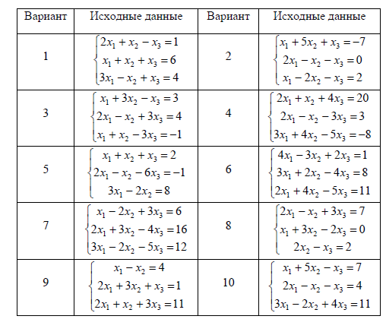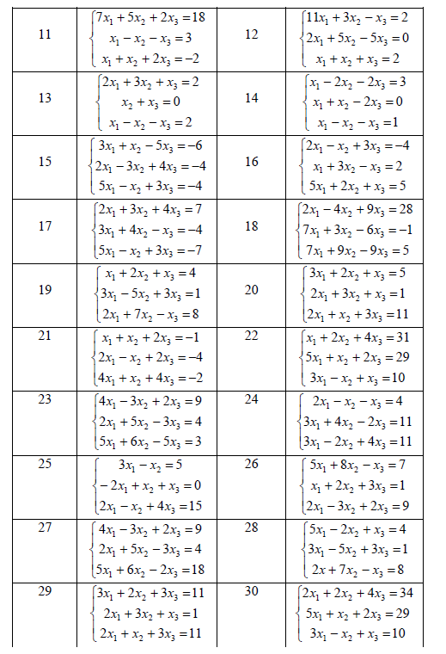
An example of completing a task in Smath Studio

Write down a system of linear algebraic equations in matrix form . Find the determinant of the matrix of the system and conclude that there is a solution. Solve the system in matrix form: . Verify the correctness of the solution.

Methodological recommendations
- Write the matrix A:=. The template for input 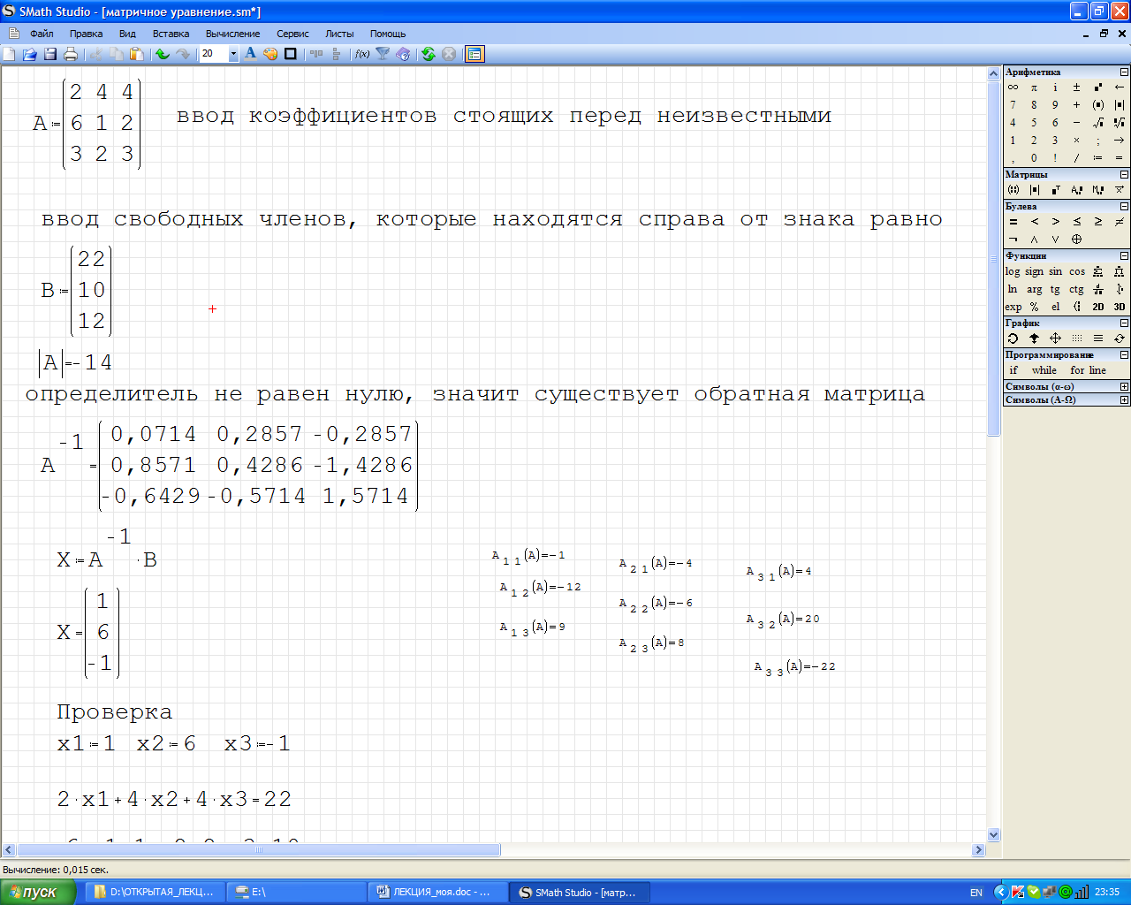 is located on the "Matrices" toolbar, in the dialog box that appears, specify the number of columns (= number of variables) and rows (= number of equations) and fill in the matrix cells with numbers, also enter the vector data B, specifying the number of columns equal to 1.
- Find the determinant of matrix A, to do this, select a template  on the "Matrices" toolbar. If the determinant is nonzero, then there is a solution.
- Find the inverse matrix. To do this, enter
- Write down the calculation of the roots of the system using a matrix expression and click below and get the solution of the system of equations.
- Check the result obtained, for this we will enter . If the solution is found correctly, then the result will coincide with B vector.

View of SMath Studio document:
