Laboratory work 7
Topic: Function Interpolation
The purpose of the lesson:
− consolidation of theoretical knowledge on the topic and the formation of skills and abilities to perform function interpolation by Lagrange’s method.
Tasks of the work:
− educational: to form the ability to perform the approximation of functions by constructing Lagrange’s interpolation polynomial
− educational: development of creative skills, independence,
cognitive interest;
− educational: to foster a positive attitude towards discipline.
Assessed knowledge:
− methods for solving basic mathematical problems using computers.
The order of the work.
1. choose your own task option
2. create a Lagrange’s polynomial by independently determining its degree using the initial data;
3. find the values of the resulting function at x1 and x2 points;
4. answer the questions

- 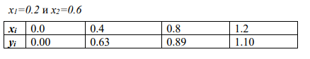
- 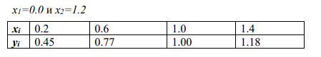
- 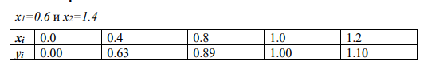
- 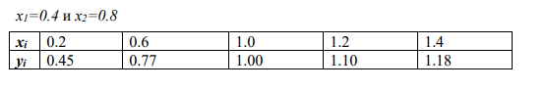
- 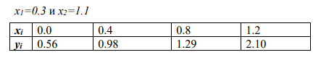
- 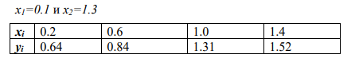
- 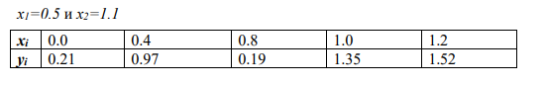
- 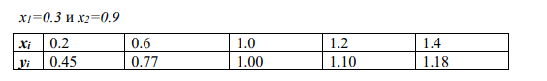
- 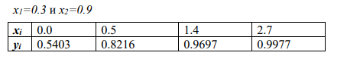
- 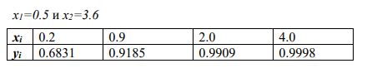
- 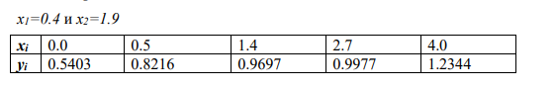
- 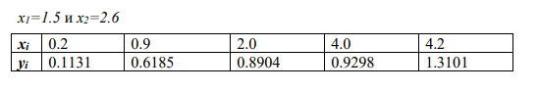
- 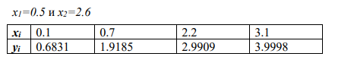
- 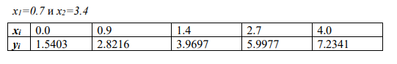
- 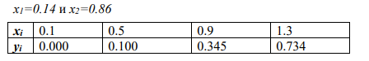
- 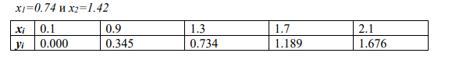
- 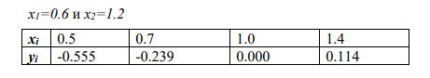
- 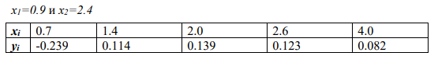
- 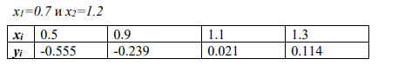
- 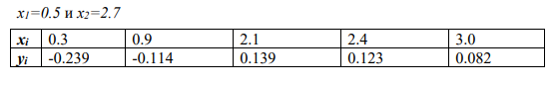
- 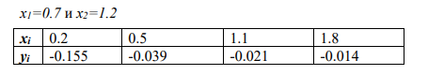
- 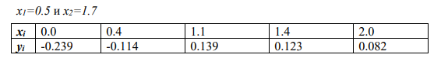
- 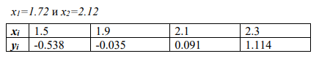
- 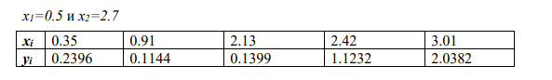
- 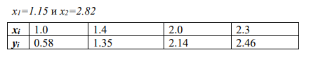
- 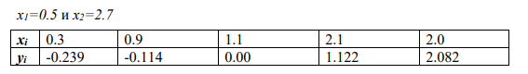
Control questions:
1. What is the task of interpolating a function?
2. What is called extrapolation?
3. What is the concept of interpolation?
4. When is it convenient to use Lagrange’s interpolation polynomial?
5. What is the disadvantage of Lagrange’s interpolation polynomial?

