Practical task No. 2
Characteristic features of modern information systems. Basic definitions. System analysis.
- The purpose of the work
To learn how to consider complex objects in the form of systems, to identify suprasystems, subsystems of various levels and elements of systems.
- General theoretical information
A system is understood as a set of elements interconnected by some structure, united by the unity of purpose (or purpose) and functional integrity. A structure is a set of those properties of the system that are essential from the point of view of the research being conducted, have invariance (constancy) and ensure the integrity of the system throughout the entire interval of the system functioning of interest to the researcher.
Structures are distinguished by different types and topologies: linear (the structure of metro stations on one line), hierarchical (the structure of university management), network (the structure of the organization of construction and installation work during the construction of a house: some work, for example, wall installation, landscaping, etc. can be performed in parallel), etc. Any system is formed as a result of interaction its constituent elements, and this interaction gives the system new properties that are missing from individual elements.
An element is further understood as an indivisible unit of the system, which has independence in relation to this system. The indivisibility of an element is considered as the inexpediency of accounting within a given system and the method of dismemberment of its internal structure. Depending on the objectives of the study, the elements of the system can be considered as subsystems. Thus, subsystems of various levels can be distinguished in any system.
A subsystem is a subset of system elements for which it is possible to specify some system-forming relationship that allows you to separate this subset from other elements of the system.
The most important system characteristic is communication – a mutual restriction on the behavior of objects, which creates a restriction on the behavior of objects and the dependence between them. The connections between subsystems and elements lead to the appearance of new properties in the system that are not inherent in subsystems and elements individually. At the same time, the properties of the system are not reduced to the sum of the properties of the constituent elements. The more connections a system has, the more complex it is. The maximum number of connections in the system is determined by the number of possible combinations between the elements and can be found by the formula: C = n(n–1), where n is the number of elements included in the system; C is the number of connections between them.
The necessary condition for the existence of the system is the external environment. The external environment is understood as a set of equivalent systems that interact with the system in question, set rules for the behavior of the system, and exchange resources with it (matter, energy, and information). In this case, the part of the external environment that the system under study enters is called a supersystem – a more general system of which the system in question is a part.
Figure 1 shows a generalized model of the system composition.
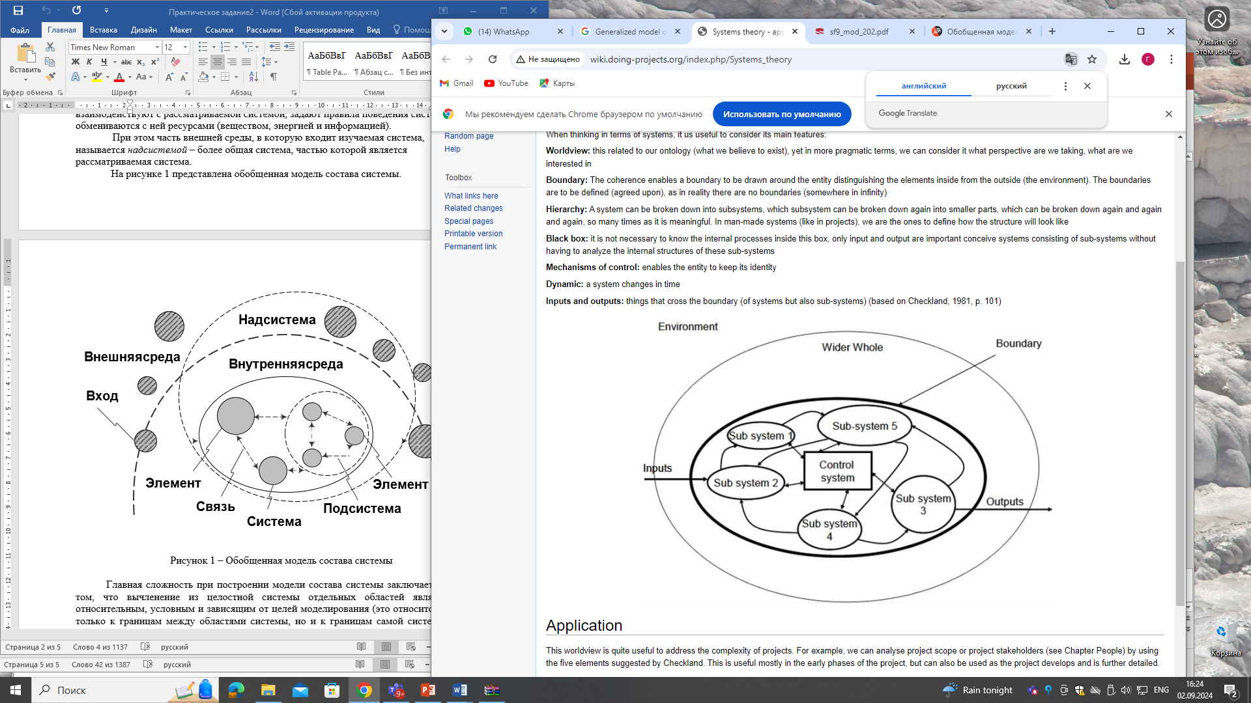
Figure 1 – Generalized model of the system composition
The main difficulty in constructing a model of the composition of the system is that the separation of individual areas from an integrated system is relative, conditional and dependent on the goals of modeling (this applies not only to the boundaries between the areas of the system, but also to the boundaries of the system itself). In addition, the definition of the smallest part, the element, is relative.
There are three main ways to allocate systems:
1. A phenomenon or process is divided into many constituent elements and system-forming inter-element connections and relationships are revealed between them, giving this set integrity. Example: A faculty is a system consisting of departments, specialties, groups, and students.
2. Representation not of the entire object, phenomenon, or process under study as a system, but only of its individual sides, facets, aspects, sections that are considered essential for the problem under study. In this case, each system in the same object expresses only a certain facet of its essence. This application of the concept of a system allows you to thoroughly and comprehensively study different aspects or facets of a single object.
Example: consideration of the production of an aircraft power plant in the technological aspect, consideration of the operation of an internal combustion engine from the standpoint of its efficiency – in the economic aspect.
Let's say we consider the TV and school systems. Using the example of a TV:
1. The TV consists of: a kinescope, an amplifier, an antenna, a housing, etc.
2. Technically, a TV is an electrical circuit. 3. In the process approach, the TV is an object in which the analog signal from the antenna input is converted into an image at the output of the cathode ray tube of the kinescope.
If we consider the school as a system, then the following subsystems can be distinguished: administration, economic and educational blocks. The administration includes the principal, the school's parent committee, and secretaries. All decisions are made at the pedagogical council, which is also part of the "Administration" subsystem.
Academic part (junior and senior classes) It includes the second-level subsystems "Teachers" and "Junior (senior) class", which are headed by deputy directors for academic affairs. In each such subsystem, classes, classroom teachers, and subject teachers can be distinguished. Each class consists of a prefect and students. The business unit is headed by a deputy director, who is subordinate to the system administrator, security, and cleaners.
The model of the structure of the above-described "School" system will have the following form (Fig. 2).
The boundary of the system
Senior classes (P₁₂)
Junior classes (P₁₁)
Administration (P1)

DISTRICT DEPARTMENT OF EDUCATION
Senior classes (P₁₂₁)
Teachers (P₁₂₁)
Deputy Director for Academic Affairs
E121
УчителяE1212
предметники
ClassE E1211
руководители
Class Leader
E1212
Students
E1211
Parent Committee (P₁₁₃)
Junior classes (P₁₁₂)
Teachers (P₁₁₁)
E111
Deputy Director for Academic Affairs
Parents
E1132
E1131
Chairman
Class Leader
E1122
Students
E1121
TeachersE1112
предметники
ClassE1111
руководители
Secretaries
E13
School's Parent Committee
E14
E12
Pedagogical Council
Director
E11
Parents
E1232
Chairman
редседатель
Parent Committee (P₁₂₃)

Chefs
Cleaners
Security
E1312
E134
E133
System Administrator
E1311
Canteen (P₁₃₁)
Head of the canteen
Deputy Director for General Affairs
E131

service personnel (P₁₃)
Figure 2 – Model of the "School" system
Tasks for students to solve independently
1. Make up the structure of the system (for example, university, faculty).
2. To identify in the compiled structure a super-system, subsystems of the first, second and third levels with their elements.
3. Determine the external links of the system with the suprasystem.
4. Make a complete list of all subsystems.
5. Make a list of elements for each subsystem.
6. Show the relationships between subsystems and elements of subsystems.
7. Introduce abstract designations for subsystems (Pijk) and elements (ELijk), where i, j, k are the indices of the first, second and third levels, respectively, variable from 1 to the maximum number of elements or subsystems at the level, and L is the number of the subsystem at the level.
8. Fill in the table (Table 1) to classify all subsystems and elements.
Table 1 – Classifications of subsystems and system elements
Designation | Type(subsystem/element) | Name(of the subsystem/element) | Connections to subsystems/elements
P1 | The subsystem of the first level | Administration | P11, P12, P13,  E11, E12, E13, E14
E11 | The first element of the first-level subsystem | Director | P1,  E12, E13, E14

9. Build an abstract model of the system structure based on the table.
10. Present the process of mastering the training course (lectures, conducting and defending laboratory and term papers, passing the exam) in the form of a system.
11. Identify elementary processes as elements of the system.
12. Determine the relationships between the elements, build a structural model in the form of designations of elementary processes (Ei).
13. Define the super-system for the process and external links to it.

Control questions
1. Formulate the definition of the concepts "system", "subsystem", "element", "supersystem".
2. Give an example demonstrating that the properties of a system are not reduced to the sum of the properties of its constituent elements.
3. What is the external environment of the system?
4. How does the system interact with the external environment?
5. List the environmental factors affecting the system.
6. Give the main ways to allocate systems.

