LABORATORY WORK No. 5
APPROXIMATE SOLUTIONS OF NONLINEAR ALGEBRAIC EQUATIONS (BISECTION, NEWTON, CHORD METHOD)
Written by Zhantassova Adina ISU-1 group
Purpose: to study the basic methods of approximate solution of nonlinear equations using the Smath Studio application, as well as in the Excel environment.
Questions for self-control
- What are the ways to study the function?
Answer: First of all, plotting a graph,next determining the domain, then finding intercepts, and analyzing derivatives and limits.
- What methods are used to find the roots of the equation?
Answer: Graphical method,bisection method,Newton’s method,secant method,built-in functions in SMath Studio and Excel.
- What is the root separation procedure used for?
Answer: I supposed that for identifying intervals where roots are located by checking function signs at segment endpoints.
- What is the essence of the dichotomy method?
Answer: The essence of the dichotomy method is repeatedly dividing an interval in half and selecting the subinterval where the function changes sign, gradually narrowing it down to the root.
- What is the essence of the Newton, Chord method?
Answer: The essence of the Newton, Chord method is iterative methods that refine the root using tangents (Newton) or secants (secant method).
- Criteria for stopping the iterative process.
Answer: Small change in approximations, achieving desired accuracy, or reaching the iteration limit.
- What is the difference between numerical and analytical finding of the roots of an equation?
Answer: Analytical methods give an exact expression, while numerical methods provide an approximate value.

Individual task

Tools Used:
- SMath Studio Online
- Microsoft Excel
- Computer with internet access
Findings: №19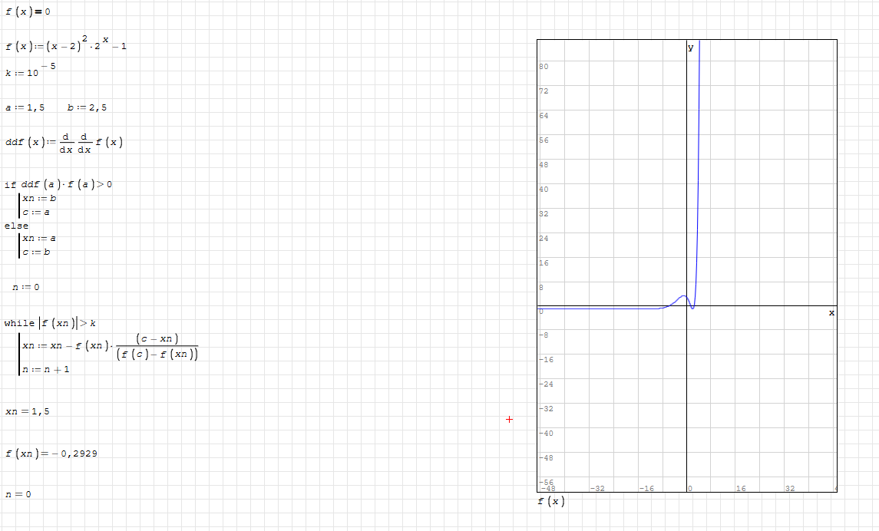
  - The function f(x) has been analyzed numerically using an iterative method.
  - The root -finding process was implemented with a stopping criterion based on accuracy.
  - The obtained approximation is xn=1.5 with f(xn)=-0,2929
  - The graph shows a sharp increase, indicating a possible singularity or steep gradient.
  - The method works but may need adjustments for improved precision or stability.

Analysis:
- The function f(x) is given and differentiated.
- An iterative process is used to find the root within a given accuracy.
- The graph shows the function’s behavior, including rapid growth near a certain point.
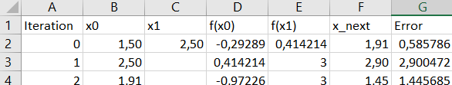

Conclusion
During the work in SMath Studio and Excel, a numerical root-finding process for a nonlinear equation was performed using an iterative method. Graphs of the function were plotted, initial approximations were defined, and the calculation algorithm was implemented.
Using Excel allowed for automation through a formula-based table, where each iteration was recalculated automatically. It was important to set the correct cell format for proper data entry.
The results showed that the method converges to an approximate root, but accuracy depends on the chosen parameters and initial conditions. To improve efficiency, additional stopping criteria or alternative numerical methods can be used.

