Laboratory work No. 1
Topic: Tools for implementing computational algorithms (mathematical packages)
Progress of work:
1. Run the Mathcad 7.0 program
2. Familiarize yourself with the theoretical material, complete the "Task- An example of the work"
3. Complete the "Option Assignment"
4. When passing the laboratory work, answer the control questions
Theoretical material:
1 The basics of the user interface of the Mathcad 7.0 system
The user interface refers to a set of Mathcad graphical shell tools that provide easy control of the system both from the keyboard and with the mouse.
The user interface of the system is designed so that a user with basic skills of working with Windows applications can easily master it.
Most Mathcad calculations can be performed in three ways:
- by selecting an operation in the menu;
- using the push-button toolbars;
- by accessing the relevant functions.
Almost all operations assigned to menu items are duplicated by the corresponding toolbar buttons. To access the built-in function, you can:
- Insert a function into a working document by selecting the desired name from the list of functions;
- Enter the function name from the keyboard;
- For the most frequently used functions, insert the function name by clicking on the button in the toolbar.
Thus, the same procedure is followed in all three cases:
- the operation is selected by clicking on a menu item or a button in the toolbar, after which, if necessary, the user gets access to a drop-down menu or an additional panel;
- When an operation is selected, the user enters the necessary information in the dialog box or fills in the marked fields in the input field that opens directly in the working document.
1.1 The main menu of the system
The top line of the system window contains an indication of the name of the system or the currently open window. The next line contains the main menu items (Figure 1).
The menu has a set of standard items for Windows applications:
File | working with files, the Internet and e-mail
Edit | editing
View | viewing, changing the means of viewing and turning on/off interface elements
Format | changing the format (parameters) of objects

All operations of the Format menu are designed to determine the style and form of displaying expressions, data, calculation results and graphs in a working document — determining background colors and labels, font size and type, text alignment in a working document, dividing a working document into areas, etc. When installing Mathcad, some neutral design style is selected by default. The user can diversify the design of the document. For example, the Number clause contains operations for determining the output formats of numeric data and results. Clicking on Number opens a dialog box for entering parameters. In the Radix field (Base of the number system), the selected number system is marked (Decimal — decimal, Hex — hexadecimal, Octal — octal). In the Precision field, you can set the number of characters in various forms of displaying numbers within the boundaries indicated on the right; in the Imaginary field, you can select a symbol to display the imaginary unit. At the bottom of the window there are fields that allow you to determine whether the settings apply to the entire working document (Set as worksheet default) or only to the current input area (Set for current region only).
Mathcad-specific items:
Insert | installing inserts of objects and their templates (including graphics)
Math | managing the computing process
Graphics | working with a graphic editor
Symbolic | selecting character processor operations
Books | working with e-books

Clicking on a menu item opens a drop-down menu with a list of operations available in this menu item.
1.2 Using toolbars and typesetting panels
Working with Mathcad documents usually does not require the mandatory use of the main menu features, since the main ones are duplicated by the quick control buttons. They can be displayed on the screen or removed from it using the corresponding options of the View position of the Windows main menu.
Mathematical operations in Mathcad are divided into groups, and each button of the mathematical toolbar opens access to a specific group of operations. Clicking on the button of this panel opens another, additional panel, on which the buttons of mathematical operations of the corresponding group are actually located (just as clicking on a menu item opens a drop-down menu). The rules for working with panels will be discussed in more detail below using specific examples.
Two such panels are most often used: the toolbar (which duplicates a number of the most common commands and operations) and the formatting panel for selecting the type and size of fonts and how to align text comments. These panels are visible in Figure 1 under the main menu bar. Under the rows of the toolbars is the Mathcad working document window — a space in which all entered commands and expressions are located, where Mathcad displays the results of calculations and graphs, and where text comments are placed. The contents of this window can be edited, formatted, saved to files on disk, printed, etc. The window is equipped with two scroll bars — vertical and horizontal. By clicking on the corresponding arrow button or dragging the elevator button, you can view fragments of the window that are outside the screen.
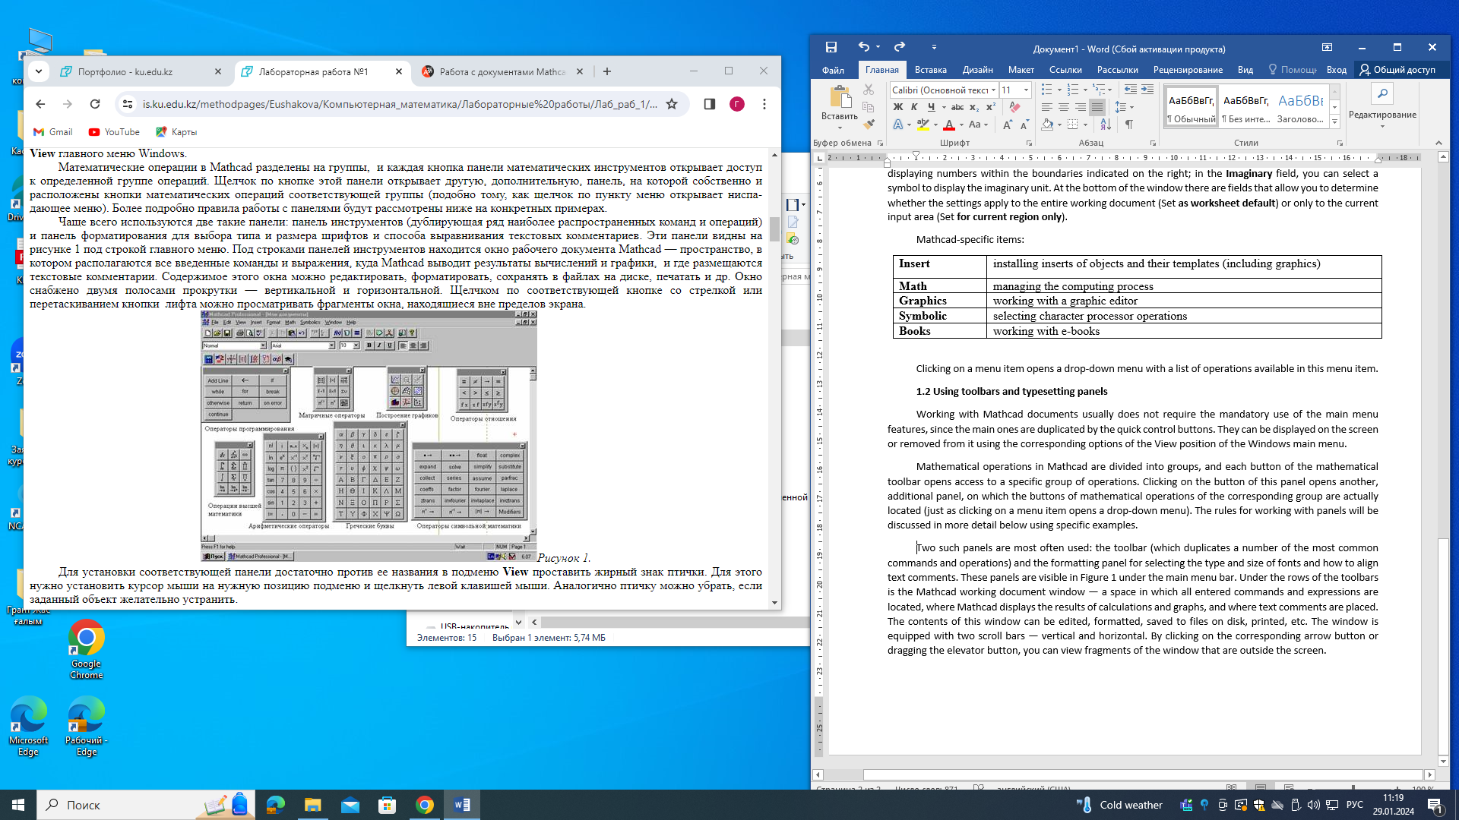
Figure 1
To install the corresponding panel, it is enough to put a bold bird sign against its name in the View submenu. To do this, place the mouse cursor at the desired position of the submenu and click with the left mouse button. Similarly, a bird can be removed if it is desirable to eliminate the specified object.
1.3 Working with files - the File position of the main menu
The File position of the main menu is used to work with document files. It contains typical file operations that can be found in any Windows application.
Document files in Mathcad have the mcd extension, which is indicated by a dot after the file name. It is also possible to record documents in a special RTF format designed to store complex multicomponent data (containing texts and graphs).
The File submenu contains a number of operations that perform the following operations on working with documents:
New (Ctrl+N) | open an empty window for a new document
Open (Ctrl+0) | open the document file search window and download the required document
Close | close the current document
Save (F6) | save the current document to disk
Save as (Ctrl+S) | open a window to search for a directory, specify the name and type (extension) of the file in which the document will be written in the selected directory
A user who has skills working with Windows applications, after reading the examples below describing the performance of specific tasks in the Mathcad environment, will easily understand the specifics of the Mathcad interface.
1.4 Working with matrices

Mathcad provides the ability to perform various operations with matrices.
Previously, the matrix must be defined and entered into the Mathcad working document. In order to determine the matrix, you need to enter the name of the matrix and the assignment sign from the keyboard - press the key combination <Shift >+<:> on the keyboard. Then click on the button 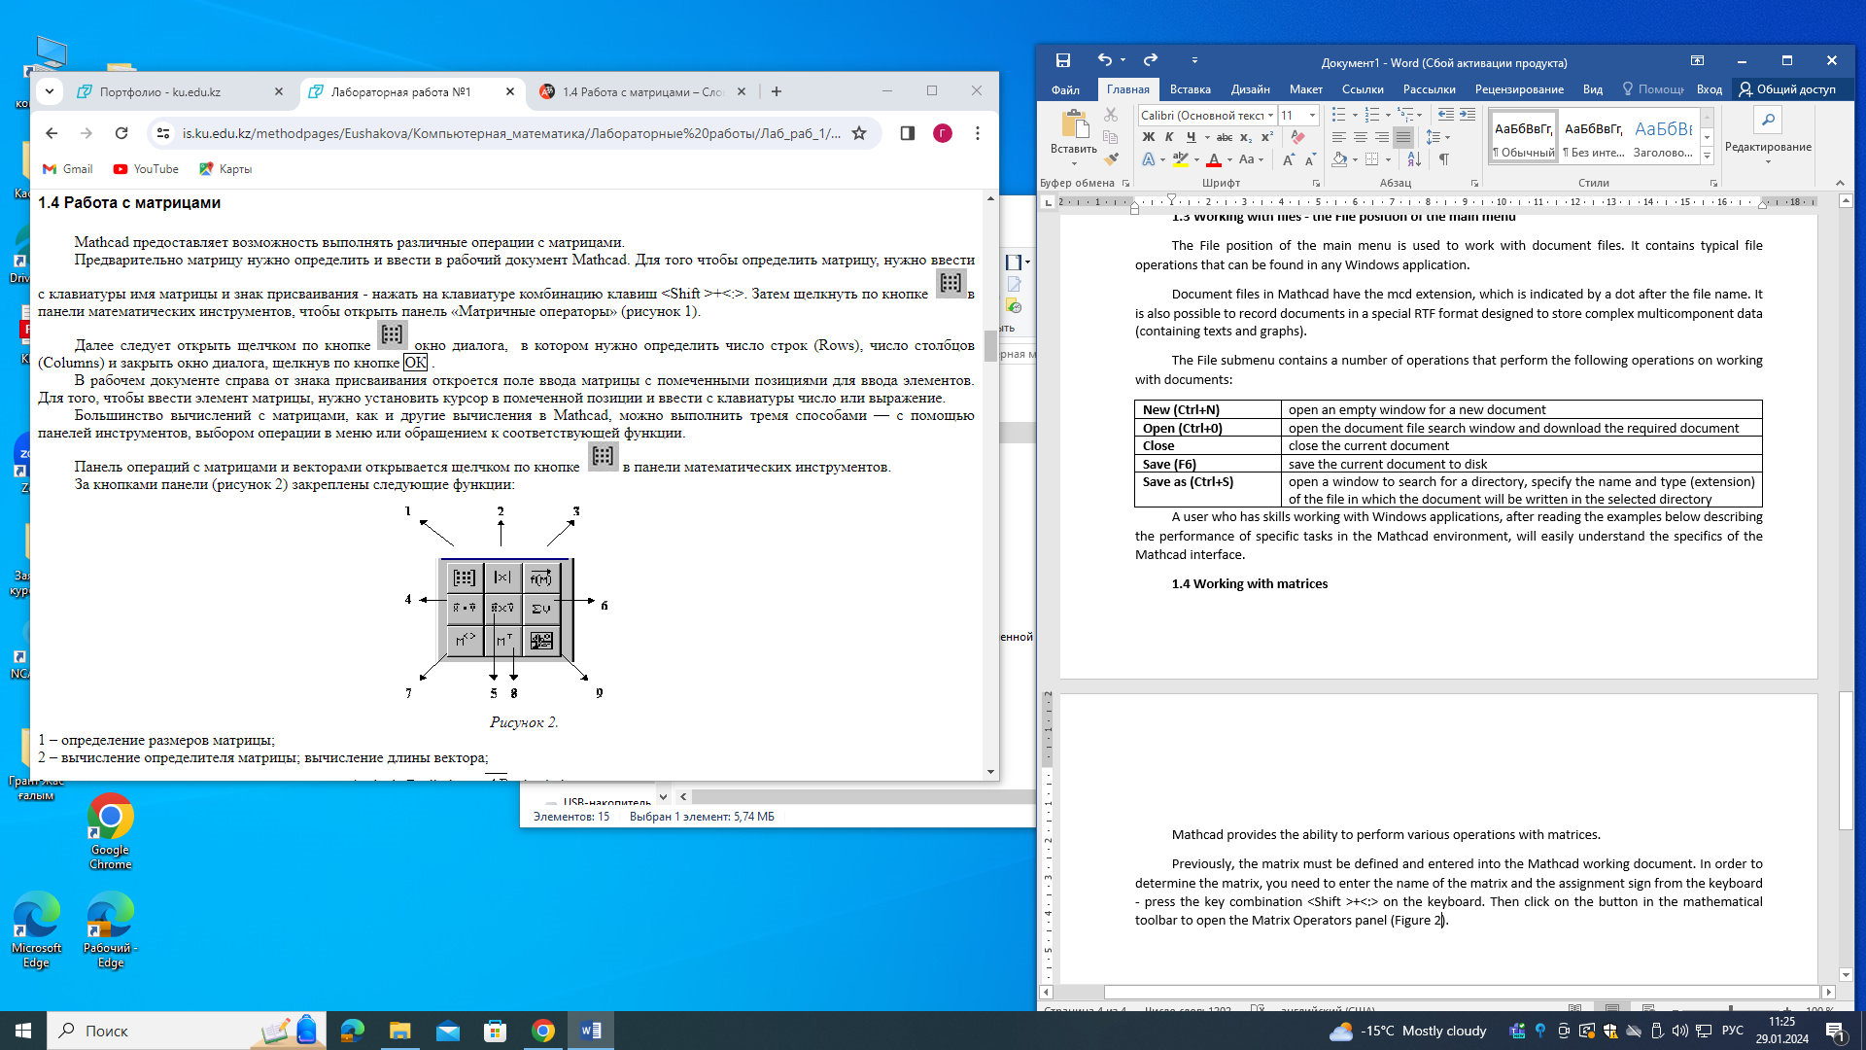in the mathematical toolbar to open the Matrix Operators panel (Figure 2).
Next, click on the button  to open a dialog box in which you need to determine the number of rows, the number of columns and close the dialog box by clicking OK.
In the working document, to the right of the assignment mark, a matrix input field opens with marked positions for entering elements. In order to enter an element of the matrix, you need to place the cursor in the marked position and enter a number or expression from the keyboard.
Most calculations with matrices, like other calculations in Mathcad, can be performed in three ways — using toolbars, selecting an operation in the menu, or accessing the appropriate function.
The Matrix and Vector operations panel opens by clicking on the button  in the mathematical tools panel.
The following functions are assigned to the panel buttons (Figure 2):
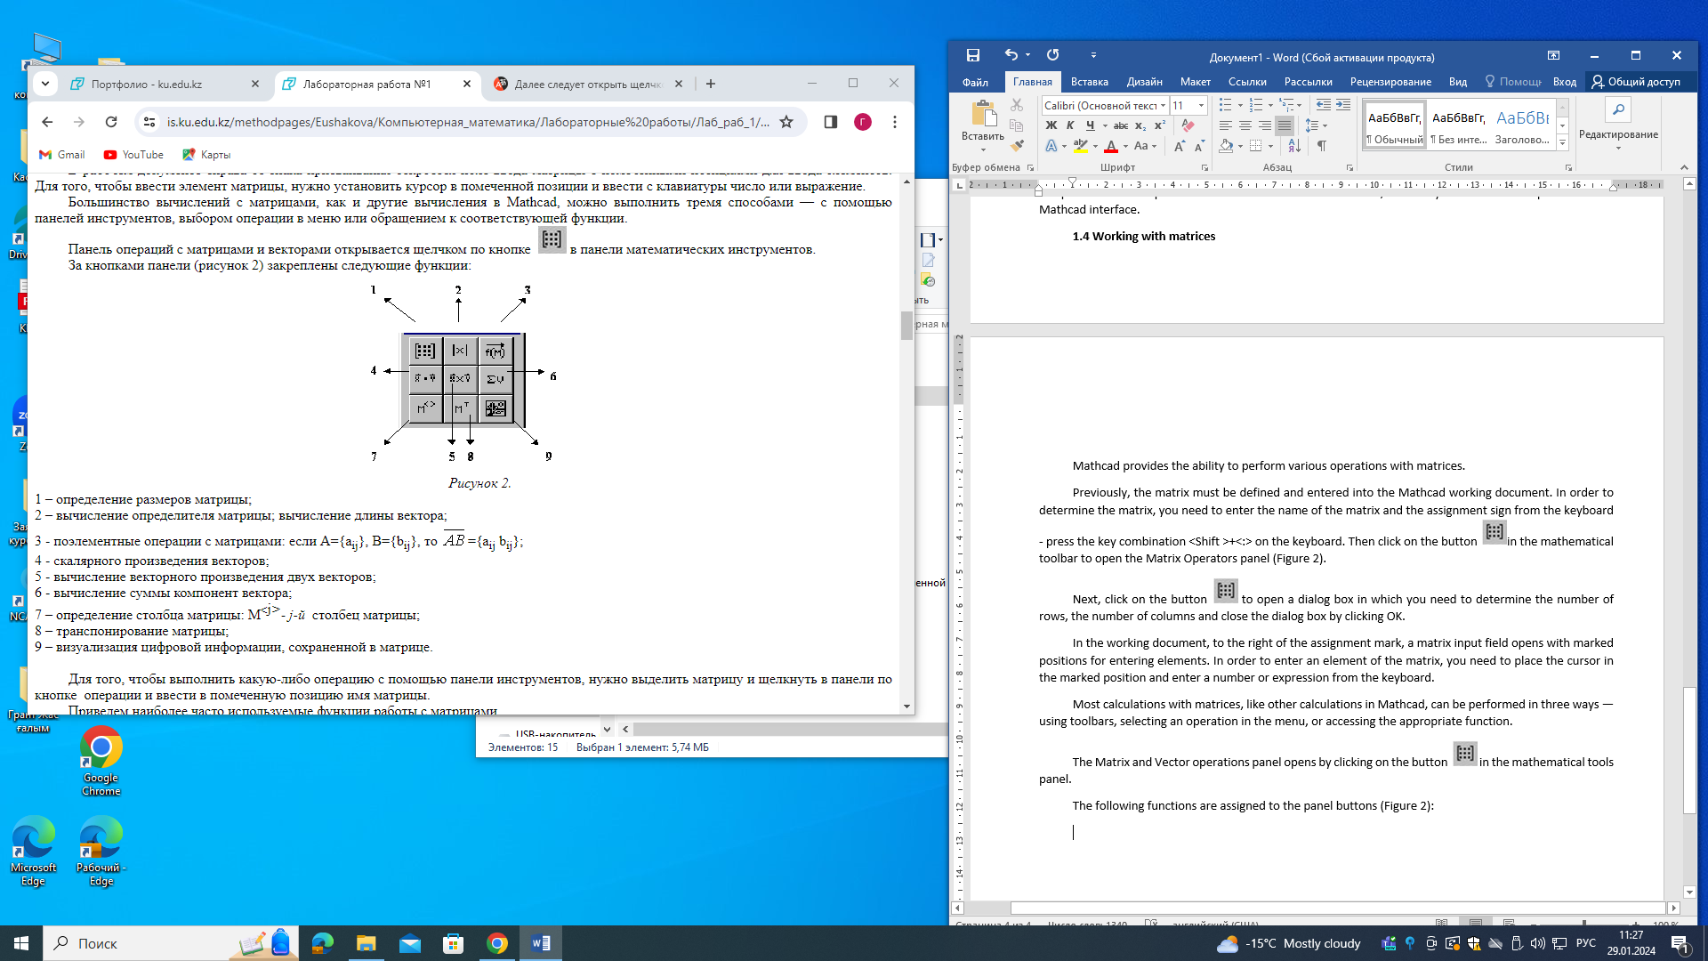
Figure 2

1 – determining the size of the matrix;
2 – calculation of the determinant of the matrix; calculation of the length of the vector;
3 - element operations with matrices: if A={aij}, B={bij}, then ={aij bij};
4 - scalar product of vectors;
5 - calculation of the vector product of two vectors;
6 - calculation of the sum of the components of the vector;

7 – definition of the matrix column: M - <j>- the j-th column of the matrix;
8 – matrix transposition;
9 – visualization of digital information stored in the matrix.
In order to perform any operation using the toolbar, you need to select the matrix and click on the operations button in the panel and enter the name of the matrix in the marked position.
Here are the most frequently used functions for working with matrices.
Matrix definition functions and operations with matrix blocks:
matrix(m, n, f) — creates and fills in a matrix of dimension m x n, the element of which, located in the ith row, jth column, is equal to the value f(i,j) of the function f(x,y);
diag(v) — creates a diagonal matrix, the elements of the main diagonal of which are stored in the vector v;
identity(n) — creates a unit matrix of order n;
augment(A, B) — forms a matrix, the first columns of which contain matrix A, and the last ones contain matrix B (matrices A and B must have the same number of rows);
stack(A, B) — forms a matrix, the first rows of which contain matrix A, and the last ones contain matrix B (matrices A and B must have the same number of columns);
submatrix(A, ir,jr, ic,jc) — forms a matrix, which is a block of matrix A, located in rows with ir no jr and in columns from ic to jc, ir jr, icjc.
The number of the first row (column) of the matrix or the first component of the vector is stored in Mathcad in the ORIGIN variable. By default, in Mathcad, the coordinates of vectors, columns and rows of the matrix are numbered starting from 0 (ORIGIN := 0).
The task
An example of the work being done:
Plotting functions in the Mathcad environment
Task
1.Построить график функции

2. Построить в одной системе координат графики функций
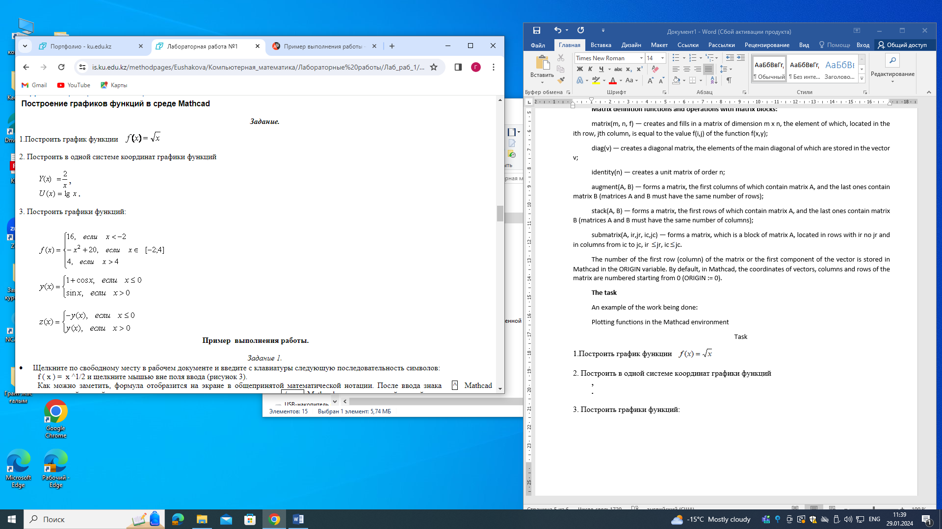
3. Построить графики функций:


An example of the work

Task 1.
  - Click on an empty space in the working document and enter the following sequence of characters from the keyboard:

f( x ) = x ^1/2 and click outside the input field (Figure 3).

As you can see, the formula will be displayed on the screen in a generally accepted mathematical notation. After entering the sign ^, Mathcad indicates with a black label the position for entering the degree, and after entering the sign / Mathcad indicates with a black label the position for entering the denominator.

When you enter an expression in a working document, the input field bounded by a rectangle is highlighted. The entered expression can be changed (edited) and the calculated value of the new expression can be obtained by clicking the mouse outside the highlighted frame.

  - Click on an empty space in the working document, then on button 1 (Figure 3) in the mathematical tools panel and in the panel that opens, click on button 2. The cursor will be positioned in the marked position near the abscissa axis.

  - Enter the name of the argument x using the keyboard, then click on the marked position near the ordinate axis, enter f(x) using the keyboard and click outside the rectangular frame.

  - In order for the graph to be more expressive, you need to determine the interval for changing the argument, for example, equal to [0.10]. To do this, click on the graph field, then on the number that sets the smallest value of the argument (the number in the lower—left corner of the graph field bounded by the frame), press the <Backspace> key and enter 0 from the keyboard. Similarly, change the second border - instead of the number in the lower-right corner of the graph field, enter 10.
  - Click the mouse outside the graph field

Figure 3 shows the result of the performed actions.

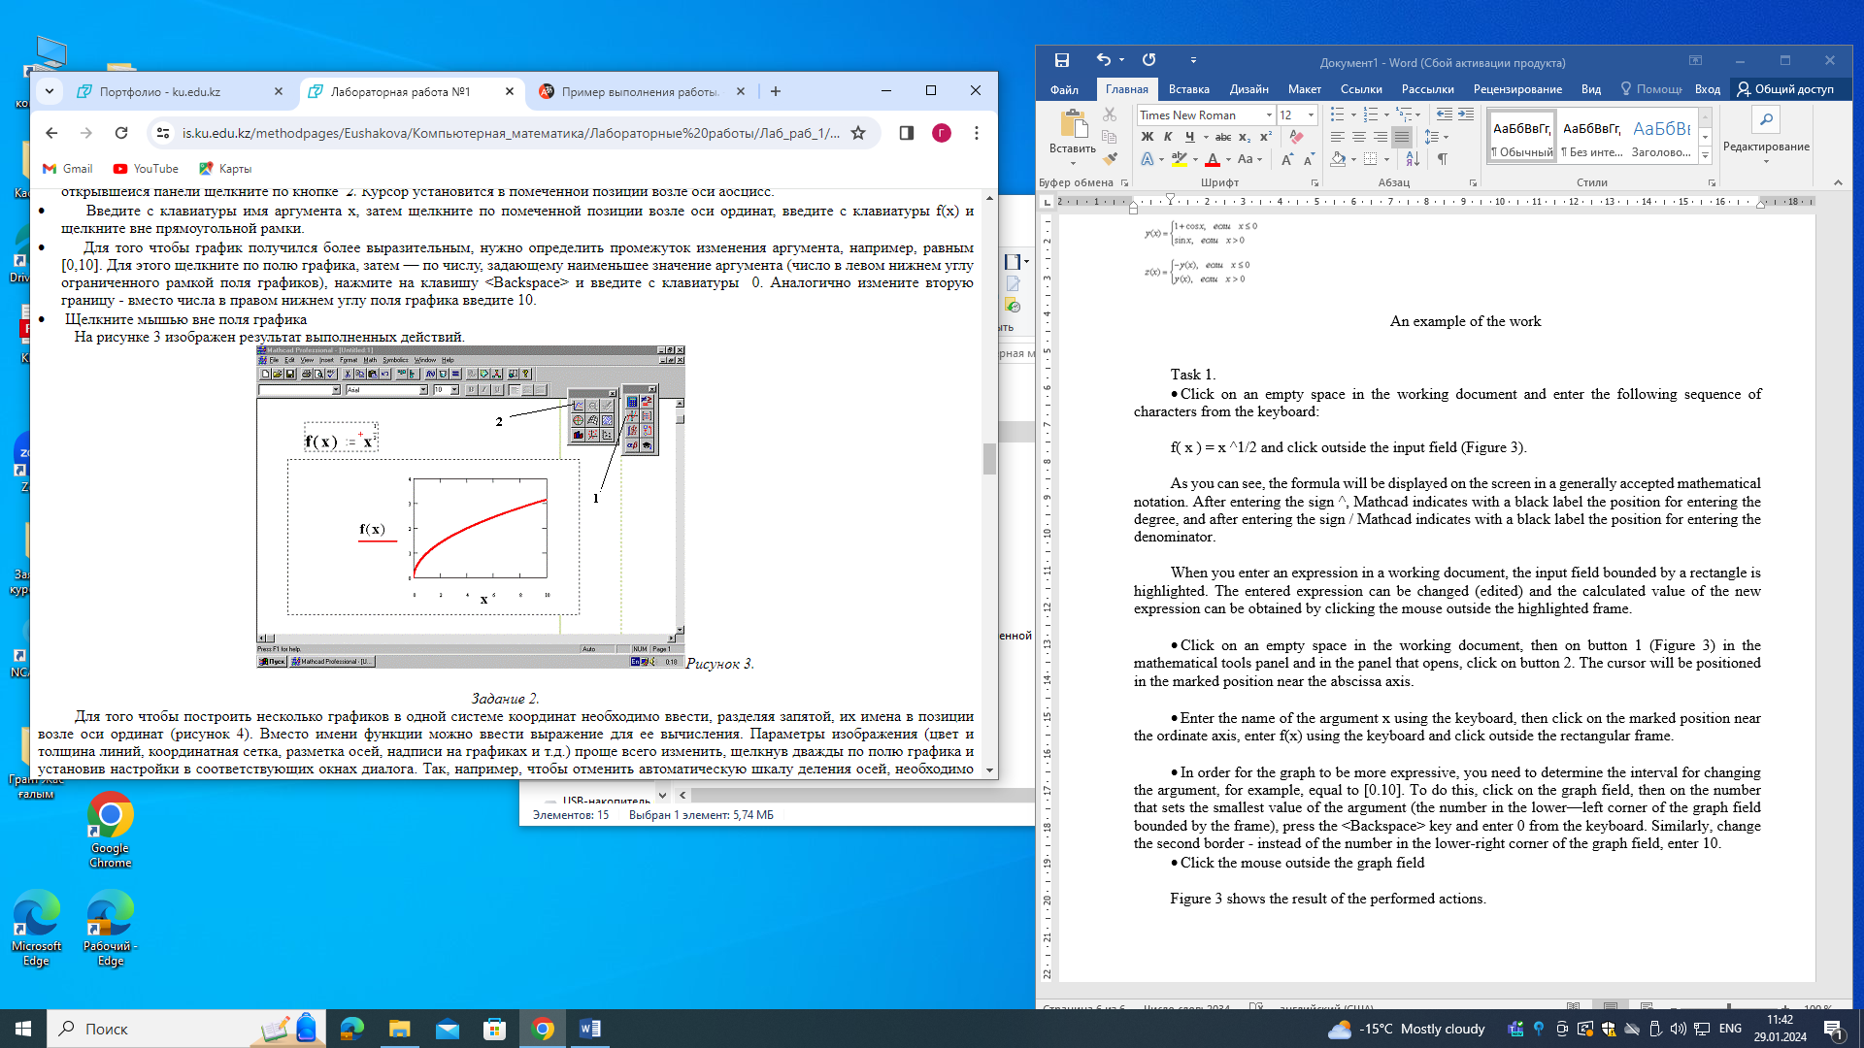
Figure 3
Task 2.
In order to build several graphs in the same coordinate system, it is necessary to enter their names, separated by commas, in the position near the ordinate axis (Figure 4). Instead of the function name, you can enter an expression to calculate it. The image parameters (color and thickness of lines, coordinate grid, axis markings, labels on graphs, etc.) are easiest to change by double-clicking on the graph field and setting the settings in the corresponding dialog boxes. So, for example, to cancel the automatic axis division scale, you need to uncheck the AutoGrid in the dialog box that appears (X-Y Axes) and enter the desired number of divisions (Number of Grids), click Apply. In the example below (Figure 4), the number of divisions along the abscissa axis is 8 and along the ordinate axis is 4.
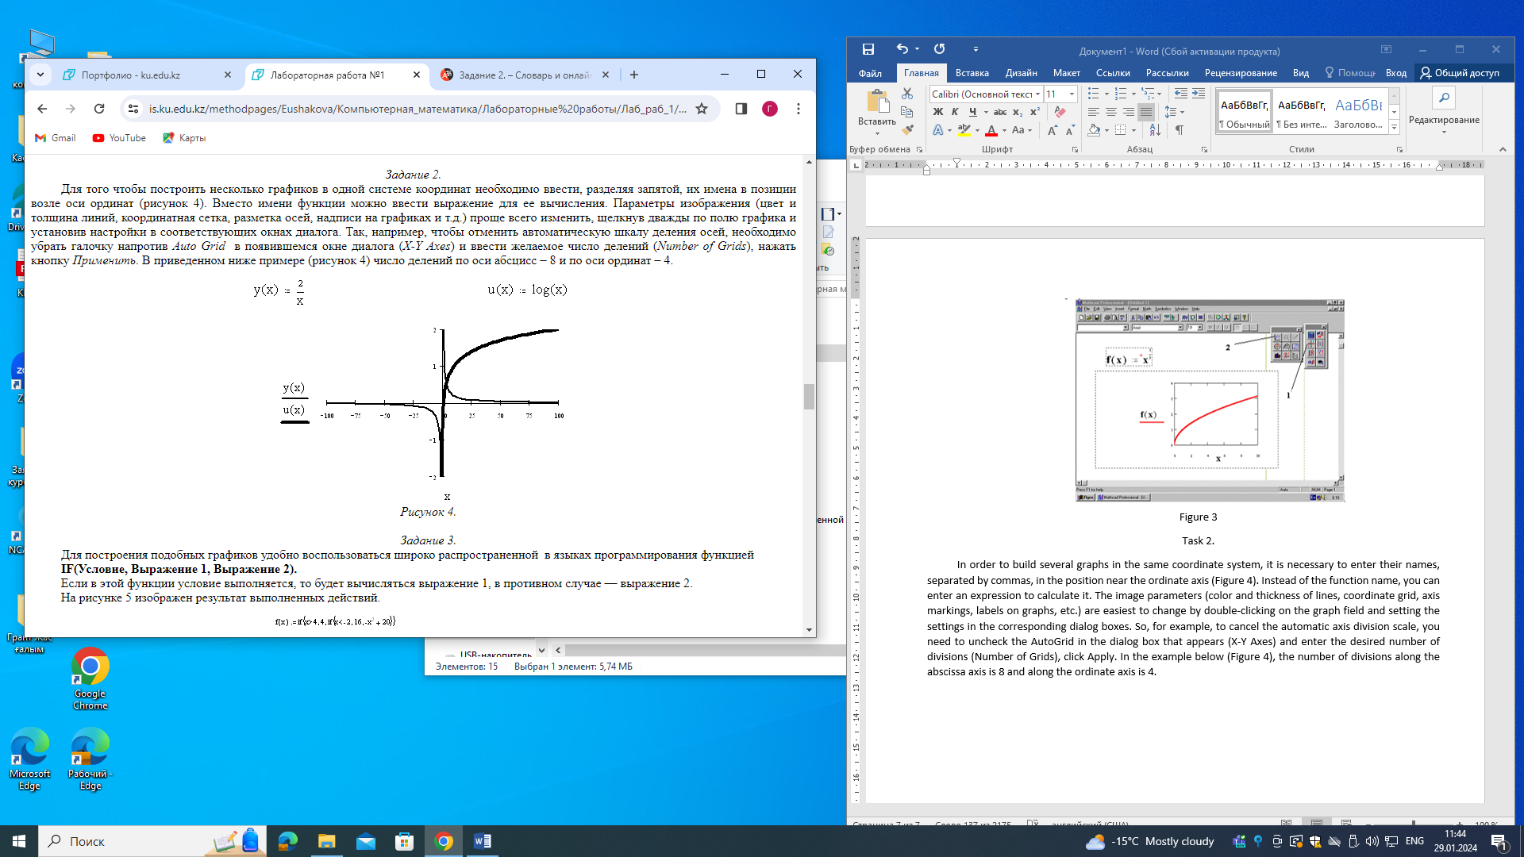
Figure 4

Task 3.
To build such graphs, it is convenient to use a widely used function in programming languages
IF(Condition, Expression 1, Expression 2).
If the condition is met in this function, expression 1 will be evaluated, otherwise expression 2 will be evaluated.
Figure 5 shows the result of the performed actions.
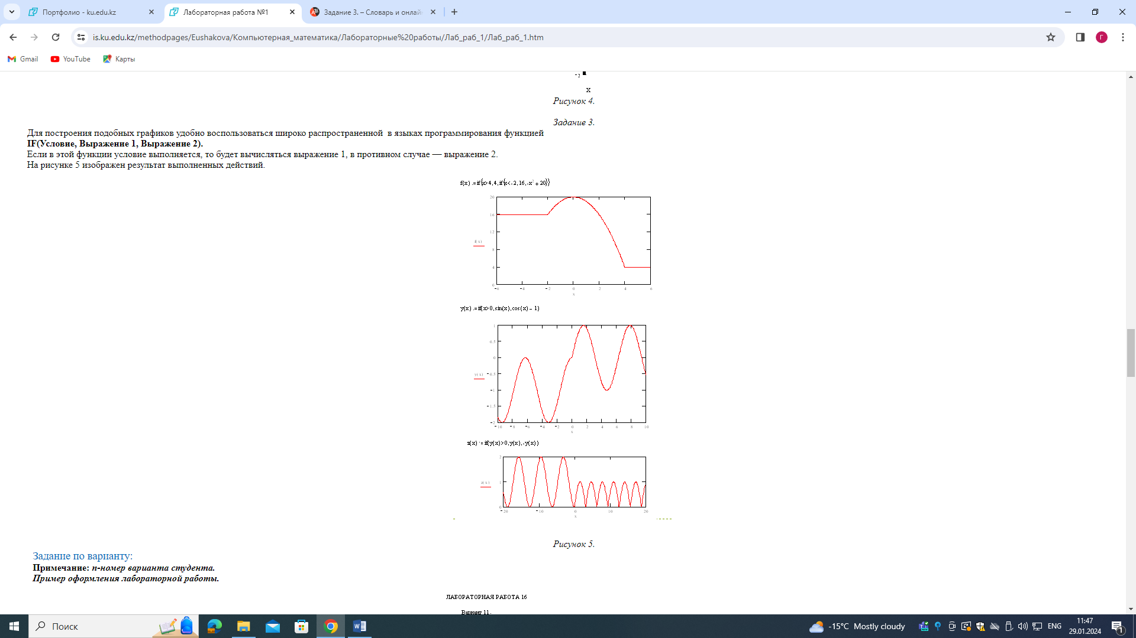
Figure 5
Option assignment:
Note: n is the student's option number.
An example of the design of a laboratory work.
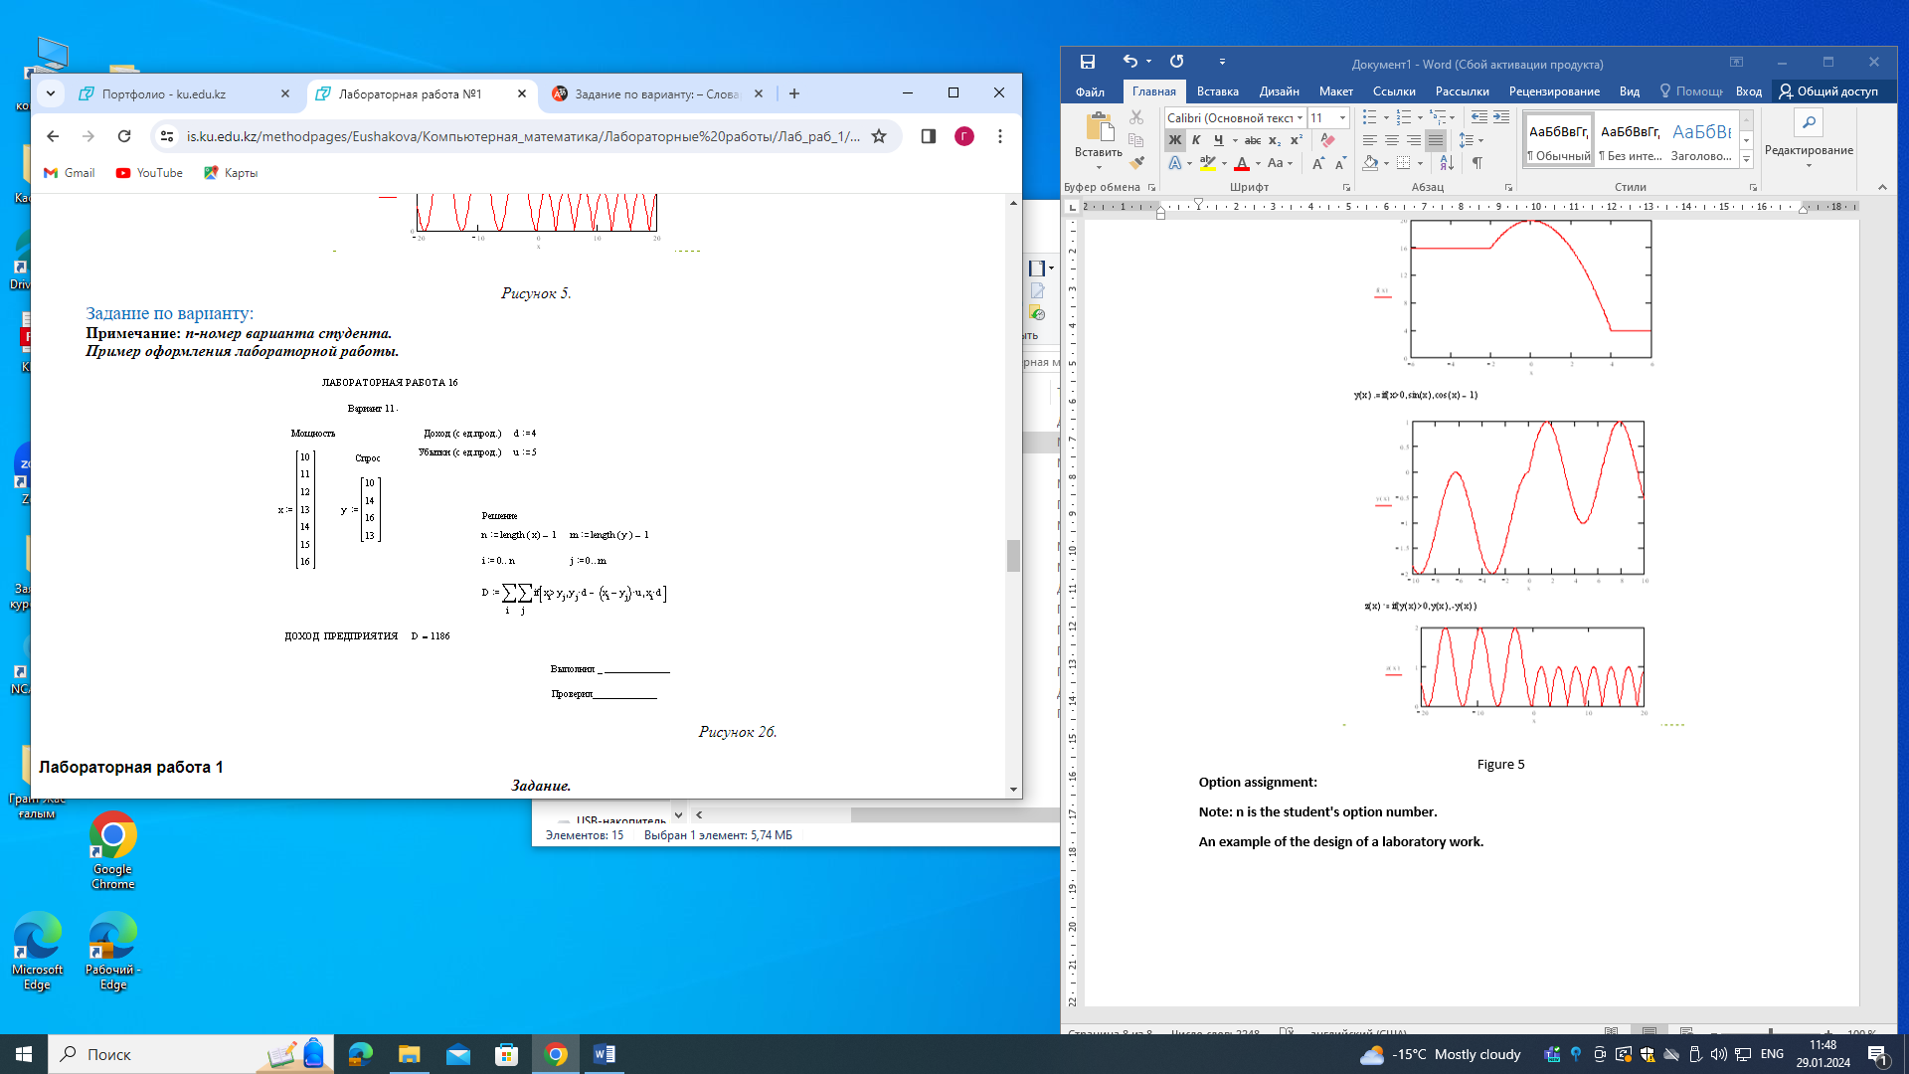
Figure 6
Laboratory work 1

Task.

1. Plot the function 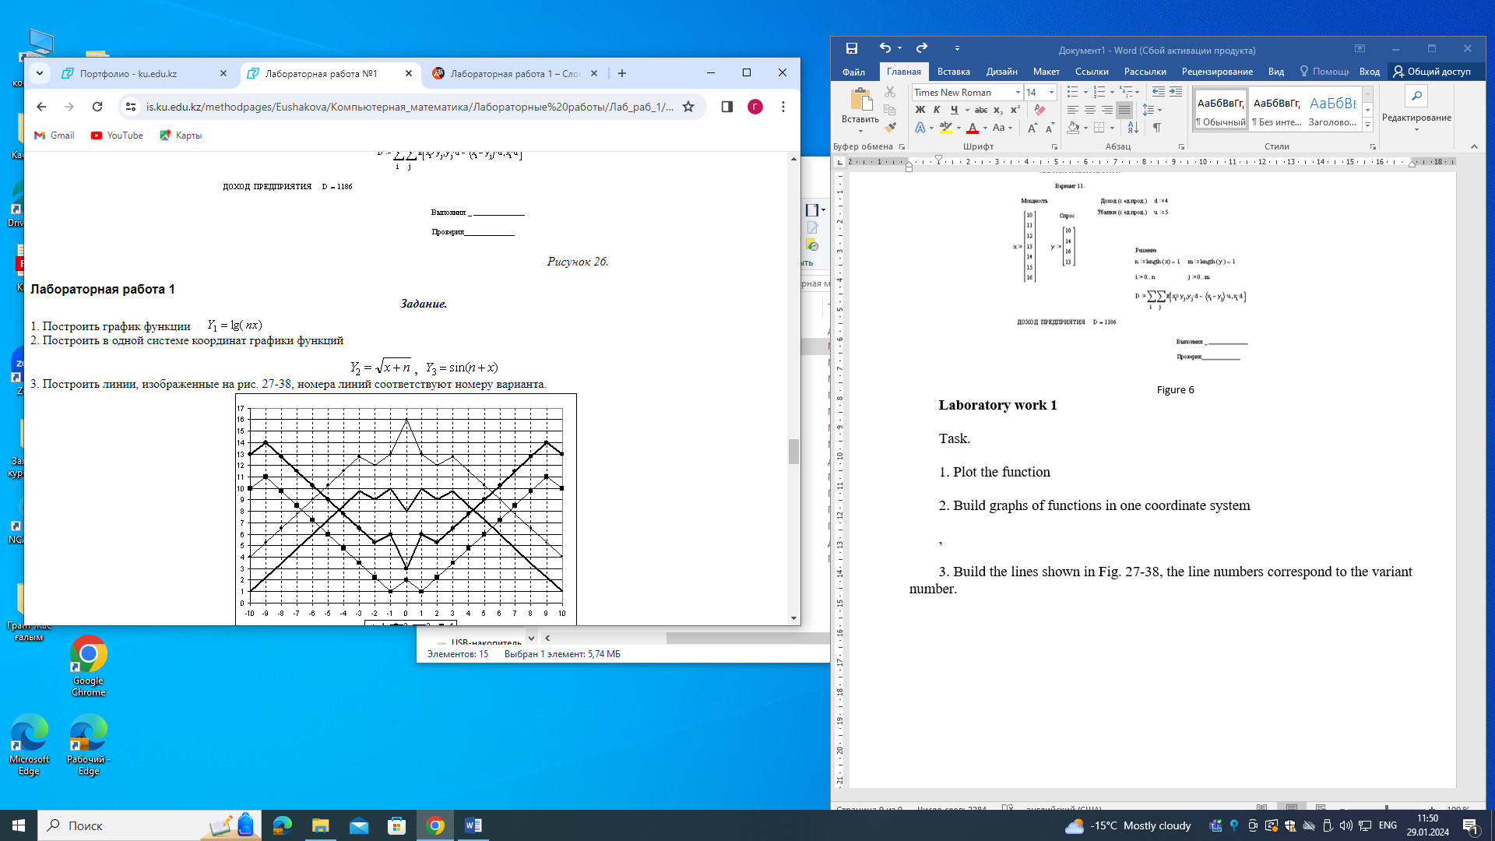

2. Build graphs of functions in one coordinate system

3. Build the lines shown in Fig. 27-38, the line numbers correspond to the variant number.
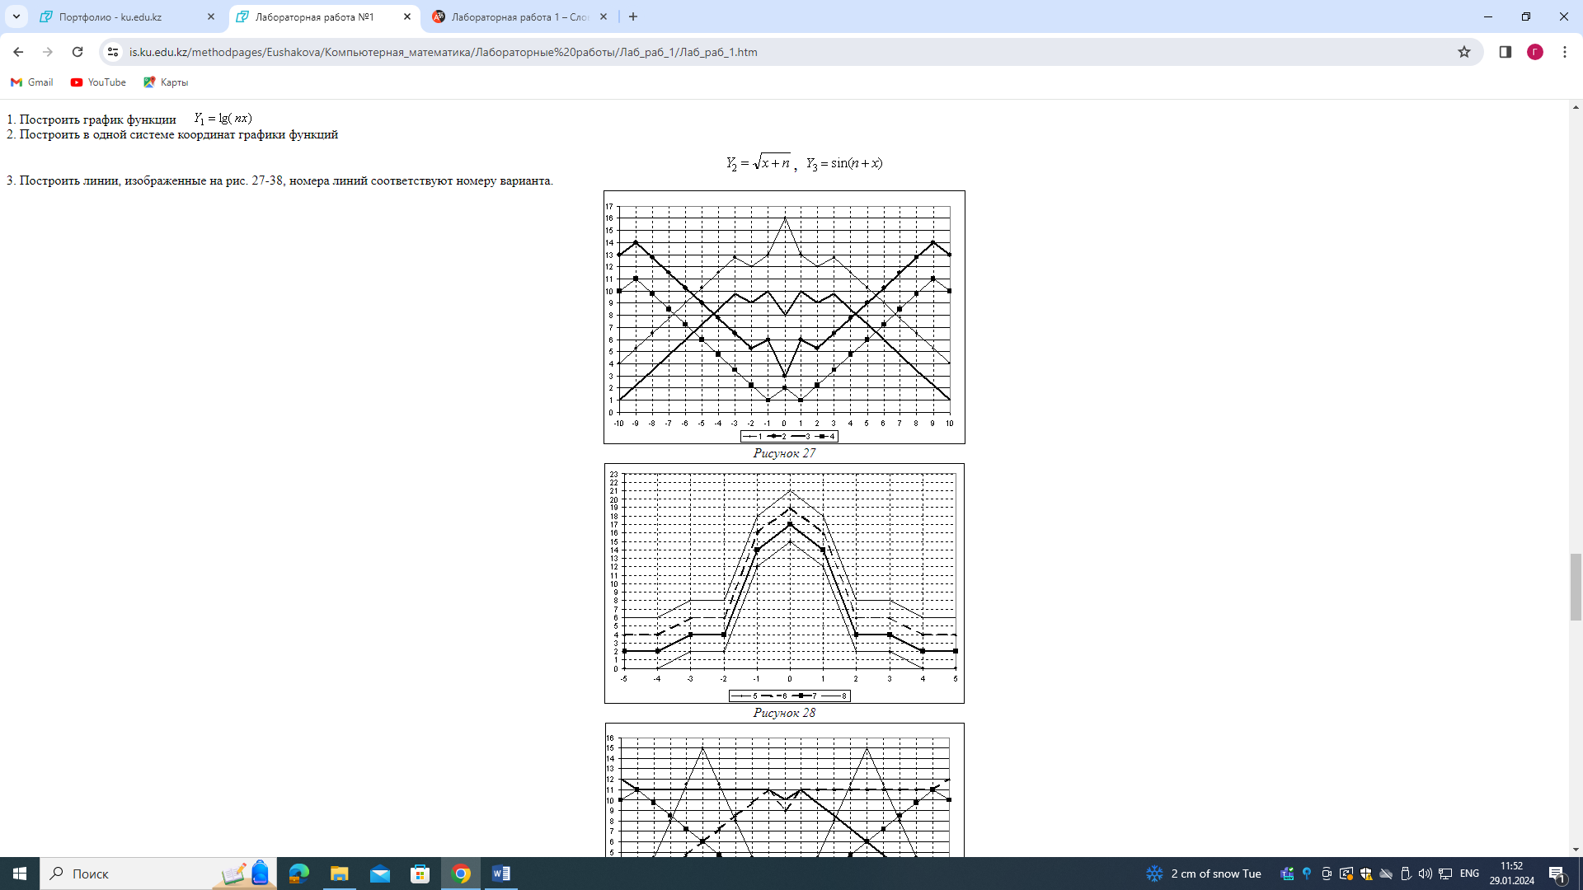
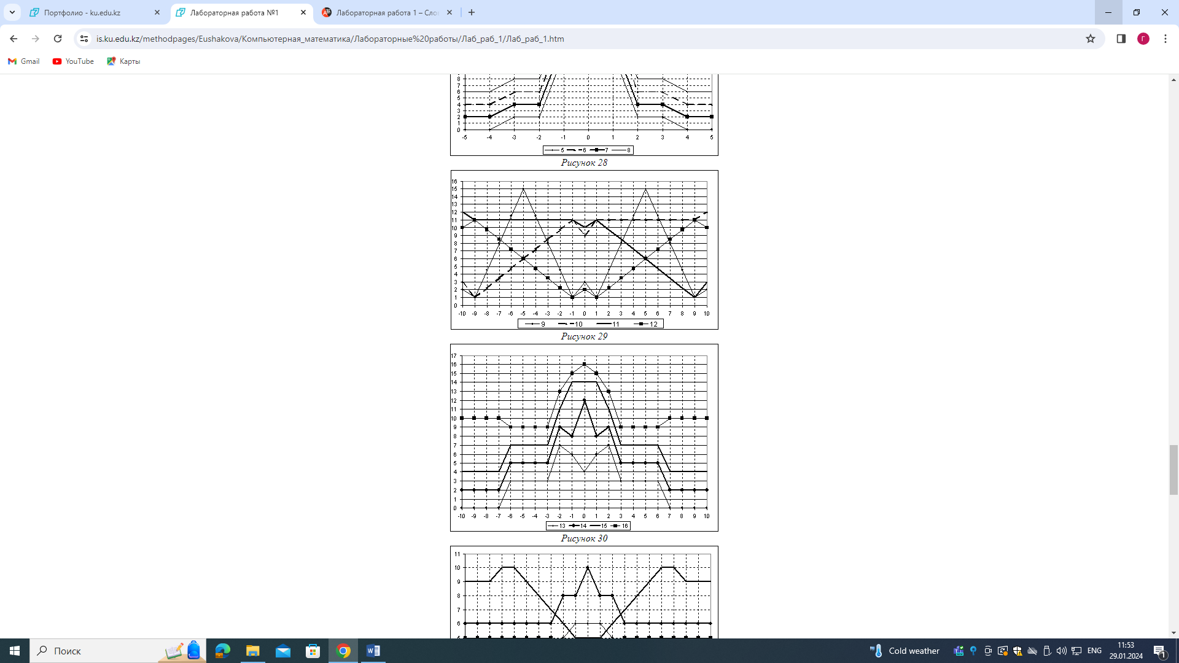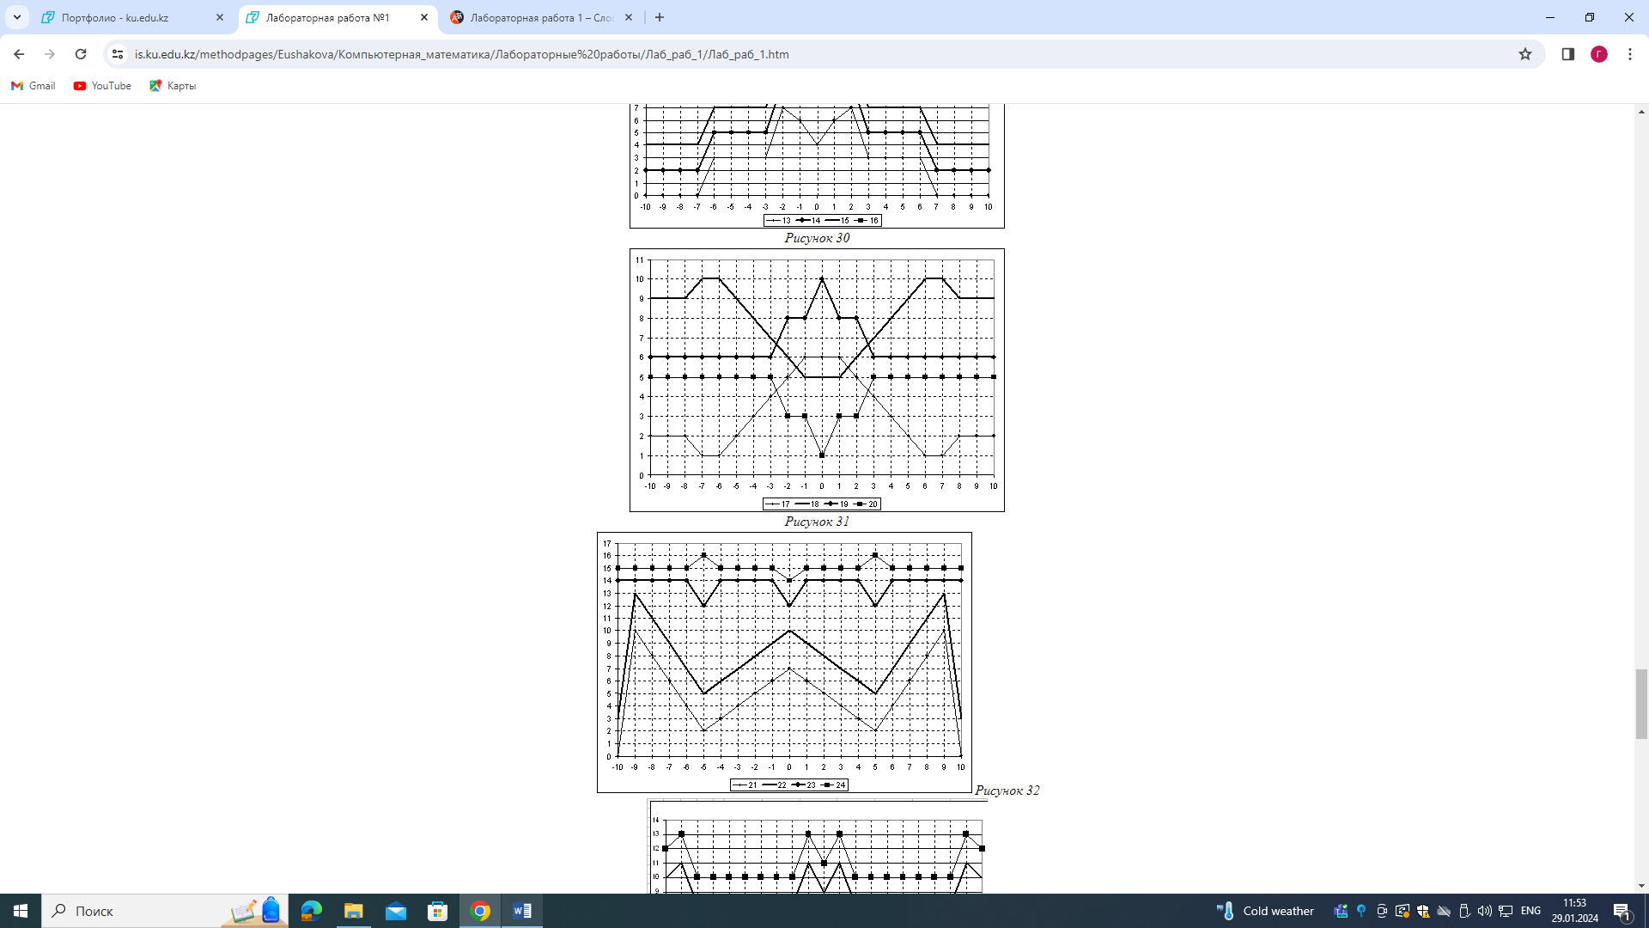
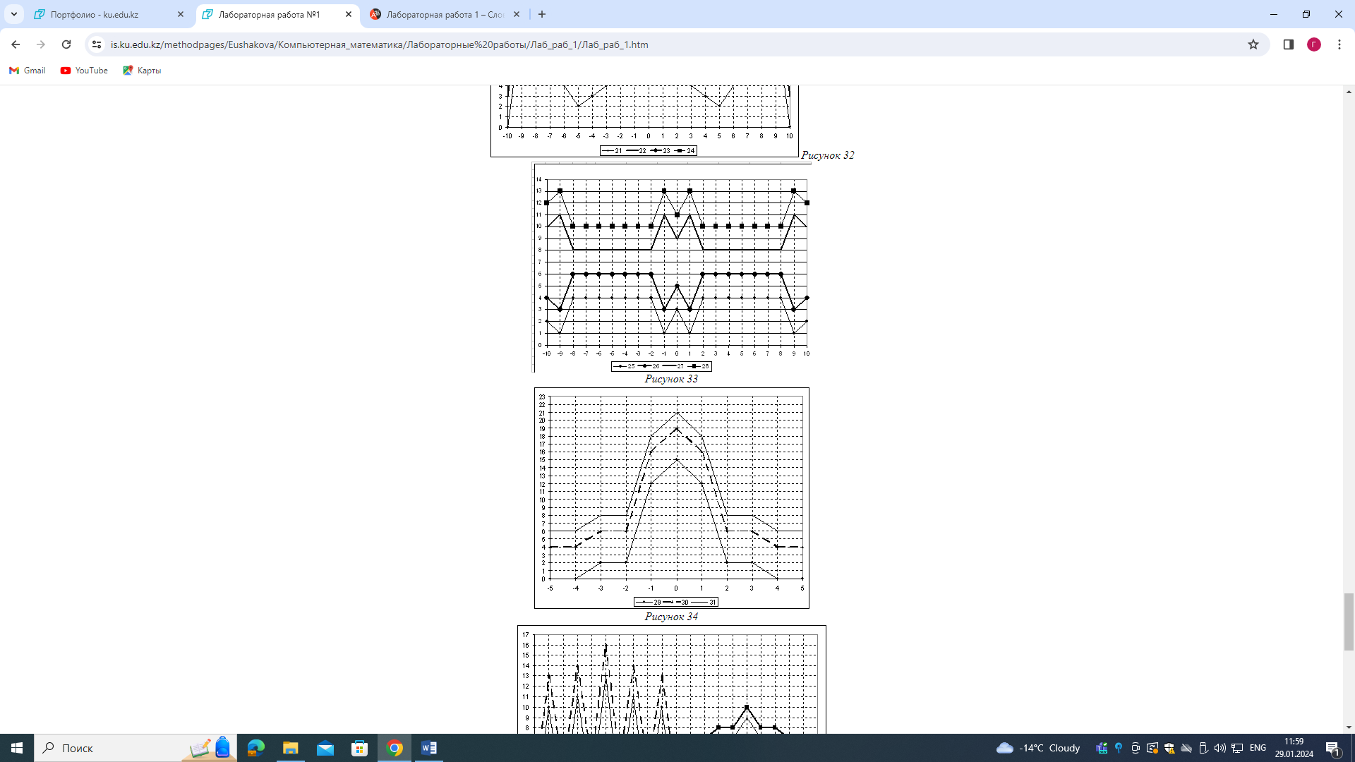
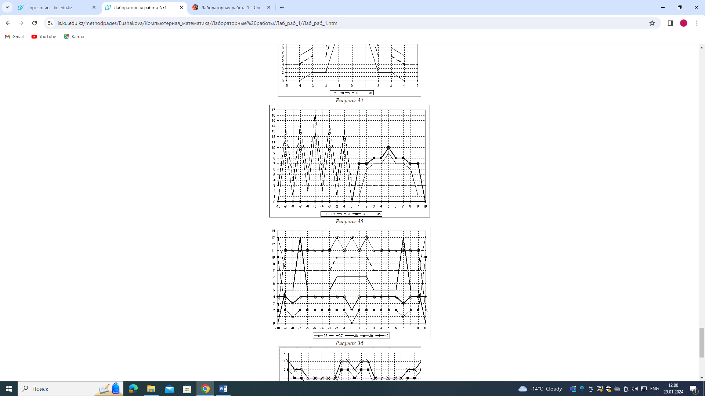
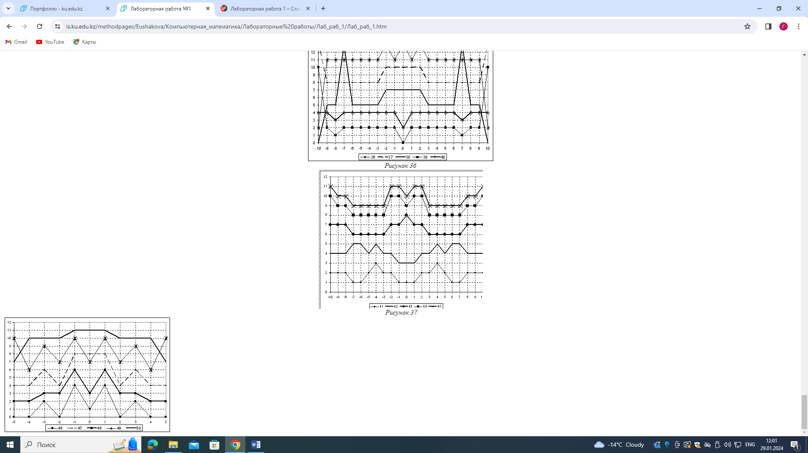
Figure 38

