LABORATORY WORK No. 5
APPROXIMATE SOLUTIONS OF NONLINEAR ALGEBRAIC EQUATIONS (BISECTION, NEWTON, CHORD METHOD)

Purpose: to study the basic methods of approximate solution of nonlinear equations using the Smath Studio application, as well as in the Excel environment.
Questions for self-control
1. What are the ways to study the function?
2. What methods are used to find the roots of the equation?
3. What is the root separation procedure used for?
4. What is the essence of the dichotomy method?
5. What is the essence of the Newton, Chord method?
6. Criteria for stopping the iterative process.
7. What is the difference between numerical and analytical finding of the roots of an equation?

Individual tasks
Find approximate solutions of nonlinear algebraic equations. Separate the roots of a given equation. If there are several roots, then refine one of them using the methods of half division, Newton, chords in the Smath Studio environment, using programming elements, built-in functions, as well as in the Excel environment. Compare the results obtained in different environments.
Table 1– Job options
Option | Equation | Option | Equation
1 |  | 14
2 |  | 15
3 |  | 16
4 |  | 17
5 |  | 18
6 |  | 19
7 |  | 20
8 |  | 21
9
10
11
12
13

Methodological recommendations:
Find the root of the equation $$x^{3}+4x-3=0$$

Solving a nonlinear equation by the chord method

1) In the Smath Studio application
1. Consider the chord method.
1.1. We define the calculation of the second derivative of the function.
1.2. Using the conditional operator, we check the sign of the expression f(a)f’’(a). Depending on the sign, the chord method has two solutions.
1.3. Using while loop, specify the root.
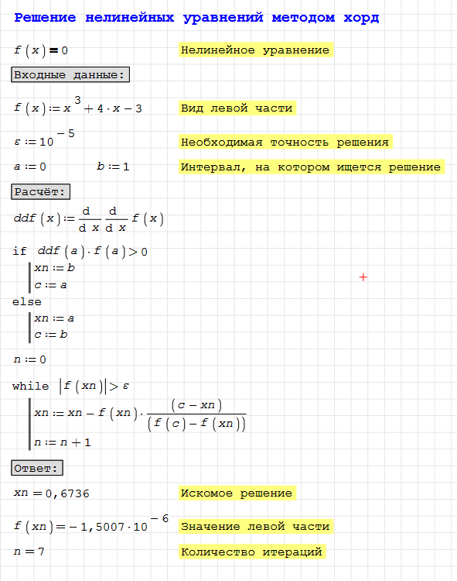
2) In the Microsoft Excel application
Independently implement Chord method to solve a nonlinear equation in Microsoft Excel.

