LABORATORY WORK No. 8
SOLVING SYSTEMS OF LINEAR EQUATIONS BY KRAMER’S METHOD
Task: solve a system of linear algebraic equations using Kramer’s method.
Purpose: to explore the main features of the Smath Studio application for finding solutions to systems of linear equations.
Questions for self-control
- What is called a system of linear equations?
Answer: A system of linear equations is a set of two or more linear equations involving the same set of variables. The goal is to find values for these variables that satisfy all equations simultaneously.
- What is the solution of a system of linear equations?
Answer: The solution of a system of linear equations is the set of values for the variables that make all the given equations true. If there is at least one such set of values, the system is considered consistent; otherwise, it is inconsistent.
- Matrix notation of a system of linear equations?
Answer: A system of linear equations can be written in matrix form as: A * X = B. Where A is the coefficient matrix (containing the coefficients of the variables), X is the column vector of variables, B is the column vector of constants.
- Why do I need to find the determinant of the coefficient matrix?
Answer: The determinant of the coefficient matrix A (det(A)) is used to determine whether the system has a unique solution. If det⁡(A) ≠ 0, the matrix is invertible, and the system has a unique solution. If det⁡(A) = 0, the matrix is singular, meaning the system may have either infinitely many solutions or no solution at all.

Individual task

Tools Used:
- SMath Studio Online
- Computer with internet access
Findings: №19
- Solution with Smath Studio
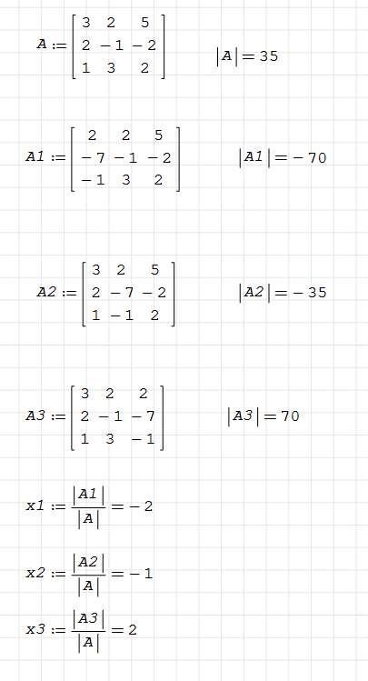
- Write the System in Matrix Form
Represent the system of linear equations as A * X = B
where:
A is the coefficient matrix,
X is the column vector of variables,
B is the column vector of constants.
- Compute the Determinant of the Coefficient Matrix A
If D non-zero, proceed with Cramer’s Rule. If D = 0, the system has either no solution or infinitely many solutions.
- Construct Matrices A₁, A₂, A₃ by Replacing Columns
For each variable x_{i}, create a new matrix A_{i}, by replacing the i-th column of A with the vector B.
- Compute the Determinants of Modified Matrices A₁, A₂, A₃
D₁ = det(A₁), D₂ = det(A₂), D₃ = det(A₃)
- Calculate the Values of the Variables
Using the formula: x₁ = D₁/D, x₂ = D₂/D, x₃ = D₃/D
- Verify the Solution
Substitute the values of x₁, x₂, x₃ back into the original equations to check if they satisfy all equations.
2) Manual solution

Conclusion
Using Smath Studio, we successfully solved the system of linear equations using Kramer’s Rule. The determinant test confirmed that the system had a unique solution, as the determinant of the coefficient matrix was nonzero. By computing the determinants of modified matrices and applying Cramer’s formulas, we obtained the correct values for the variables. This approach demonstrates the effectiveness of determinant-based methods in solving systems of equations efficiently.

