Laboratory work No. 8
Solving systems of linear equations by Kramer’s method
Task: solve a system of linear algebraic equations using Kramer’s method
Name :Chaikin Danil
Given:
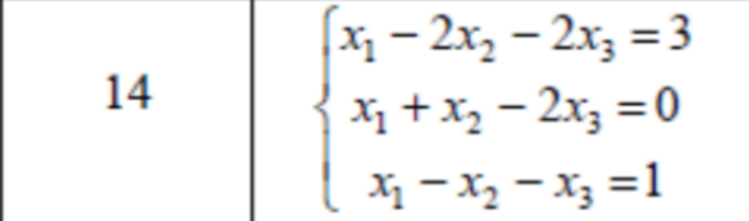

1)
First, we need to make a matrix from our system of equations and find the determinant:
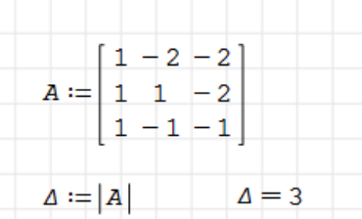

2)Next, we need to replace elements for each column of the matrix with elements of an additional column and find their determinant:
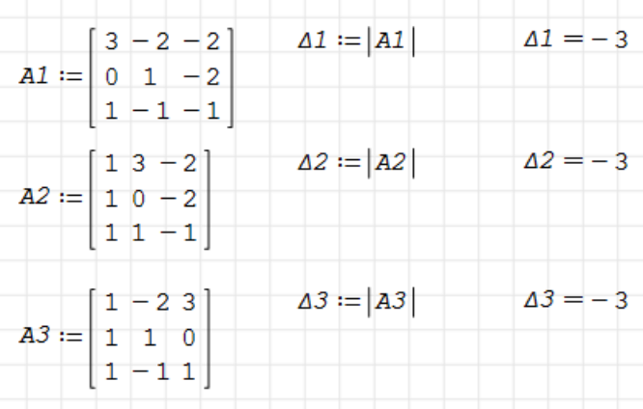

3)The next step will be to use this formula, we need to substitute the main determinant and side effects:
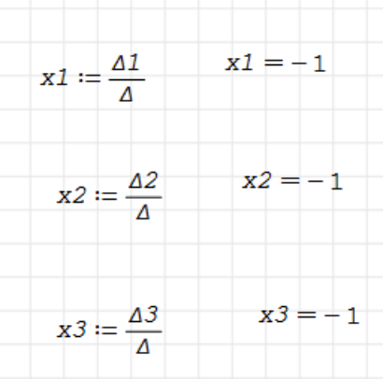

Сonclusion :
We utilized Kramer's method to discover the solutions to the system of equations. This technique is employed for solving systems of linear algebraic equations where the number of equations matches the number of unknowns, and the determinant of the coefficient matrix is non-zero. Through this laboratory exercise, I confirmed its efficacy.

