Rapport de conception

# 1. Use Case Diagram1

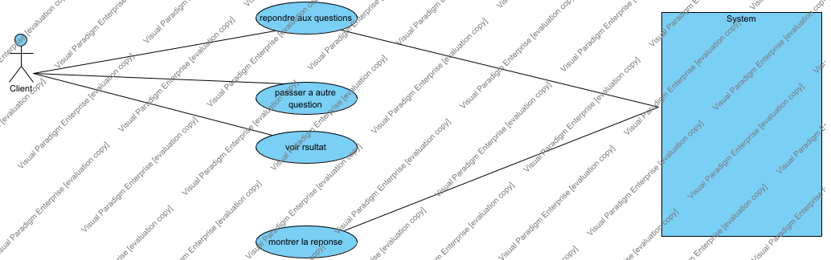

# 2. repondre aux questions

ID: UC05

le client doit repondre a la question afficher

# 3. montrer la reponse

ID: UC03

le sys affiche la reponse correcte

# 4. passser a autre question

apres voir le resulter passer a l'autre question

# 5. voir rsultat

ID: UC07

apres la repoinse le client voir si la reponse correcte ou pas

# 6. voir rsultat

ID: UC07

apres la repoinse le client voir si la reponse correcte ou pas

# 7. voir rsultat

ID: UC07

apres la repoinse le client voir si la reponse correcte ou pas

## 7.1. Primary Actors

 Client

## 7.2. Details

|  |  |
| --- | --- |
| Level | N/A |
| Complexity | N/A |
| Use Case Status | N/A |
| Implementation Status | N/A |
| Preconditions | N/A |
| Post-conditions | N/A |
| Author | N/A |
| Assumptions | N/A |

## 7.3. Relationships

| Relationship | From | To |
| --- | --- | --- |
| unnamed | [voir rsultat](#ewEwkgGGAqACah7s" \o "voir rsultat) | Client |

# 8. Tagged Values

| Name | Type | Value |
| --- | --- | --- |
| Assumptions | Multi-line Text |  |
| Author | Text |  |
| Complexity | Ad Hoc Enumeration |  |
| Implementation Status | Ad Hoc Enumeration |  |
| Level | Ad Hoc Enumeration |  |
| Post-conditions | Multi-line Text |  |
| Preconditions | Multi-line Text |  |
| Use Case Status | Ad Hoc Enumeration |  |

# 9. diagramme de classe

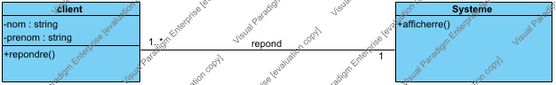

# 10. Systeme

# 11. client

un client peut choisir la reponse ce qu'il veut pour repondre a une question si la reponse est fause le systeme lui ecrit

|  |  |  |  |  |
| --- | --- | --- | --- | --- |
| name | classifier | visibility | type | initial value |
| nom | client | private | string |  |
| prenom | client | private | string |  |

|  |  |  |  |
| --- | --- | --- | --- |
| name | classifier | visibility | return type |
| repondre | clinet | public |  |

# 12. Sequence Diagram1

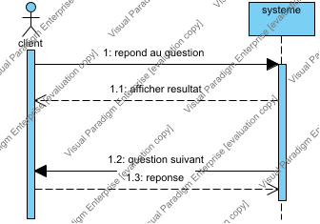

un client peut jouer un jeu des question avec ce systeme

## 12.1. client

## 12.2. systeme

## 12.3. Messages

| From | No. | Name | Type | Action Type | To | Async. |
| --- | --- | --- | --- | --- | --- | --- |
| client | 1 | repond au question |  | Unspecified | systeme |  |
| systeme | 1.1 | afficher resultat |  | Reply | client |  |
| systeme | 1.2 | question suivant |  | Unspecified | client |  |
| client | 1.3 | reponse |  | Reply | systeme |  |