DQN PROJECT DETAILS & DOCUMENTAION:
braking model.DQN:
braking model is made using neural net for braking
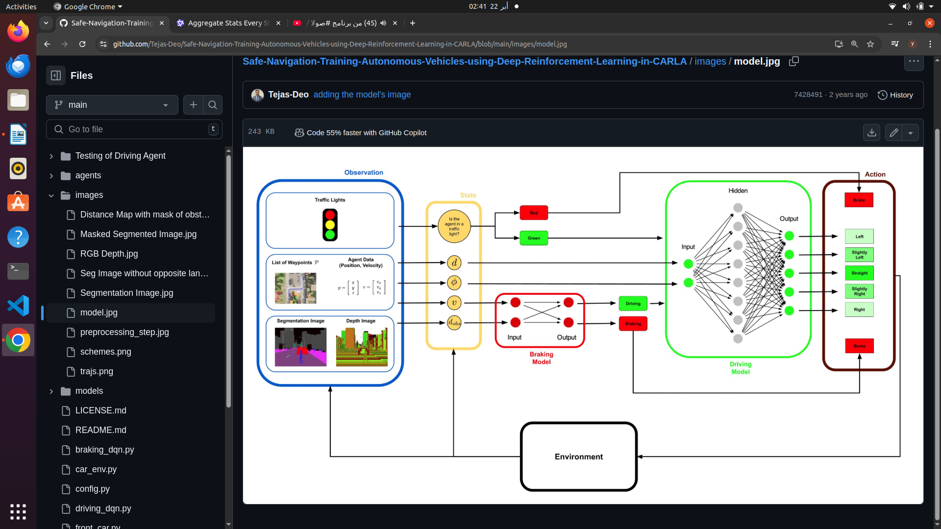

BRAKING DQN IMPLEMENTATION STEP BY STEP:
DQN: WE have target main neural net and also a target neural network ,the main neural network predicts the Qs , and the seprate target network used to stabilize the training process,and target weights is the same as the main model weights ..
Purpose of Two Models :
  - The main model (self.model) is updated frequently during training.
  - The target model (self.target_model) is updated less frequently (e.g., every UPDATE_TARGET_EVERY steps) to provide stable Q-value targets for training.

We have a replay memory buffer to store transitions experienced during training and each transition has the form of Each transition is a tuple of the form (current_state, action, reward, new_state, done).
Purpose :
- Replay memory allows the agent to sample past experiences and learn from them, breaking the correlation between consecutive experiences and improving stability
also we have tensor board log to monitor our training process

braking model inputs and outputs :
Currently, the model is a simple dense neural network with one layer (Dense(2)), which takes a 2-dimensional state vector as input.
We use a hierarchical approach where the braking model is used as a safety net to prevent collisions when an obstacle is too close.
Inputs are velocity and distance to observed object

note inputs are taken from:segmentation camera and 2 depth cameras , segmentation camera exactly in between the 2 depth cameras,collision sensor,lane invasion sensor ,RGB camera

image processing steps:
depth camers image processing:
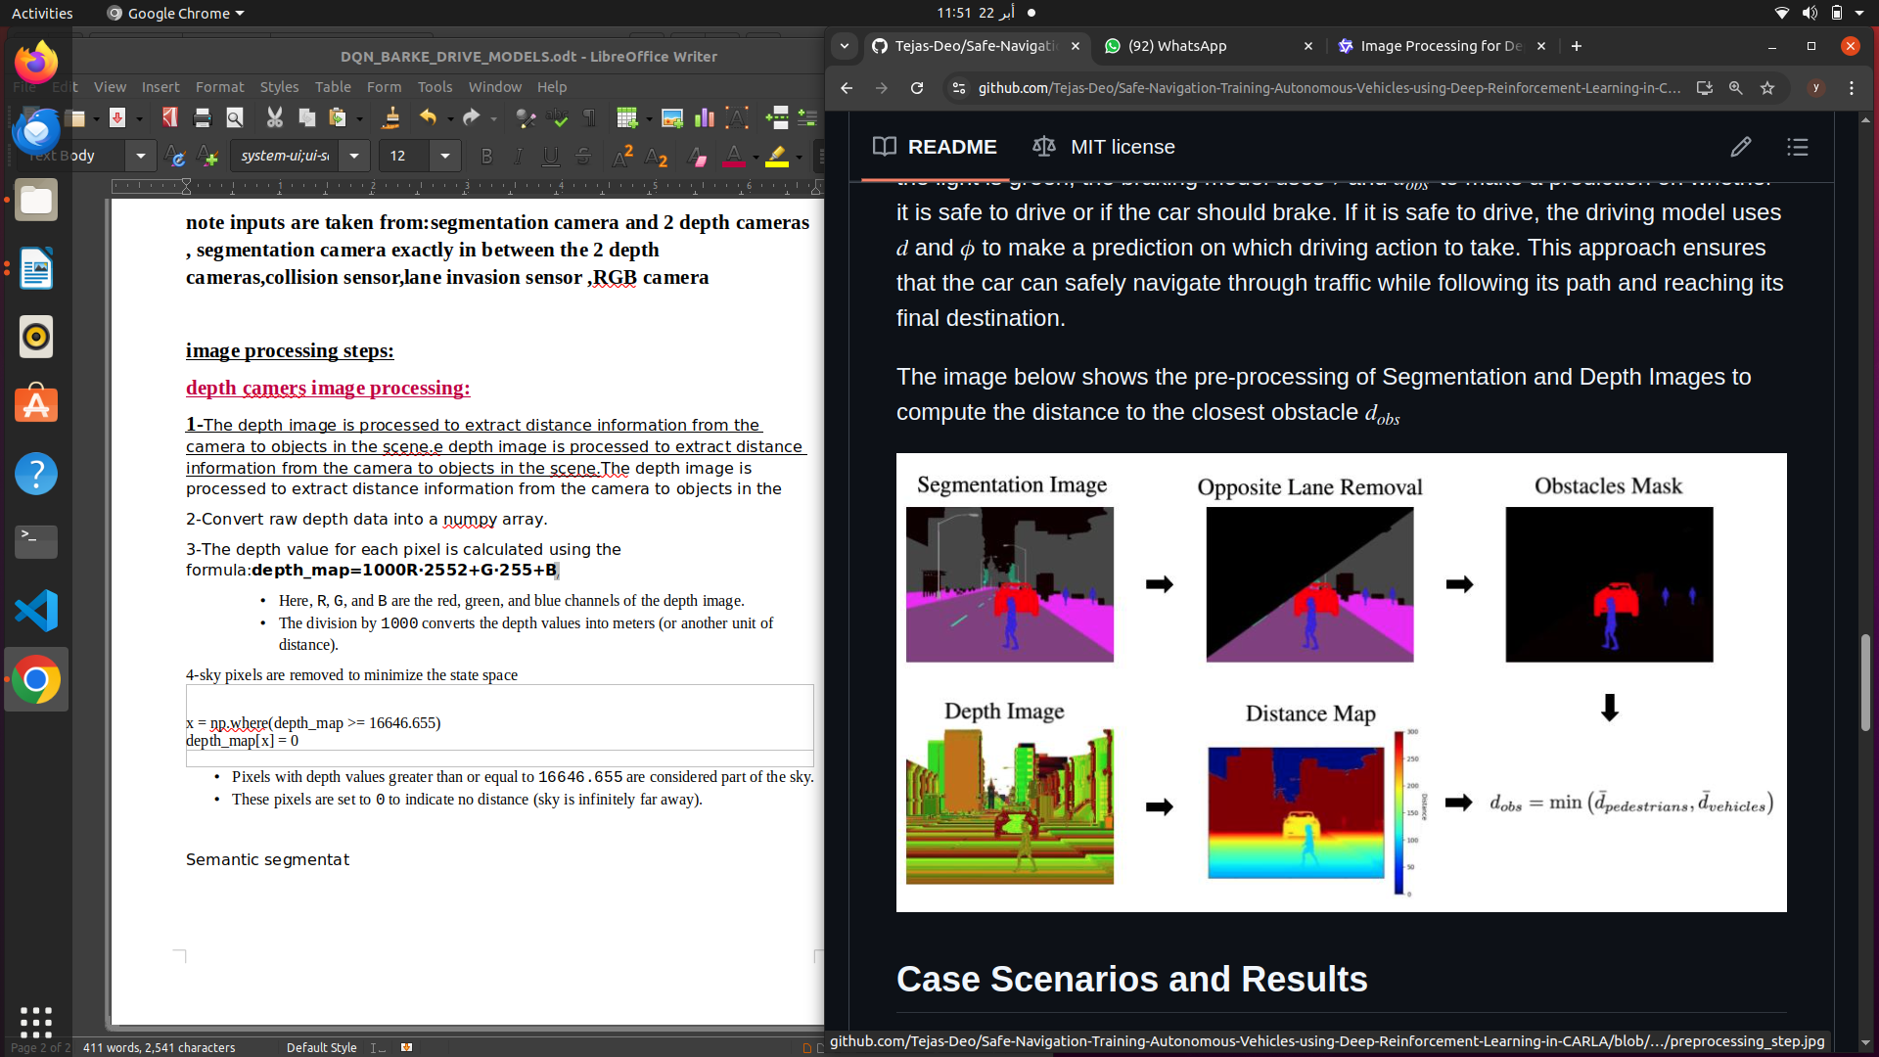
1-The depth image is processed to extract distance information from the camera to objects in the scene.e depth image is processed to extract distance information from the camera to objects in the scene.The depth image is processed to extract distance information from the camera to objects in the
2-Convert raw depth data into a numpy array.
3-The depth value for each pixel is calculated using the formula:depth_map=1000R⋅2552+G⋅255+B​
  - Here, R, G, and B are the red, green, and blue channels of the depth image.
  - The division by 1000 converts the depth values into meters (or another unit of distance).
4-sky pixels are removed to minimize the state space

x = np.where(depth_map >= 16646.655)
depth_map[x] = 0

- Pixels with depth values greater than or equal to 16646.655 are considered part of the sky.
- These pixels are set to 0 to indicate no distance (sky is infinitely far away).

semantic segmentation image processing :
The semantic segmentation image assigns a unique color to each class of object in the scene (e.g., vehicles, roads, pedestrians). This section identifies specific classes (e.g., vehicles) and calculates their average distance.
1-a. Convert raw segmentation data into a NumPy array
2-
The data is reshaped into a 3D array with dimensions (height, width, 4-SMART COLORING STARTEGY:
each pixel in the image is labelled with a class that represents it’s type of class:ex vehcile ,building,pedestrian
-how??defining a map between class ids and their corresponding rgb colorsPixels labeled as [0, 0, 10] represent "Vehicles."
- Pixels labeled as [70, 70, 70] represent "Buildings."
This mapping enables the algorithm to filter and process only the pixels relevant to a specific class (e.g., vehicles).

Structure of the Color Mapping
The color mapping is implemented using a Python dictionary called colors. Each key-value pair in the dictionary represents:
- Key : The class ID (an integer, e.g., 0, 1, 2, etc.).
- Value : The RGB color assigned to that class (a list of three integers, e.g., [0, 0, 10]).
colors = {
0: [0, 0, 0], # None
1: [70, 70, 70], # Buildings
2: [190, 153, 153], # Fences
3: [72, 0, 90], # Other
4: [220, 20, 60], # Pedestrians
If the distance to nearby vehicles is small (self.distance < threshold), the policy might favor braking (action=0).
- If the vehicle is far from obstacles and moving slowly, the policy might favor throttling (action=1).
5: [153, 153, 153], # Poles
6: [157, 234, 50], # RoadLines
7: [128, 64, 128], # Roads
8: [244, 35, 232], # Sidewalks
9: [107, 142, 35], # Vegetation
10: [0, 0, 255], # Vehicles
11: [102, 102, 156], # Walls
12: [220, 220, 0], # TrafficSigns
}
Tthe color mapping strategy is a simple and effective way to label and process semantic classes in a segmentation image. By assigning unique RGB colors to each class and leveraging NumPy operations, the algorithm can efficiently identify and analyze objects of interest (e.g., vehicles) in the scene. This approach is widely used in computer vision tasks such as autonomous driving, robotics, and scene understanding.
Summary of the 2 image processing approaches :

1. Depth Camera Image Processing
The depth camera provides raw data that encodes distance information for every pixel in the scene.

Steps :
- Convert Raw Data to Depth Map :
  - The raw depth image is read as a byte stream and reshaped into a 3D array (height × width × 4).
  - Each pixel's depth value is computed using a formula that combines the RGB channels:depth_map=1000R⋅2552+G⋅255+B​
    - The result represents the distance (in meters) from the camera to the object at that pixel.
- Handle Sky Pixels :
  - Pixels with unusually large depth values (e.g., >= 16646.655) are considered part of the sky.
  - These pixels are set to 0 to indicate no measurable distance.
- Store Distances :
  - The resulting depth map (distances) contains the distance from the camera to each point in the scene.

2. Semantic Segmentation Camera Image Processing
The semantic segmentation camera assigns a unique RGB color to each class of object (e.g., vehicles, roads, pedestrians).

Steps :
- Convert Raw Data to RGB Image :
  - The raw segmentation image is read as a byte stream and reshaped into a 3D array (height × width × 4).
  - The alpha channel is removed, leaving only the RGB channels.
- Define Color Mapping :
  - A dictionary maps each class ID (e.g., 10 for "Vehicles") to its corresponding RGB color (e.g., [0, 0, 255]).
- Identify Pixels of Interest :
  - Using NumPy operations, the algorithm identifies pixels belonging to specific classes by matching their RGB values to the predefined colors.
  - For example, vehicle pixels are identified by finding all pixels with the RGB value [0, 0, 10].
- Calculate Average Distance :
  - For the identified pixels (e.g., vehicles), the algorithm calculates the average distance using the depth map.
  - If no pixels of the target class are found, the distance is set to a default large value (e.g., 10000).
combined output :The algorithm outputs the average distance to a specific class (e.g., vehicles), enabling downstream decision-making.
Step function explainn:
THE STEP FUNCTON BHAS ONLY 2 MAIN ACTIONS … BARKE 0 AND THROTTLE 1 :If action != 0, it defaults to 1. This ensures that only two actions are possible: braking or throttling.
Throtle 0.3 is moderate throttlen

reward function startegy and implementaion:
we simply have 2 actions . Action0 is full brake and action1 is moderate throttle =0.3 and no steering (throttle =0.3 and steer=0)

RL CONCEPTS IN THE REWRARD DESIGN STARTEGY:

During training, the agent must balance exploration (trying new actions to discover their effects) and exploitation (choosing actions known to yield high rewards).
- For example:
  - If the agent always brakes (action=0) when unsure, it may avoid collisions but fail to reach the goal efficiently.
  - Conversely, if the agent always throttles (action=1), it risks collisions and penalties.
If the distance to nearby vehicles is small (self.distance < threshold), the policy might favor braking (action=0).
- If the vehicle is far from obstacles and moving slowly, the policy might favor throttling (action=1).
DRIVING MODEL.DQN DOCUMENTATION:

