DQN PROJECT DETAILS & DOCUMENTAION:
braking model.DQN:
braking model is made using neural net for braking
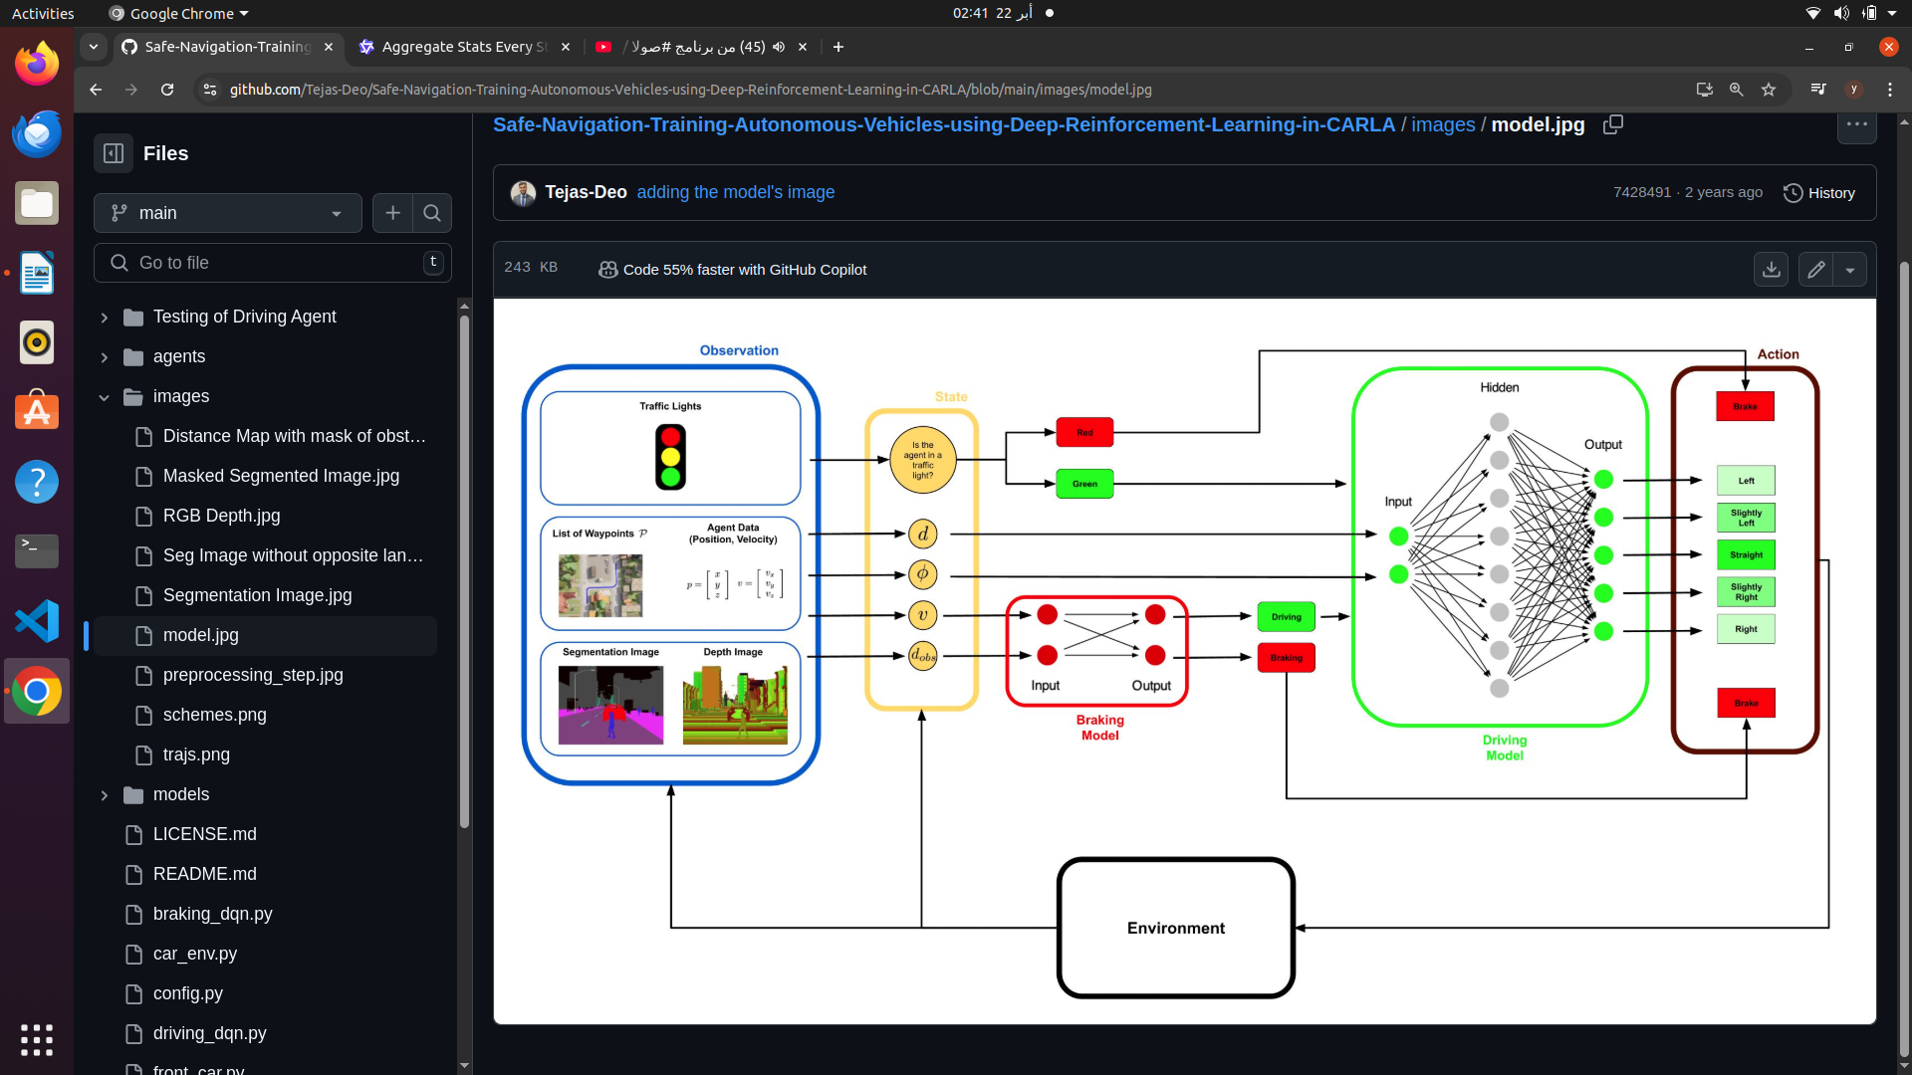

BRAKING DQN IMPLEMENTATION STEP BY STEP:
DQN: WE have target main neural net and also a target neural network ,the main neural network predicts the Qs , and the seprate target network used to stabilize the training process,and target weights is the same as the main model weights ..
Purpose of Two Models :
  - The main model (self.model) is updated frequently during training.
  - The target model (self.target_model) is updated less frequently (e.g., every UPDATE_TARGET_EVERY steps) to provide stable Q-value targets for training.

We have a replay memory buffer to store transitions experienced during training and each transition has the form of Each transition is a tuple of the form (current_state, action, reward, new_state, done).
Purpose :
- Replay memory allows the agent to sample past experiences and learn from them, breaking the correlation between consecutive experiences and improving stability
also we have tensor board log to monitor our training process

braking model inputs and outputs :
Currently, the model is a simple dense neural network with one layer (Dense(2)), which takes a 2-dimensional state vector as input.
We use a hierarchical approach where the braking model is used as a safety net to prevent collisions when an obstacle is too close.
Inputs are velocity and distance to observed object

note inputs are taken from:segmentation camera and 2 depth cameras , segmentation camera exactly in between the 2 depth cameras,collision sensor,lane invasion sensor ,RGB camera

image processing steps:
depth camers image processing:
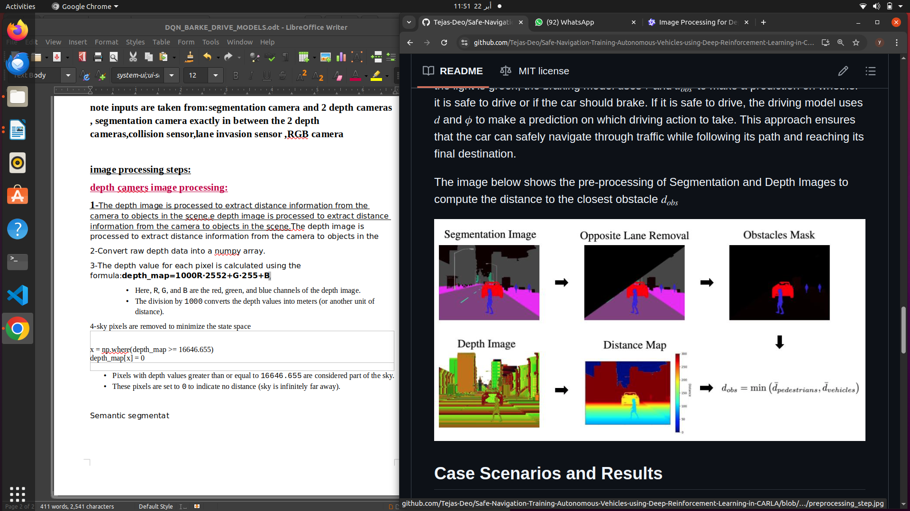
1-The depth image is processed to extract distance information from the camera to objects in the scene.e depth image is processed to extract distance information from the camera to objects in the scene.The depth image is processed to extract distance information from the camera to objects in the
2-Convert raw depth data into a numpy array.
3-The depth value for each pixel is calculated using the formula:depth_map=1000R⋅2552+G⋅255+B​
  - Here, R, G, and B are the red, green, and blue channels of the depth image.
  - The division by 1000 converts the depth values into meters (or another unit of distance).
4-sky pixels are removed to minimize the state space

x = np.where(depth_map >= 16646.655)
depth_map[x] = 0

- Pixels with depth values greater than or equal to 16646.655 are considered part of the sky.
- These pixels are set to 0 to indicate no distance (sky is infinitely far away).

semantic segmentation image processing :
The semantic segmentation image assigns a unique color to each class of object in the scene (e.g., vehicles, roads, pedestrians). This section identifies specific classes (e.g., vehicles) and calculates their average distance.
1-a. Convert raw segmentation data into a NumPy array
2-
The data is reshaped into a 3D array with dimensions (height, width, 4-SMART COLORING STARTEGY:
each pixel in the image is labelled with a class that represents it’s type of class:ex vehcile ,building,pedestrian
-how??defining a map between class ids and their corresponding rgb colorsPixels labeled as [0, 0, 10] represent "Vehicles."
- Pixels labeled as [70, 70, 70] represent "Buildings."
This mapping enables the algorithm to filter and process only the pixels relevant to a specific class (e.g., vehicles).

Structure of the Color Mapping
The color mapping is implemented using a Python dictionary called colors. Each key-value pair in the dictionary represents:
- Key : The class ID (an integer, e.g., 0, 1, 2, etc.).
- Value : The RGB color assigned to that class (a list of three integers, e.g., [0, 0, 10]).
colors = {
0: [0, 0, 0], # None
1: [70, 70, 70], # Buildings
2: [190, 153, 153], # Fences
3: [72, 0, 90], # Other
4: [220, 20, 60], # Pedestrians
If the distance to nearby vehicles is small (self.distance < threshold), the policy might favor braking (action=0).
- If the vehicle is far from obstacles and moving slowly, the policy might favor throttling (action=1).
5: [153, 153, 153], # Poles
6: [157, 234, 50], # RoadLines
7: [128, 64, 128], # Roads
8: [244, 35, 232], # Sidewalks
9: [107, 142, 35], # Vegetation
10: [0, 0, 255], # Vehicles
11: [102, 102, 156], # Walls
12: [220, 220, 0], # TrafficSigns
}
Tthe color mapping strategy is a simple and effective way to label and process semantic classes in a segmentation image. By assigning unique RGB colors to each class and leveraging NumPy operations, the algorithm can efficiently identify and analyze objects of interest (e.g., vehicles) in the scene. This approach is widely used in computer vision tasks such as autonomous driving, robotics, and scene understanding.
Summary of the 2 image processing approaches :

1. Depth Camera Image Processing
The depth camera provides raw data that encodes distance information for every pixel in the scene.

Steps :
- Convert Raw Data to Depth Map :
  - The raw depth image is read as a byte stream and reshaped into a 3D array (height × width × 4).
  - Each pixel's depth value is computed using a formula that combines the RGB channels:depth_map=1000R⋅2552+G⋅255+B​
    - The result represents the distance (in meters) from the camera to the object at that pixel.
- Handle Sky Pixels :
  - Pixels with unusually large depth values (e.g., >= 16646.655) are considered part of the sky.
  - These pixels are set to 0 to indicate no measurable distance.
- Store Distances :
  - The resulting depth map (distances) contains the distance from the camera to each point in the scene.

2. Semantic Segmentation Camera Image Processing
The semantic segmentation camera assigns a unique RGB color to each class of object (e.g., vehicles, roads, pedestrians).

Steps :
- Convert Raw Data to RGB Image :
  - The raw segmentation image is read as a byte stream and reshaped into a 3D array (height × width × 4).
  - The alpha channel is removed, leaving only the RGB channels.
- Define Color Mapping :
  - A dictionary maps each class ID (e.g., 10 for "Vehicles") to its corresponding RGB color (e.g., [0, 0, 255]).
- Identify Pixels of Interest :
  - Using NumPy operations, the algorithm identifies pixels belonging to specific classes by matching their RGB values to the predefined colors.
  - For example, vehicle pixels are identified by finding all pixels with the RGB value [0, 0, 10].
- Calculate Average Distance :
  - For the identified pixels (e.g., vehicles), the algorithm calculates the average distance using the depth map.
  - If no pixels of the target class are found, the distance is set to a default large value (e.g., 10000).
combined output :The algorithm outputs the average distance to a specific class (e.g., vehicles), enabling downstream decision-making.
Step function explainn:
THE STEP FUNCTON BHAS ONLY 2 MAIN ACTIONS … BARKE 0 AND THROTTLE 1 :If action != 0, it defaults to 1. This ensures that only two actions are possible: braking or throttling.
Throtle 0.3 is moderate throttlen

reward function startegy and implementaion:
we simply have 2 actions . Action0 is full brake and action1 is moderate throttle =0.3 and no steering (throttle =0.3 and steer=0)

RL CONCEPTS IN THE REWRARD DESIGN STARTEGY:

During training, the agent must balance exploration (trying new actions to discover their effects) and exploitation (choosing actions known to yield high rewards).
- For example:
  - If the agent always brakes (action=0) when unsure, it may avoid collisions but fail to reach the goal efficiently.
  - Conversely, if the agent always throttles (action=1), it risks collisions and penalties.
If the distance to nearby vehicles is small (self.distance < threshold), the policy might favor braking (action=0).
- If the vehicle is far from obstacles and moving slowly, the policy might favor throttling (action=1).
DRIVING MODEL.DQN DOCUMENTATION:

IN DRIVING MODULE :
we have 5 actions mapped into straight,l,r,slighL,slightR
actions are mapped from 0 to 4 ,,
action0:go straight>>moderate throttle=0.3,steer =0
action1:drive left:throttle=0.1,steer*0.6
action2:drive right
action3:drive slightly left
action4:drive slightly right

states are phi,angle between car orientation and the road [phi, signed_dis*15] ,,and signed to know car is shifted more to right or to the left ,signed_dis : The signed distance of the vehicle from the centerline of the road. Positive or negative values indicate whether the vehicle is to the left or right of the centerline.
RL concepts here :

a. Exploration vs. Exploitation
- During training, the agent must balance exploration (trying new actions to discover their effects) and exploitation (choosing actions known to yield high rewards).
- For example:
  - Exploring sharp turns (action=1 or action=2) might help the agent learn to recover from misalignment.
  - Exploiting slight adjustments (action=3 or action=4) might help maintain alignment.

b. Policy Optimization
- The agent learns a policy that maps states to actions. For example:
  - If the vehicle is misaligned to the left (current_state[0] < 0), the policy might favor turning slightly right (action=4).
  - If

c. Value Functions
- The agent implicitly estimates value functions during training:
  - State-Value Function (V(s)) : Predicts the expected cumulative reward starting from state s.
  - Action-Value Function (Q(s, a)) : Predicts the expected cumulative reward for taking action a in state s.
For example:
- If the agent observes a high reward for staying aligned, it updates its Q-values to reflect this.

Reward design strategy :
.Alignment with the road : How well the vehicle's orientation matches the road's direction.
- Distance from the centerline : How close the vehicle is to the center of the lane.
- Collision avoidance : Whether the vehicle avoids obstacles or other vehicles.
- Progress toward the goal : Whether the vehicle moves closer to its destination.
- Time constraints : Whether the episode completes within the allowed time.
- Vehcile current state[0] documents vehcile lateral deviation..how far is the car from rhe center line
- Vehcile current state[1] documents vehcile longitudinal deviation..how far is the car from rhe center line

tabulized reward and penaloization docyumentation:
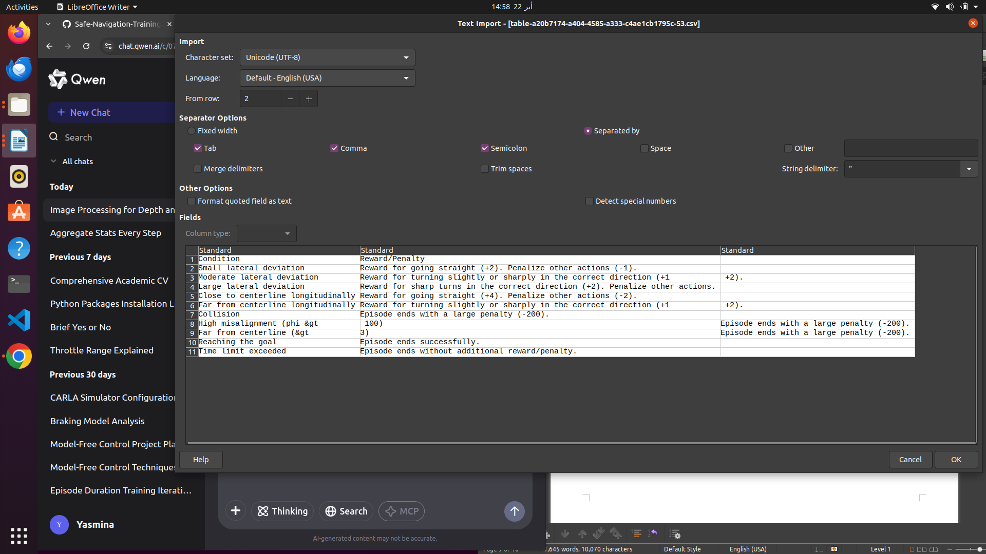
driving dqn network implementaion:
The Driving NN is responsible for controlling the vehicle's steering and model is seqential ,meaning keras feedforward neuralnetwork,
loss function calculated via mse ,then used adam optimizer,
Qwen2.5-Max4:14 pm
The provided create_model function defines and compiles a neural network model for use in reinforcement learning (RL), specifically for a Deep Q-Network (DQN) . Let’s break it down step by step, explaining its structure, purpose, and relevance to RL.

1. Purpose of the Model
This neural network serves as the Q-function approximator in a DQN. It estimates the Q-values for each possible action given the current state. These Q-values represent the expected cumulative reward for taking a specific action in a given state.

2. Key Components of the Model

a. Sequential Model
python
Copy
1
model3 = Sequential()

  - The `Sequential API from Keras is used to define a simple feedforward neural network.
  - Layers are added sequentially, one after another.

b. Input Layer
python
Copy
1
model3.add(Dense(8, input_shape=(2,), activation='relu', name='dense1'))

  - Input Shape : (2,) indicates that the input to the network is a 2-dimensional vector. This corresponds to the state representation ([phi, signed_dis*15])
  - Dense Layer : A fully connected layer with 8 neurons.
  - Activation Function : 'relu' (Rectified Linear Unit) introduces non-linearity into the model, enabling it to learn complex patterns.
  - Purpose : This layer processes the raw state inputs and extracts higher-level features.

c. Output Layer
python
Copy
1
model3.add(Dense(5, activation='linear', name='output'))

  - Output Size : 5 corresponds to the number of discrete actions available in the environment:
    - Go straight (action=0)
    - Turn left (action=1)
    - Turn right (action=2)
    - Turn slightly left (action=3)
    - Turn slightly right (action=4)
  - Activation Function : 'linear' means the output is unbounded. This is appropriate for regression tasks, where the goal is to predict Q-values (continuous values).
  - Purpose : The output layer predicts the Q-values for each of the 5 possible actions.

d. Combined Model
python
Copy
1
combined_model = Model(inputs=model3.input, outputs=model3.output)

  - TheModel API wraps the sequential model into a more flexible format. While this step is unnecessary here (since model3 is already a valid model), it may be useful for more complex architectures or extensions.

3. Compilation of the Model
python
Copy
1
combined_model.compile(loss='mse', optimizer=Adam(lr=0.0001), metrics=['accuracy'])

a. Loss Function
  - Mean Squared Error (mse) : The loss function measures the difference between the predicted Q-values and the target Q-values during training.
    - Formula:MSE=n1​i=1∑n​(predicted_Qi​−target_Qi​)2
    - Purpose: Minimizing MSE ensures that the predicted Q-values converge to the true Q-values over time.

b. Optimizer
  - Adam Optimizer : Adaptive Moment Estimation (Adam) is a popular optimization algorithm that combines the benefits of RMSProp and Momentum .
    - Learning Rate (lr=0.0001): Controls the step size during gradient descent. A small learning rate ensures stable convergence but may slow down training.

c. Metrics
  - Accuracy : Tracks the classification accuracy during training. However, accuracy is not particularly meaningful for regression tasks like Q-value prediction. This metric is likely included for debugging or logging purposes.

4. How the Model Fits into Reinforcement Learning
In a Deep Q-Learning setup, this neural network is used as follows:

a. Q-Value Prediction
  - Given a state [phi, signed_dis*15], the model predicts Q-values for all 5 possible actions:
python
Copy
1
q_values = model.predict(state)

    - Example output:
Copy
1
[q0, q1, q2, q3, q4] # Q-values for actions 0, 1, 2, 3, 4

b. Action Selection
  - During training, the agent selects actions using an epsilon-greedy policy :
    - With probability epsilon, the agent explores by choosing a random action.
    - Otherwise, the agent exploits by choosing the action with the highest predicted Q-value:
python
Copy
1
action = np.argmax(q_values)

c. Training the Model
  - The model is trained using the Bellman Equation to update the Q-values:
Q(s,a)←Q(s,a)+a⋅(r+c⋅a′max​Q(s′,a′)−Q(s,a))
    - s: Current state.
    - a: Action taken.
    - r: Reward received.
    - s′: Next state.
    - c: Discount factor (future rewards are discounted).
    - a: Learning rate.

The model takes a 2-dimensional state as input and outputs Q-values for 5 possible actions.
- The model is compiled with the MSE loss and Adam optimizer , making it suitable for regression tasks like Q-learning.

Driving NN input is simply the phi,orientation from lane and the d , distance to lane ,The output of the Driving NN is usually:
    - Asteering angle (e.g., -1 for full left, 0 for straight, +1 for full right).
    - Athrottle level (e.g., 0 for no throttle, 1 for full throttle).

Focus | DRIVING NN  Navigation, alignment, and progress toward the goal. | BRAKE NN  Safety, collision avoidance, and stopping. | Balance efficient navigation with safety by coordinating steering, throttle, and braking.
Inputs | -phi: Orientation difference between the vehicle and the road (in degrees). | -Distance to Obstacles: Distance to nearby vehicles, pedestrians, or other obstacles. | Shared inputs like speed (kmh) are used by both networks for coordination.
 | -signed_dis: Signed distance from the centerline of the road (positive or negative). | -Vehicle Speed (kmh): Current speed of the vehicle. | Each network focuses on its specialized inputs (e.g.,phifor Driving NN, obstacle distance for Brake NN).
 | -Vehicle Speed (kmh): Current speed of the vehicle. | -Proximity to Stopping Points: Distance to traffic lights, stop signs, or intersections.
 | -Proximity to Waypoints: Distance to the next waypoint on the road. | -Obstacle Velocity: Relative velocity of nearby obstacles (if available).
 | -Other Features: Additional state information (e.g., curvature of the road). | -Road Conditions: Information about road friction, weather, etc. (optional).
Outputs | -Steering Angle: Continuous value indicating steering direction. | -Braking Intensity: Continuous value indicating braking force. | Combined outputs determine the final vehicle control commands (steering, throttle, braking).
 | --1: Full left turn. | -0: No braking. | Example: If both suggest conflicting actions, prioritize safety (e.g., braking overrides acceleration).
 | -0: Go straight. | -1: Full braking.
 | -+1: Full right turn.
 | -Throttle Level: Continuous value indicating throttle intensity.
 | -0: No throttle.
 | -1: Full throttle.
Reward Design | Rewards staying aligned, maintaining speed, and progressing toward the goal. | Penalizes collisions, unsafe behavior, and rewards smooth braking. | Rewards are balanced to encourage efficient navigation while ensuring safety.
Priority | Performance-oriented (e.g., efficient navigation). | Safety-oriented (e.g., preventing accidents). | Prioritize safety in conflicting scenarios (e.g., braking overrides throttle).
Example Scenarios | - Vehicle is on a straight road: Steer straight (0), apply moderate throttle (0.5). | - Vehicle detects an obstacle ahead: Full braking (1). | - Vehicle is on a straight road: Continue driving forward safely.
 | - Vehicle approaches a sharp curve: Steer slightly left (-0.3), reduce throttle (0.2). | - Vehicle approaches a stop sign: Gradual braking (0.7). | - Vehicle approaches a sharp curve: Slow down and adjust steering to navigate the curve.
 |  |  | - Vehicle detects an obstacle ahead: Stop the vehicle to avoid a collision.
 |  |  | - Vehicle approaches a stop sign: Slow down and come to a complete stop.

carENV class:
we already implemented a reward function for the brake.dqn which takes as input (velocity and ditnace to observed object) and output brake control Q values,whether to brake or not .. SO OUTPUTS ARE LITERALLY (DRIVE OR BRAKE )
and also we implemented the reward functions for the drive.dqn which takes as input distance to lane and the phi,orientation to lane , and output 5 actions Q VALUES , right left,slightly left ,stop…

now in CARENV the actions will be taken from both the DRIVR and BRAKE network ,so we need to build rewward logic based on these 2 neuralnwteoks:this is our FULL ARCITICTRURE :
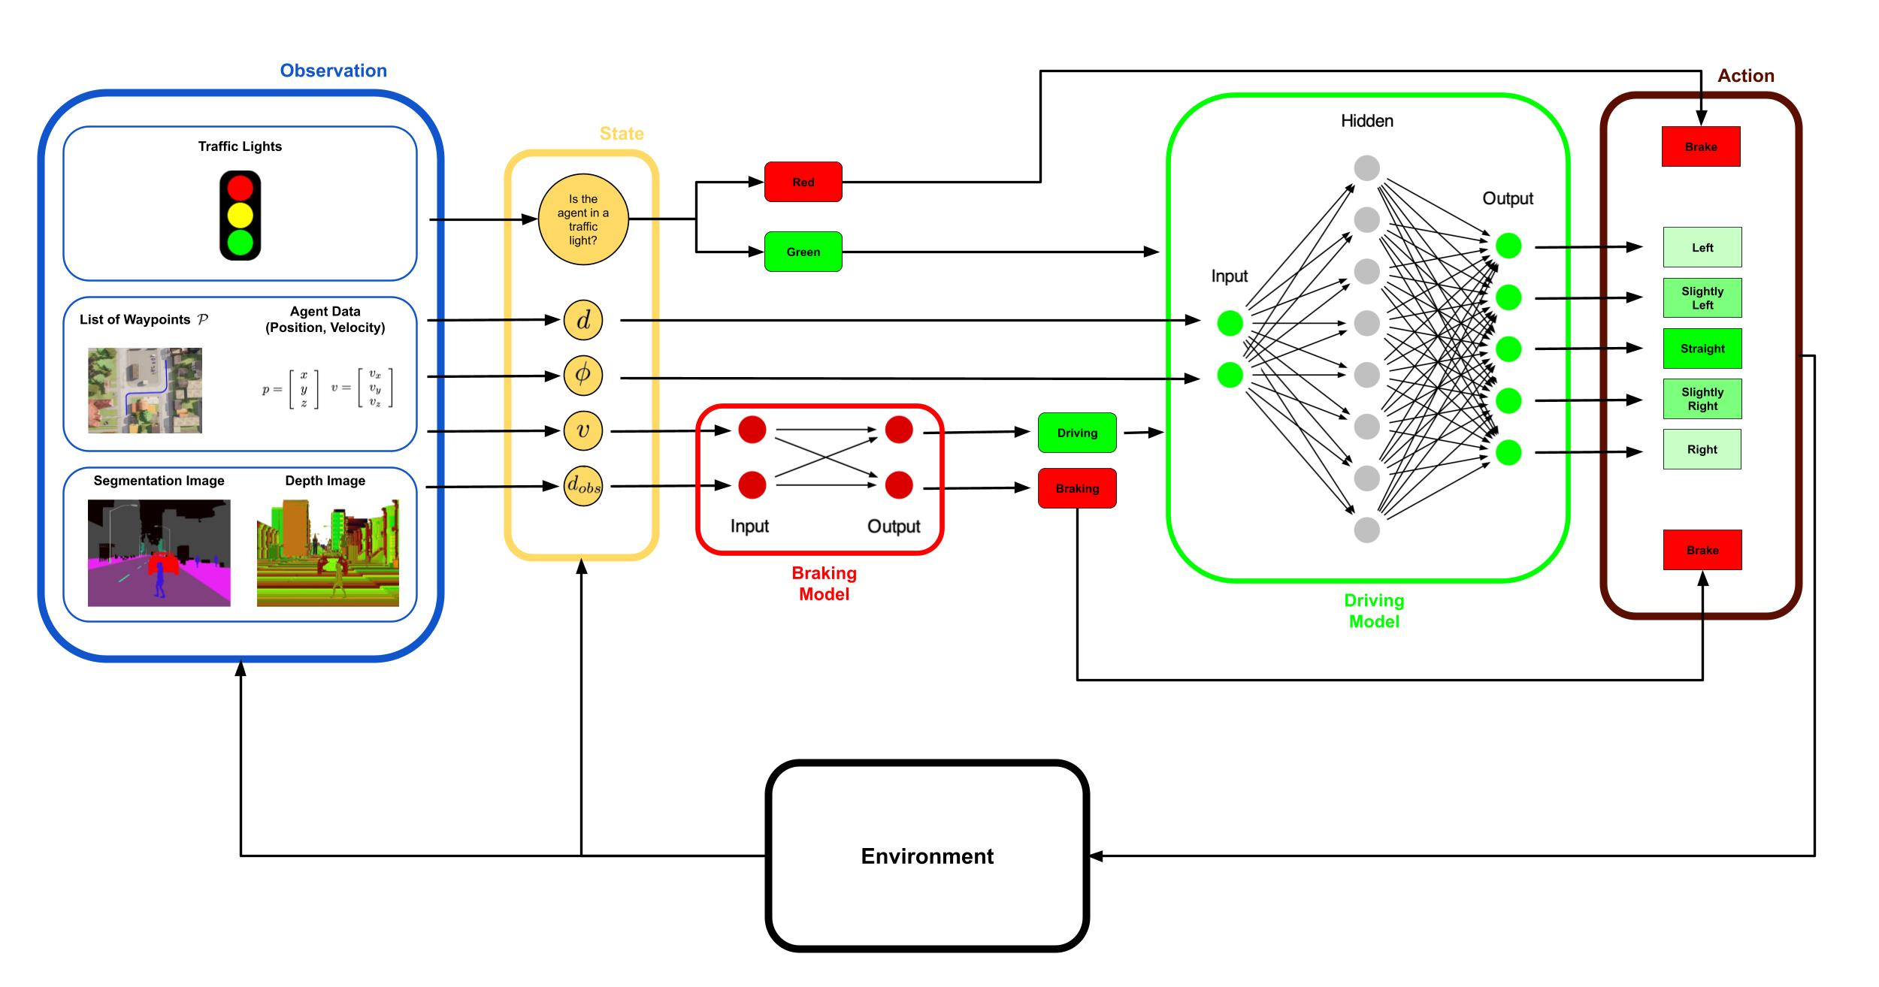
IN OTHER WORDS: we need to find the “OPTIMAL POLICY FOR EACH NEURAL NETWORK”
Braking Policy : Encourages the agent to brake appropriately when obstacles are near.
Driving Policy : Guides the agent to maintain lane discipline, follow the trajectory, and avoid sharp maneuvers.
So the reward function we need is a combination of both NN
Termionoligies to understand well:
current_state[0]: Normalized Distance to the Closest Obstacle
- Description : This value represents the normalized distance to the closest obstacle detected by the sensors

current_state[1]: Normalized Speed of the Vehicle
  - Description : This value represents the normalized speed of the vehicle.

current_state[2]: Orientation Difference (phi)

Description : This value represents the orientation difference between the vehicle and the road (in degrees).

current_state[3]: Signed Lateral Displacement
  - Description : This value represents the signed lateral displacement of the vehicle relative to the center of the lane.

terminolgies table :used in reward functions
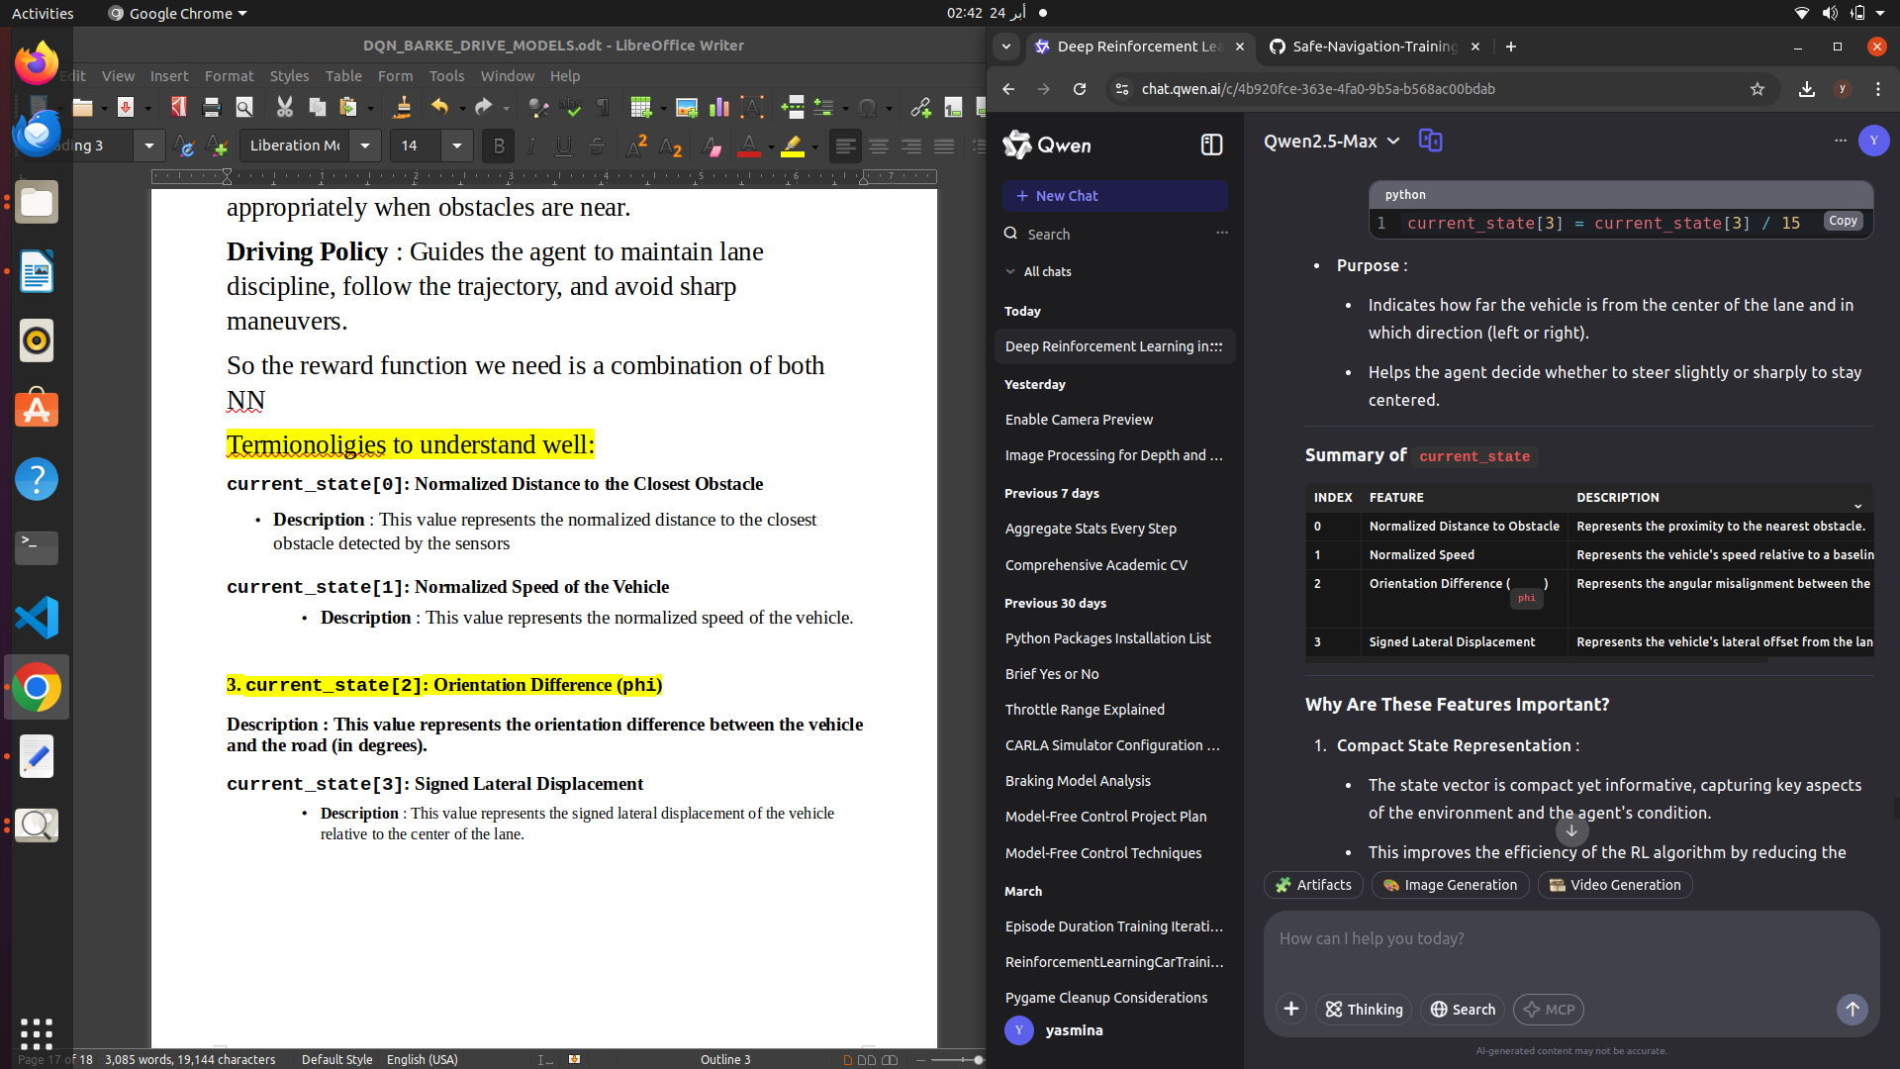
training goals:
goal is to train an autonomous driving agent that:
- Avoids collisions.
- Stays on the road and follows the lane.
- Maintains appropriate speed.
- Reaches the destination efficiently.
- The reward function achieves this by combining two key policies:
- Braking Policy : Encourages the agent to brake appropriately when obstacles are near.
- Driving Policy : Guides the agent to maintain lane discipline, follow the trajectory, and avoid sharp maneuvers.
- KEY OBJECTIVES::
Qwen2.5-Max2:45 am
Certainly! Let’s break down the reward function and its components in detail, highlighting the strategic thinking behind it, the Reinforcement Learning (RL) concepts involved, and the reasoning process that led to this design.

1. Purpose of the Reward Function
The reward function is one of the most critical components of an RL system because it defines the agent's objective. In this case, the goal is to train an autonomous driving agent that:
- Avoids collisions.
- Stays on the road and follows the lane.
- Maintains appropriate speed.
- Reaches the destination efficiently.
The reward function achieves this by combining two key policies:
- Braking Policy : Encourages the agent to brake appropriately when obstacles are near.
- Driving Policy : Guides the agent to maintain lane discipline, follow the trajectory, and avoid sharp maneuvers.

2. Strategic Thinking Behind the Reward Function

Key Objectives
- Safety First :
  - The agent must prioritize avoiding collisions and staying on the road.
  - Severe penalties are imposed for unsafe actions like collisions or deviating too far from the lane center.
- Efficient Navigation :
  - The agent should follow the planned trajectory and reach the destination within a reasonable time.
  - Rewards encourage staying aligned with the road and maintaining a steady speed.
- Smooth Driving :
  - Sharp turns or unnecessary braking are penalized to ensure smooth and natural driving behavior.
- Balanced Exploration :
  - The reward function provides clear signals for good vs. bad actions, helping the agent learn faster while still exploring new strategies.

reward function implemenation steps:
1-design clear objectives :
safety,effeciency,smooth driving
2-iterate and refine till u reach ur results

details:
if (current_state[0]*300+300) < (((current_state[1]+current_state[0])*30+30)*10 + 10):
checking on state0:distance to obstacle and state1 which is the car speed,and then check whther the car shoulb break orr not based on the distance to osntavle and the current speed.
So if braking is optimal but we didnt brake then reward-1,but if going straight was optimal we did something elsde then reward-2.
So basically,checking on distance from obstacle and velocity of the car,we see wether or not we need to brake ,and then if we did the right action it’s good,but if we did something else we penalize the car and so on

code explainining the reward logic :
this one is the optimal policy for breaking
if (current_state[0]*300+300) < (((current_state[1]+current_state[0])*30+30)*10 + 10):
if action == 0:
reward += 3
else:
reward -= 1
else:
if action == 1:
reward += 2
else:
reward -= 2
left side represents the distance to opbstacle while the right side combines both speed and sistance to osbtacle “threshold” from both,
Encourages the agent to make decisions based on both safety (distance to obstacles) and efficiency (speed).
- Balances braking and forward motion to prevent overly cautious or reckless behavior.This condition checks whether the vehicle should brake based on its proximity to obstacles and speed.

if current_state[0]*300+300 > 100 and (current_state[1]+current_state[0])*30+30 < 1:
if action == 0:
reward -= 10

if normaliozed distance to obstacle is grater than 100 meter ,this means that no need to do “unneccsarily brake , si if we brake (action=0) then this is not the right action and we get penalized
“dont break 3al fady”

if abs(current_state[2]) < 5:
if action == 0:
reward += 2
else:
reward -= 1
if orientation betwwen the car and the road is less than 5 , checking men el akher law el car is “well alligned on the lane “,penalize law 3amalt steering maloosh lazma 3shan ana already mashya kowayis w msh mehtaga a steer or aghyur el orientation bta3y l ay sabsb
if action==0 break.i will be slighly rewarded,i mean not bad but not the best in all cases,unlkinke steer,steer will make the car diverge

elif abs(current_state[2]) < 10: /
if current_state[2] < 0:
if action == 3: # Turn right
reward += 2 elif action == 1: # Go straight
reward += 1
else:
reward -= 1
else:
if action == 4: # Turn left
reward += 2
elif action == 2: # Turn slightly left
reward += 1
else:
reward -= 1
if phi.angle betwwen road and the car is less than 10,
fe divergence moderate ,tayeb ymeen wla shmaal??
if phi less than 0..negative convergence then I need to go right , then if I take action3==right I get a rewrd ,if I go straight still we get a reward because it’s not the worst ,we still have a problem but we didnt make it worse..buttt if we take an action that made us converge more ,hena baa the penaklie.
Takenote:msh shurt akoon ba3mel el right action 3shan akhod reward,mmkn a3mel haga matbawush el situation bta3y aktar and still be rewarded bs msh reward kkbeer

if abs(current_state[3]) < 0.1:#lateral displacement from the lane
if action == 0:
reward += 4
else:
reward -= 2
this is made to center the car between lane “lane centering”

elif abs(current_state[3]) < 0.5:
if current_state[3] < 0:
if action == 3:
reward += 2
elif action == 1:
reward += 1
else:
reward -= 1
else:
if action == 4:
reward += 2
elif action == 2:
reward += 1
else:
reward -= 1
“again we try to reward for being ceneterd in the klane “,but we checking on values aktar zy 0.5 then 0,bnhot nafsena f intervals ..check if lateral displacement is moderate or not ..
how bad is the lateral diplavcment . And from values how can we correct ..so if u try to center el car or u do nothing bad u get a reward,else if u do action by make it worse,u get a punish ..

FINALLy collision,extreme orintation misslaignmentt,large lateral deviation gets very HARSH PUNISHMENTS

Final Note : Fine-tuning these conditions and their associated rewards can further enhance the agent's performance, especially in complex or dynamic driving scenarios.

PID IN OUR PROJECT :
why needed ?
LISTEN ,WE HAVE HIGH LEVEL AND LOW LEVEL CONTROL,WNERE THE MODEL FREE IS THE HIGH LEVEL AND THE MODEL BASED IS THE LOW LEVEL CONTROL,a PID controller would serve as a low-level control mechanism to ensure smooth and precise execution of steering, throttle, and braking actions. It complements the high-level decision-making performed by your reinforcement learning (RL) agent

HOW THE PID AND RL INTEGRATED TOGETHER :
The PID controller computes the following outputs:
- Steering Angle : For lateral control, the PID controller calculates the appropriate steering angle to minimize signed_dis and phi.
- Throttle/Brake Values : For longitudinal control, the PID controller calculates the appropriate throttle or brake values to achieve the target speed.

c. Example Workflow
Here’s how the PID controller would fit into your project:
- High-Level Decision by the RL Agent :
  - The RL agent decides on a high-level action, such as "turn left" or "slow down."
  - This decision is based on the current state vector (current_state) and the reward function.
- Low-Level Execution by the PID Controller :
  - The PID controller translates the RL agent's decision into precise control signals:
    - For "turn left," the PID controller computes the exact steering angle needed to follow the trajectory.
    - For "slow down," the PID controller adjusts the throttle/brake to reduce speed smoothly.
- Feedback Loop :
  - The PID controller continuously monitors the vehicle's state (e.g., signed_dis, phi, kmh) and adjusts the control signals in real-time to minimize errors.
High level decision making is the RL agent:
the rl agent gives outputs like brake,straight,left,slighly left and so on,so these actions may lead to unstable behavior ,this where pid comes in
the use of the lower level pid control,The PID controller translates the RL agent's high-level decisions into precise, smooth control signals for steering , throttle , and brake . It operates in real-time, continuously adjusting these signals based on feedback from the vehicle's sensors.

We have 2 pid controllers one for lateral control”steering” and one longitudinal control “throttle and brake” ,
the lateral takes as input signed distsace d”distance to lane “ and phi,car orientation
Instead of hardcoding steer=-0.6*self.STEER_AMT for turning left or steer=0.6*self.STEER_AMT for turning right, the PID controller dynamically computes the exact steering angle needed to minimize signed_dis and phi
the pid control dynamicALLY the exact steer insteadof saying go left or go right,it tells me exactly how much right or left needed to go .
The PID controller works by continuously minimizing the error between the current state of the vehicle and the desired state . For steering control, the key inputs

braking.dqn again to confirm on basic rl points and concepts :
any dqn structrure is
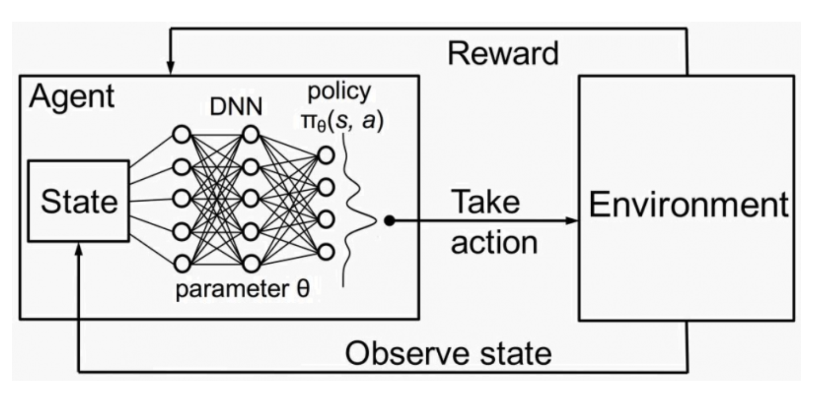
DQNs are a neural network architecture used in RL that combines Q-learning with Deep Learning
(DL) techniques. They approximate the Q-function rather than storing it in a lookup table, making
them suitable for complex and high-dimensional environments. DQN’s use of experience replay
prevents overfitting and stabilizes training, making it a powerful method for learning a policy in a
model-free approach. Once the DQN is trained, we get the optimal policy as follows:
π(s) = arg max Q(s, a)
THE MODEL HAS 2 ACTION , 0 FOR BREAK AND 1 FOR DRIVING
THE REWARD FUNCTION IS : R b (v, d obs , a) = [v < 10 d obs + 10] ∧ (3[a = 0] − [a = 1]) + 2 [v > 10 d obs + 10] ∧ (2 [a = 1] − 1)
− 10 [v < 1] ∧ [d obs > 100] + 200 [v = 0] ∧ [d obs < 150] − 200 [collisions > 0]

Term 1: Braking When Close to Obstacles
[v<10⋅dobs​+10]∧(3[a=0]−[a=1])
- Condition : [v<10⋅dobs​+10]
  - If the vehicle's velocity v is less than 10⋅dobs​+10, this condition is true.
  - This ensures that the vehicle slows down when it is close to an obstacle (small dobs​).
- Action-Based Reward :
  - 3[a=0]: If the action is braking (a=0), the agent receives a reward of +3.
  - −[a=1]: If the action is going straight (a=1), the agent receives a penalty of −1.

Term 2: Maintaining Speed When Far from Obstacles
[v>10⋅dobs​+10]∧(2[a=1]−1)
- Condition : [v>10⋅dobs​+10]
  - If the vehicle's velocity v is greater than 10⋅dobs​+10, this condition is true.
  - This ensures that the vehicle maintains speed when it is far from obstacles (large dobs​).
- Action-Based Reward :
  - 2[a=1]: If the action is going straight (a=1), the agent receives a reward of +2.
  - −1: A small penalty of −1 is applied if the action is not going straight.
- Purpose :
  - Encourages maintaining forward motion (a=1) when the vehicle is far from obstacles.

Term 3: Penalizing Unnecessary Braking
−10[v<1]∧[dobs​>100]
- Condition : [v<1]∧[dobs​>100]
  - If the vehicle's velocity v is very low (v<1) and the distance to the closest obstacle is large (dobs​>100), this condition is true.
- Penalty :
  - The agent receives a penalty of −10.
- Purpose :
  - Prevents unnecessary braking when there is no immediate obstacle.

Term 4: Rewarding Stopping Near Obstacles
200[v=0]∧[dobs​<150]
- Condition : [v=0]∧[dobs​<150]
  - If the vehicle has stopped (v=0) and the distance to the closest obstacle is small (dobs​<150), this condition is true.
- Reward :
  - The agent receives a reward of +200.
- Purpose :
  - Encourages stopping safely when the vehicle is near an obstacle.

Term 5: Penalizing Collisions
−200[collisions>0]
- Condition : [collisions>0]
  - If the vehicle has collided with an obstacle (collisions>0), this condition is true.
- Penalty :
  - The agent receives a severe penalty of −200.
- Purpose :
  - Strongly discourages collisions, ensuring safety.

7. Conclusion
This reward function is carefully designed to balance safety, efficiency, and smooth driving. It encourages the agent to:
- Brake appropriately when close to obstacles.
- Maintain speed when far from obstacles.
- Stop safely when necessary.
- Avoid collisions at all costs.
OTHER REALTED INFO:
SECONDS_PER_EPISODE = 20
REPLAY_MEMORY_SIZE = 5_000
MIN_REPLAY_MEMORY_SIZE = 1_000
MINIBATCH_SIZE = 16
PREDICTION_BATCH_SIZE = 1
TRAINING_BATCH_SIZE = MINIBATCH_SIZE // 4
UPDATE_TARGET_EVERY = 2
EPISODES = 40
DISCOUNT = 0.99
epsilon = 0.5
EPSILON_DECAY = 0.95 #0.95 ## 0.9975 99975
MIN_EPSILON = 0.01AGGREGATE_STATS_EVERY = 1
IN DQN DESIGN ITSELD WE USE 2 NN ,ONE IS THE BASE MODEL AND ONE IS THE TARGET MODEL:

In Deep Q-Networks (DQN) , the use of two neural networks—the target network and the prediction network (base network) —is a key mechanism to stabilize training and improve the learning process. Let’s delve into the purpose and functionality of these two networks in detail.

1. Why Do We Need Two Networks?
Reinforcement Learning (RL) algorithms like DQN aim to approximate the Q-value function , which estimates the expected cumulative reward for taking an action in a given state. However, training a single neural network to predict Q-values can lead to instability due to the following reasons:

a. Moving Target Problem
- In Q-learning, the target Q-value is computed using the Bellman equation:Q(s,a)←r+γa′max​Q(s′,a′)Here, Q(s′,a′) is the predicted Q-value for the next state.
- If the same network is used to predict both the current Q-value (Q(s,a)) and the target Q-value (r+γmaxa′​Q(s′,a′)), the target becomes highly correlated with the network's weights. This causes rapid fluctuations in the target values during training, leading to instability or divergence.

b. Bootstrapping Issue
- The Q-learning algorithm relies on bootstrapping , where the network uses its own predictions to update its weights. This creates a feedback loop that can amplify errors if the predictions are noisy or unstable.
To address these issues, DQN introduces a target network that stabilizes the learning process by decoupling the computation of target Q-values from the updates to the main network.

2. What Are the Two Networks?

a. Prediction Network (Base Network)
- The prediction network (also called the online network ) is the primary network used for decision-making and learning.
- It takes the current state as input and outputs Q-values for all possible actions:Qpred​(s,a;θ)Here, θ represents the weights of the prediction network.
- During training, the prediction network is updated frequently using gradient descent to minimize the difference between its predictions and the target Q-values.

b. Target Network
- The target network is a copy of the prediction network but with fixed weights (θ−).
- It is used to compute the target Q-values for training:y=r+γa′max​Qtarget​(s′,a′;θ−)Here, Qtarget​(s′,a′;θ−) is the Q-value predicted by the target network for the next state (s′).
- The weights of the target network (θ−) are updated less frequently (e.g., every UPDATE_TARGET_EVERY steps) by copying the weights of the prediction network (θ).

3. How Do They Work Together?
The interaction between the prediction network and the target network is central to the DQN algorithm. Here’s how they work together during training:

Step 1: Compute Target Q-Values
- For each transition (s,a,r,s′,done) sampled from the replay memory:
  - Use the target network to compute the target Q-value:y=r+γa′max​Qtarget​(s′,a′;θ−)(if not done)y=r(if done)

Step 2: Predict Current Q-Values
- Use the prediction network to predict the current Q-values for the states in the minibatch:Qpred​(s,a;θ)

Step 3: Compute Loss
- Compute the loss between the predicted Q-values and the target Q-values:Loss=N1​i=1∑N​(yi​−Qpred​(si​,ai​;θ))2

Step 4: Update the Prediction Network
- Perform gradient descent to update the weights of the prediction network (θ) to minimize the loss.

Step 5: Periodically Update the Target Network
- After every UPDATE_TARGET_EVERY steps, copy the weights of the prediction network to the target network :θ−←θ

4. Benefits of Using Two Networks

a. Stability
- By decoupling the computation of target Q-values from the prediction network, the training process becomes more stable.
- The target network provides a "lagging" version of the Q-values, reducing correlation between the current Q-values and the targets.

b. Smoother Learning
- The periodic updates to the target network ensure that the learning process is gradual and smooth.
- Without the target network, frequent updates to the prediction network could lead to erratic behavior.

c. Better Generalization
- The separation of responsibilities between the two networks helps the agent generalize better to unseen states, improving overall performance.

5. Implementation in Your Code
In your code, the interaction between the prediction network and the target network is implemented as follows:

a. Initialization
python
1
2
3
self.model = self.create_model() # Prediction network
self.target_model = self.create_model() # Target network
self.target_model.set_weights(self.model.get_weights())

- Both networks are initialized with the same architecture and weights.

b. Updating the Replay Memory
python
1
self.replay_memory.append((current_state, action, reward, new_state, done))

- Experiences are stored in the replay memory for training.

c. Training the Prediction Network
python
1
2
current_qs_list = self.model.predict(current_data, PREDICTION_BATCH_SIZE)
future_qs_list = self.target_model.predict(new_current_data, PREDICTION_BATCH_SIZE)

- The prediction network predicts the current Q-values.
- The target network computes the target Q-values.

d. Periodic Synchronization
python
1
2
3
⌄
if self.target_update_counter > UPDATE_TARGET_EVERY:
self.target_model.set_weights(self.model.get_weights())
self.target_update_counter = 0

- The target network's weights are updated periodically to match the prediction network.

6. Summary
Aspect | Prediction Network | Target Network
Purpose | Used for decision-making and predicting current Q-values. | Used for computing stable target Q-values during training.
Updates | Updated frequently using gradient descent. | Updated periodically by copying weights from the prediction network.
Stability | Prone to instability due to frequent updates. | Provides stability by keeping target Q-values fixed for a period.

7. Conclusion
The use of a prediction network and a target network in DQN is crucial for stabilizing the training process. The prediction network is responsible for decision-making and learning, while the target network provides stable target Q-values. By periodically synchronizing the target network with the prediction network, the agent achieves smoother and more reliable learning.
Answer : {In DQN, the prediction network is updated frequently for decision-making, while the target network provides stable target Q-values by being updated less frequently. This separation stabilizes training and prevents oscillations or divergence.}

