BANK DATABASE SERVER LOG ANALYZER
Test Cases Results

ENCS3130 Linux Laboratory - Python Programming Project
Summer 2025/2026

Team
Yasmin (1230271)
Sanabel (1230288)

Coverage Matrix
Scenario | Covered by
Normal cases | TC-01 to TC-10
Zero results | TC-12e, TC-12f, TC-12g, TC-12h
Invalid line (malformed) | TC-10, TC-11a
Invalid timestamp (month/day/hour/date) | TC-10, TC-11a
Empty line | TC-10, TC-11a
Empty file | TC-12a to TC-12h
Wrong module | TC-01, TC-02, TC-03, TC-04, TC-08
Wrong log level | TC-01, TC-03, TC-05
Wrong message | TC-01, TC-03
Wrong username | TC-07, TC-13
Wrong CLI option | TC-14, TC-15
Wrong menu option | TC-16a, TC-16b, TC-16c
Missing file | TC-17
Ties in failed-login counts | TC-01
Ties in peak-hour counts | TC-09
Ties in busiest modules | TC-10
Multiple users / multiple IPs | TC-01, TC-06
Multiple modules | TC-05, TC-06, TC-10
Case-insensitive username | TC-06
Case-insensitive log level / module | TC-11b
Unsorted timestamps | TC-03, TC-05, TC-06, TC-08
Sessions without logout | TC-08
Logout without login | TC-08
Amount missing | TC-04
Slow-query time missing | TC-03

TC-01 - Failed Login Report
Test Case ID
TC-01
Command
python main.py test_failed.log --report failed

What it covers
Brute force at exactly 3 attempts; More than one brute-force IP; Ties in counts; IP below threshold (2 attempts); ERROR level counted; WARNING ignored; INFO ignored; AUTH module with a different message ignored; QUERY module ignored even with a matching message
Input (log file)
File: test_failed.log
[2026-08-15 08:00:00] [ERROR] [S1] [unknown] [203.0.113.55] [AUTH] - Failed login attempt for user root
[2026-08-15 08:01:00] [ERROR] [S2] [unknown] [203.0.113.55] [AUTH] - Failed login attempt for user root
[2026-08-15 08:02:00] [ERROR] [S3] [unknown] [203.0.113.55] [AUTH] - Failed login attempt for user root
[2026-08-15 08:03:00] [ERROR] [S4] [admin] [192.168.1.10] [AUTH] - Failed login attempt for user admin
[2026-08-15 08:04:00] [ERROR] [S5] [admin] [192.168.1.10] [AUTH] - Failed login attempt for user admin
[2026-08-15 08:05:00] [ERROR] [S6] [admin] [192.168.1.10] [AUTH] - Failed login attempt for user admin
[2026-08-15 08:06:00] [ERROR] [S7] [teller01] [10.0.0.5] [AUTH] - Failed login attempt for user teller01
[2026-08-15 08:07:00] [ERROR] [S8] [teller01] [10.0.0.5] [AUTH] - Failed login attempt for user teller01
[2026-08-15 08:08:00] [INFO] [S9] [admin] [192.168.1.10] [AUTH] - Successful login
[2026-08-15 08:09:00] [ERROR] [S10] [admin] [192.168.1.10] [AUTH] - Password expired
[2026-08-15 08:10:00] [WARNING] [S11] [admin] [192.168.1.10] [AUTH] - Failed login attempt for user admin
[2026-08-15 08:11:00] [ERROR] [S12] [admin] [192.168.1.10] [QUERY] - Failed login attempt

Output
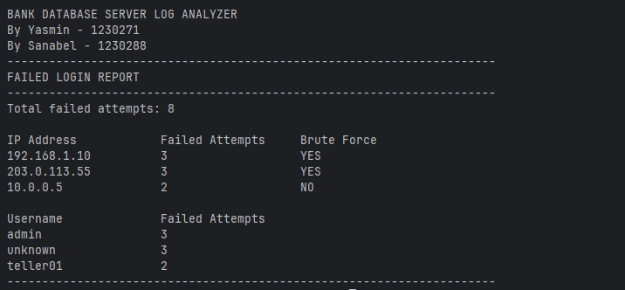

TC-02 - Query Activity Summary
Test Case ID
TC-02
Command
python main.py test_query.log --report query

What it covers
Lowercase query; Uppercase query; All four query types; More than one Uncategorized; Ties; AUTH line containing SELECT is not counted
Input (log file)
File: test_query.log
[2026-08-15 09:00:00] [INFO] [S1] [admin] [1.1.1.1] [QUERY] - SELECT * FROM accounts
[2026-08-15 09:01:00] [INFO] [S2] [admin] [1.1.1.1] [QUERY] - select name from users
[2026-08-15 09:02:00] [INFO] [S3] [admin] [1.1.1.1] [QUERY] - UPDATE accounts SET balance=100
[2026-08-15 09:03:00] [INFO] [S4] [admin] [1.1.1.1] [QUERY] - update users set active=1
[2026-08-15 09:04:00] [INFO] [S5] [admin] [1.1.1.1] [QUERY] - INSERT INTO accounts VALUES (1)
[2026-08-15 09:05:00] [INFO] [S6] [admin] [1.1.1.1] [QUERY] - DELETE FROM accounts WHERE id=1
[2026-08-15 09:06:00] [INFO] [S7] [admin] [1.1.1.1] [QUERY] - COMMIT transaction
[2026-08-15 09:07:00] [INFO] [S8] [admin] [1.1.1.1] [QUERY] - CREATE TABLE test
[2026-08-15 09:08:00] [INFO] [S9] [admin] [1.1.1.1] [AUTH] - SELECT * FROM users
Output
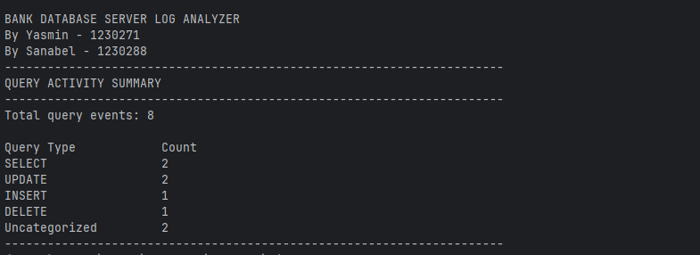

TC-03 - Slow Query Detector
Test Case ID
TC-03
Command
python main.py test_slow.log --report slow

What it covers
ms unit; seconds unit; Decimal seconds; No execution time (Not found); INFO ignored; ERROR ignored; AUTH module ignored; WARNING QUERY without the word 'slow' ignored; Chronological sorting
Input (log file)
File: test_slow.log
[2026-08-15 10:20:00] [WARNING] [S4] [admin] [1.1.1.1] [QUERY] - Slow query took 3 seconds
[2026-08-15 10:00:00] [WARNING] [S1] [admin] [1.1.1.1] [QUERY] - Slow query execution time 2500ms
[2026-08-15 10:10:00] [WARNING] [S3] [teller01] [1.1.1.2] [QUERY] - Slow query detected
[2026-08-15 10:05:00] [WARNING] [S2] [teller01] [1.1.1.2] [QUERY] - Slow query completed in 1.5 seconds
[2026-08-15 10:25:00] [INFO] [S5] [admin] [1.1.1.1] [QUERY] - Slow query 9000ms
[2026-08-15 10:30:00] [ERROR] [S6] [admin] [1.1.1.1] [QUERY] - Slow query 6000ms
[2026-08-15 10:35:00] [WARNING] [S7] [admin] [1.1.1.1] [AUTH] - Slow query 5000ms
[2026-08-15 10:40:00] [WARNING] [S8] [admin] [1.1.1.1] [QUERY] - Query took 7 seconds
Output
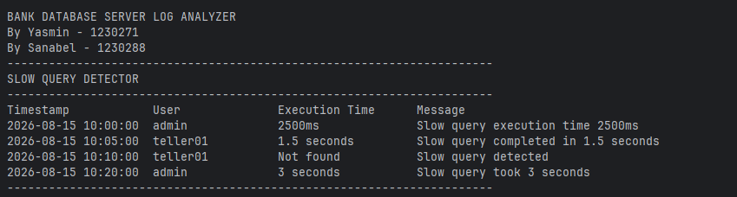

TC-04 - Transaction Report
Test Case ID
TC-04
Command
python main.py test_transaction.log --report transaction

What it covers
Integer amount; Decimal amount; Transaction without an amount; 'Withdrawal' and 'Withdraw' wording; More than one declined; More than one rollback; AUTH-module line ignored
Input (log file)
File: test_transaction.log
[2026-08-15 11:00:00] [INFO] [S1] [admin] [1.1.1.1] [TRANSACTION] - Deposit amount $500 completed
[2026-08-15 11:01:00] [INFO] [S2] [admin] [1.1.1.1] [TRANSACTION] - Deposit amount $250.50 completed
[2026-08-15 11:02:00] [INFO] [S3] [admin] [1.1.1.1] [TRANSACTION] - Deposit completed successfully
[2026-08-15 11:03:00] [INFO] [S4] [teller01] [1.1.1.2] [TRANSACTION] - Withdrawal amount $200 completed
[2026-08-15 11:04:00] [INFO] [S5] [teller01] [1.1.1.2] [TRANSACTION] - Withdraw amount 100.25 completed
[2026-08-15 11:05:00] [WARNING] [S6] [admin] [1.1.1.1] [TRANSACTION] - Transaction declined
[2026-08-15 11:06:00] [WARNING] [S7] [admin] [1.1.1.1] [TRANSACTION] - Another transaction declined
[2026-08-15 11:07:00] [CRITICAL] [S8] [system] [1.1.1.3] [TRANSACTION] - Transaction rollback
[2026-08-15 11:08:00] [CRITICAL] [S9] [system] [1.1.1.3] [TRANSACTION] - Emergency rollback
[2026-08-15 11:09:00] [INFO] [S10] [admin] [1.1.1.1] [AUTH] - Deposit amount $999
Output
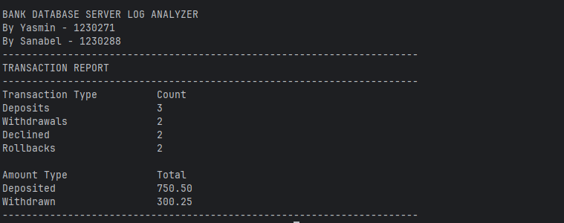

TC-05 - Critical Events Report
Test Case ID
TC-05
Command
python main.py test_critical.log --report critical

What it covers
Multiple modules; Unsorted input; Sorting; ERROR ignored; WARNING ignored
Input (log file)
File: test_critical.log
[2026-08-15 12:30:00] [CRITICAL] [S4] [admin] [4.4.4.4] [AUTH] - Critical authentication failure
[2026-08-15 12:00:00] [CRITICAL] [S1] [system] [1.1.1.1] [BACKUP] - Backup failed
[2026-08-15 12:20:00] [CRITICAL] [S3] [teller01] [3.3.3.3] [TRANSACTION] - Transaction rollback
[2026-08-15 12:10:00] [CRITICAL] [S2] [admin] [2.2.2.2] [QUERY] - Database unavailable
[2026-08-15 12:40:00] [ERROR] [S5] [admin] [5.5.5.5] [BACKUP] - Backup failed
[2026-08-15 12:50:00] [WARNING] [S6] [admin] [6.6.6.6] [QUERY] - Slow query
Output
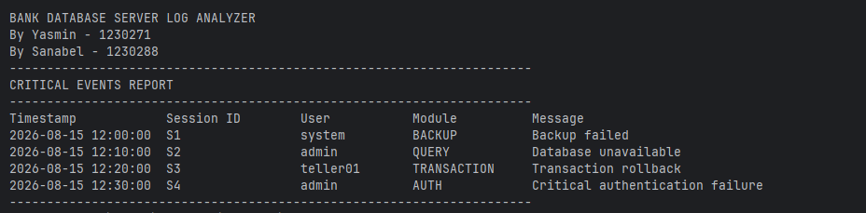

TC-06 - User Activity Report (username = admin)
Test Case ID
TC-06
Command
python main.py test_user.log --report user --username admin

What it covers
Case-insensitive username; Mixed-case usernames; Multiple log levels; Multiple modules; Unsorted input; Chronological output; Unrelated user ignored
Input (log file)
File: test_user.log
[2026-08-15 13:30:00] [WARNING] [S1] [admin] [1.1.1.1] [TRANSACTION] - Transaction declined
[2026-08-15 13:00:00] [INFO] [S1] [Admin] [1.1.1.1] [AUTH] - Successful login
[2026-08-15 13:20:00] [INFO] [S1] [ADMIN] [1.1.1.1] [QUERY] - SELECT * FROM accounts
[2026-08-15 13:10:00] [INFO] [S2] [teller01] [2.2.2.2] [AUTH] - Successful login
[2026-08-15 13:40:00] [ERROR] [S1] [admin] [1.1.1.1] [AUTH] - Failed login attempt

Output
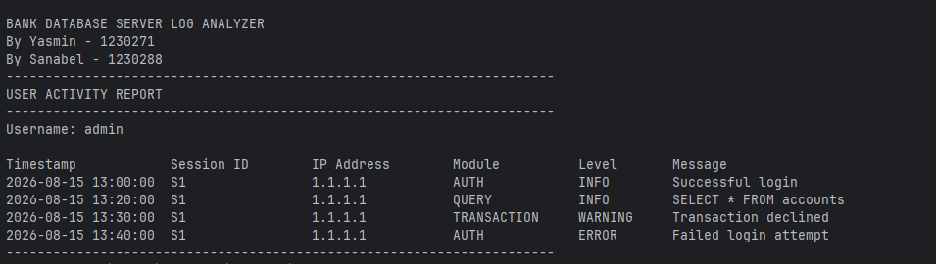

TC-07 - User Activity Report - user does not exist
Test Case ID
TC-07
Command
python main.py test_user.log --report user --username mayar

What it covers
Username not found
Input (log file)
File: test_user.log
[2026-08-15 13:30:00] [WARNING] [S1] [admin] [1.1.1.1] [TRANSACTION] - Transaction declined
[2026-08-15 13:00:00] [INFO] [S1] [Admin] [1.1.1.1] [AUTH] - Successful login
[2026-08-15 13:20:00] [INFO] [S1] [ADMIN] [1.1.1.1] [QUERY] - SELECT * FROM accounts
[2026-08-15 13:10:00] [INFO] [S2] [teller01] [2.2.2.2] [AUTH] - Successful login
[2026-08-15 13:40:00] [ERROR] [S1] [admin] [1.1.1.1] [AUTH] - Failed login attempt

Output
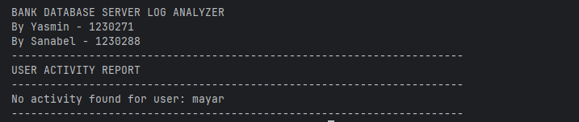

TC-08 - Login/Logout Session Report
Test Case ID
TC-08
Command
python main.py test_session.log --report session

What it covers
Complete session; Open session; Another open session; Orphan logout; Failed login ignored; Non-AUTH line ignored; Unsorted input; Chronological handling
Input (log file)
File: test_session.log
[2026-08-15 15:30:00] [INFO] [SESSION_2] [teller01] [2.2.2.2] [AUTH] - Successful login
[2026-08-15 14:45:30] [INFO] [SESSION_1] [admin] [1.1.1.1] [AUTH] - Logout
[2026-08-15 14:00:00] [INFO] [SESSION_1] [admin] [1.1.1.1] [AUTH] - Successful login
[2026-08-15 13:00:00] [INFO] [SESSION_ORPHAN] [ghost] [3.3.3.3] [AUTH] - Logout
[2026-08-15 16:00:00] [INFO] [SESSION_3] [admin] [1.1.1.1] [AUTH] - Successful login
[2026-08-15 16:20:00] [INFO] [SESSION_3] [admin] [1.1.1.1] [QUERY] - SELECT * FROM accounts
[2026-08-15 17:00:00] [ERROR] [SESSION_4] [unknown] [4.4.4.4] [AUTH] - Failed login attempt

Output
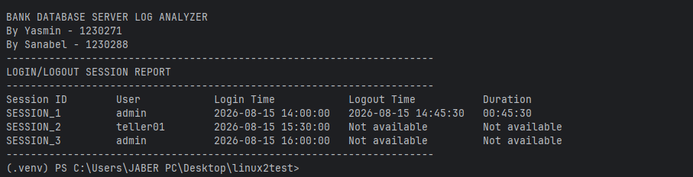

TC-09 - Events-per-Hour Report (peak tie)
Test Case ID
TC-09
Command
python main.py test_hourly.log --report hourly

What it covers
Boundaries 08:59:59 / 09:00:00; Last second of the day (23:59:59); Zero-activity hours shown; Tie for peak hour
Input (log file)
File: test_hourly.log
[2026-08-15 08:00:00] [INFO] [S1] [admin] [1.1.1.1] [AUTH] - A
[2026-08-15 08:10:00] [INFO] [S2] [admin] [1.1.1.1] [QUERY] - B
[2026-08-15 08:59:59] [ERROR] [S3] [admin] [1.1.1.1] [AUTH] - C
[2026-08-15 09:00:00] [INFO] [S4] [admin] [1.1.1.1] [AUTH] - D
[2026-08-15 09:30:00] [WARNING] [S5] [admin] [1.1.1.1] [QUERY] - E
[2026-08-15 09:59:59] [CRITICAL] [S6] [admin] [1.1.1.1] [BACKUP] - F
[2026-08-15 10:00:00] [INFO] [S7] [admin] [1.1.1.1] [AUTH] - G
[2026-08-15 23:59:59] [INFO] [S8] [admin] [1.1.1.1] [AUTH] - H
Output
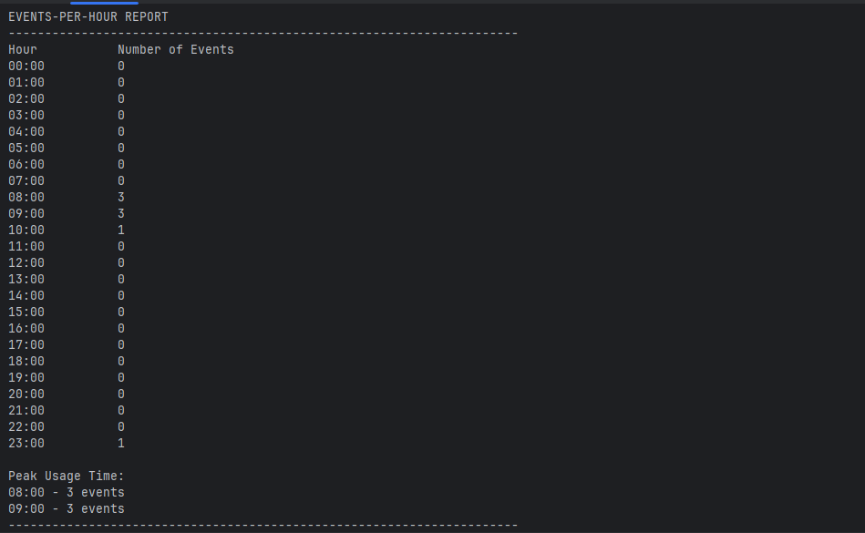

TC-10 - General Log Summary (tie for busiest module)
Test Case ID
TC-10
Command
python main.py test_summary.log --report summary
What it covers
Empty line counted as invalid; Malformed line; Invalid timestamp; Counts per log level; Counts per module; Tie for busiest module
Input (log file)
File: test_summary.log
[2026-08-15 08:00:00] [INFO] [S1] [admin] [1.1.1.1] [AUTH] - Successful login
[2026-08-15 08:01:00] [INFO] [S2] [admin] [1.1.1.1] [QUERY] - SELECT * FROM users
[2026-08-15 08:02:00] [WARNING] [S3] [admin] [1.1.1.1] [QUERY] - Slow query 2s
[2026-08-15 08:03:00] [WARNING] [S4] [admin] [1.1.1.1] [AUTH] - Warning
[2026-08-15 08:04:00] [ERROR] [S5] [unknown] [2.2.2.2] [AUTH] - Failed login attempt
[2026-08-15 08:05:00] [ERROR] [S6] [unknown] [2.2.2.2] [QUERY] - Query failed
[2026-08-15 08:06:00] [CRITICAL] [S7] [system] [3.3.3.3] [BACKUP] - Backup failed
[2026-08-15 08:07:00] [CRITICAL] [S8] [system] [3.3.3.3] [TRANSACTION] - Transaction rollback
BROKEN LINE
[2026-99-99 08:08:00] [INFO] [S9] [admin] [1.1.1.1] [AUTH] - Successful login
[2026-08-15 08:09:00] [INFO] [S10] [admin] [1.1.1.1] [BACKUP] - Backup complete
[2026-08-15 08:10:00] [INFO] [S11] [admin] [1.1.1.1] [TRANSACTION] - Deposit amount $100
Output 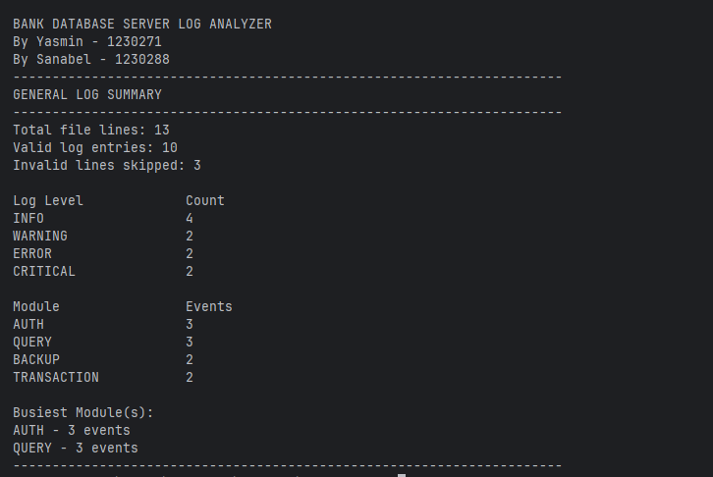

TC-11a - Parser edge cases - counters
Test Case ID
TC-11a
Command
python main.py test_parser.log --report summary

What it covers
Empty lines; Malformed line; Invalid month; Invalid day; Invalid hour; Lowercase level/module accepted
Input (log file)
File: test_parser.log
[2026-08-15 08:00:00] [INFO] [S1] [admin] [1.1.1.1] [AUTH] - Successful login
THIS IS NOT A LOG
[2026-13-15 08:00:00] [INFO] [S2] [admin] [1.1.1.1] [AUTH] - Invalid month
[2026-08-32 08:00:00] [INFO] [S3] [admin] [1.1.1.1] [AUTH] - Invalid day
[2026-08-15 25:00:00] [INFO] [S4] [admin] [1.1.1.1] [AUTH] - Invalid hour
[2026-08-15 09:00:00] [error] [S5] [admin] [1.1.1.1] [auth] - Failed login attempt
NOTE: The test file must contain 3 intentional empty lines so the total line count is 9.
Output
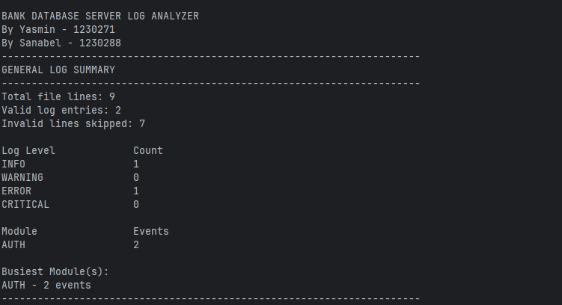

TC-11b - Parser edge cases - lowercase level/module normalised
Test Case ID
TC-11b
Command
python main.py test_parser.log --report failed

What it covers
Lowercase level/module converted with .upper()
Input (log file)
File: test_parser.log
[2026-08-15 08:00:00] [INFO] [S1] [admin] [1.1.1.1] [AUTH] - Successful login
THIS IS NOT A LOG
[2026-13-15 08:00:00] [INFO] [S2] [admin] [1.1.1.1] [AUTH] - Invalid month
[2026-08-32 08:00:00] [INFO] [S3] [admin] [1.1.1.1] [AUTH] - Invalid day
[2026-08-15 25:00:00] [INFO] [S4] [admin] [1.1.1.1] [AUTH] - Invalid hour
[2026-08-15 09:00:00] [error] [S5] [admin] [1.1.1.1] [auth] - Failed login attempt

Output
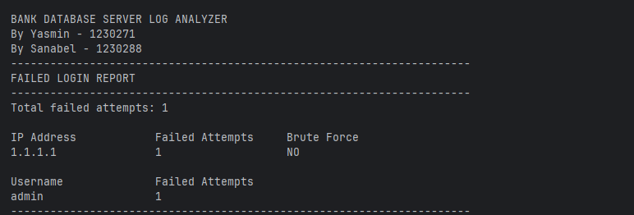

TC-12a - Empty file - Summary
Test Case ID
TC-12a
Command
python main.py test_empty.log --report summary

What it covers
Empty file; No crash
Input (log file)
File: test_empty.log (completely empty, 0 bytes)

Output
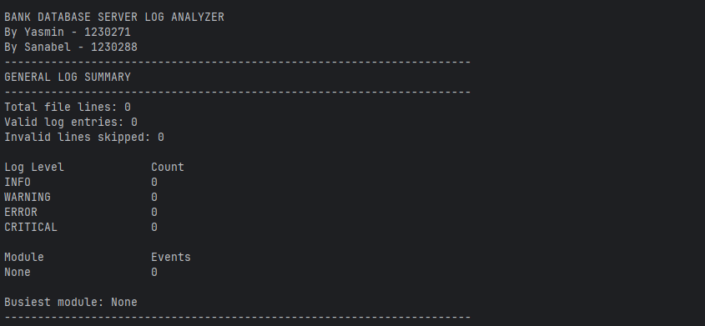

TC-12b - Empty file - Events per hour
Test Case ID
TC-12b
Command
python main.py test_empty.log --report hourly

What it covers
Empty file
Input (log file)
File: test_empty.log (completely empty, 0 bytes)

Output
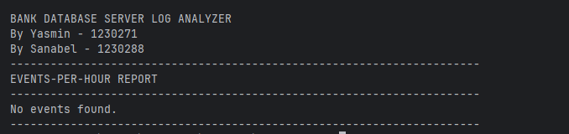

TC-12c - Empty file - Critical events
Test Case ID
TC-12c
Command
python main.py test_empty.log --report critical

What it covers
Empty file
Input (log file)
File: test_empty.log (completely empty, 0 bytes)

Output
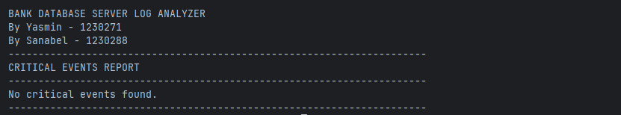

TC-12d - Empty file - Sessions
Test Case ID
TC-12d
Command
python main.py test_empty.log --report session

What it covers
Empty file
Input (log file)
File: test_empty.log (completely empty, 0 bytes)

Output
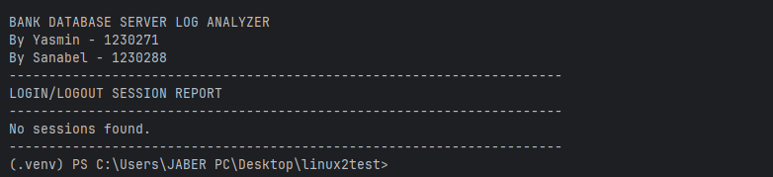

TC-12e - Empty file - Failed login
Test Case ID
TC-12e
Command
python main.py test_empty.log --report failed

What it covers
Empty file
Input (log file)
File: test_empty.log (completely empty, 0 bytes)

Output
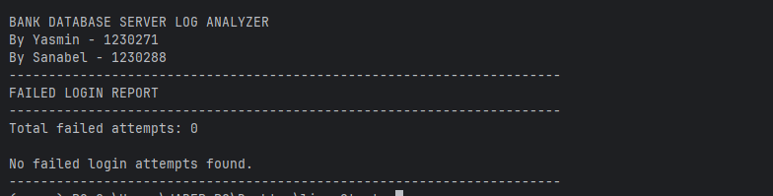

TC-12f - Empty file - Slow queries
Test Case ID
TC-12f
Command
python main.py test_empty.log --report slow

What it covers
Empty file
Input (log file)
File: test_empty.log (completely empty, 0 bytes)

Output
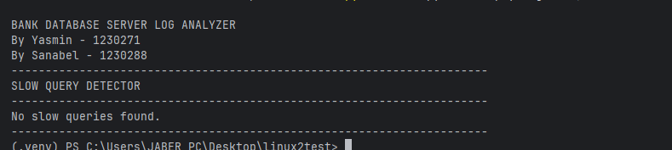

TC-12g - Empty file - Query activity
Test Case ID
TC-12g
Command
python main.py test_empty.log --report query

What it covers
Empty file
Input (log file)
File: test_empty.log (completely empty, 0 bytes)

Output
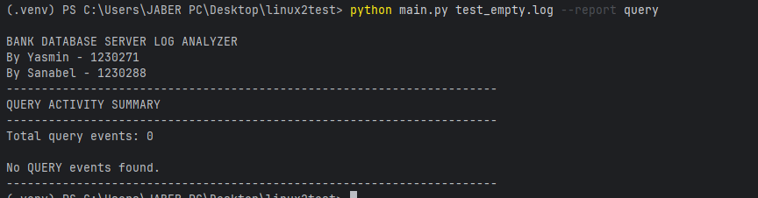

TC-12h - Empty file - Transactions
Test Case ID
TC-12h
Command
python main.py test_empty.log --report transaction

What it covers
Empty file
Input (log file)
File: test_empty.log (completely empty, 0 bytes)

Output
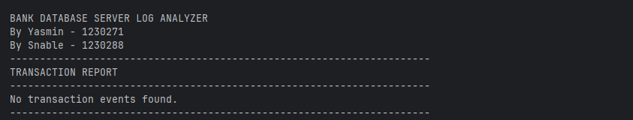

TC-13 - Wrong username
Test Case ID
TC-13
Command
python main.py test_user.log --report user --username xyz123

What it covers
Wrong username
Input (log file)
File: test_user.log
[2026-08-15 13:30:00] [WARNING] [S1] [admin] [1.1.1.1] [TRANSACTION] - Transaction declined
[2026-08-15 13:00:00] [INFO] [S1] [Admin] [1.1.1.1] [AUTH] - Successful login
[2026-08-15 13:20:00] [INFO] [S1] [ADMIN] [1.1.1.1] [QUERY] - SELECT * FROM accounts
[2026-08-15 13:10:00] [INFO] [S2] [teller01] [2.2.2.2] [AUTH] - Successful login
[2026-08-15 13:40:00] [ERROR] [S1] [admin] [1.1.1.1] [AUTH] - Failed login attempt

Output
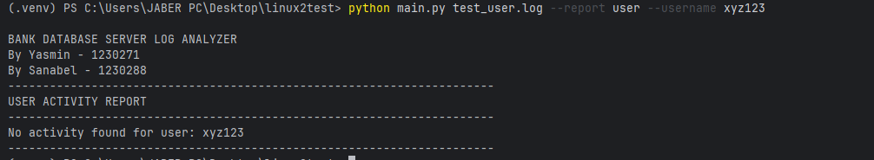

TC-14 - User report without --username
Test Case ID
TC-14
Command
python main.py test_user.log --report user

What it covers
Missing CLI argument
Input (log file)
File: test_user.log
[2026-08-15 13:30:00] [WARNING] [S1] [admin] [1.1.1.1] [TRANSACTION] - Transaction declined
[2026-08-15 13:00:00] [INFO] [S1] [Admin] [1.1.1.1] [AUTH] - Successful login
[2026-08-15 13:20:00] [INFO] [S1] [ADMIN] [1.1.1.1] [QUERY] - SELECT * FROM accounts
[2026-08-15 13:10:00] [INFO] [S2] [teller01] [2.2.2.2] [AUTH] - Successful login
[2026-08-15 13:40:00] [ERROR] [S1] [admin] [1.1.1.1] [AUTH] - Failed login attempt

Output
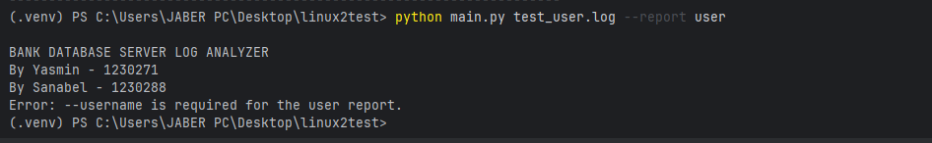

TC-15 - Wrong report name
Test Case ID
TC-15
Command
python main.py test_user.log --report mayar

What it covers
Wrong CLI option
Input (log file)
File: test_user.log
[2026-08-15 13:30:00] [WARNING] [S1] [admin] [1.1.1.1] [TRANSACTION] - Transaction declined
[2026-08-15 13:00:00] [INFO] [S1] [Admin] [1.1.1.1] [AUTH] - Successful login
[2026-08-15 13:20:00] [INFO] [S1] [ADMIN] [1.1.1.1] [QUERY] - SELECT * FROM accounts
[2026-08-15 13:10:00] [INFO] [S2] [teller01] [2.2.2.2] [AUTH] - Successful login
[2026-08-15 13:40:00] [ERROR] [S1] [admin] [1.1.1.1] [AUTH] - Failed login attempt

Output
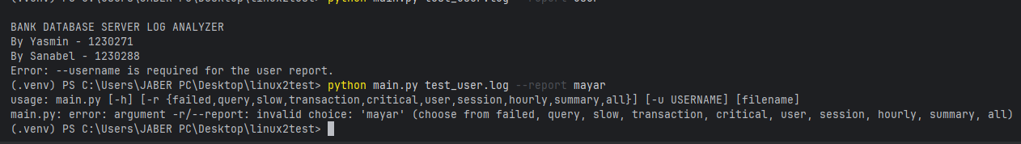

TC-16a - Wrong menu input (20)
Test Case ID
TC-16a
Command
python main.py test_user.log
Keyboard input: 20, then 0

What it covers
Wrong menu option
Input (log file)
File: test_user.log
[2026-08-15 13:30:00] [WARNING] [S1] [admin] [1.1.1.1] [TRANSACTION] - Transaction declined
[2026-08-15 13:00:00] [INFO] [S1] [Admin] [1.1.1.1] [AUTH] - Successful login
[2026-08-15 13:20:00] [INFO] [S1] [ADMIN] [1.1.1.1] [QUERY] - SELECT * FROM accounts
[2026-08-15 13:10:00] [INFO] [S2] [teller01] [2.2.2.2] [AUTH] - Successful login
[2026-08-15 13:40:00] [ERROR] [S1] [admin] [1.1.1.1] [AUTH] - Failed login attempt
Keyboard input at the menu prompt: 20 then 0
Output
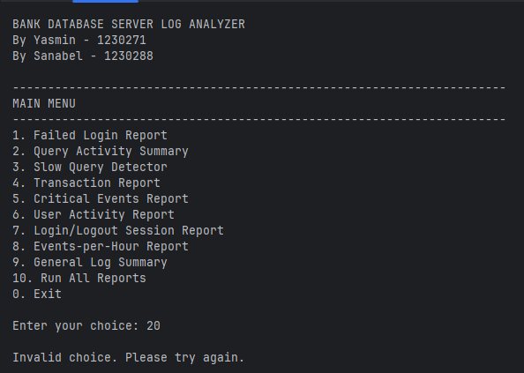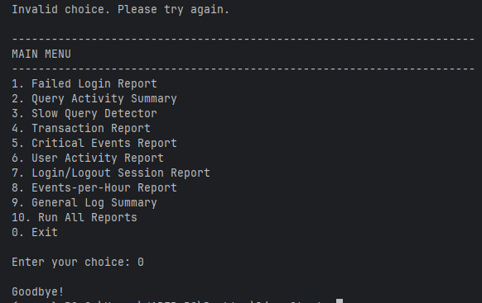

TC-16b - Wrong menu input (abc)
Test Case ID
TC-16b
Command
python main.py test_user.log
Keyboard input: abc, then 0

What it covers
Wrong menu option
Input (log file)
File: test_user.log
[2026-08-15 13:30:00] [WARNING] [S1] [admin] [1.1.1.1] [TRANSACTION] - Transaction declined
[2026-08-15 13:00:00] [INFO] [S1] [Admin] [1.1.1.1] [AUTH] - Successful login
[2026-08-15 13:20:00] [INFO] [S1] [ADMIN] [1.1.1.1] [QUERY] - SELECT * FROM accounts
[2026-08-15 13:10:00] [INFO] [S2] [teller01] [2.2.2.2] [AUTH] - Successful login
[2026-08-15 13:40:00] [ERROR] [S1] [admin] [1.1.1.1] [AUTH] - Failed login attempt
Keyboard input at the menu prompt: abc then 0
Output
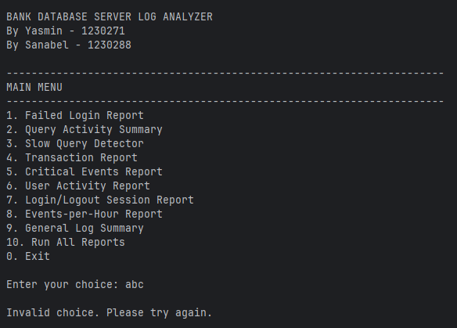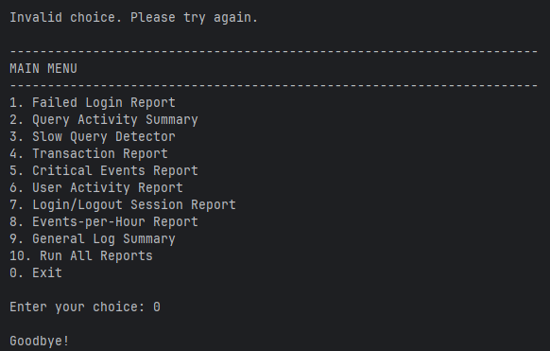

TC-16c - Wrong menu input (-1)
Test Case ID
TC-16c
Command
python main.py test_user.log
Keyboard input: -1, then 0

What it covers
Wrong menu option
Input (log file)
File: test_user.log
[2026-08-15 13:30:00] [WARNING] [S1] [admin] [1.1.1.1] [TRANSACTION] - Transaction declined
[2026-08-15 13:00:00] [INFO] [S1] [Admin] [1.1.1.1] [AUTH] - Successful login
[2026-08-15 13:20:00] [INFO] [S1] [ADMIN] [1.1.1.1] [QUERY] - SELECT * FROM accounts
[2026-08-15 13:10:00] [INFO] [S2] [teller01] [2.2.2.2] [AUTH] - Successful login
[2026-08-15 13:40:00] [ERROR] [S1] [admin] [1.1.1.1] [AUTH] - Failed login attempt
Keyboard input at the menu prompt: -1 then 0

Output
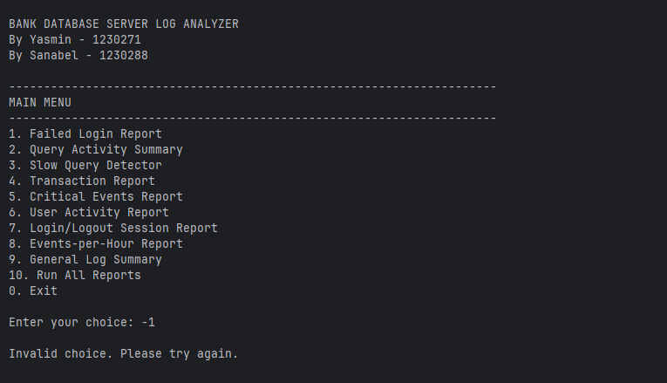

TC-17 - File does not exist
Test Case ID
TC-17
Command
python main.py nothing.log

What it covers
Missing file
Input (log file)
File: nothing.log (does not exist)

Output
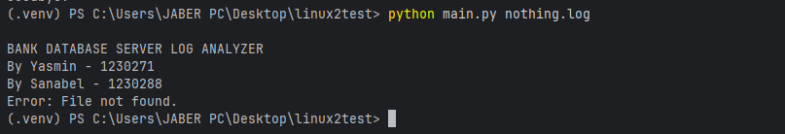

5. Final Test Result
27 / 27 test cases passed.
The program successfully handled normal report generation, parser edge cases, empty files, invalid command-line arguments, invalid menu input, case-insensitive fields, unsorted timestamps, open/orphan sessions, ties, and a missing input file.

