1. Failed Login Report
Test 1.1 - Normal Failed Login Attempts
bank_server.log Input:
[2026-08-15 08:00:00] [ERROR] [SESSION_1001] [admin] [192.168.1.10] [AUTH] - Failed login attempt
[2026-08-15 08:01:00] [ERROR] [SESSION_1002] [root] [192.168.1.20] [AUTH] - Failed login attempt
Program Input:
Menu Choice: 1
Output:
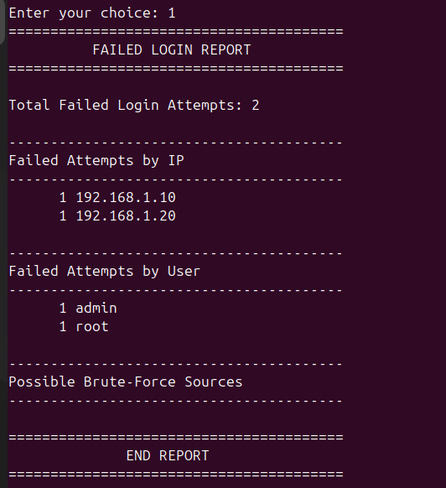

Test 1.2 - Brute-Force Threshold (Exactly 3 Attempts)
bank_server.log Input:
[2026-08-15 08:00:00] [ERROR] [SESSION_1001] [admin] [203.0.113.55] [AUTH] - Failed login attempt
[2026-08-15 08:01:00] [ERROR] [SESSION_1002] [root] [203.0.113.55] [AUTH] - Failed login attempt
[2026-08-15 08:02:00] [ERROR] [SESSION_1003] [unknown] [203.0.113.55] [AUTH] - Failed login attempt
Program Input:
Menu Choice: 1
Output:
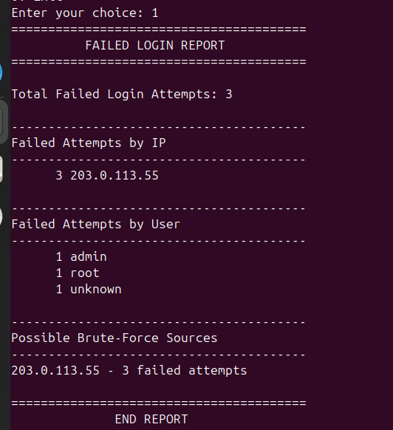

Test 1.3 - Multiple Brute-Force IP Addresses
bank_server.log Input:
[2026-08-15 08:00:00] [ERROR] [SESSION_1001] [admin] [10.0.0.1] [AUTH] - Failed login attempt
[2026-08-15 08:01:00] [ERROR] [SESSION_1002] [admin] [10.0.0.1] [AUTH] - Failed login attempt
[2026-08-15 08:02:00] [ERROR] [SESSION_1003] [root] [10.0.0.1] [AUTH] - Failed login attempt
[2026-08-15 08:03:00] [ERROR] [SESSION_1004] [unknown] [20.0.0.1] [AUTH] - Failed login attempt
[2026-08-15 08:04:00] [ERROR] [SESSION_1005] [unknown] [20.0.0.1] [AUTH] - Failed login attempt
[2026-08-15 08:05:00] [ERROR] [SESSION_1006] [unknown] [20.0.0.1] [AUTH] - Failed login attempt
[2026-08-15 08:06:00] [ERROR] [SESSION_1007] [unknown] [20.0.0.1] [AUTH] - Failed login attempt
Program Input:
Menu Choice: 1
Output:
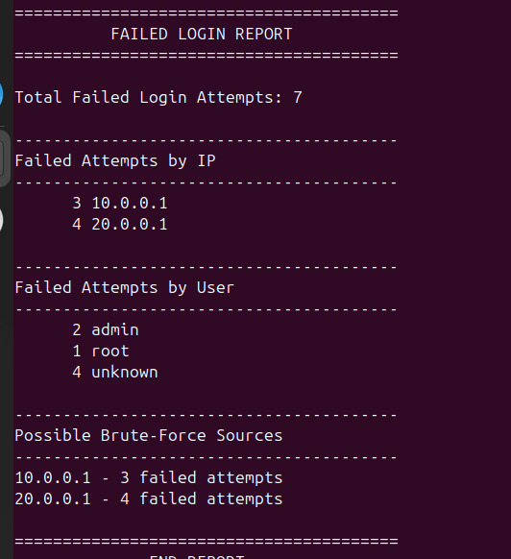

Test 1.5 - Invalid Failed-Login-Like Entries Are Ignored
bank_server.log Input:
[2026-08-15 08:00:00] [INFO] [SESSION_1001] [admin] [192.168.1.10] [AUTH] - Failed login attempt
[2026-08-15 08:01:00] [ERROR] [SESSION_1002] [root] [192.168.1.20] [QUERY] - Failed login attempt
[2026-08-15 08:02:00] [ERROR] [SESSION_1003] [admin] [192.168.1.30] [AUTH] - Account locked
[2026-08-15 08:03:00] [ERROR] [SESSION_1004] [admin] [192.168.1.40] [AUTH] - Failed login attempt
Program Input:
Menu Choice: 1
Output:
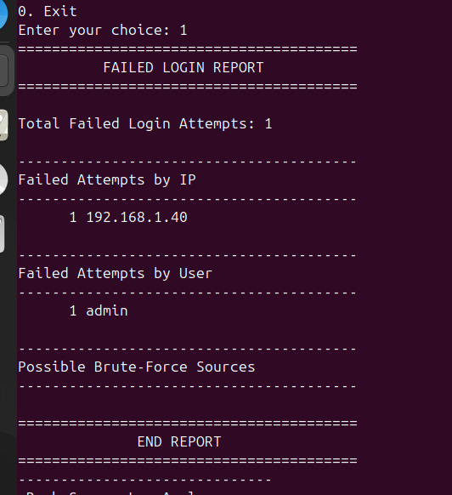

2. Query Activity Summary
Test 2.1 - All Main Query Types
bank_server.log Input:
[2026-08-15 08:00:00] [INFO] [SESSION_2001] [admin] [192.168.1.10] [QUERY] - SELECT * FROM accounts
[2026-08-15 08:01:00] [INFO] [SESSION_2002] [admin] [192.168.1.10] [QUERY] - UPDATE accounts SET balance=500
[2026-08-15 08:02:00] [INFO] [SESSION_2003] [admin] [192.168.1.10] [QUERY] - INSERT INTO users VALUES (1,'Ali')
[2026-08-15 08:03:00] [INFO] [SESSION_2004] [admin] [192.168.1.10] [QUERY] - DELETE FROM users WHERE id=1
Program Input:
Menu Choice: 2
Output:
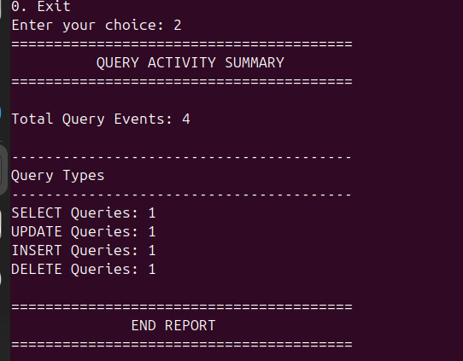

Test 2.2 - Multiple Queries of the Same Type
bank_server.log Input:
[2026-08-15 08:00:00] [INFO] [SESSION_2001] [admin] [192.168.1.10] [QUERY] - SELECT * FROM accounts
[2026-08-15 08:01:00] [INFO] [SESSION_2002] [admin] [192.168.1.10] [QUERY] - SELECT * FROM users
[2026-08-15 08:02:00] [INFO] [SESSION_2003] [admin] [192.168.1.10] [QUERY] - SELECT * FROM customers
Program Input:
Menu Choice: 2
Output:
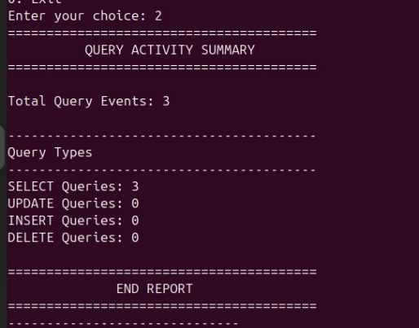

Test 2.3 - Other Query Type Included in Total
bank_server.log Input:
[2026-08-15 08:00:00] [INFO] [SESSION_2001] [admin] [192.168.1.10] [QUERY] - SELECT * FROM accounts
[2026-08-15 08:01:00] [INFO] [SESSION_2002] [admin] [192.168.1.10] [QUERY] - CREATE TABLE test
Program Input:
Menu Choice: 2
Output:
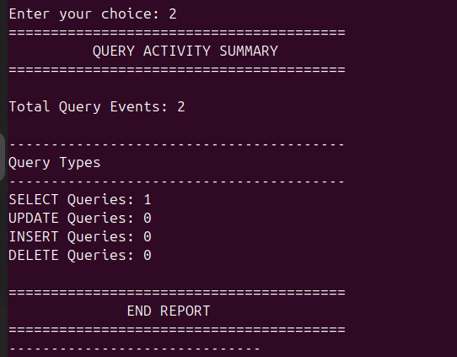

3. Slow Query Detector
Test 3.1 - Slow Queries in Milliseconds and Seconds
bank_server.log Input:
[2026-08-15 08:00:00] [WARNING] [SESSION_3001] [admin] [192.168.1.10] [QUERY] - Slow query execution time 2500ms
[2026-08-15 08:01:00] [WARNING] [SESSION_3002] [teller01] [192.168.1.11] [QUERY] - Slow query execution time 1.5 seconds
Program Input:
Menu Choice: 3
Output:
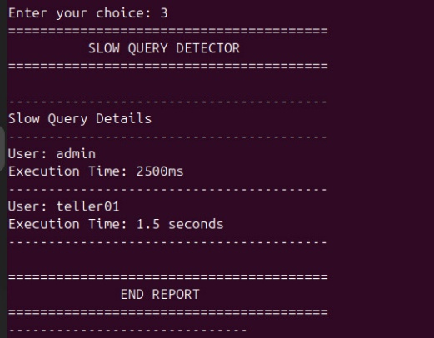

4. Transaction Report
Test 4.1 - Deposits, Withdrawals, Decline, and Rollback
bank_server.log Input:
[2026-08-15 08:00:00] [INFO] [SESSION_4001] [admin] [192.168.1.10] [TRANSACTION] - Deposit amount 500
[2026-08-15 08:01:00] [INFO] [SESSION_4002] [admin] [192.168.1.10] [TRANSACTION] - Withdrawal amount 100
[2026-08-15 08:02:00] [WARNING] [SESSION_4003] [admin] [192.168.1.10] [TRANSACTION] - Transaction declined
[2026-08-15 08:03:00] [CRITICAL] [SESSION_4004] [manager] [192.168.1.12] [TRANSACTION] - Transaction rollback
Program Input:
Menu Choice: 4
Output:
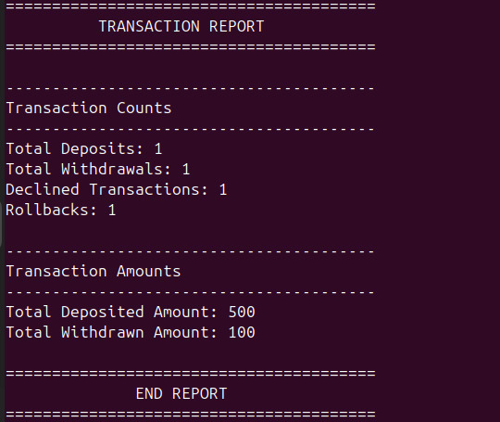

Test 4.2 - Decimal Amounts and Currency Text
bank_server.log Input:
[2026-08-15 08:00:00] [INFO] [SESSION_4001] [admin] [192.168.1.10] [TRANSACTION] - Deposit amount 200 USD
[2026-08-15 08:01:00] [INFO] [SESSION_4002] [admin] [192.168.1.10] [TRANSACTION] - Deposit amount 50.50
[2026-08-15 08:02:00] [INFO] [SESSION_4003] [admin] [192.168.1.10] [TRANSACTION] - Withdrawal amount 25.75 USD
Program Input:
Menu Choice: 4
Output:
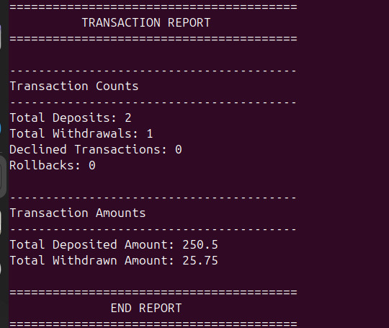

Test 4.3 - Invalid Amount Text Does Not Add to Total
bank_server.log Input:
[2026-08-15 08:00:00] [INFO] [SESSION_4001] [admin] [192.168.1.10] [TRANSACTION] - Deposit amount abc
[2026-08-15 08:01:00] [INFO] [SESSION_4002] [admin] [192.168.1.10] [TRANSACTION] - Withdrawal amount xyz
Program Input:
Menu Choice: 4
Output:
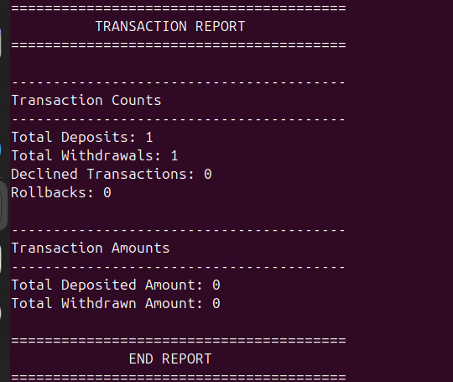

5. Critical Events Report
Test 5.1 - Multiple CRITICAL Events
bank_server.log Input:
[2026-08-15 08:00:00] [CRITICAL] [SESSION_5001] [admin] [192.168.1.10] [BACKUP] - Backup failure
[2026-08-15 08:05:00] [CRITICAL] [SESSION_5002] [manager] [192.168.1.11] [TRANSACTION] - Transaction rollback
[2026-08-15 08:10:00] [CRITICAL] [SESSION_5003] [admin] [192.168.1.12] [BACKUP] - Backup failure - disk unavailable
Program Input:
Menu Choice: 5
Output:
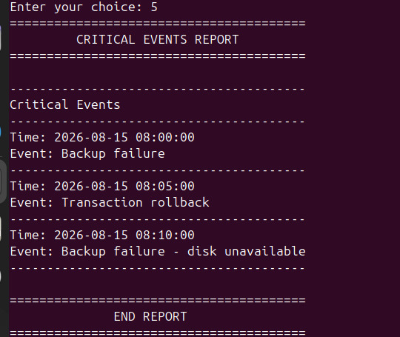

Test 5.2 - Similar Non-CRITICAL Events Are Ignored
bank_server.log Input:
[2026-08-15 08:00:00] [ERROR] [SESSION_5001] [admin] [192.168.1.10] [BACKUP] - Backup failure
[2026-08-15 08:05:00] [WARNING] [SESSION_5002] [manager] [192.168.1.11] [TRANSACTION] - Transaction rollback
[2026-08-15 08:10:00] [CRITICAL] [SESSION_5003] [admin] [192.168.1.12] [BACKUP] - Disk failure
Program Input:
Menu Choice: 5
Output:
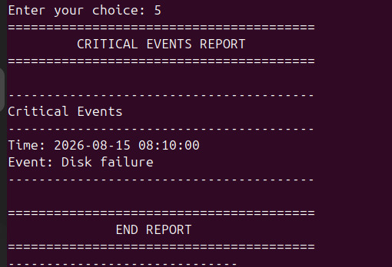

6. User Activity Report
Test 6.1 - Existing Username and Chronological Sorting
bank_server.log Input:
[2026-08-15 10:00:00] [INFO] [SESSION_6003] [admin] [192.168.1.10] [TRANSACTION] - Deposit amount 500
[2026-08-15 08:00:00] [INFO] [SESSION_6001] [admin] [192.168.1.10] [AUTH] - Successful login
[2026-08-15 09:00:00] [INFO] [SESSION_6002] [teller01] [192.168.1.11] [AUTH] - Successful login
[2026-08-15 08:30:00] [INFO] [SESSION_6001] [admin] [192.168.1.10] [QUERY] - SELECT * FROM accounts
[2026-08-15 12:00:00] [INFO] [SESSION_6001] [admin] [192.168.1.10] [AUTH] - Logout
[2026-08-15 07:00:00] [ERROR] [SESSION_6999] [unknown] [10.0.0.1] [AUTH] - Failed login attempt for user admin
Program Input:
Menu Choice: 6
Username: admin or Admin
Output:
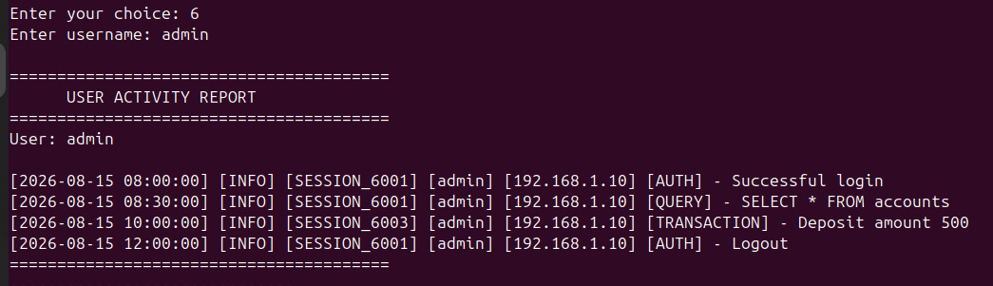

Test 6.2 - Username Not Found
bank_server.log Input:
[2026-08-15 10:00:00] [INFO] [SESSION_6003] [admin] [192.168.1.10] [TRANSACTION] - Deposit amount 500
[2026-08-15 08:00:00] [INFO] [SESSION_6001] [admin] [192.168.1.10] [AUTH] - Successful login
[2026-08-15 09:00:00] [INFO] [SESSION_6002] [teller01] [192.168.1.11] [AUTH] - Successful login
[2026-08-15 08:30:00] [INFO] [SESSION_6001] [admin] [192.168.1.10] [QUERY] - SELECT * FROM accounts
[2026-08-15 12:00:00] [INFO] [SESSION_6001] [admin] [192.168.1.10] [AUTH] - Logout
[2026-08-15 07:00:00] [ERROR] [SESSION_6999] [unknown] [10.0.0.1] [AUTH] - Failed login attempt for user admin
Program Input:
Menu Choice: 6
Username: yy
Output:
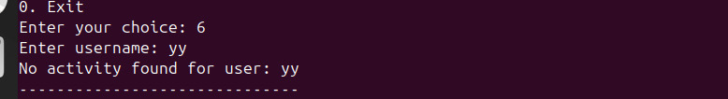

Test 6.3 - Empty Username
bank_server.log Input:
[2026-08-15 10:00:00] [INFO] [SESSION_6003] [admin] [192.168.1.10] [TRANSACTION] - Deposit amount 500
[2026-08-15 08:00:00] [INFO] [SESSION_6001] [admin] [192.168.1.10] [AUTH] - Successful login
[2026-08-15 09:00:00] [INFO] [SESSION_6002] [teller01] [192.168.1.11] [AUTH] - Successful login
[2026-08-15 08:30:00] [INFO] [SESSION_6001] [admin] [192.168.1.10] [QUERY] - SELECT * FROM accounts
[2026-08-15 12:00:00] [INFO] [SESSION_6001] [admin] [192.168.1.10] [AUTH] - Logout
[2026-08-15 07:00:00] [ERROR] [SESSION_6999] [unknown] [10.0.0.1] [AUTH] - Failed login attempt for user admin
Program Input:
Menu Choice: 6
Username: [Press Enter without typing]
Output:
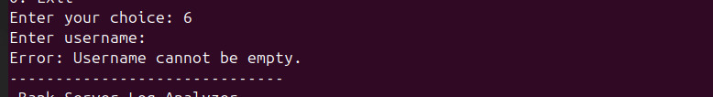

7. Login/Logout Session Report
Test 7.1 - Complete Session
bank_server.log Input:
[2026-08-15 08:00:00] [INFO] [SESSION_7001] [admin] [192.168.1.10] [AUTH] - Successful login
[2026-08-15 08:30:00] [INFO] [SESSION_7001] [admin] [192.168.1.10] [AUTH] - Logout
Program Input:
Menu Choice: 7
Output:
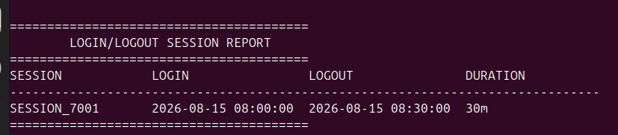

Test 7.2 - Login Without Logout
bank_server.log Input:
[2026-08-15 09:00:00] [INFO] [SESSION_7002] [teller01] [192.168.1.11] [AUTH] - Successful login
[2026-08-15 09:15:00] [INFO] [SESSION_7002] [teller01] [192.168.1.11] [QUERY] - SELECT * FROM customers
Program Input:
Menu Choice: 7
Output:

Test 7.4 - Logout Earlier Than Login (Invalid Duration)
bank_server.log Input:
[2026-08-15 10:00:00] [INFO] [SESSION_7006] [admin] [192.168.1.10] [AUTH] - Logout
[2026-08-15 11:00:00] [INFO] [SESSION_7006] [admin] [192.168.1.10] [AUTH] - Successful login
Program Input:
Menu Choice: 7
Output:
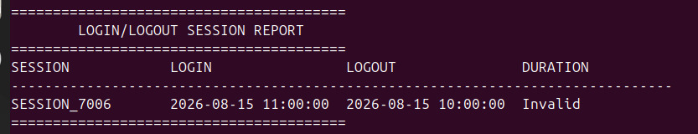

8. Events-per-Hour Report
Test 8.1 - Events Distributed Across Different Hours
bank_server.log Input:
[2026-08-15 00:10:00] [INFO] [SESSION_8001] [admin] [192.168.1.10] [AUTH] - Successful login
[2026-08-15 08:00:00] [INFO] [SESSION_8002] [admin] [192.168.1.10] [QUERY] - SELECT * FROM accounts
[2026-08-15 08:15:00] [ERROR] [SESSION_8003] [root] [10.0.0.1] [AUTH] - Failed login attempt
[2026-08-15 08:30:00] [WARNING] [SESSION_8004] [admin] [192.168.1.10] [QUERY] - Slow query execution time 2 seconds
[2026-08-15 08:59:59] [INFO] [SESSION_8005] [admin] [192.168.1.10] [TRANSACTION] - Deposit amount 500
[2026-08-15 09:00:00] [INFO] [SESSION_8006] [admin] [192.168.1.10] [AUTH] - Successful login
[2026-08-15 09:45:00] [INFO] [SESSION_8007] [admin] [192.168.1.10] [QUERY] - SELECT * FROM users
[2026-08-15 23:59:59] [CRITICAL] [SESSION_8008] [manager] [192.168.1.12] [BACKUP] - Backup failure
Program Input:
Menu Choice: 8
Output:
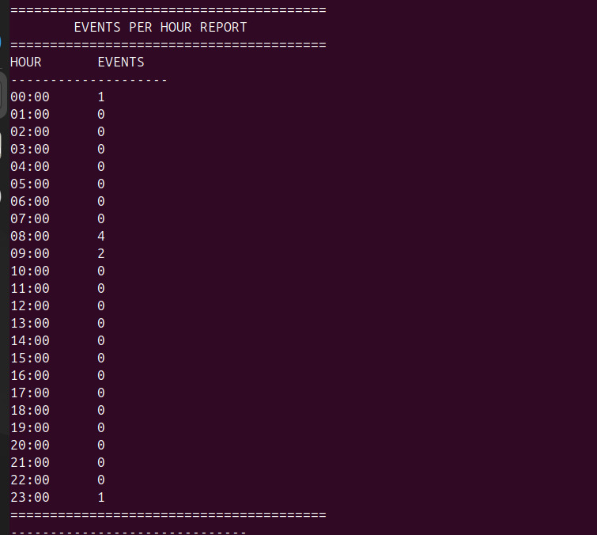

9. General Log Summary
Test 9.1 - General Summary With All Log Levels
bank_server.log Input:
[2026-08-15 08:00:00] [INFO] [SESSION_9001] [admin] [192.168.1.10] [AUTH] - Successful login
[2026-08-15 08:01:00] [ERROR] [SESSION_9002] [admin] [192.168.1.10] [AUTH] - Failed login attempt
[2026-08-15 08:02:00] [INFO] [SESSION_9003] [admin] [192.168.1.10] [QUERY] - SELECT * FROM accounts
[2026-08-15 08:03:00] [WARNING] [SESSION_9004] [admin] [192.168.1.10] [QUERY] - Slow query execution time 2 seconds
[2026-08-15 08:04:00] [INFO] [SESSION_9005] [admin] [192.168.1.10] [TRANSACTION] - Deposit amount 500
[2026-08-15 08:05:00] [CRITICAL] [SESSION_9006] [manager] [192.168.1.12] [BACKUP] - Backup failure
[2026-08-15 08:06:00] [INFO] [SESSION_9007] [admin] [192.168.1.10] [AUTH] - Logout
[2026-08-15 08:07:00] [ERROR] [SESSION_9008] [root] [10.0.0.1] [AUTH] - Failed login attempt
Program Input:
Menu Choice: 9
Output:
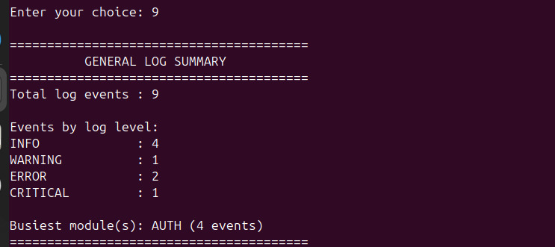

Test 9.2 - Tie Between Busiest Modules
bank_server.log Input:
[2026-08-15 08:00:00] [INFO] [SESSION_9011] [admin] [192.168.1.10] [AUTH] - Successful login
[2026-08-15 08:01:00] [INFO] [SESSION_9012] [admin] [192.168.1.10] [AUTH] - Logout
[2026-08-15 08:02:00] [INFO] [SESSION_9013] [admin] [192.168.1.10] [QUERY] - SELECT * FROM accounts
[2026-08-15 08:03:00] [WARNING] [SESSION_9014] [admin] [192.168.1.10] [QUERY] - Slow query execution time 2 seconds
Program Input:
Menu Choice: 9
Output:
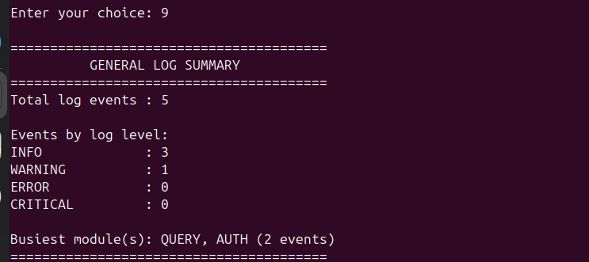
10. Run All Reports and Error Handling
Test 10.1 - Run All Reports
bank_server.log Input:
[2026-08-15 08:00:00] [INFO] [SESSION_A001] [admin] [192.168.1.10] [AUTH] - Successful login
[2026-08-15 08:05:00] [ERROR] [SESSION_A002] [root] [10.0.0.1] [AUTH] - Failed login attempt
[2026-08-15 08:06:00] [ERROR] [SESSION_A003] [root] [10.0.0.1] [AUTH] - Failed login attempt
[2026-08-15 08:07:00] [ERROR] [SESSION_A004] [root] [10.0.0.1] [AUTH] - Failed login attempt
[2026-08-15 08:10:00] [INFO] [SESSION_A001] [admin] [192.168.1.10] [QUERY] - SELECT * FROM accounts
[2026-08-15 08:11:00] [WARNING] [SESSION_A001] [admin] [192.168.1.10] [QUERY] - Slow query execution time 2500ms
[2026-08-15 08:20:00] [INFO] [SESSION_A001] [admin] [192.168.1.10] [TRANSACTION] - Deposit amount 500
[2026-08-15 08:21:00] [INFO] [SESSION_A001] [admin] [192.168.1.10] [TRANSACTION] - Withdrawal amount 100
[2026-08-15 08:25:00] [CRITICAL] [SESSION_A005] [manager] [192.168.1.12] [BACKUP] - Backup failure
[2026-08-15 08:30:00] [INFO] [SESSION_A001] [admin] [192.168.1.10] [AUTH] - Logout
Program Input:
Menu Choice: 10
Username when prompted: admin
Output:
done

Test 10.2 - Invalid Numeric Menu Choice
Program Input:
Menu Choice: 99
Output:
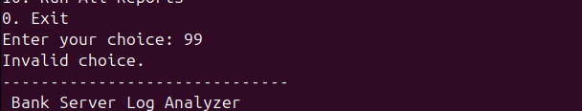

Test 10.3 - Invalid Text Menu Choice
bank_server.log Input:
Program Input:
Menu Choice: uu
Output:
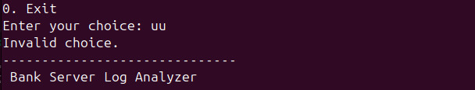

Test 10.4 - Exit
bank_server.log Input:
Program Input:
Menu Choice: 0
Output:
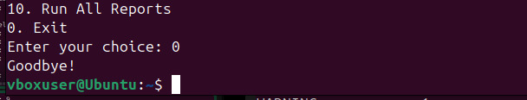
Test 10.5 - Missing Log File
Program Input:
Rename or remove bank_server.log, then run the script.

