**Table of Contents___________________________________________________________________________**

***1. Introduction****__________________________________________________________________________*

1.1 Purpose

1.2 Scope

1.3 Definitions, Acronyms, and Abbreviations

***2. System Overview****______________________________________________________________________*

2.1 System Description

2.2 System Architecture

***3. Functional Requirements****_________________________________________________________________*

**3.1 User Registration and Authentication**____________________________________________________

3.1.1 User Registration

3.1.2 User Login

3.1.3 Password Reset

***3.2 Profile Management****__________________________________________________________________*

3.2.1 Create, Edit, and Delete Profiles

3.2.2 Profile Picture and Information Updates

***3.3 Portfolio Management****________________________________________________________________*

3.3.1 Create, Edit, and Delete Portfolio Entries

3.3.2 Portfolio Entry Details

***3.4 Search and Filter****_____________________________________________________________________*

3.4.1 User Search

3.4.2 Search Filters

***3.5 Messaging****__________________________________________________________________________*

3.5.1 Send and Receive Messages

3.5.2 Message History

***3.6 Notifications****________________________________________________________________________*

3.6.1 New Message Notifications

***4. Non-Functional Requirements****____________________________________________________________*

4.1 Performance

4.2 Security

4.3 Usability

***5. User Interface (UI) Design****________________________________________________________________*

***6. Constraints****____________________________________________________________________________*

***8. Appendix****_____________________________________________________________________________*

**Software Requirements Specification (SRS) for Java Portfolio Website**

**1. Introduction**

**1.1 Purpose**

The purpose of this document is to define the requirements for the development of a Portfolio Website using Java, adhering to the Functional Specification Document (FSD).

**1.2 Scope**

This document covers the functional and non-functional requirements, as well as the features and capabilities of the Portfolio Website. It is intended for the development team, stakeholders, and anyone involved in the project.

**1.3 Definitions, Acronyms, and Abbreviations**

* FSD: Functional Specification Document

**2. System Overview**

**2.1 System Description**

The Portfolio Website is a web application that allows users to showcase their professional portfolio, skills, and achievements. It provides a platform for users to create and manage their portfolios.

**2.2 System Architecture**

The system will be developed using Java technologies, including Java EE for web development. It will utilize a front-end framework (e.g., HTML, CSS, JavaScript) and a back-end framework (e.g., Spring Framework) for handling server-side logic.

**3. Functional Requirements**

**3.1 User Registration and Authentication**

1. Users can register for an account with a unique username and email address.
2. Users can log in to the system using their credentials.
3. Users can reset their passwords if forgotten.

**3.2 Profile Management**

1. Users can create, edit, and delete their profiles.
2. Users can upload a profile picture and update personal information.

**3.3 Portfolio Management**

1. Users can create, edit, and delete portfolio entries.
2. Each portfolio entry can include a title, description, images, and links to external projects.

**3.4 Search and Filter**

1. Users can search for other users' profiles and portfolios.
2. Users can filter search results based on criteria like skills, location, and tags.

**3.5 Messaging**

1. Users can send and receive messages from other users.
2. Users can view their message history.

**3.6 Notifications**

1. Users receive notifications for new messages and profile interactions.

**4. Non-Functional Requirements**

**4.1 Performance**

The website should load quickly and handle a reasonable number of concurrent users without performance degradation.

**4.2 Security**

User data should be stored securely, and authentication should be robust. The website should prevent common security vulnerabilities like SQL injection and cross-site scripting (XSS).

**4.3 Usability**

The website should have an intuitive and user-friendly interface, making it easy for users to navigate and perform tasks.

**5. User Interface (UI) Design**

Provide mock-ups or wireframes of the user interface, including the homepage, profile pages, and portfolio entry pages.

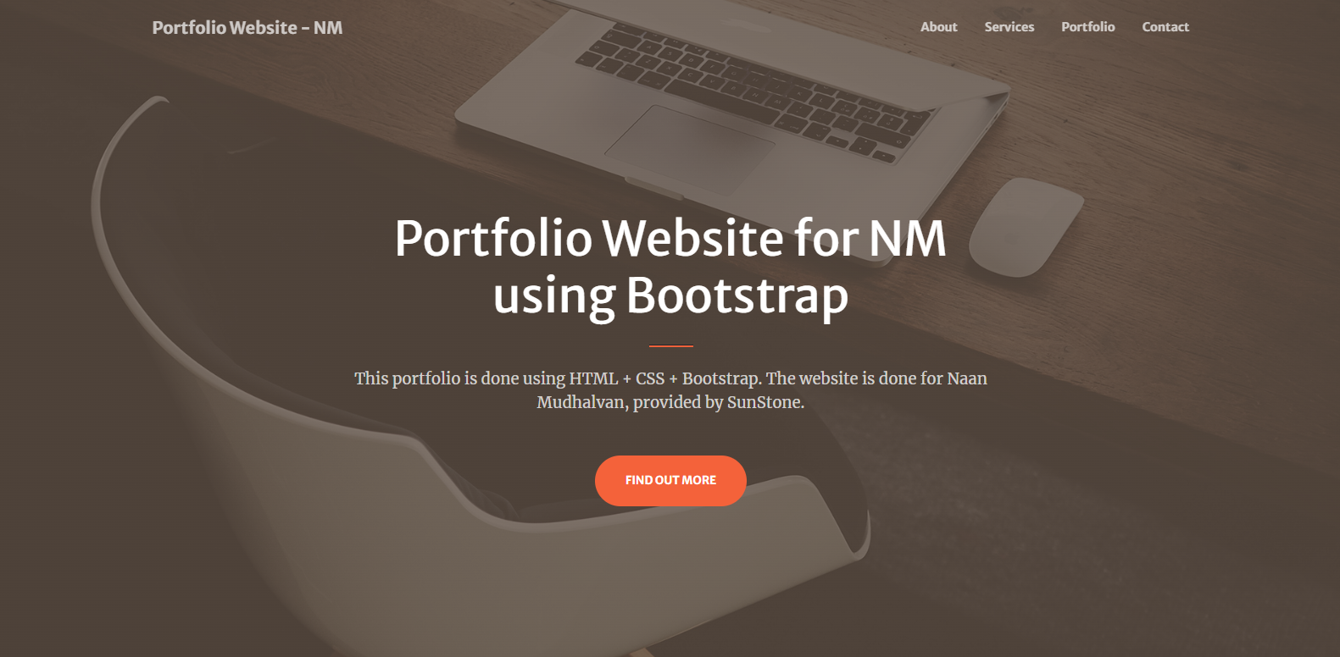

5.1 Portfolio FSD- Home Page

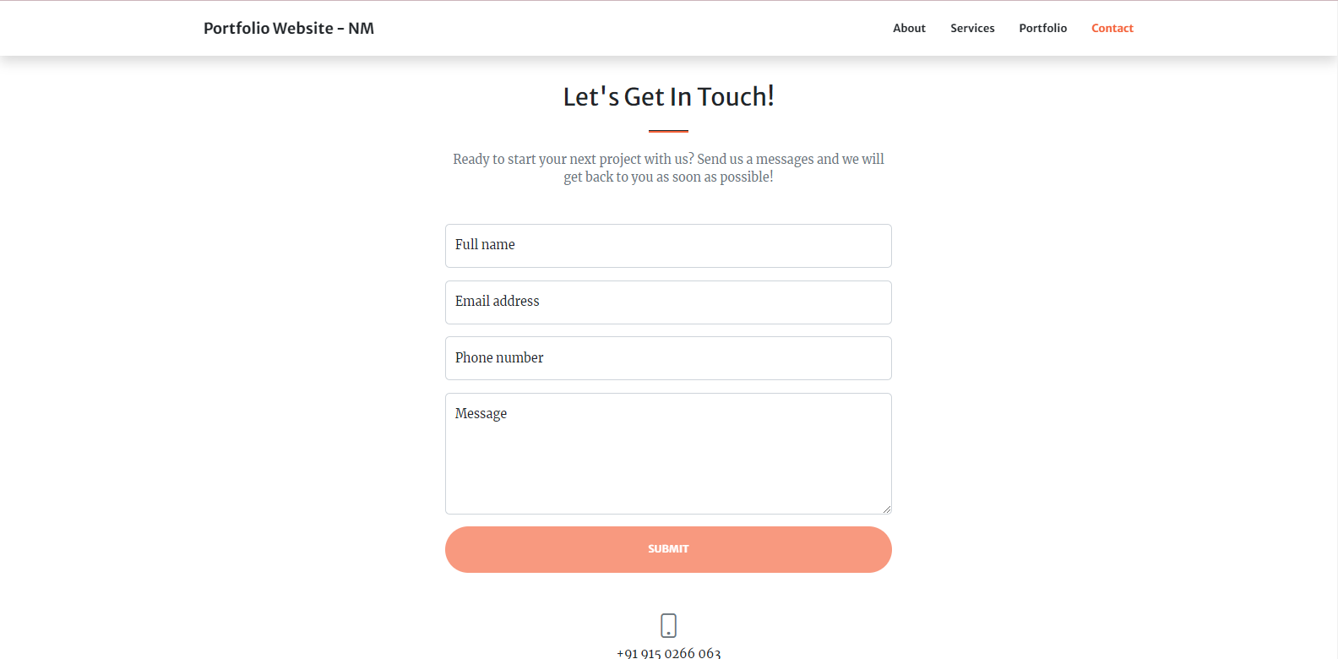

5.2 Portfolio FSD-Profile Entry Page

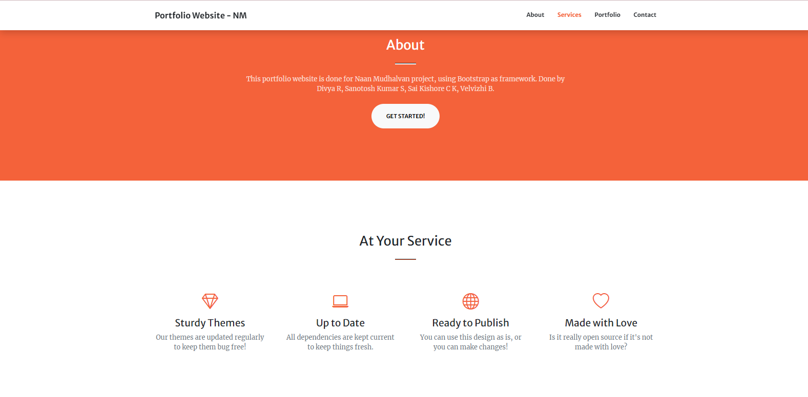

5.3 Portfolio FSD-Profile Page Description

**6. Constraints**

List any constraints that may affect the project, such as the choice of technology, budget, or timeline. But there are no constraints.

**7. Appendix**

Include any additional information or documents relevant to the project, such as the FSD, data models, or diagrams.

Portfolio FSD- Bootstrap-JS code:

<!DOCTYPE html>

<html lang="en">

<head>

<meta charset="utf-8" />

<meta name="viewport" content="width=device-width, initial-scale=1, shrink-to-fit=no" />

<meta name="description" content="" />

<meta name="author" content="" />

<title>Portfolio Website - Bootstrap</title>

<!-- Favicon-->

<link rel="icon" type="image/x-icon" href="assets/favicon.ico" />

<!-- Font Awesome icons (free version)-->

<script src="https://use.fontawesome.com/releases/v6.3.0/js/all.js" crossorigin="anonymous"></script>

<!-- Google fonts-->

<link href="https://fonts.googleapis.com/css?family=Montserrat:400,700" rel="stylesheet" type="text/css" />

<link href="https://fonts.googleapis.com/css?family=Lato:400,700,400italic,700italic" rel="stylesheet" type="text/css" />

<!-- Core theme CSS (includes Bootstrap)-->

<link href="css/styles.css" rel="stylesheet" />

</head>

<body id="page-top">

<!-- Navigation-->

<nav class="navbar navbar-expand-lg bg-secondary text-uppercase fixed-top" id="mainNav">

<div class="container">

<a class="navbar-brand" href="#page-top">Java FSD - Portfolio Website</a>

<button class="navbar-toggler text-uppercase font-weight-bold bg-primary text-white rounded" type="button" data-bs-toggle="collapse" data-bs-target="#navbarResponsive" aria-controls="navbarResponsive" aria-expanded="false" aria-label="Toggle navigation">

Menu

<i class="fas fa-bars"></i>

</button>

<div class="collapse navbar-collapse" id="navbarResponsive">

<ul class="navbar-nav ms-auto">

<li class="nav-item mx-0 mx-lg-1"><a class="nav-link py-3 px-0 px-lg-3 rounded" href="#portfolio">Portfolio</a></li>

<li class="nav-item mx-0 mx-lg-1"><a class="nav-link py-3 px-0 px-lg-3 rounded" href="#about">About</a></li>

<li class="nav-item mx-0 mx-lg-1"><a class="nav-link py-3 px-0 px-lg-3 rounded" href="#contact">Contact</a></li>

</ul>

</div>

</div>

</nav>

<!-- Masthead-->

<header class="masthead bg-primary text-white text-center">

<div class="container d-flex align-items-center flex-column">

<!-- Masthead Avatar Image-->

<img class="masthead-avatar mb-5" src="assets/img/avataaars.svg" alt="..." />

<!-- Masthead Heading-->

<h1 class="masthead-heading text-uppercase mb-0">Start Bootstrap + JS</h1>

<!-- Icon Divider-->

<div class="divider-custom divider-light">

<div class="divider-custom-line"></div>

<div class="divider-custom-icon"><i class="fas fa-star"></i></div>

<div class="divider-custom-line"></div>

</div>

<!-- Masthead Subheading-->

<p class="masthead-subheading font-weight-light mb-0">Web Designer - Full Stack Developer</p>

</div>

</header>

<!-- Portfolio Section-->

<section class="page-section portfolio" id="portfolio">

<div class="container">

<!-- Portfolio Section Heading-->

<h2 class="page-section-heading text-center text-uppercase text-secondary mb-0">Portfolio</h2>

<!-- Icon Divider-->

<div class="divider-custom">

<div class="divider-custom-line"></div>

<div class="divider-custom-icon"><i class="fas fa-star"></i></div>

<div class="divider-custom-line"></div>

</div>

<!-- Portfolio Grid Items-->

<div class="row justify-content-center">

<!-- Portfolio Item 1-->

<div class="col-md-6 col-lg-4 mb-5">

<div class="portfolio-item mx-auto" data-bs-toggle="modal" data-bs-target="#portfolioModal1">

<div class="portfolio-item-caption d-flex align-items-center justify-content-center h-100 w-100">

<div class="portfolio-item-caption-content text-center text-white"><i class="fas fa-plus fa-3x"></i></div>

</div>

<img class="img-fluid" src="assets/img/portfolio/cabin.png" alt="..." />

</div>

</div>

<!-- Portfolio Item 2-->

<div class="col-md-6 col-lg-4 mb-5">

<div class="portfolio-item mx-auto" data-bs-toggle="modal" data-bs-target="#portfolioModal2">

<div class="portfolio-item-caption d-flex align-items-center justify-content-center h-100 w-100">

<div class="portfolio-item-caption-content text-center text-white"><i class="fas fa-plus fa-3x"></i></div>

</div>

<img class="img-fluid" src="assets/img/portfolio/cake.png" alt="..." />

</div>

</div>

<!-- Portfolio Item 3-->

<div class="col-md-6 col-lg-4 mb-5">

<div class="portfolio-item mx-auto" data-bs-toggle="modal" data-bs-target="#portfolioModal3">

<div class="portfolio-item-caption d-flex align-items-center justify-content-center h-100 w-100">

<div class="portfolio-item-caption-content text-center text-white"><i class="fas fa-plus fa-3x"></i></div>

</div>

<img class="img-fluid" src="assets/img/portfolio/circus.png" alt="..." />

</div>

</div>

<!-- Portfolio Item 4-->

<div class="col-md-6 col-lg-4 mb-5 mb-lg-0">

<div class="portfolio-item mx-auto" data-bs-toggle="modal" data-bs-target="#portfolioModal4">

<div class="portfolio-item-caption d-flex align-items-center justify-content-center h-100 w-100">

<div class="portfolio-item-caption-content text-center text-white"><i class="fas fa-plus fa-3x"></i></div>

</div>

<img class="img-fluid" src="assets/img/portfolio/game.png" alt="..." />

</div>

</div>

<!-- Portfolio Item 5-->

<div class="col-md-6 col-lg-4 mb-5 mb-md-0">

<div class="portfolio-item mx-auto" data-bs-toggle="modal" data-bs-target="#portfolioModal5">

<div class="portfolio-item-caption d-flex align-items-center justify-content-center h-100 w-100">

<div class="portfolio-item-caption-content text-center text-white"><i class="fas fa-plus fa-3x"></i></div>

</div>

<img class="img-fluid" src="assets/img/portfolio/safe.png" alt="..." />

</div>

</div>

<!-- Portfolio Item 6-->

<div class="col-md-6 col-lg-4">

<div class="portfolio-item mx-auto" data-bs-toggle="modal" data-bs-target="#portfolioModal6">

<div class="portfolio-item-caption d-flex align-items-center justify-content-center h-100 w-100">

<div class="portfolio-item-caption-content text-center text-white"><i class="fas fa-plus fa-3x"></i></div>

</div>

<img class="img-fluid" src="assets/img/portfolio/submarine.png" alt="..." />

</div>

</div>

</div>

</div>

</section>

<!-- About Section-->

<section class="page-section bg-primary text-white mb-0" id="about">

<div class="container">

<!-- About Section Heading-->

<h2 class="page-section-heading text-center text-uppercase text-white">About</h2>

<!-- Icon Divider-->

<div class="divider-custom divider-light">

<div class="divider-custom-line"></div>

<div class="divider-custom-icon"><i class="fas fa-star"></i></div>

<div class="divider-custom-line"></div>

</div>

<!-- About Section Content-->

<div class="row">

<div class="col-lg-4 ms-auto"><p class="lead">Bootstrap + JS theme created by Divya R, Sai Kishore CK, Santhosh S, Velvizhi B. The download includes the complete source files including HTML, CSS, and JavaScript as well as optional SASS stylesheets for easy customization.</p></div>

<div class="col-lg-4 me-auto"><p class="lead">You can create your own custom avatar for the masthead, change the icon in the dividers, and add your email address to the contact form to make it fully functional.</p></div>

</div>

<!-- About Section Button-->

<div class="text-center mt-4">

<a class="btn btn-xl btn-outline-light" href="https://startbootstrap.com/theme/freelancer/">

<i class="fas fa-download me-2"></i>

Free Download!

</a>

</div>

</div>

</section>

<!-- Contact Section-->

<section class="page-section" id="contact">

<div class="container">

<!-- Contact Section Heading-->

<h2 class="page-section-heading text-center text-uppercase text-secondary mb-0">Contact Me</h2>

<!-- Icon Divider-->

<div class="divider-custom">

<div class="divider-custom-line"></div>

<div class="divider-custom-icon"><i class="fas fa-star"></i></div>

<div class="divider-custom-line"></div>

</div>

<!-- Contact Section Form-->

<div class="row justify-content-center">

<div class="col-lg-8 col-xl-7">

<!-- * * * * * * * * * * * * * * *-->

<!-- * * SB Forms Contact Form * *-->

<!-- * * * * * * * * * * * * * * *-->

<!-- This form is pre-integrated with SB Forms.-->

<!-- To make this form functional, sign up at-->

<!-- https://startbootstrap.com/solution/contact-forms-->

<!-- to get an API token!-->

<form id="contactForm" data-sb-form-api-token="API_TOKEN">

<!-- Name input-->

<div class="form-floating mb-3">

<input class="form-control" id="name" type="text" placeholder="Enter your name..." data-sb-validations="required" />

<label for="name">Full name</label>

<div class="invalid-feedback" data-sb-feedback="name:required">A name is required.</div>

</div>

<!-- Email address input-->

<div class="form-floating mb-3">

<input class="form-control" id="email" type="email" placeholder="name@example.com" data-sb-validations="required,email" />

<label for="email">Email address</label>

<div class="invalid-feedback" data-sb-feedback="email:required">An email is required.</div>

<div class="invalid-feedback" data-sb-feedback="email:email">Email is not valid.</div>

</div>

<!-- Phone number input-->

<div class="form-floating mb-3">

<input class="form-control" id="phone" type="tel" placeholder="(123) 456-7890" data-sb-validations="required" />

<label for="phone">Phone number</label>

<div class="invalid-feedback" data-sb-feedback="phone:required">A phone number is required.</div>

</div>

<!-- Message input-->

<div class="form-floating mb-3">

<textarea class="form-control" id="message" type="text" placeholder="Enter your message here..." style="height: 10rem" data-sb-validations="required"></textarea>

<label for="message">Message</label>

<div class="invalid-feedback" data-sb-feedback="message:required">A message is required.</div>

</div>

<!-- Submit success message-->

<!---->

<!-- This is what your users will see when the form-->

<!-- has successfully submitted-->

<div class="d-none" id="submitSuccessMessage">

<div class="text-center mb-3">

<div class="fw-bolder">Form submission successful!</div>

To activate this form, sign up at

<br />

<a href="https://startbootstrap.com/solution/contact-forms">https://startbootstrap.com/solution/contact-forms</a>

</div>

</div>

<!-- Submit error message-->

<!---->

<!-- This is what your users will see when there is-->

<!-- an error submitting the form-->

<div class="d-none" id="submitErrorMessage"><div class="text-center text-danger mb-3">Error sending message!</div></div>

<!-- Submit Button-->

<button class="btn btn-primary btn-xl disabled" id="submitButton" type="submit">Send</button>

</form>

</div>

</div>

</div>

</section>

<!-- Footer-->

<footer class="footer text-center">

<div class="container">

<div class="row">

<!-- Footer Location-->

<div class="col-lg-4 mb-5 mb-lg-0">

<h4 class="text-uppercase mb-4">WEB SITE by</h4>

<p class="lead mb-0">

Divya R

<br />

Sai Kishore CK

<br />

Santhosh S

<br />

Velvizhi B

</p>

</div>

<!-- Footer Social Icons-->

<div class="col-lg-4 mb-5 mb-lg-0">

<h4 class="text-uppercase mb-4">Around the Web</h4>

<a class="btn btn-outline-light btn-social mx-1" href="#!"><i class="fab fa-fw fa-facebook-f"></i></a>

<a class="btn btn-outline-light btn-social mx-1" href="#!"><i class="fab fa-fw fa-twitter"></i></a>

<a class="btn btn-outline-light btn-social mx-1" href="#!"><i class="fab fa-fw fa-linkedin-in"></i></a>

<a class="btn btn-outline-light btn-social mx-1" href="#!"><i class="fab fa-fw fa-dribbble"></i></a>

</div>

<!-- Footer About Text-->

<div class="col-lg-4">

<h4 class="text-uppercase mb-4">Project for Naan Mudhalvaan</h4>

<p class="lead mb-0">

MIT licensed Bootstrap + JS theme

.

</p>

</div>

</div>

</div>

</footer>

<!-- Copyright Section-->

<div class="copyright py-4 text-center text-white">

<div class="container"><small>Copyright &copy; Naan Mudhalvaan Project Website 2023</small></div>

</div>

<!-- Portfolio Modals-->

<!-- Portfolio Modal 1-->

<div class="portfolio-modal modal fade" id="portfolioModal1" tabindex="-1" aria-labelledby="portfolioModal1" aria-hidden="true">

<div class="modal-dialog modal-xl">

<div class="modal-content">

<div class="modal-header border-0"><button class="btn-close" type="button" data-bs-dismiss="modal" aria-label="Close"></button></div>

<div class="modal-body text-center pb-5">

<div class="container">

<div class="row justify-content-center">

<div class="col-lg-8">

<!-- Portfolio Modal - Title-->

<h2 class="portfolio-modal-title text-secondary text-uppercase mb-0">Log Cabin</h2>

<!-- Icon Divider-->

<div class="divider-custom">

<div class="divider-custom-line"></div>

<div class="divider-custom-icon"><i class="fas fa-star"></i></div>

<div class="divider-custom-line"></div>

</div>

<!-- Portfolio Modal - Image-->

<img class="img-fluid rounded mb-5" src="assets/img/portfolio/cabin.png" alt="..." />

<!-- Portfolio Modal - Text-->

<p class="mb-4">Lorem ipsum dolor sit amet, consectetur adipisicing elit. Mollitia neque assumenda ipsam nihil, molestias magnam, recusandae quos quis inventore quisquam velit asperiores, vitae? Reprehenderit soluta, eos quod consequuntur itaque. Nam.</p>

<button class="btn btn-primary" data-bs-dismiss="modal">

<i class="fas fa-xmark fa-fw"></i>

Close Window

</button>

</div>

</div>

</div>

</div>

</div>

</div>

</div>

<!-- Portfolio Modal 2-->

<div class="portfolio-modal modal fade" id="portfolioModal2" tabindex="-1" aria-labelledby="portfolioModal2" aria-hidden="true">

<div class="modal-dialog modal-xl">

<div class="modal-content">

<div class="modal-header border-0"><button class="btn-close" type="button" data-bs-dismiss="modal" aria-label="Close"></button></div>

<div class="modal-body text-center pb-5">

<div class="container">

<div class="row justify-content-center">

<div class="col-lg-8">

<!-- Portfolio Modal - Title-->

<h2 class="portfolio-modal-title text-secondary text-uppercase mb-0">Tasty Cake</h2>

<!-- Icon Divider-->

<div class="divider-custom">

<div class="divider-custom-line"></div>

<div class="divider-custom-icon"><i class="fas fa-star"></i></div>

<div class="divider-custom-line"></div>

</div>

<!-- Portfolio Modal - Image-->

<img class="img-fluid rounded mb-5" src="assets/img/portfolio/cake.png" alt="..." />

<!-- Portfolio Modal - Text-->

<p class="mb-4">Lorem ipsum dolor sit amet, consectetur adipisicing elit. Mollitia neque assumenda ipsam nihil, molestias magnam, recusandae quos quis inventore quisquam velit asperiores, vitae? Reprehenderit soluta, eos quod consequuntur itaque. Nam.</p>

<button class="btn btn-primary" data-bs-dismiss="modal">

<i class="fas fa-xmark fa-fw"></i>

Close Window

</button>

</div>

</div>

</div>

</div>

</div>

</div>

</div>

<!-- Portfolio Modal 3-->

<div class="portfolio-modal modal fade" id="portfolioModal3" tabindex="-1" aria-labelledby="portfolioModal3" aria-hidden="true">

<div class="modal-dialog modal-xl">

<div class="modal-content">

<div class="modal-header border-0"><button class="btn-close" type="button" data-bs-dismiss="modal" aria-label="Close"></button></div>

<div class="modal-body text-center pb-5">

<div class="container">

<div class="row justify-content-center">

<div class="col-lg-8">

<!-- Portfolio Modal - Title-->

<h2 class="portfolio-modal-title text-secondary text-uppercase mb-0">Circus Tent</h2>

<!-- Icon Divider-->

<div class="divider-custom">

<div class="divider-custom-line"></div>

<div class="divider-custom-icon"><i class="fas fa-star"></i></div>

<div class="divider-custom-line"></div>

</div>

<!-- Portfolio Modal - Image-->

<img class="img-fluid rounded mb-5" src="assets/img/portfolio/circus.png" alt="..." />

<!-- Portfolio Modal - Text-->

<p class="mb-4">Lorem ipsum dolor sit amet, consectetur adipisicing elit. Mollitia neque assumenda ipsam nihil, molestias magnam, recusandae quos quis inventore quisquam velit asperiores, vitae? Reprehenderit soluta, eos quod consequuntur itaque. Nam.</p>

<button class="btn btn-primary" data-bs-dismiss="modal">

<i class="fas fa-xmark fa-fw"></i>

Close Window

</button>

</div>

</div>

</div>

</div>

</div>

</div>

</div>

<!-- Portfolio Modal 4-->

<div class="portfolio-modal modal fade" id="portfolioModal4" tabindex="-1" aria-labelledby="portfolioModal4" aria-hidden="true">

<div class="modal-dialog modal-xl">

<div class="modal-content">

<div class="modal-header border-0"><button class="btn-close" type="button" data-bs-dismiss="modal" aria-label="Close"></button></div>

<div class="modal-body text-center pb-5">

<div class="container">

<div class="row justify-content-center">

<div class="col-lg-8">

<!-- Portfolio Modal - Title-->

<h2 class="portfolio-modal-title text-secondary text-uppercase mb-0">Controller</h2>

<!-- Icon Divider-->

<div class="divider-custom">

<div class="divider-custom-line"></div>

<div class="divider-custom-icon"><i class="fas fa-star"></i></div>

<div class="divider-custom-line"></div>

</div>

<!-- Portfolio Modal - Image-->

<img class="img-fluid rounded mb-5" src="assets/img/portfolio/game.png" alt="..." />

<!-- Portfolio Modal - Text-->

<p class="mb-4">Lorem ipsum dolor sit amet, consectetur adipisicing elit. Mollitia neque assumenda ipsam nihil, molestias magnam, recusandae quos quis inventore quisquam velit asperiores, vitae? Reprehenderit soluta, eos quod consequuntur itaque. Nam.</p>

<button class="btn btn-primary" data-bs-dismiss="modal">

<i class="fas fa-xmark fa-fw"></i>

Close Window

</button>

</div>

</div>

</div>

</div>

</div>

</div>

</div>

<!-- Portfolio Modal 5-->

<div class="portfolio-modal modal fade" id="portfolioModal5" tabindex="-1" aria-labelledby="portfolioModal5" aria-hidden="true">

<div class="modal-dialog modal-xl">

<div class="modal-content">

<div class="modal-header border-0"><button class="btn-close" type="button" data-bs-dismiss="modal" aria-label="Close"></button></div>

<div class="modal-body text-center pb-5">

<div class="container">

<div class="row justify-content-center">

<div class="col-lg-8">

<!-- Portfolio Modal - Title-->

<h2 class="portfolio-modal-title text-secondary text-uppercase mb-0">Locked Safe</h2>

<!-- Icon Divider-->

<div class="divider-custom">

<div class="divider-custom-line"></div>

<div class="divider-custom-icon"><i class="fas fa-star"></i></div>

<div class="divider-custom-line"></div>

</div>

<!-- Portfolio Modal - Image-->

<img class="img-fluid rounded mb-5" src="assets/img/portfolio/safe.png" alt="..." />

<!-- Portfolio Modal - Text-->

<p class="mb-4">Lorem ipsum dolor sit amet, consectetur adipisicing elit. Mollitia neque assumenda ipsam nihil, molestias magnam, recusandae quos quis inventore quisquam velit asperiores, vitae? Reprehenderit soluta, eos quod consequuntur itaque. Nam.</p>

<button class="btn btn-primary" data-bs-dismiss="modal">

<i class="fas fa-xmark fa-fw"></i>

Close Window

</button>

</div>

</div>

</div>

</div>

</div>

</div>

</div>

<!-- Portfolio Modal 6-->

<div class="portfolio-modal modal fade" id="portfolioModal6" tabindex="-1" aria-labelledby="portfolioModal6" aria-hidden="true">

<div class="modal-dialog modal-xl">

<div class="modal-content">

<div class="modal-header border-0"><button class="btn-close" type="button" data-bs-dismiss="modal" aria-label="Close"></button></div>

<div class="modal-body text-center pb-5">

<div class="container">

<div class="row justify-content-center">

<div class="col-lg-8">

<!-- Portfolio Modal - Title-->

<h2 class="portfolio-modal-title text-secondary text-uppercase mb-0">Submarine</h2>

<!-- Icon Divider-->

<div class="divider-custom">

<div class="divider-custom-line"></div>

<div class="divider-custom-icon"><i class="fas fa-star"></i></div>

<div class="divider-custom-line"></div>

</div>

<!-- Portfolio Modal - Image-->

<img class="img-fluid rounded mb-5" src="assets/img/portfolio/submarine.png" alt="..." />

<!-- Portfolio Modal - Text-->

<p class="mb-4">Lorem ipsum dolor sit amet, consectetur adipisicing elit. Mollitia neque assumenda ipsam nihil, molestias magnam, recusandae quos quis inventore quisquam velit asperiores, vitae? Reprehenderit soluta, eos quod consequuntur itaque. Nam.</p>

<button class="btn btn-primary" data-bs-dismiss="modal">

<i class="fas fa-xmark fa-fw"></i>

Close Window

</button>

</div>

</div>

</div>

</div>

</div>

</div>

</div>

<!-- Bootstrap core JS-->

<script src="https://cdn.jsdelivr.net/npm/bootstrap@5.2.3/dist/js/bootstrap.bundle.min.js"></script>

<!-- Core theme JS-->

<script src="js/scripts.js"></script>

<!-- * * * * * * * * * * * * * * * * * * * * * * * * * * * * * * * * * * * * * * * *-->

<!-- * * SB Forms JS * *-->

<!-- * * Activate your form at https://startbootstrap.com/solution/contact-forms * *-->

<!-- * * * * * * * * * * * * * * * * * * * * * * * * * * * * * * * * * * * * * * * *-->

<script src="https://cdn.startbootstrap.com/sb-forms-latest.js"></script>

</body>

</html>