|  |  |
| --- | --- |
| **Credit Hours System** | **Cairo University Faculty of Engineering** |

Pattern recognition

Final report

|  |  |
| --- | --- |
| Farah Mostafa | 1158066 |
| Nermine Safwat | 1154228 |
| Yasmine Hatem | 1152059 |
| Ahmed Khaled | 1152085 |

**i. Project Pipeline.**

*1)Line segmentation:*

We added each row in the image if the sum of the row equal the image shape then at this row there exist part of the line if not then this is a white row so by applying this algorithm we can get the beginning and the end of the line vertically

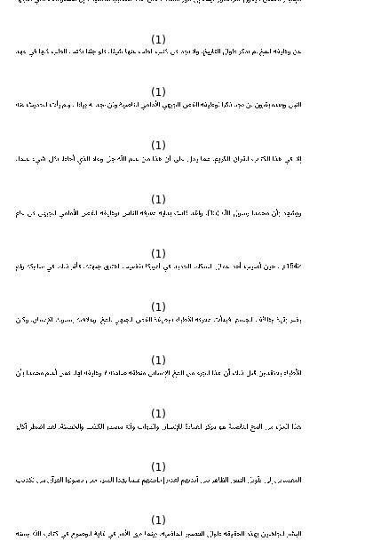

*2) word segmentation:*

We will add each column in every line image and when we find white space we will use threshold to check if it is part of the word or this will be new word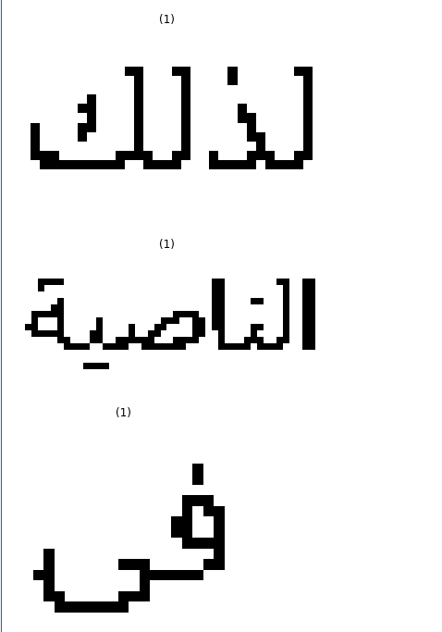

*3) Character segmentation*

We followed the paper “An efficient, font independent word and character segmentation algorithm for printed Arabic text” published in Journal of King Saud university computer and information sciences

*4)Labeling*

Mapping the segmented character to its label and its feature vector .

*5) Feature extraction*

We extracted features for every letter . Every letter should be a binary (0s and 1s ) image 28x28 as an input to every feature function (discussed at iii)

*6)Model and training*

(discussed at iv )

*7) Testing*

**ii. Preprocessing Module.**

We made all the segmentations previously discussed , we made thresholding , rotating , erosion and dilation , filtering to reduce noise and skeletonization .

**iii.Feature Extraction/Selection Module**

*1)pixel vector*

We fit the letter in a 28x28 image where the letter is bounded (no space background) and every pixel represents a feature we append them all in a vector .

*2)get width*

Calculate the width of the letter from the left most character pixel to the right most character pixel.

*3) get height*

Calculate the height of the letter from the top most character to the bottom most character.

*4)checkdots2*

Return s 1 if there is at least 1 dot else returns 0.

*5)count_holes*

Count the number of holes inside the letter.

*6)dotes*

Count the number of dots inside the letter.

*7)dotes*

Also returns if the dotes is above or below base line.

*8)get4areas*

We fit the letter in a 28x28 image where the letter is bounded (no space background) , divide the image to 4 quarters and then calculate the area for each.

*9)get4areasfit*

We fit the letter in a 28x28 image where the letter is bounded (no space background) , fill the holes inside the letter , perform edge detection using sobel , divide the image to 4 quarters and then calculate the area for each.

Features number 8 and 9 were suggested in this paper <https://www.semanticscholar.org/paper/Recognize-printed-Arabic-letter-using-new-features-Mohamad-Hashim/e90e0d4fe9676cbc8d856fe6b4b76a09153dc703>

**iv. Model Selection and Training Modules.**

A multilayer perceptron (MLP) is a class of feedforward artificial neural network (ANN). The term MLP is used ambiguously, sometimes loosely to refer to any feedforward ANN, sometimes strictly to refer to networks composed of multiple layers of perceptrons (with threshold activation) .

Multilayer perceptrons are sometimes colloquially referred to as "vanilla" neural networks, especially when they have a single hidden layer. An MLP consists of at least three layers of nodes: an input layer, a hidden layer and an output layer. Except for the input nodes, each node is a neuron that uses a nonlinear activation function.

MLP utilizes a supervised learning technique called backpropagation for training. Its multiple layers and non-linear activation distinguish MLP from a linear perceptron

. It can distinguish data that is not linearly separable.

We used adam for solver and learning rate constant and regularization parameter 0.00012 hidden layers and number of internal nodes 35 40 by expirment

**v. Performance Analysis Module.**

The model takes around 40 minutes to train .

**vi. Enhancements and Future work.**

We need to improve our segmentation accuracy . We probably need to use ngram model to minimize the error of classification .

**vii. Work load distribution**

|  |  |
| --- | --- |
| Farah Mostafa | Character segmentation |
| Nermine Safwat | Labeling , testing ,training |
| Yasmine Hatem | Feature extraction |
| Ahmed Khaled | Model |