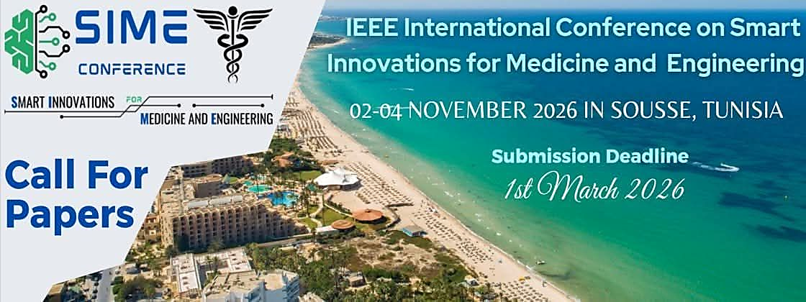

CALL FOR PAPERS - SPECIAL SESSION
Special Session Title
for SIME 2026
November 02 -04, 2026, Sousse, Tunisia
Session Co-Chairs:
- Author 1, affiliation, email.
- Author 2, affiliation, email.
- Author 3, affiliation, email.
- Author 4, affiliation, email.

Session description:
This special session will provide an in-depth exploration of ……………………………………………………………………………………………………………………………………………………………………………………………………………………………………………………………………………………………………………………………………………………………………………………………………………………………………………………………………………………………………………………………………………………………………………………………………………………………………………………………………………………………………………………………………………………………………………………………
Topics of Interest (not limited to):
- …………………………………………;
- …………………………………………;
- …………………………………………;
- …………………………………………;
- …………………………………………;
- …………………………………………;

SUBMISSION
Papers must be submitted electronically for peer review by: May 15, 2026
https://sime-conf.org/submission/

All papers must be written in English and should describe original work. The length of the paper is limited to a maximum of 6 pages (in the standard IEEE conference double column format).

