Smart Detection of Fraudulent Online Job Postings Using Machine Learning
Ms. Yasmin Rahim Shaikh
Department of Artificial Intelligence
Sanghavi College of Engineering, Nashik, Maharashtra, India
Yasminshaikh703@gmail.com
Prof. Ms. Swati S. Hinge
HOD, Department of Artificial Intelligence
Sanghavi College of Engineering, Nashik, Maharashtra, India
swati.hinge@shreemahavir.org
Abstract—The rapid expansion of online recruitment platforms has intensified the risk of fraudulent job postings that exploit unsuspecting job seekers. This paper presents an intelligent machine learning framework for the automated detection of fraudulent online job advertisements using Natural Language Processing (NLP). The Employment Scam Aegean Dataset (EMSCAD) containing 17,880 job postings is used as the benchmark. Text features are extracted using Term Frequency–Inverse Document Frequency (TF-IDF) vectorization. Class imbalance is addressed through SMOTE and ADASYN oversampling techniques. Four classifiers—Random Forest (RF), Gradient Boosting (GB), Extreme Gradient Boosting (XGBoost), and K-Nearest Neighbors (KNN)—are trained and evaluated. XGBoost with ADASYN achieves the highest accuracy of 98.43% with an F1-score of 0.82. Feature importance analysis identifies "data entry" and "earn" as the strongest fraud-indicating terms. A Flask-based web application with real-time prediction capability is deployed, demonstrating the practical applicability of the proposed system.
Index Terms—Fraud detection, machine learning, NLP, TF-IDF, SMOTE, ADASYN, XGBoost, ensemble learning, EMSCAD, explainable AI.

I. Introduction
Online job portals have become the primary channel for employment search and talent acquisition worldwide. Platforms such as LinkedIn, Indeed, Naukri, and Glassdoor host millions of job postings daily, offering unprecedented access for both employers and job seekers. However, this digital convenience has been systematically exploited by fraudulent actors who post deceptive job advertisements to extract sensitive personal data or financial payments from unsuspecting applicants.
Fraudulent job postings typically exhibit distinguishing characteristics such as unrealistic salary promises, vague company descriptions, requests for registration fees, and urgent hiring language. Despite these signals, manual detection at scale is impractical given the volume of postings on modern platforms. Traditional rule-based filtering systems fail to capture the evolving and sophisticated linguistic patterns used in recruitment scams.
Machine Learning (ML) combined with Natural Language Processing (NLP) offers a robust solution by automatically learning discriminative patterns from historical data. This paper proposes a comprehensive framework integrating TF-IDF feature extraction, adaptive class balancing, and ensemble classifiers for intelligent fraud detection. Additionally, the system incorporates feature importance analysis to provide explainability—a critical requirement for real-world deployment.
The key contributions of this paper are:
• A systematic NLP preprocessing pipeline for textual job posting data.
• Application of SMOTE and ADASYN to address severe class imbalance (20:1 ratio).
• Comparative evaluation of four ML classifiers with and without balancing.
• Feature importance analysis identifying top fraud-indicating linguistic patterns.
• A deployed Flask web application enabling real-time fraud detection.
II. Related Work
Several studies have investigated automated detection of fraudulent job postings. Early work relied on Naive Bayes and Logistic Regression, which offered baseline performance but struggled with complex feature interactions [4]. Subsequent research demonstrated that ensemble models such as Random Forest and Gradient Boosting significantly improve detection accuracy due to their ability to capture non-linear relationships in textual features [6].
The role of TF-IDF in fraud detection has been well-established. It outperforms simple Bag-of-Words representations by weighting terms according to their discriminative power across the corpus [3]. Deep learning approaches including CNN and LSTM have been explored but require substantially larger datasets and computational resources, limiting their practical applicability on benchmark datasets like EMSCAD [5].
Class imbalance remains a persistent challenge in fraud detection research. Chawla et al. [1] introduced SMOTE as a foundational oversampling technique, while He et al. [2] proposed ADASYN as an adaptive extension that generates more synthetic samples near difficult classification boundaries. Both methods have demonstrated significant improvements in minority class recall for imbalanced fraud datasets.
Existing literature largely focuses on maximizing accuracy without addressing model interpretability or providing deployable systems. This work bridges these gaps by integrating explainable feature analysis and a production-ready web interface.
III. Proposed Methodology
The proposed framework follows a structured pipeline comprising five stages: data collection and preprocessing, feature extraction, class balancing, model training, and evaluation with explainability analysis.
A. Dataset Description
The Employment Scam Aegean Dataset (EMSCAD) is used as the benchmark. It contains 17,880 real-world job postings collected from online recruitment platforms, labeled as fraudulent (866 records, 4.84%) or legitimate (17,014 records, 95.16%). Each record includes textual attributes: job title, company profile, job description, requirements, and benefits. The severe class imbalance ratio of approximately 20:1 presents a significant modeling challenge, as illustrated in Fig. 1.
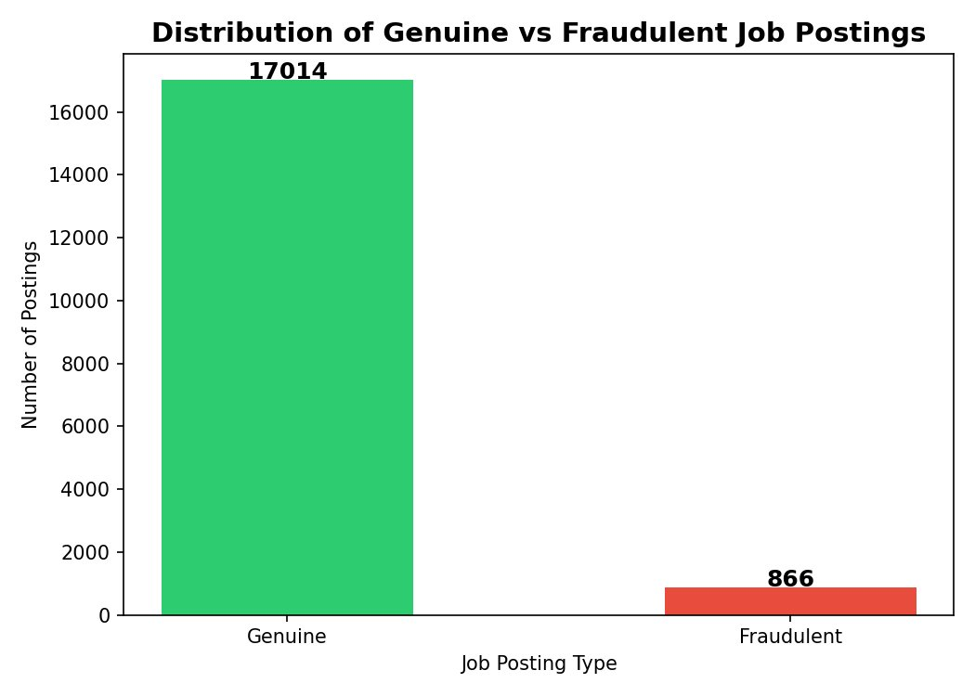
Fig. 1. Distribution of genuine vs. fraudulent job postings in the EMSCAD dataset.
B. Data Preprocessing
Multiple textual columns are concatenated into a single feature field. The preprocessing pipeline applies: (i) lowercasing, (ii) HTML tag removal using regular expressions, (iii) special character and numeral removal, (iv) tokenization, (v) stopword removal using NLTK, and (vi) lemmatization using WordNetLemmatizer. This produces a clean, standardized text representation suitable for vectorization. Fig. 2 shows the top 20 most discriminative terms by average TF-IDF score.
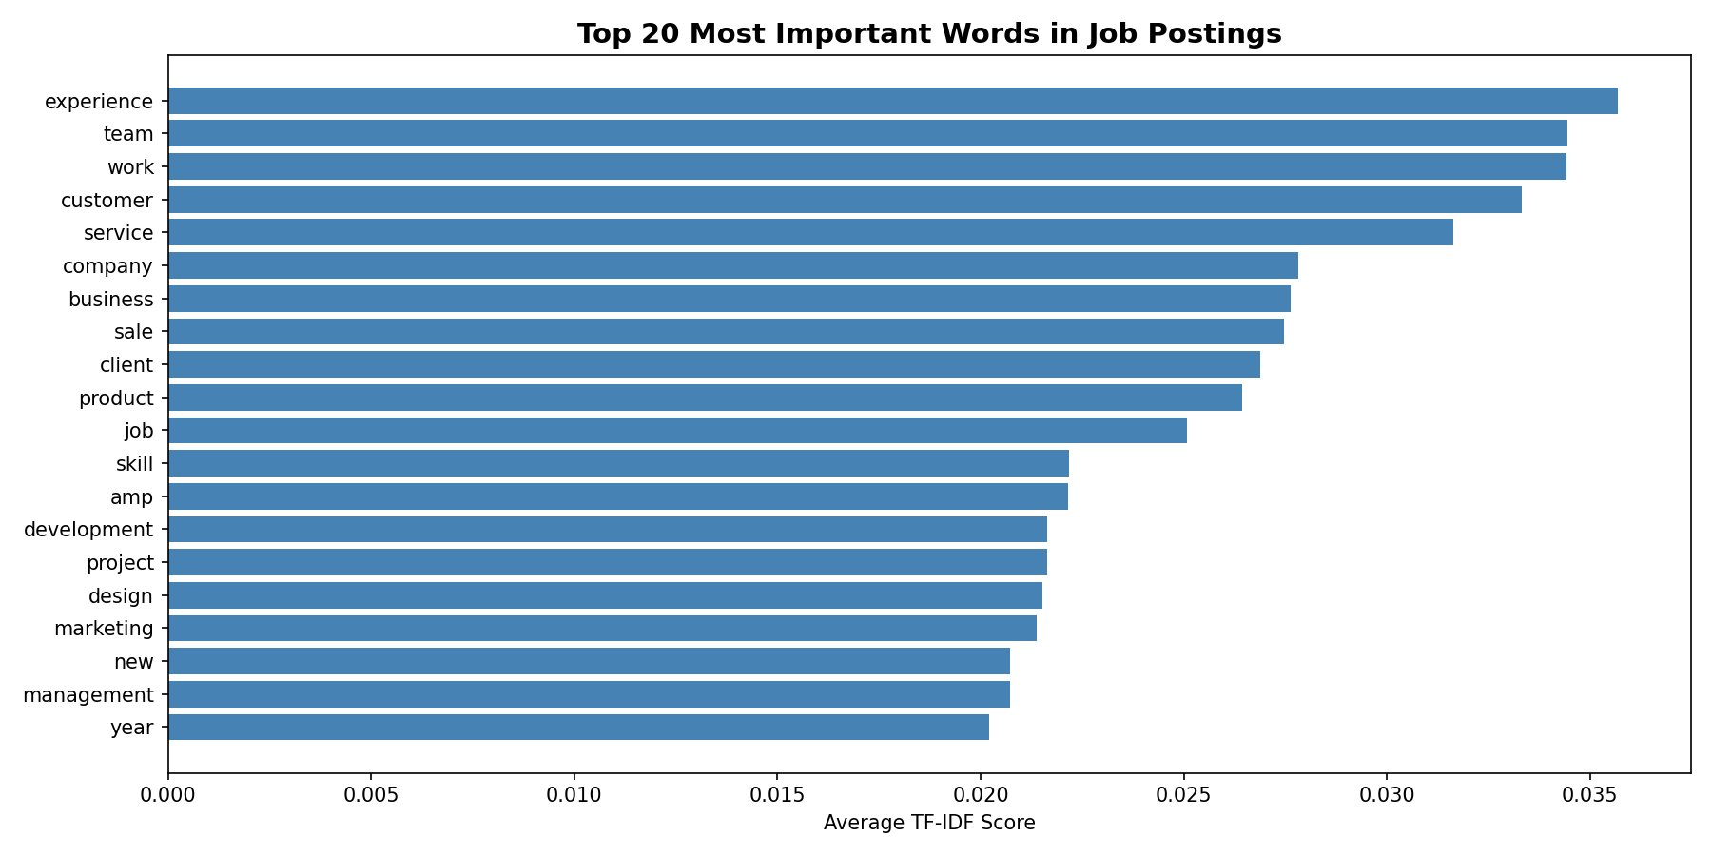
Fig. 2. Top 20 most important words in job postings by average TF-IDF score.
C. Feature Extraction
TF-IDF vectorization converts preprocessed text into numerical feature vectors. The TF-IDF score for term t in document d is computed as:
TF-IDF(t, d) = TF(t, d) × log(N / DF(t))
where N is the total number of documents and DF(t) is the number of documents containing term t. The vectorizer is configured with max_features=5,000 and ngram_range=(1,2) to capture both unigrams and bigrams. The resulting feature matrix has dimensions 17,880 × 5,000.
D. Handling Class Imbalance
Two oversampling techniques are applied to the training set to address the 20:1 class imbalance. SMOTE generates synthetic minority samples by interpolating between existing instances in feature space. ADASYN adaptively generates more samples near misclassified boundary regions, focusing learning on difficult examples. Both methods produce a balanced training distribution with equal class representation, as shown in Fig. 3.
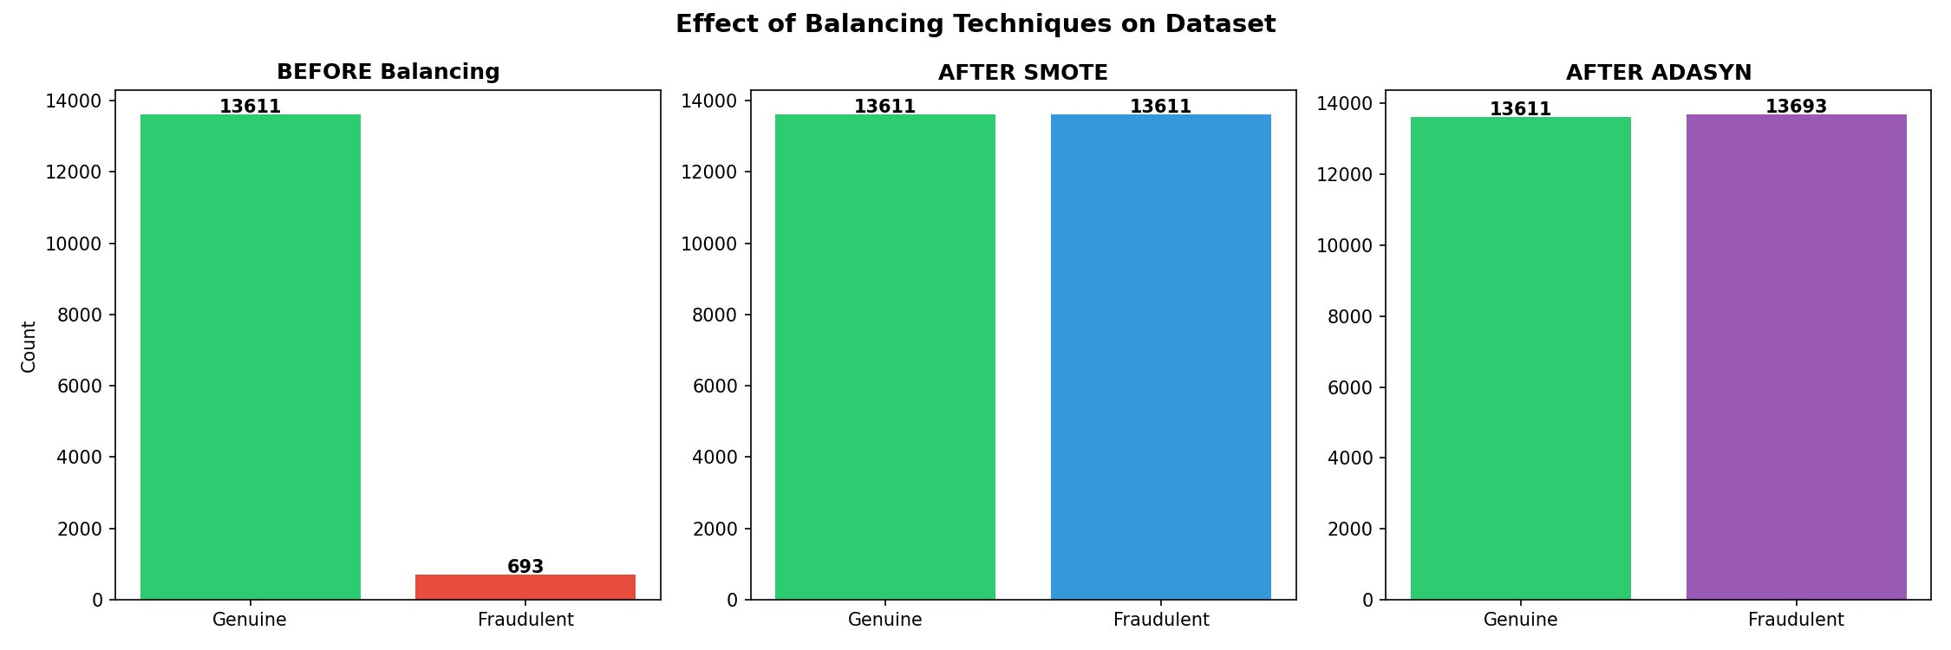
Fig. 3. Effect of SMOTE and ADASYN balancing techniques on training dataset distribution.
E. Machine Learning Models
Four supervised classifiers are implemented and compared:
• Random Forest (RF): Ensemble of 100 decision trees with majority voting.
• Gradient Boosting (GB): Sequential boosting with 100 estimators.
• XGBoost: Optimized gradient boosting with regularization and parallel processing.
• K-Nearest Neighbors (KNN): Instance-based classification with k=5.
The dataset is partitioned into 80% training and 20% testing subsets with stratified sampling to preserve class distribution. Hyperparameters are set to established defaults with random_state=42 for reproducibility.
IV. Experimental Results
A. Model Performance Comparison
Table I presents the comparative performance of all classifiers evaluated on the test set. Fig. 4 provides a visual comparison of accuracy and F1-score across models.
TABLE I
Comparative Performance of Machine Learning Classifiers
Model | Balancing | Accuracy (%) | Precision | Recall | F1-Score
XGBoost ★ | ADASYN | 98.43 | 0.91 | 0.75 | 0.82
Random Forest | SMOTE | 98.35 | 0.99 | 0.66 | 0.80
Gradient Boosting | SMOTE | 96.95 | 0.65 | 0.80 | 0.72
KNN | SMOTE | 77.80 | 0.18 | 0.98 | 0.30
★ Best performing model
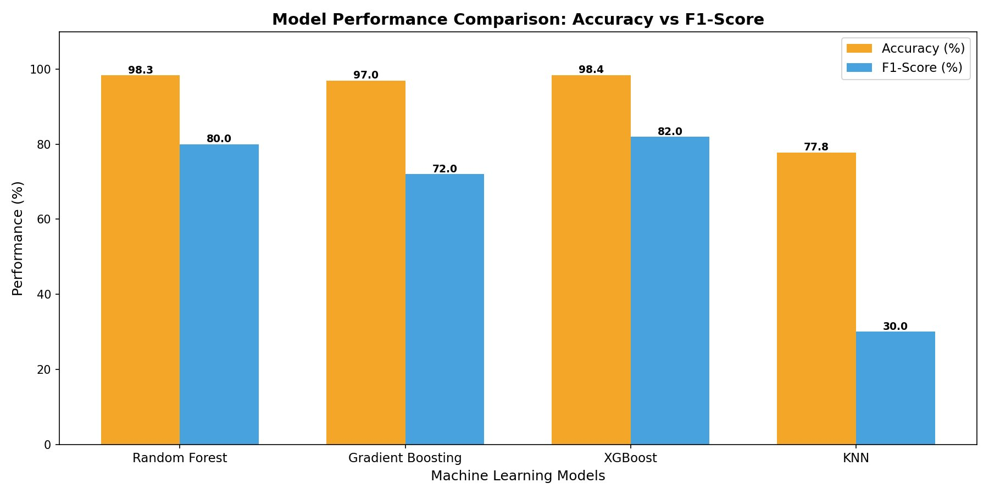
Fig. 4. Model performance comparison: accuracy vs. F1-score across all classifiers.
XGBoost combined with ADASYN achieves the highest accuracy of 98.43% and F1-score of 0.82, making it the best overall model. Random Forest with SMOTE achieves the highest precision of 0.99, indicating minimal false positive fraud alerts. KNN achieves the highest recall of 0.98 but suffers from extremely low precision (0.18), flagging the majority of legitimate jobs as fraudulent—an unacceptable result for practical deployment.
B. Confusion Matrix Analysis
Fig. 5 presents the confusion matrices for all four models. Random Forest (SMOTE) correctly classifies 3,402 genuine and 115 fraudulent postings with only 1 false positive and 58 false negatives. XGBoost (ADASYN) achieves 3,391 true genuine and 129 true fraudulent with 12 false positives and 44 false negatives, demonstrating strong balanced performance.
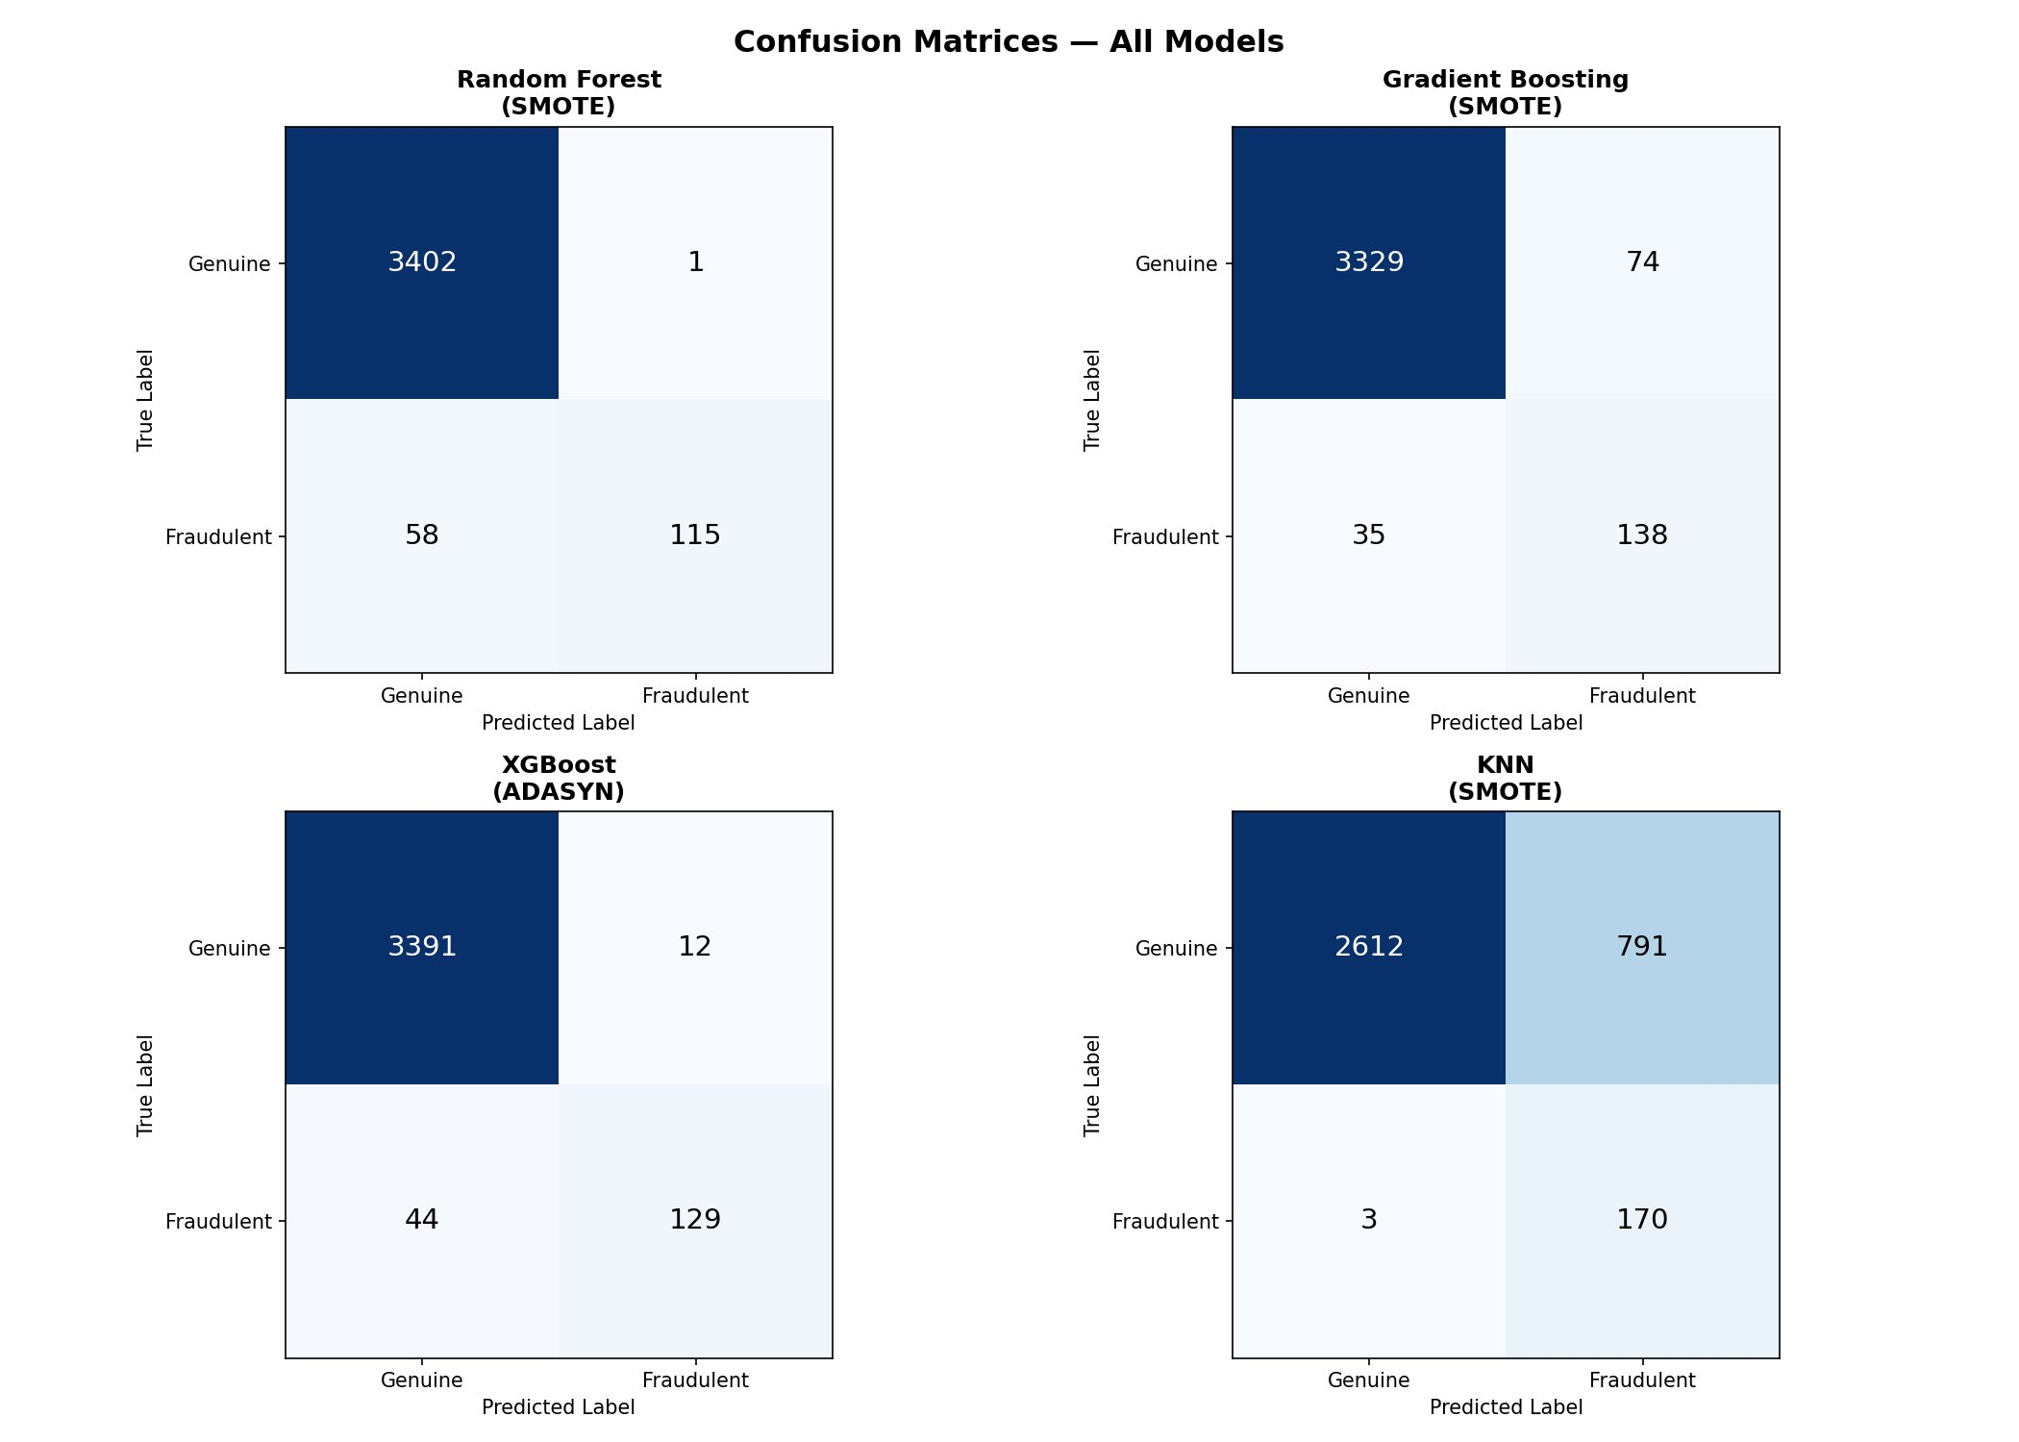
Fig. 5. Confusion matrices for all four models: Random Forest (SMOTE), Gradient Boosting (SMOTE), XGBoost (ADASYN), and KNN (SMOTE).
C. ROC Curve Analysis
The Receiver Operating Characteristic (ROC) curves in Fig. 6 confirm the discriminative power of all models. Random Forest (SMOTE) achieves the highest AUC of 0.986, followed by XGBoost (ADASYN) at 0.982, Gradient Boosting (SMOTE) at 0.973, and KNN (SMOTE) at 0.939. All models substantially outperform the random baseline, validating the effectiveness of the proposed approach.
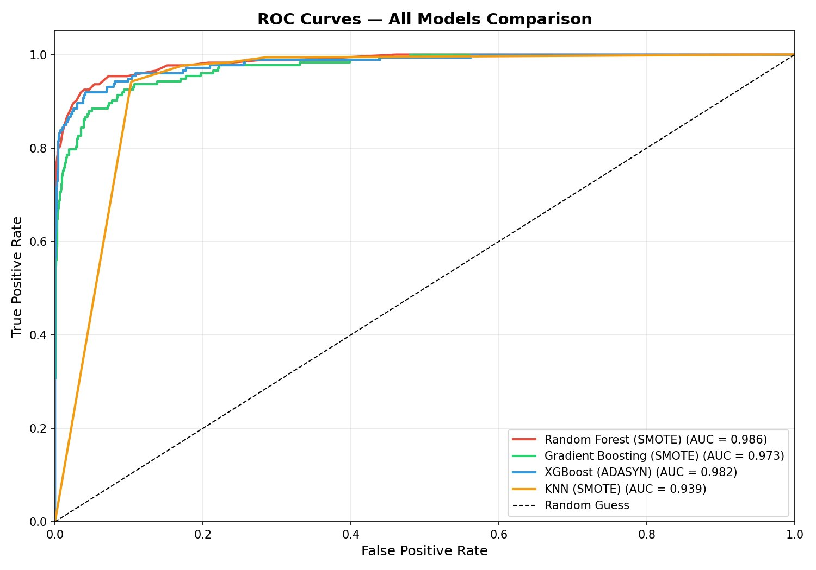
Fig. 6. ROC curves for all models. Random Forest achieves the highest AUC of 0.986.
D. Feature Importance Analysis
Feature importance extracted from the trained Random Forest model reveals interpretable linguistic patterns distinguishing fraudulent from legitimate postings. Fig. 7 illustrates the top 25 features, color-coded by class association.
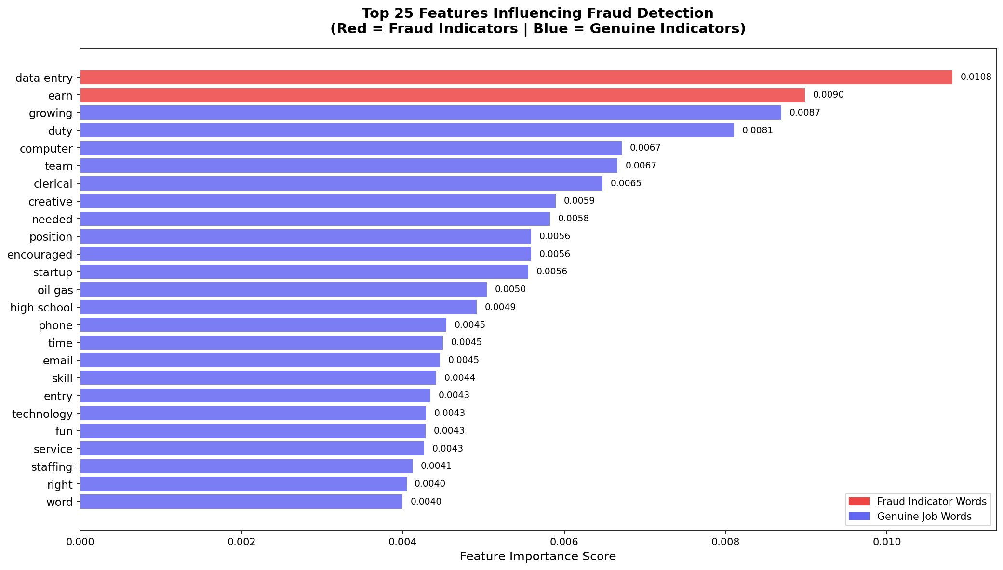
Fig. 7. Top 25 features influencing fraud detection. Red bars indicate fraud-indicator words; blue bars indicate genuine job words.
The top fraud-indicating terms are "data entry" (importance: 0.0108)—the single strongest fraud predictor—and "earn" (importance: 0.0090), associated with unrealistic earning promises. Legitimate job indicators include terms such as "growing", "duty", "computer", "team", and "skill", reflecting professional role descriptions. This analysis confirms that fraudulent postings exploit specific linguistic patterns centered on immediate earning opportunities and personal information collection.
E. Effect of Class Balancing
Without balancing, classifiers exhibit strong bias toward the majority class (legitimate postings), achieving high accuracy while virtually ignoring fraudulent cases. After SMOTE application, the training set expands from 14,304 samples (13,611 genuine, 693 fraudulent) to 27,222 balanced samples. ADASYN produces 27,304 samples with slight adaptive variation. Both techniques substantially improve fraud recall, with SMOTE yielding better overall F1-score performance across most classifiers.
V. System Deployment
A production-ready web application named "JobGuard AI" is developed using Flask (Python) as the backend framework. The frontend interface is built with HTML5, CSS3, and JavaScript, providing a responsive and professional user experience accessible via any modern web browser.
The system accepts job posting text through two input modalities: (i) direct text paste for manual input, and (ii) URL-based fetching for automated extraction from supported job portals. The trained XGBoost model and TF-IDF vectorizer are serialized using Python's joblib library and loaded at application startup.
Input validation logic rejects non-job content (code, random text) based on keyword pattern matching before prediction. The prediction endpoint returns fraud probability scores with confidence percentages, providing transparent uncertainty quantification to end users. Analysis history is maintained client-side for session-level auditability.
VI. Conclusion
This paper presented a machine learning framework for intelligent detection of fraudulent online job postings. By integrating TF-IDF-based NLP feature extraction with SMOTE/ADASYN class balancing and ensemble learning classifiers, the proposed system achieves 98.43% accuracy with XGBoost. ROC analysis confirms strong discriminative ability with AUC values reaching 0.986. Feature importance analysis provides explainability by identifying "data entry" and "earn" as primary fraud linguistic markers. A deployed Flask web application demonstrates practical real-world applicability.
Future work will explore transformer-based language models (BERT, RoBERTa) for richer semantic feature extraction, multilingual fraud detection for regional job markets, real-time scraping integration with major job portals, and browser extension deployment for inline fraud warnings during job browsing.

Acknowledgment
The authors express sincere gratitude to the Department of Artificial Intelligence, Sanghavi College of Engineering, Nashik, for providing the necessary computational resources and academic environment. This work is carried out under the M.E. Dissertation program affiliated with Savitribai Phule Pune University, Pune, during the academic year 2025–2026.
References
[1] N. V. Chawla, K. W. Bowyer, L. O. Hall, and W. P. Kegelmeyer, "SMOTE: Synthetic Minority Over-sampling Technique," Journal of Artificial Intelligence Research, vol. 16, pp. 321–357, 2002.
[2] H. He, Y. Bai, E. A. Garcia, and S. Li, "ADASYN: Adaptive Synthetic Sampling Approach for Imbalanced Learning," in Proc. IEEE Int. Joint Conf. Neural Networks, 2008, pp. 1322–1328.
[3] V. Chandola, A. Banerjee, and V. Kumar, "Anomaly Detection: A Survey," ACM Computing Surveys, vol. 41, no. 3, pp. 1–58, 2009.
[4] C. Phua, V. Lee, K. Smith, and R. Gayler, "A Comprehensive Survey of Data Mining-based Fraud Detection Research," Artificial Intelligence Review, Springer, 2010.
[5] F. Pedregosa et al., "Scikit-learn: Machine Learning in Python," Journal of Machine Learning Research, vol. 12, pp. 2825–2830, 2011.
[6] Z.-H. Zhou, Ensemble Methods: Foundations and Algorithms. Chapman and Hall/CRC, 2012.
[7] I. H. Sarker, "Machine Learning: Algorithms, Real-World Applications and Research Directions," SN Computer Science, Springer, 2021.
[8] S. Saini and N. Kaur, "Online Job Fraud Detection Using Machine Learning," International Journal of Computer Applications, vol. 176, no. 18, pp. 1–6, 2020.
[9] T. Chen and C. Guestrin, "XGBoost: A Scalable Tree Boosting System," in Proc. 22nd ACM SIGKDD Int. Conf. Knowledge Discovery and Data Mining, 2016, pp. 785–794.
[10] M. Yasmin R. Shaikh and S. S. Hinge, "Smart Detection of Fraudulent Online Job Posting Using Machine Learning," IJARSCT, vol. 6, no. 4, pp. 493–496, Jan. 2026. DOI: 10.48175/IJARSCT-31064.

