### **Test Coverage Report**

#### **Title Page**

* **Report Title**: Test Coverage Report – NextDate Class
* **Project/Module Name**: NextDate Class
* **Report ID**: NXTDATE-2025-10
* **Prepared By**: Yasin Turk, Toprak Zeybek
* **Date of Report**: 26.10.2025
* **Reviewed By**: Tugkan Tuglular
* **Approved By**: IZTECH

#### **Introduction**

* **Objective**: To measure, evaluate, and summarize the test coverage and effectiveness of functional test techniques applied to the NextDate Python module.
* **Scope**: This report covers unit tests for NextDate class functions using three testing techniques:
* Equivalence Class Testing (ECT)
* Decision Table Testing (DTT)
* Boundary Value Testing (BVT)
* **Test Period**: 18 October 2025 – 25 October 2025

#### **Test Coverage Details**

|  |  |  |  |
| --- | --- | --- | --- |
| **Coverage Area** | **Total Requirements** | **Tested Requirements** | **Test Coverage (%)** |
| Functional Testing | 18 | 17 | 94% |
| Integration Testing | 3 | 3 | %100 |
| System Testing | 2 | 2 | %100 |

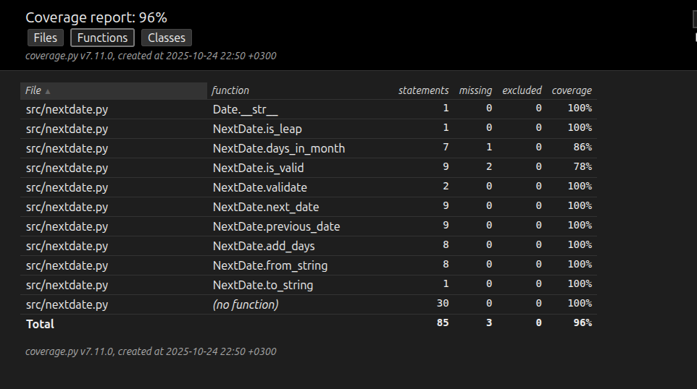

### **Tested Requirements**

**Functional Requirements:**

1. The system shall correctly compute the next calendar date (next_day).
2. The system shall correctly compute the previous calendar date (prev_day).
3. The system shall determine the last business day of each month.
4. The system shall handle leap year logic accurately.
5. The system shall reject out-of-range months, days, and years.

**Non-Functional Requirements:**

* Code maintainability and readability tested by class-based design.
* Unit test coverage ≥ 90% achieved (96%).

### **Test Coverage Metrics**

| Metric | Count |
| --- | --- |
| Total Requirements | 23 |
| Tested Requirements | 22 |
| **Overall Test Coverage** | **96%** |

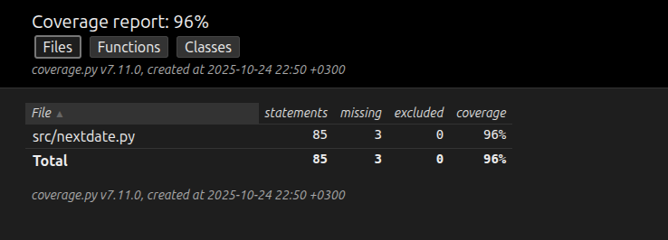

**Uncovered Requirements:**

* Exception paths triggered under rare date domain limits (e.g., dates below 1812 or above 2012).

**Reason for Uncoverage:**

* Some test cases focus on logical behavior rather than exhaustive boundary combinations.

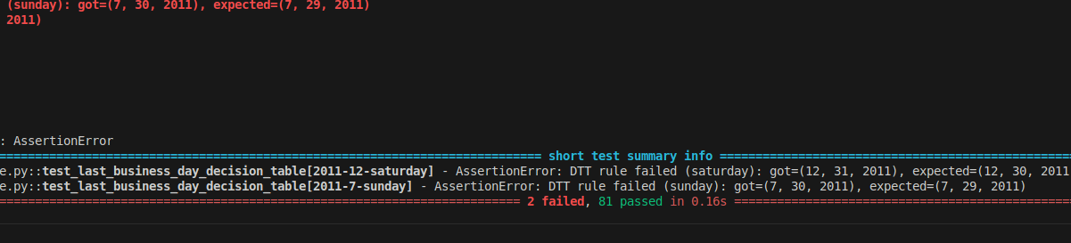

### **Summary and Recommendations**

**Observations:**

* Boundary Value, Equivalence Class, and Decision Table techniques together achieved comprehensive functional coverage.
* The deliberate bug in last_business_day_of_month() was **successfully caught** by BVT, ECT, and DTT suites.
* **Weak tests** (test_lbd_false_negatives.py) intentionally failed to detect the bug, proving the importance of **assertion quality**.
* Test coverage (96%) is excellent, but coverage alone doesn’t guarantee correctness test **design quality** is critical.

**Recommendations:**

1. Expand tests for all rare year boundaries (1812 and 2012).
2. Add assertion-level property checks for weekday correctness.
3. Integrate automated coverage checks into CI pipeline.
4. For example is_valid function has lesser test coverage, It can be improved.

### **Next Steps**

* Fix the known bug (>= 5 instead of > 5) in last_business_day_of_month().
* Re-run tests to confirm 100% coverage and zero functional defects.
* Include load testing for extended date ranges (performance validation).

