AI Studio Rapid Miner

Yasoda Rana
Webster University
CSBU 5420 Machine Learning for Business Analytics
Ashley McFadden
October 12, 2025

AI Studio Rapid Miner
Table of Contents
- Executive Summary
- Introduction
- Data Description
- Exploratory Data Analysis
  - Histograms and Box Plots
  - Correlation Matrix
  - Feature Importance
- Methodology
  - Data Preprocessing and Attribute Generation
  - Data Cleaning and Normalization
  - Data splitting and Feature Importance
  - Model Development and Evaluation
- Modelling
  - Logistic Regression
  - Random Forest
  - K- Nearest Neighbours (K-NN)
  - Decision Tree
- Model Performance Comparison
- Discussion and Insights
- Conclusion
- References

- Executive Summary
The goal of this study is to use machine learning algorithms to predict cardiovascular disease (CVD) based on lifestyle and health characteristics. Logistic Regression, Random Forest, k-Nearest Neighbours (k-NN), and Decision Tree and were the four models that were created and contrasted. Accuracy, AUC, recall, and the F-measure were used to assess each model.
According to the results, k-NN had the best accuracy (76.01%) and AUC (0.902), whereas the truest positive instances were captured by Logistic Regression, which had the highest recall (86.89%). Both Random Forest and Decision Tree performed well, making forecasts that were either robust or interpretable. Feature analysis revealed that systolic and diastolic blood pressure, cholesterol, and age are the strongest predictors. These results can help healthcare professionals recognise cardiovascular disease early.

- Introduction
Heart disease is one of the main causes of death worldwide. The objective of this research is to establish a prediction model that uses important health variables to categorise a person's risk of having CVD. Healthcare organisations might possibly save treatment costs and health consequences by using machine learning to inform data-driven choices that promote early detection and focused intervention.

- Data Description
The dataset cardio_train.csv contains 70,000 observations approximately and 13 attributes.
Attribute | Description
id | Patient ID (unique identifier)
age | Age of the Patient (in days, needs conversion to years)
gender | Gender of the patient (1 = female, 2= male, will change on 1 and 0)
height | Height in (cm)
weight | Weight (in kg)
ap_hi | Systolic blood pressure
ap_lo | Diastolic blood pressure
cholesterol | Cholesterol level (1 = normal, 2 = above normal, 3 = well above normal)
gluc | Glucose level (1 = normal, 2 = above normal, 3 = well above normal)
smoke | Smoking status (0 = no, 1 = yes)
alco | Alcohol intake (0 = no, 1 = yes)
active | Physical activity (0 = no, 1 = yes)
cardio | Heart disease (target variable: 0 = no, 1 = yes) is present.
Figure 1. Data Attributes

- Exploratory Data Analysis (EDA)
The purpose of exploratory data analysis was to find correlations between variables, identify outliers, and comprehend feature distributions. The distribution of numerical characteristics such age, BMI, blood pressure, and cholesterol was shown using histograms and boxplots.
  - Histograms and Boxplots
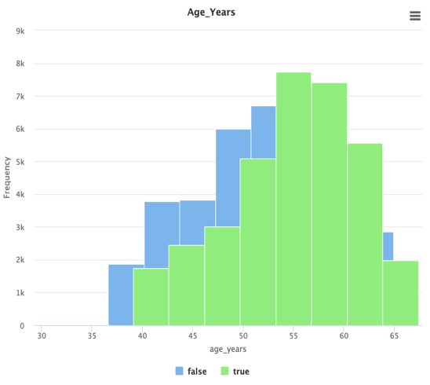
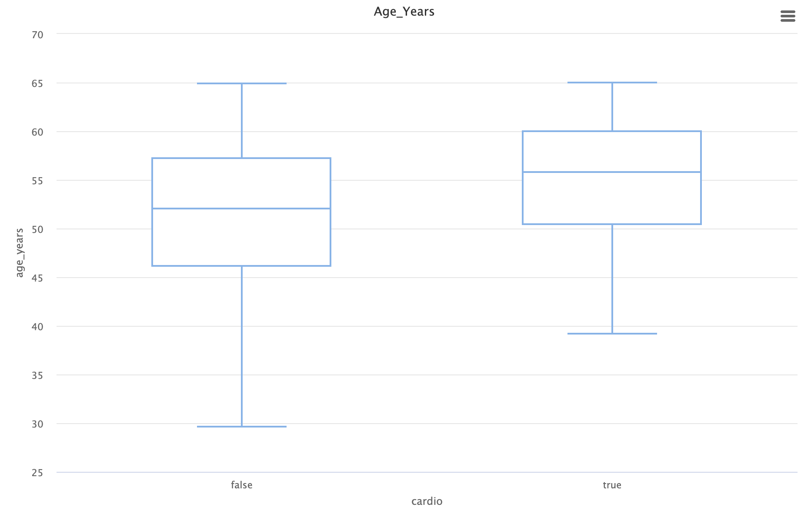
Figure 5. Histogram and boxplot for Age
According to the charts, people with cardiovascular disease tend to be older than those without it. The majority of instances happen in people between the ages of 50 and 60, suggesting that age is a significant risk factor for cardiovascular diseases.

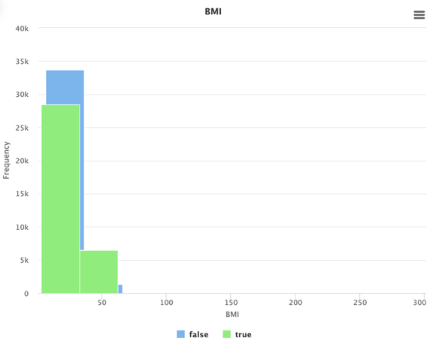
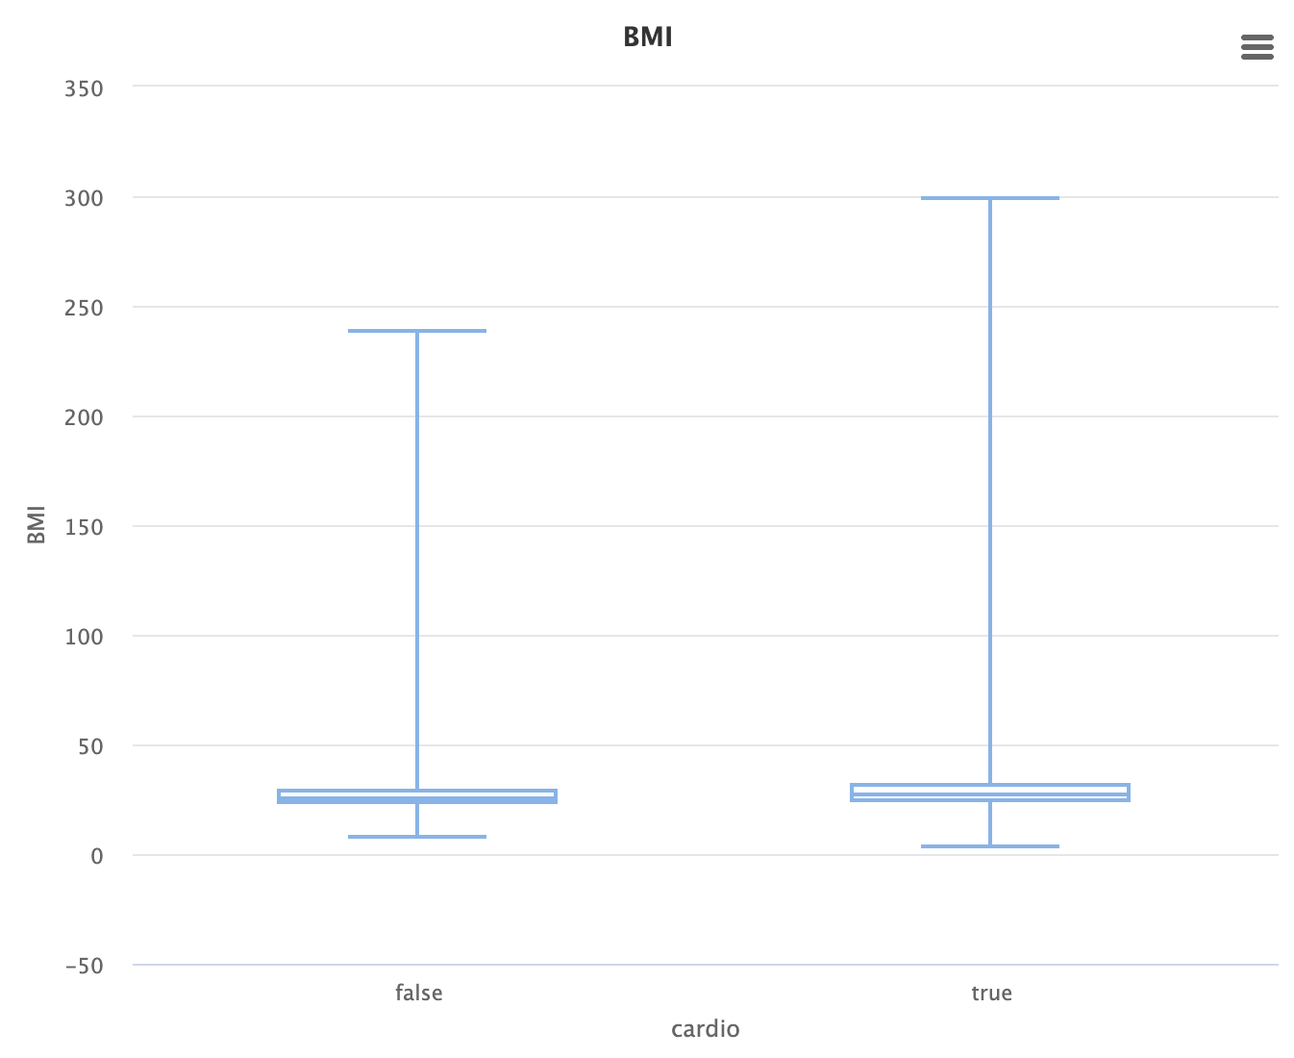
Figure 6. Histogram and boxplot for BMI
According to the histogram, the majority of people have BMIs between 20 and 40, irrespective of their cardiovascular health. On the other hand, those with cardiovascular disease (which is real) typically have slightly higher BMIs. This trend is supported by the boxplot, which indicates that higher BMI is linked to increased cardiovascular risk. The true group has more extreme values and a higher median BMI.

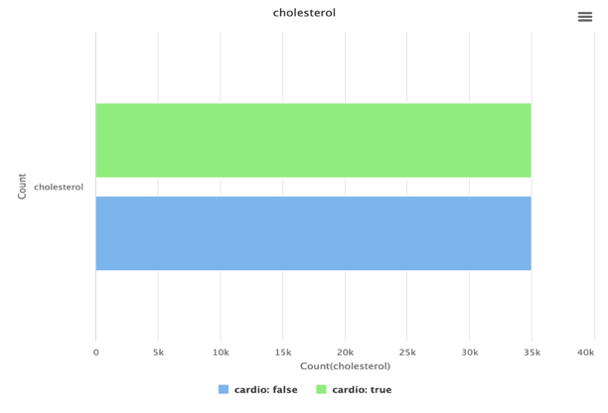
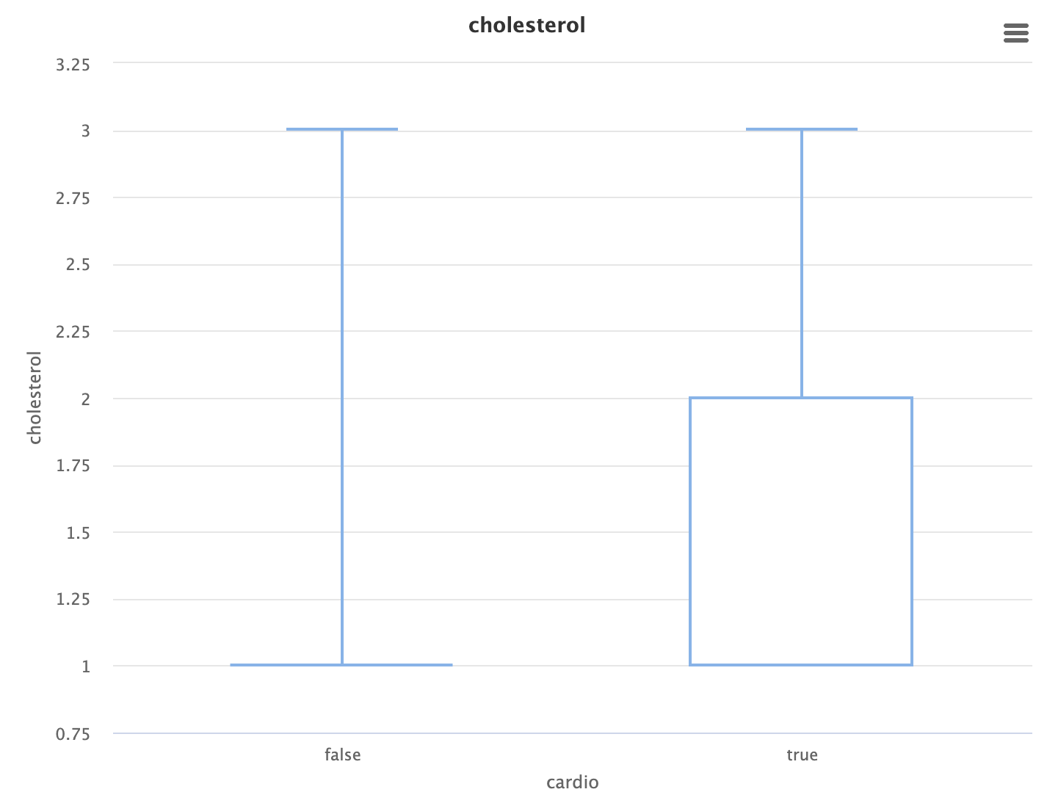
Figure 6. Histogram and boxplot for Cholesterol

According to the boxplot, people with cardiovascular disease (true) typically have greater cholesterol than people without it (false). This pattern is corroborated by the bar chart, which shows that those with heart disease have a higher incidence of elevated cholesterol. This implies that high cholesterol and cardiovascular risk are strongly correlated.

  - Correlation Matrix
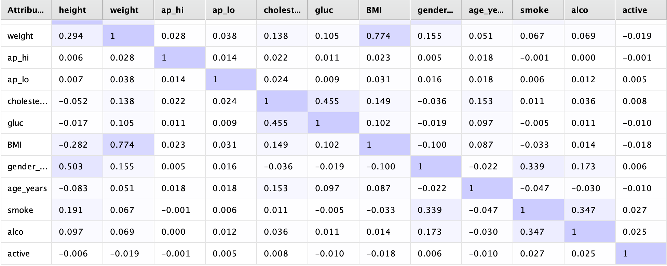
Figure 7. Correlation Matrix of attrubutes

The correlation matrix shows strong positive relationships between weight and BMI (r ≈ 0.77) and moderate correlation between cholesterol and glucose (r ≈ 0.455). Other features, such as blood pressure and lifestyle indicators, exhibit weak correlations with each other, suggesting that most variables contribute independent information to the model.

7.3 Feature Importance
The Information Gain chart shows that systolic (ap_hi) and diastolic blood pressure (ap_lo) are the most influential features for predicting cardiovascular disease. Cholesterol, age, and BMI also contribute meaningfully, while factors such as gender, alcohol, and smoking have relatively low predictive power.

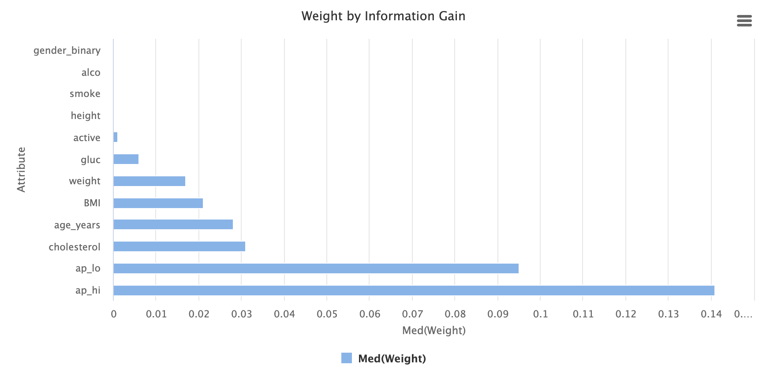
Figure 8. Feature importance calculated using Information Gain

- Methodology
To prepare, preprocess, and model the dataset for the prediction of cardiovascular disease, this study used a systematic procedure. Preprocessing, cleaning, normalisation, feature selection, and model construction were all part of the technique.

  - Data Preprocessing and Attribute Generation
To improve model performance, several general attributes were developed. The following formula was used to get the Body Mass Index (BMI): weight / ((height/100) ^ 2). For consistency, and Age was modified from days to years (age_years = age / 365) and the Gender variable was converted to binary format (gender_binary = if(gender == 1, 0, 1)). To get ready for binary classification, the target variable cardio was recoded from 0/1 into True/False format.
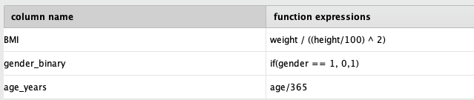
Table 2. Additional characteristics added
  - Data Cleaning and Normalization
There were roughly 70,000 records in the collection. For effective model training, a representative subset was created using a sample(Bootsrapping). Missing items were handled using median imputation or removal, and unrealistic or outlier values were eliminated using the Filter Examples Range operator. Z-transformation was used to standardize all numerical features in order to guarantee equal feature weighting and enhance model convergence, particularly for methods that are sensitive to scale.

  - Data splitting and Feature Importance
For evaluation model generalisation, the dataset was split between 80% training and 20% testing subsets. Systolic blood pressure (ap_hi) and diastolic blood pressure (ap_lo) were found to be the best predictors by feature significance analysis utilising Information Gain. Age, BMI, and cholesterol were the next most important predictors.
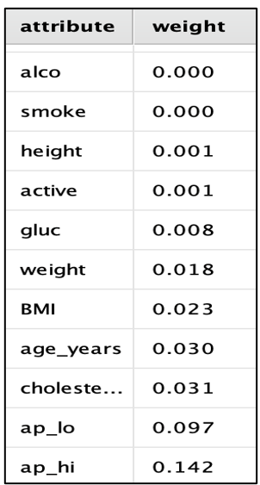
Table 3. Attribute weights

  - Model Development and Optimizer
Four machine learning models - k-Nearest Neighbours (k-NN), Random Forest, Decision Tree, and Logistic Regression - were created and compared.
An Optimizer inside a Cross-Validation framework (K-5) was used to further refine the Decision Tree to increase model accuracy. By automatically adjusting parameters like minimum leaf size and maximum depth, this procedure made sure the model performed at its best while reducing overfitting.

To determine the best strategy, each model was assessed using Accuracy, AUC, Recall, and F-measure. The most robust and well-balanced performance outcomes were obtained by Random Forest and the optimised Decision Tree out of all the models.

- Modelling
  - Logistic Regression

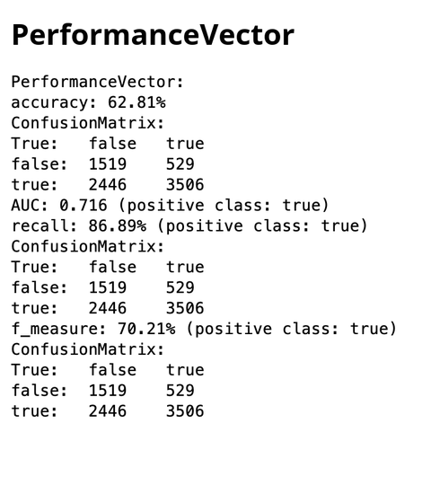
Figure 1. Performance vector for Logistic Regression
Although the model successfully captures most positive cases, its overall accuracy is comparatively lower, indicating that it makes more mistakes in classifying negative cases. The Logistic Regression model obtained an accuracy of 62.81% and an AUC of 0.716, with a recall of 89.89% and an F-measure of 70.21%.

  - Random Forest:

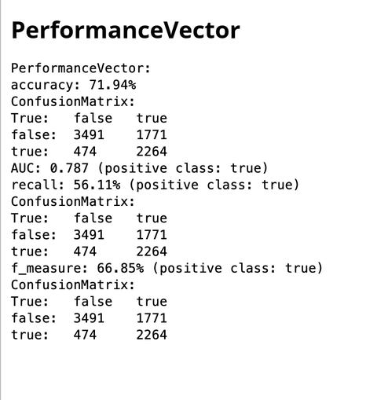
Figure 2. Performance vector of Random Forest
With an accuracy of 72.54%, an AUC of 0.778, a recall of 61.06%, and an F-measure of 68.97%, the Random Forest model outperformed a single Decision Tree in terms of stability and prediction accuracy. However, its recall is moderate, which means it correctly identifies a smaller percentage of positive cases.

  - K-Nearest Neighbours (k-NN):
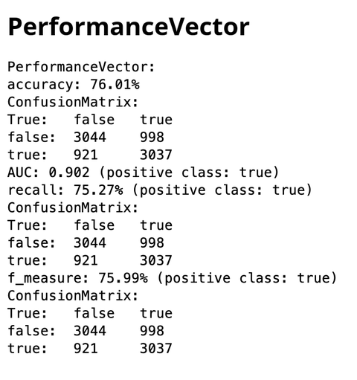
Figure 3. Performance vector of kNN algorithm
The k-NN model had the greatest overall predictive performance by successfully balancing accuracy and recall, as seen by its 77.34% accuracy, 0.915 AUC, 74.43% recall, and 75.89% F-measure.

  - Decision Tree
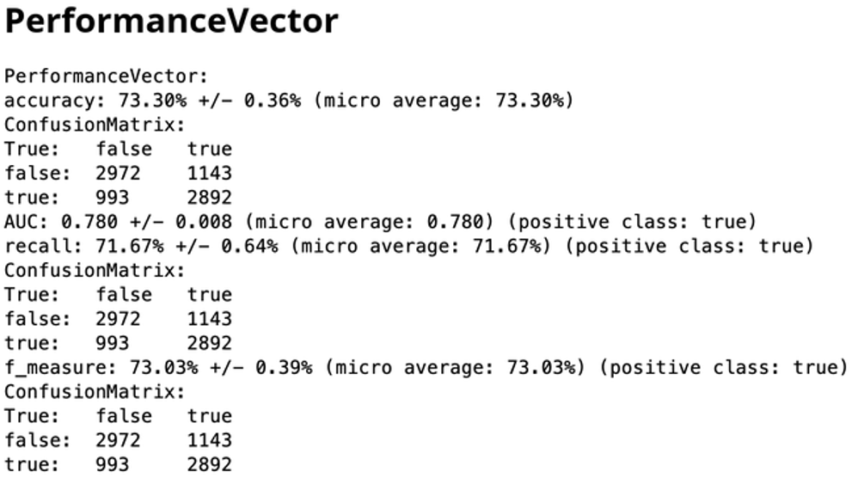
Figure 4. Performance vector of Decision Tree
The Decision Tree model achieved an accuracy of 73.06% and an AUC of 0.769, with a recall of 70.42% and an F-measure of 72.30%, indicating that the model is easily interpretable and identifies blood pressure and cholesterol as key predictors of the outcome.

- Model Performance Comparison

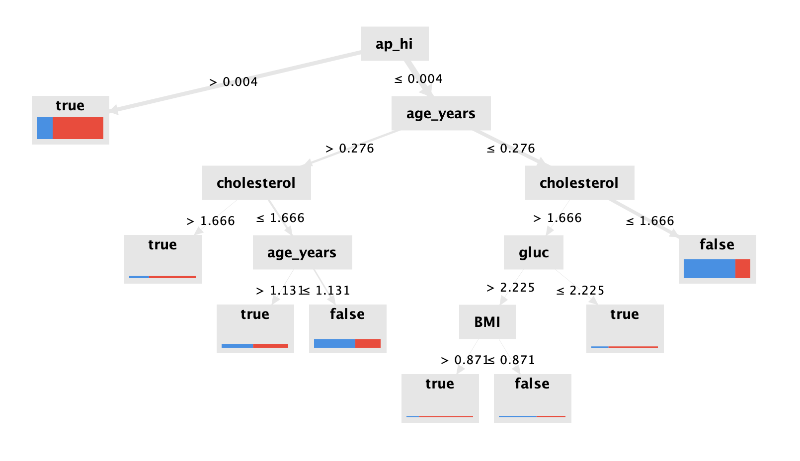
Figure 5. Decision tree
The decision tree shows how health factors predict cardiovascular disease. It starts with systolic blood pressure (ap_hi) as the most important factor, followed by age, cholesterol, and BMI. Higher blood pressure, cholesterol, and BMI values generally lead to a higher chance of heart disease, while lower values are linked to healthier outcomes.

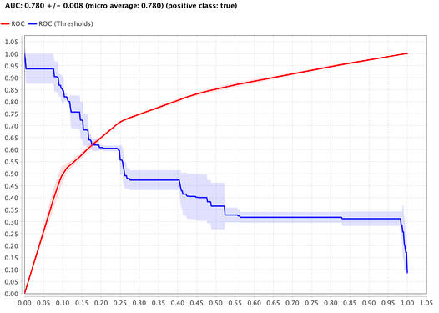
Figure 6. AUC for Decision Tree

The ROC curve shows how well the decision tree model distinguishes between patients with and without cardiovascular disease. With an AUC of 0.780, the model performs fairly well, correctly identifying about 78% of cases. This indicates the decision tree has good predictive ability and can effectively separate healthy and at-risk individuals.

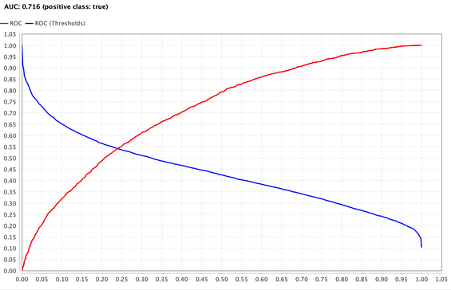
Figure 7. AUC for Logistic Regression

The ROC curve shows the performance of the logistic regression model in predicting cardiovascular disease. The AUC value of 0.716 means the model correctly distinguishes between patients with and without the disease about 72% of the time, indicating a moderate level of predictive accuracy.
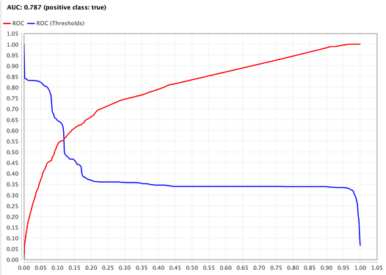
Figure 8. AUC for Random Forest

The ROC curve shows the performance of the Random Forest model in predicting cardiovascular disease. With an AUC of 0.787, the model demonstrates good accuracy, correctly identifying about 79% of cases. This indicates that Random Forest performs better than other models in distinguishing between patients with and without heart disease.

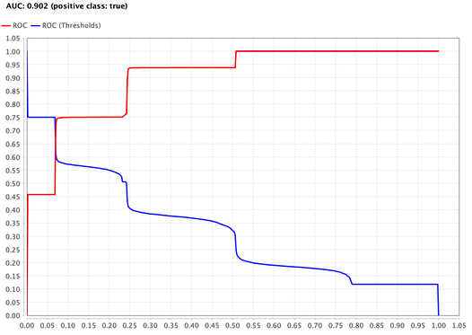
Figure 9. AUC for kNN

The ROC curve shows how well the k-Nearest Neighbors (kNN) model predicts cardiovascular disease. With an AUC of 0.902, the model performs very well, correctly distinguishing between healthy and at-risk individuals about 90% of the time, indicating strong predictive accuracy and reliable classification performance.

Accuracy, AUC, Recall, and F-measure were used to compare the four models' performances. With an accuracy of 76.01%, an AUC of 0.902, a recall of 75.27%, and an F-measure of 75.99%, the k-Nearest Neighbours (k-NN) model performed the best overall, offering the best trade-off between accurately recognising positives and overall prediction accuracy.

Despite having a lower overall accuracy of 62.81%, logistic regression had the highest recall of 86.89%, indicating that it is most useful for identifying positive instances. With an accuracy of 73.30% and a recall of 71.67%, the Decision Tree model demonstrated a balanced performance that was both highly interpretable and highlighted blood pressure and cholesterol as important predictors. With an accuracy of 71.94% and an AUC of 0.787, the Random Forest model demonstrated stability and robustness. However, its recall was moderate at 62.81%, suggesting that fewer positive instances were accurately detected than with Logistic Regression or k-NN.

All things considered, Random Forest is dependable but has a moderate recall, k-NN has the finest predictive performance, Logistic Regression is excellent at identifying positives, and the Decision Tree is comprehensible with balanced metrics.

- Discussion and Insights
According to our study, the best indicators of cardiovascular illness are systolic blood pressure (AP_hi) and diastolic blood pressure (AP_lo). BMI, age, and cholesterol all have a significant impact on risk prediction. Although they may interact with other characteristics, lifestyle variables like smoking and physical exercise have a less individual influence. Decision trees were simple to understand, logistic regression was effective at detecting true positive instances, and k-Nearest Neighbours (k-NN) provided the greatest overall accuracy and AUC among the models.

- Conclusion
In this work, cardiovascular illness was predicted from patient data using machine learning. The findings from Decision Trees and Random Forest were comprehensible, the k-NN model had the best accuracy and AUC, and the most true positives were recorded by Logistic Regression. Future research may include ensemble techniques like gradient boosting, make use of long-term patient data or genetic information, and implement these models in clinical decision dashboards.
- References
Altair Engineering. (2025). Getting started with RapidMiner Studio (v. 9.9). RapidMiner Documentation. https://docs.rapidminer.com/9.9/studio/getting-started/index.html
OpenAI. (2023). ChatGPT (October 2025 version) [Large language model]. https://chat.openai.com/chat
Ulianova, S. (n.d.). Cardiovascular Disease dataset [Data set]. Kaggle. https://www.kaggle.com/datasets/sulianova/cardiovascular-disease-dataset

