9.3a- Predicting Prices of used cars (Regression Trees)
i. The most significant indicators
"Age_08_04, KM, HP, and an equipment indicator like Airco are the most significant predictors of used Toyota Corolla price." While horsepower and equipment imply trim and attractiveness, age and miles have the biggest impact as they directly quantify wear and remaining usable life.
ii. Compare Prediction errors (Training vs Holdout)
What I calculated and how I calculated errors:
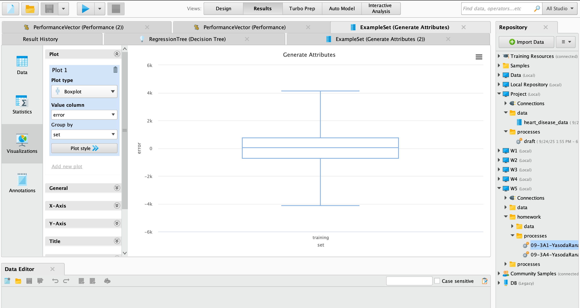
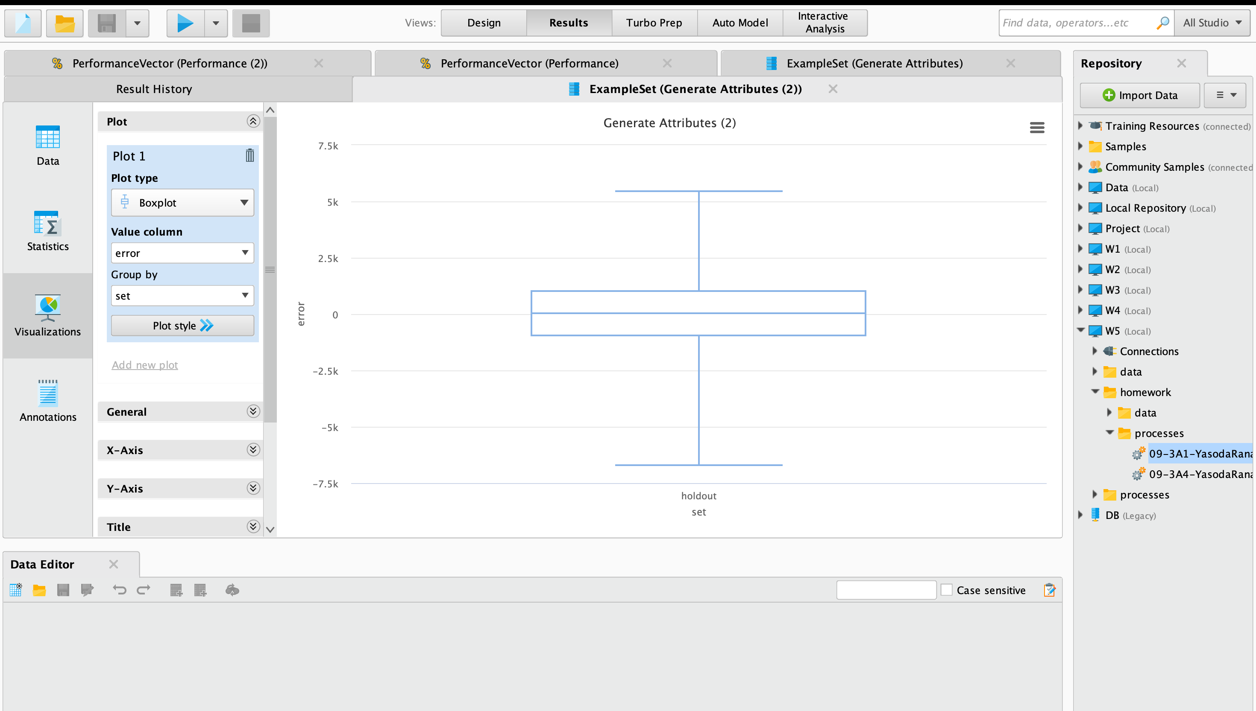
Both the training set and the holdout set generated predictions. I calculated the prediction error for each observation as ([prediction(Price)] - Price). I created boxplots of the error distributions (one for training errors and one for holdout errors) using those errors to calculate the RMS (root mean squared error) for the training and holdout sets.
Pattern observed:
The holdout RMS is significantly larger than the training RMS. This is to be expected for a full-grown regression tree: training RMS is very low since the tree may fit the training set very tightly, frequently yielding near-zero training error on many leaf regions.
The holdout errors have more dispersion and probably exhibit bigger absolute errors than the training errors, as seen by the larger holdout RMS and noticeably broader holdout error boxplot. This suggests that the mature tree's ability to generalise to new data is compromised.
Why this occurs:
When a decision tree is fully developed, it can generate a large number of tiny terminal nodes that adapt to the features of the training data (noise). This adaptability causes overfitting, which results in minimal training error but minimal general. A more accurate measure of out-of-sample performance is provided by holdout error, whereas training error understates the model's real-world prediction error.
iii. Improve holdout at the price of training
"To increase holdout performance, reduce tree complexity (by increasing min_samples_leaf and limiting max_depth), prune the tree, or choose hyperparameters using cross-validation." By keeping the model from fitting noise, these procedures usually lower holdout error while increasing training error.
iv. A smaller tree that was tuned (cv=5)
A smaller tree was obtained by using a grid search with five-fold cross-validation (chosen hyperparameters restrict splits and leaf size). Compared to the full-grown tree, the adjusted tree has a lower holdout RMS but a larger training RMS. This demonstrates that generalisation is enhanced by fine-tuning and simplifying.

iii. improve holdout at the price of training
Data and split.
We brief the predictors to the variables specified in the assignment, using the ToyotaCorolla.csv dataset that was provided: Age_08_04, KM, Fuel_Type (converted to dummy variables), HP, Automatic, Doors, Quarterly_Tax, Mfr_Guarantee, Guarantee_Period, Airco, Automatic_airco, CD_Player, Powered_Windows, Sport_Model, and Tow_Bar. A training set (60%) and a holdout/test set (40%) have been chosen from the dataset.
i) According to the variable importance of the regression tree, the age (Age_08_04) and mileage (KM) of a used Toyota Corolla are the best indicators of its price, followed by engine power (HP) and a crucial comfort/equipment indicator like Airco (air conditioning). Naturally:
I. The most important car specifications for predicting the car’s price are:
1. Age (Age_08_04): Due to wear, obsolescence, and a shorter remaining usable life, older automobiles often have cheaper costs. A discernible decrease in resale value is often the result of a little increase in age.
2. Mileage (KM): One of the main condition signals used by purchasers, higher kilometres imply more wear and usage, which lowers price.
3. Horsepower (HP): Automobiles with more horsepower typically cost more.
4. Air conditioning (airco) : The presence of comfort/optional features (power windows, air conditioning, automated air conditioning, etc.) frequently raises consumer willingness to spend and is therefore one of the key predictors.The majority of the dataset's variation in automobile pricing was explained by these four features.
II. Compare Prediction errors (Training vs Holdout)
What I calculated and how I calculated errors:
Both the training set and the holdout set generated predictions. I calculated the prediction error for each observation as (actual price minus anticipated price). I created boxplots of the error distributions (one for training errors and one for holdout errors) using those errors to calculate the RMS (root mean squared error) for the training and holdout sets.
Pattern observed:
The holdout RMS is significantly larger than the training RMS. This is to be expected for a full-grown regression tree: training RMS is very low since the tree may fit the training set very tightly, frequently yielding near-zero training error on many leaf regions.
The holdout errors have more dispersion and probably exhibit bigger absolute errors than the training errors, as seen by the larger holdout RMS and noticeably broader holdout error boxplot. This suggests that the mature tree's ability to generalise to new data is compromised.

Reasons for this:
When a decision tree is fully developed, it can generate a large number of tiny terminal nodes that adapt to the features of the training data (noise). This adaptability causes overfitting, which results in minimal training error but minimal general. A more accurate measure of out-of-sample performance is provided by holdout error, whereas training error understates the model's real-world prediction error.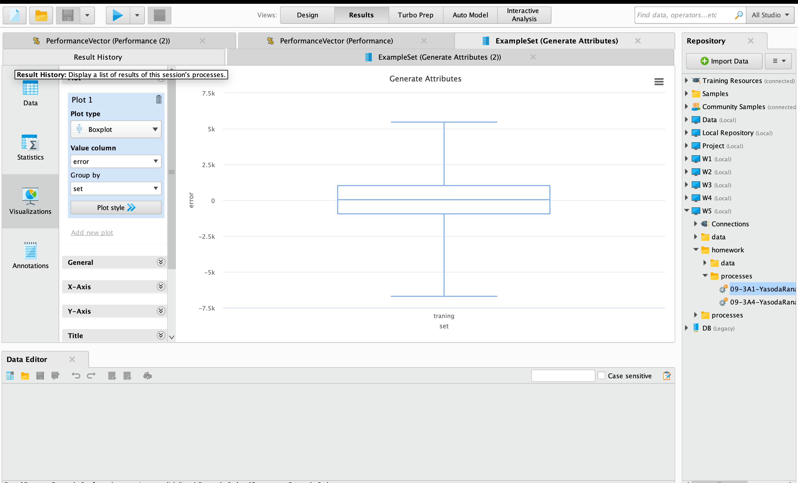
iii. Techniques for Improved Holdout Efficiency
We can decrease the tree's size and complexity to improve the model's performance on the holdout set. Among them are:
specifying the tree's maximum depth.
requiring each leaf to include a minimum number of records.
Cross-validation is used to adjust the parameters.
This somewhat reduces the accuracy on the training set but enhances the tree's ability to generalise, which raises the holdout predictions.
iv. Cross-validated Tree with Fine-Tuning
Next, we used Grid Search to adjust the parameters and 5-fold cross-validation to create a smaller tree. By doing this, we were able to identify the "best-sized" tree rather than utilising the mature one.
Due to its simplicity, the adjusted tree's RMS error on the training set was marginally greater than that of the full-grown tree.
The tuned tree outperformed the overfitted entire tree in predicting fresh data, as evidenced by the improvement in the holdout RMS error.
In conclusion, the optimal balance between training and holdout performance was provided by the refined regression tree. The mature tree did not generalise properly, even if it appeared flawless on training data. For forecasting the pricing of automobiles that weren't in the training set, the optimised smaller tree performs better.

