FDTP User Manual
File & Directory Tool for Pomera

✨ The stock Pomera software didn't have one, so I made a vertical & horizontal novel editor with ruby! ✨
(Narou and Kakuyomu notation, publisher-style formatting included)
Oh, and while I was at it: a file manager that shows images, Excel, Word, PowerPoint and PDF too!
And while I was at that: merge, split and mark up PDFs too!
PowerPoint? Press F5 for a slide show!
And English screens, for Pomera DM250US folks! 🎉
Version 1.10
By yasoteien
Contents
(The table of contents is updated when Word opens the file. If it is not, right-click here and choose Update Field.)

1. Introduction

1.1 What FDTP is
FDTP is a file manager for the King Jim Pomera DM250 running Debian 13. A file manager shows a list of files and lets you copy, move, delete and open them with the keyboard.
Its screens and keys follow FD 3.13, a file manager that many people used on the NEC PC-98. If you have used FD, most of the keys will be familiar.
Besides the file manager, FDTP includes:
• Viewers for text, hex, PDF, Word (docx), Excel (xlsx), csv, PowerPoint (pptx) and images. You can edit the text in docx, xlsx, csv and pptx files.
• PDF markup (highlights, sticky notes and more) and a PDF menu for merging, splitting and other page operations.
• An editor for Japanese novel manuscripts (ruby, emphasis dots and vertical writing).
• Browsing, creating and extracting archives (tar, zip and LHa), and splitting and joining files.
FDTP runs on the DRM/KMS console (the text screen without a desktop) and in an X11 window. Its screens are in English or Japanese.

1.2 What has been tested
FDTP has been tested only on the Japanese Pomera DM250 and on PCs.
Machine | Status
Pomera DM250 (Japanese model) | Tested
PC (Debian 13) | Tested
Pomera DM250US (US model) | Not tested. Its keyboard has a US layout, and the arrow keys are arranged differently. We do not know whether Alt and the right Shift reach Debian the same way as on the Japanese model, or whether the internal memory is in the same place
Pomera DM200 | Not tested. It has the same SoC and a 1024x600 screen, but we do not know whether a Debian 13 image for it supports DRM/KMS. It also has only 512 MB of memory
Raspberry Pi and others | Expected to work on Debian 13 with DRM/KMS, but not tested on real hardware

1.3 No warranty
FDTP comes with no warranty, as stated in sections 15 and 16 of the GNU AGPL. If something does not work on your machine, you are welcome to fix it in your own copy.

2. Installation

2.1 From a .deb package
An armhf .deb package for the Pomera is on the GitHub Releases page. Its name is fdtp_<version>-1_armhf.deb (for example fdtp_0.09-1_armhf.deb). It is for Debian 13 only.
sudo apt install ./fdtp_<version>-1_armhf.deb
sudo fdtp-pomera-setup # optional: the Pomera settings in 2.4
The .deb installs the following.
What | Where
The program | /usr/bin/fdtp
LocalSend helper (4.7) | /usr/bin/fdtp-localsend
Menu entry and icons | /usr/share/applications/fdtp.desktop, /usr/share/icons/hicolor/
README, licenses and the PDF of this manual | /usr/share/doc/fdtp/
The Pomera settings command | /usr/sbin/fdtp-pomera-setup (its helpers in /usr/share/fdtp/pomera/)

zip, unzip and lhasa, for archives, dosfstools, for checking the internal memory, and libheif1 and libheif-plugin-libde265, for HEIC photos, come along as recommended packages. Install uim-mozc for Japanese input yourself if you need it (6.5).
On a Pomera DM250, the first install only tells you about fdtp-pomera-setup. It never changes any setting by itself.
fdtp-pomera-setup asks the same two questions as ./configure (2.4) and applies the settings you choose.
Command | What it does
sudo fdtp-pomera-setup | Asks, then makes the settings. The PIO change, which rewrites the SD card, is asked once more (default "no")
sudo fdtp-pomera-setup --yes | Takes every default answer without asking. The SD card is then never rewritten
sudo fdtp-pomera-setup --undo | Undoes the settings. Undoing the PIO change is asked once more
sudo fdtp-pomera-setup --status | Lists the settings that are in place

On anything but a Pomera DM250 it does nothing. To remove FDTP, use sudo apt remove fdtp. This does not undo the Pomera settings; it lists the ones left and how to undo them (install the .deb again and run sudo fdtp-pomera-setup --undo). The original 1 MiB of the PIO change stays in /var/lib/fdtp.

2.2 From the source
./configure
make -j4
sudo make install
./configure first checks for the libraries the build needs. If something is missing, it stops and prints the sudo apt install line to install it. It then asks a few questions (2.3).
To build, you need a C11 compiler (gcc or clang), GNU make, Python 3, pkg-config, and these libraries:
For | Debian packages
Screen (DRM/KMS, EGL, GLES2) | libdrm-dev libgbm-dev libegl-dev libgles-dev
X11 window (optional) | libxcb1-dev
PDF and pptx | libmupdf-dev
Images | libjpeg-dev libpng-dev libgif-dev libwebp-dev
docx, xlsx, zip | zlib1g-dev libexpat1-dev
Japanese input (optional) | libuim-dev
LocalSend (optional; 4.7) | libssl-dev

libheif1 and libheif-plugin-libde265, for HEIC photos (5.8), are not needed to build. FDTP loads them when it opens a HEIC file, so you can install them later without building again. Run as root, ./configure offers to install them when they are missing.
For archives, FDTP uses the zip, unzip, lhasa and tar commands.
You can build on the Pomera itself, but it is slow. The README describes how to build for the Pomera on a PC (cross-building).
sudo make install installs the following. <PREFIX> is /usr/local by default.
What | Where
The program | <PREFIX>/bin/fdtp
LocalSend helper (4.7) | <PREFIX>/bin/fdtp-localsend
Menu entry and icons | <PREFIX>/share/applications/fdtp.desktop, <PREFIX>/share/icons/hicolor/
README, license and the PDF of this manual | <PREFIX>/share/doc/fdtp/
Language setting | /etc/fdtprc (when you chose a language in ./configure)

To remove FDTP, run sudo make uninstall. It does not undo the Pomera settings in 2.4; it prints how to undo them.

2.3 Questions from ./configure
Each question comes after a short explanation of what it does and how to undo it. Pressing Enter alone picks the capitalized answer in the brackets.
1. Language of the screens: Japanese, English, or auto. Auto follows LANG. You can change it later in the settings (z).
2. Wi-Fi stabilization (Pomera DM250 only; see 2.4).
3. Internal memory mount (Pomera DM250 only; see 2.4): choose read-only, read-write, or no mount.
4. libheif for HEIC (only when it is missing, and only as root): asks whether to install it. Without root, it prints the line to install it (5.8).
Options:
Option | Meaning
--yes | Do not ask; take the default answers
--lang=ja --lang=en --lang=auto | Choose the screen language
--prefix=DIR | Choose where to install (default /usr/local)
--no-pomera | Skip the Pomera questions

2.4 Pomera DM250 settings
./configure asks the following two questions only when it runs on a Pomera DM250. The settings you choose are applied by sudo make install.

Wi-Fi stabilization
On Debian 13 for the DM250, the SD card, the internal memory and Wi-Fi share one DMA controller (the circuit that moves data). A fault there can stop all three at once and freeze the Pomera. This setting does three things:
• Turns off Wi-Fi power saving.
• Enables the hardware watchdog, which restarts the Pomera automatically if it freezes.
• Switches Wi-Fi alone from DMA to PIO (the CPU moves the data itself).
The switch to PIO rewrites 1 MiB on the SD card. Please note:
• It works only with an SD card made from the ekesete.net Debian 13 image for the D250. If the data on your card is different, it stops without doing anything.
• It saves the original 1 MiB before writing.
• sudo make install asks once more before it writes to the card. The default answer to that question is "no".
• Battery life gets slightly shorter, and Wi-Fi may be slower.
• A reboot is needed afterward.

Mounting the internal memory
This mounts the internal memory, where the Pomera's own editor (the Pomera mode) keeps its documents, at /mnt/pomera-internal on every boot. You can then work with those documents in FDTP. Choose one of three options:
Answer | What it does
1. Read-only (default) | Lets you read without writing to the internal memory. Adds one line to /etc/fstab
2. Read-write | Lets Debian write to the internal memory. Files written there also appear in the Pomera mode
3. Do not mount | Does not mount it. Removes the setting from an earlier version, if present

Before choosing read-write: The setup explains the points below and asks again whether to use read-write. If you answer no, it returns to the three choices.
• If the Pomera freezes, a file being written at the time may not be recoverable.
• On each boot, it checks only the internal memory's dirty flag. If the flag is set, as after a freeze, it runs a read-only check (fsck.fat -n) after boot. It does not run the check every time, so boot is not slowed down.
• It does not repair anything automatically. The repair tool could change the Japanese short names created by the Pomera mode.
• If the check finds no problems, the memory is mounted read-write. If it finds a problem, it is mounted read-only. You are notified when you log in and when you start FDTP.
• The check needs dosfstools (sudo apt install dosfstools).
If a problem is found: FDTP shows the internal memory check window once per launch. Two lines of warning also appear when you log in to a terminal. The check output is in /var/lib/pomera-internal/fsck.txt. To repair it, make a copy first, then use sudo fsck.fat -r to review each change. If asked to change a short name, answer n. These are Japanese names used by the Pomera mode.
The location is the one used on the Japanese DM250. If nothing is found there, the question is skipped and any previous setting is left as it was.

How to undo
To undo | Command
Wi-Fi power saving and the watchdog | sudo sh scripts/pomera/pomera_stability.sh remove
Wi-Fi PIO (the SD card change) | sudo sh scripts/pomera/pomera_dma_pio.sh restore
The internal memory mount | sudo sh scripts/pomera/pomera_mount_internal.sh unpersist

Run them in the top directory of the source. If you installed the .deb, sudo fdtp-pomera-setup --undo undoes them all (2.1). Reboot after restoring the PIO change.

2.5 Updating
You do not need to remove the old version first. Install the new version over it. Check the current version with fdtp -v.
If you installed from a .deb: Install the new .deb.
sudo apt install ./fdtp_<new-version>-1_armhf.deb
If you installed from source: Get the new source with git pull, or unpack a new source archive. Run the same three commands:
./configure
make -j4
sudo make install
What stays and what changes
What | When you update
Program, helper, menu and manual | Replaced with the new version
Your settings (~/.fdtprc), input history and LocalSend certificate (~/.fdtp/) | Kept as they were
/etc/fdtprc | Only the language (LANGUAGE) line changes to your new answer
Pomera settings (2.4) | If you choose a different answer, the old setting is removed before the new one is applied. If a question is skipped, the old setting stays

3. Starting, quitting and the screen

3.1 Starting and quitting
fdtp # open the current directory
fdtp ~/Documents # open the given directory
fdtp -v # print the version
Option | Meaning
--kms | Run on the DRM/KMS console
--x11 | Run in an X11 window
--fullscreen | Start the X11 window in full screen
--size auto --size 160x45 | Set the number of columns and rows

Without --kms or --x11, FDTP opens a window when it runs on an X desktop, and uses the DRM/KMS console otherwise. You can also start it from the menu of Xfce and other desktops.
To quit, press q or Esc and answer "yes" in the confirmation box. The left Ctrl+c quits at once, without asking.
On the Pomera's 1024x600 screen, FDTP shows 85 columns by 25 rows. On larger screens, it adds columns and rows to fill the screen. The size of each character stays the same.

3.2 Notes on the Pomera keyboard
• The Alt key is to the left of the space bar, left of the Muhenkan key.
• The Pomera DM250 has separate F1 to F10 keys. Just press them.
• The Pomera has no F11 or F12. The commands on F11 and F12 are also on other keys (see the tables in chapter 4).
• Most commands on Alt are also on Ctrl+letter or Shift+F1 to F10.
• The small right Shift key works as Shift.

3.3 The file manager screen
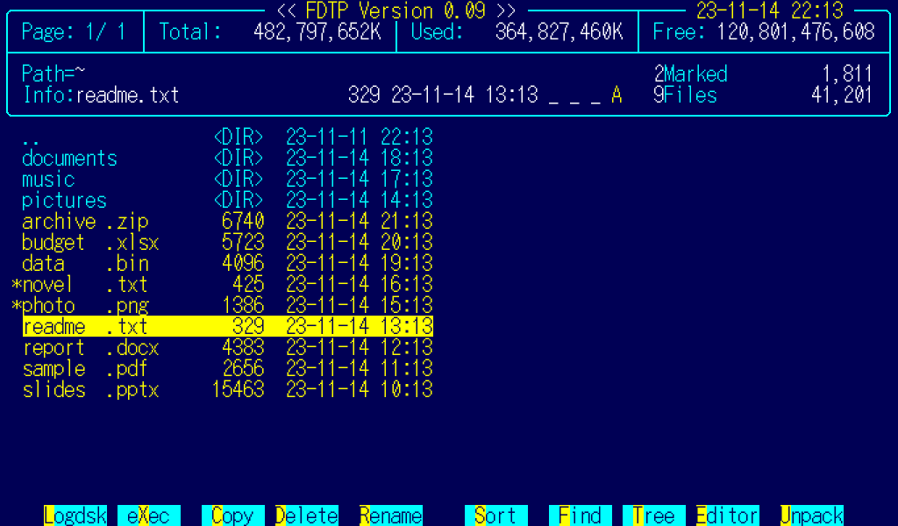
Figure 1. The file manager
From the top of the screen:
Where | Name | Contents
Row 1 | Title and clock | FDTP Version 1.00 and the current date and time
Row 2 | Page and disk space | Page: which page of the list. Total: Used: Free: the size, used space and free space of the disk
Row 4 | Path | Path= the current directory, with your home shown as ~. On the right, Marked: the number and total size of the marked files
Row 5 | Cursor info | Info: the name, size, date and attributes (R read-only, H hidden, and so on) of the file at the cursor. On the right, Files: the number and total size of the files
Row 7 down | List | The files and directories. The cursor is shown in reverse video
Second row from the bottom | Message line | Short results and errors, and input such as file names
Bottom row | Function key band | The commands on F1 to F10. While you hold Shift, it shows the commands on Shift+F1 to F10

The list shows up to 8 characters of the name and 4 of the extension. Use ( and ) to scroll long names.
Confirmations, input, choices and messages appear in boxes that float over the screen. If a box does not fit, scroll it with the up and down arrows.

3.4 Changing the language
The first time FDTP starts, it asks which language to use.
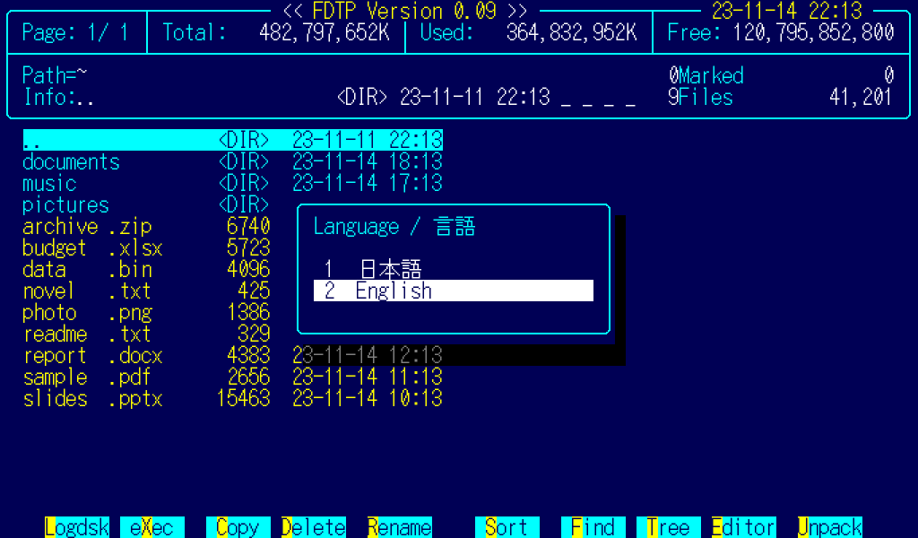
Figure 2. The first-run language question
Press 1 for Japanese or 2 for English, or choose with the arrows and Enter. The answer is saved in ~/.fdtprc. Esc saves nothing, and FDTP asks again next time. If /etc/fdtprc or ~/.fdtprc already sets the language, FDTP does not ask.
You can change the language later in three ways:
Where | How
Settings (z) | Press Enter on LANGUAGE to switch. The screen changes at once
~/.fdtprc | LANGUAGE=auto, LANGUAGE=ja or LANGUAGE=en
Environment variable | FDTP_LANGUAGE=ja or FDTP_LANGUAGE=en. This overrides the settings

With auto, FDTP looks at LC_ALL, LC_MESSAGES and LANG in that order. If the value starts with ja, the screens are in Japanese; otherwise they are in English.

4. Using the file manager
Press h or ? for the list of keys (help).
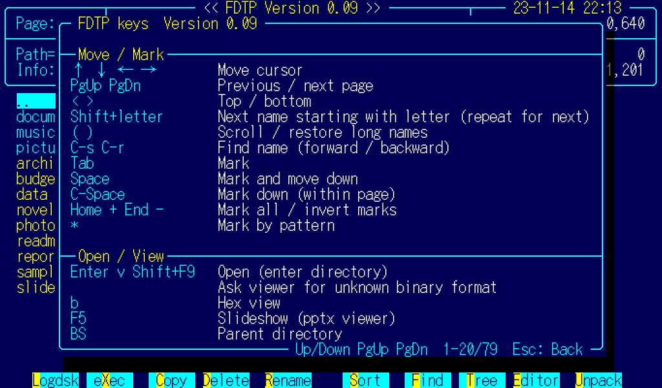
Figure 3. Help

4.1 Moving and marking
Key | Action
Up Down Left Right | Move the cursor
PgUp PgDn | Previous or next page
< > | Top or bottom of the list
Shift+letter | Next name that starts with that letter. Press again for the one after
( ) | Scroll a long name, or scroll it back
Ctrl+s Ctrl+r | Search for a name, forward or backward
Enter | Enter a directory, or open a file (chapter 5)
BS | Parent directory
\ (Yen) | Root directory
l F1 | Type a path and go there
Tab | Mark
Space | Mark and move down
Ctrl+Space | Mark and move down (within the page)
Home + | Mark all
End - | Invert the marks
* | Mark the files that match a pattern such as *.txt

When files are marked, operations such as copy apply to all the marked files.

4.2 File operations
Key | Action
c F3 | Copy
m Shift+F3 | Move
d F4 | Delete. Directories are deleted with their contents. FDTP shows the number of files and directories and asks first
r F5 | Rename
a F11 Shift+F1 | Attributes (read-only, hidden, executable, and so on)
Ctrl+a | Change attributes in all subdirectories
k Shift+F5 | Make a directory
Ctrl+d Shift+F4 | Remove a directory
x F2 | Execute
Shift+F6 | Shell. Exit the shell to return to FDTP
i | Information on the file at the cursor (location, type, size, creation and modification times, attributes, owner, and so on)
F12 Shift+F2 | File system information
Alt+i | System information (chapter 9)
Del ] | Take the name at the cursor off the list and push it (up to 5)
Ins [ | Put a pushed name back at the cursor
w Shift+F7 | Write the directory. Not available on Linux (it only shows a message)

Destination boxes
In the boxes that ask for a destination, such as copy and move:
• Down or Alt+Down opens a list of the destinations you used before (history). Choose with the arrows and press Enter. Typing narrows the list to entries that start with what you typed.
• F8 lets you choose the destination from a tree.
The history keeps up to 20 entries of each kind, newest first, in ~/.fdtp/history.

4.3 Display and windows
Key | Action
1 2 3 5 | Number of columns in the list
s F6 | Sort (by name, extension, size, date, and so on)
Ctrl+h | Show or hide hidden files (names starting with .)
Ctrl+l | Reload
/ | Split into two windows
^ | Next window
Ctrl+w Ctrl+n | Widen or narrow the window
Ctrl+k | Close the window

4.4 Finding and the tree
Key | Action
f F7 | Show only the names that match a pattern such as *.pdf
t F8 | Directory tree. Go to the directory you choose
Ctrl+f | Find a directory (searches the subdirectories by name)

4.5 Archives
Press Enter or v on an archive (tar, tar.gz, tar.bz2, tar.xz, zip or LHa) to look inside. The inside looks the same as the file manager.
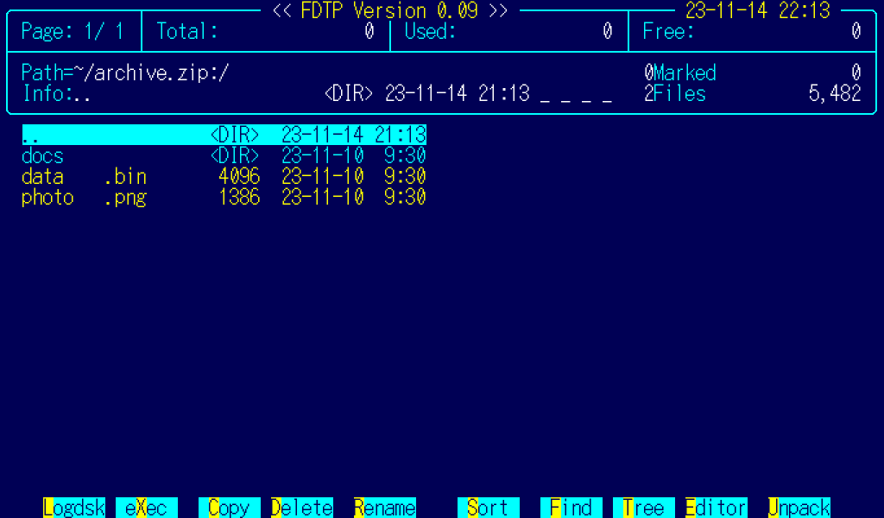
Figure 4. Inside an archive
Key | Action
u F10 | Unpack. FDTP asks for the destination
p Shift+F10 | Pack (create an archive)

p opens the "Pack archive" box. Move between the fields with Tab, choose with the arrows, and press Enter to create the archive.
Field | Contents
Archive name | The name at the cursor or of the current directory at first. The extension changes with the format
Format | LHA, ZIP, TAR, TAR.GZ, TAR.BZ2, TAR.XZ
Compression level | Low to high (TAR is not compressed)
Names | For LHA only: SJIS or UTF-8
Same name | When adding to an existing archive: always overwrite, or only if newer

LHa archives start with Shift_JIS (SJIS) file names, which a PC-98 can read. Press ← or → in the Names field to switch to UTF-8. The format, level, names and other choices are kept for the next time you open the box.

4.6 Splitting and joining files
Split (Alt+n): splits a large file into pieces of a fixed size. The default is 10 MB, a size you can attach to most email.
1. FDTP asks for the start of the new names. The pieces are named name.001, name.002, and so on.
2. It asks for the size of each piece: a number followed by K or M (1K to 1023M).
3. It shows how many pieces it will create and asks you to confirm.
4. It asks whether to create a shell script for joining the pieces (name.join.sh).
You can change the default size with SPLIT_SIZE in ~/.fdtprc.
Join (Alt+h): joins the marked files into one.
1. FDTP asks for the name of the joined file. If all the files end in .001 and so on, the name without that ending is filled in.
2. It shows the order of the files, by name at first. Choose a file with the arrows and move it up or down.
If a file with the same name exists, FDTP asks before overwriting it. Alt+n and Alt+h on PDF files split and join the pages instead (5.4).
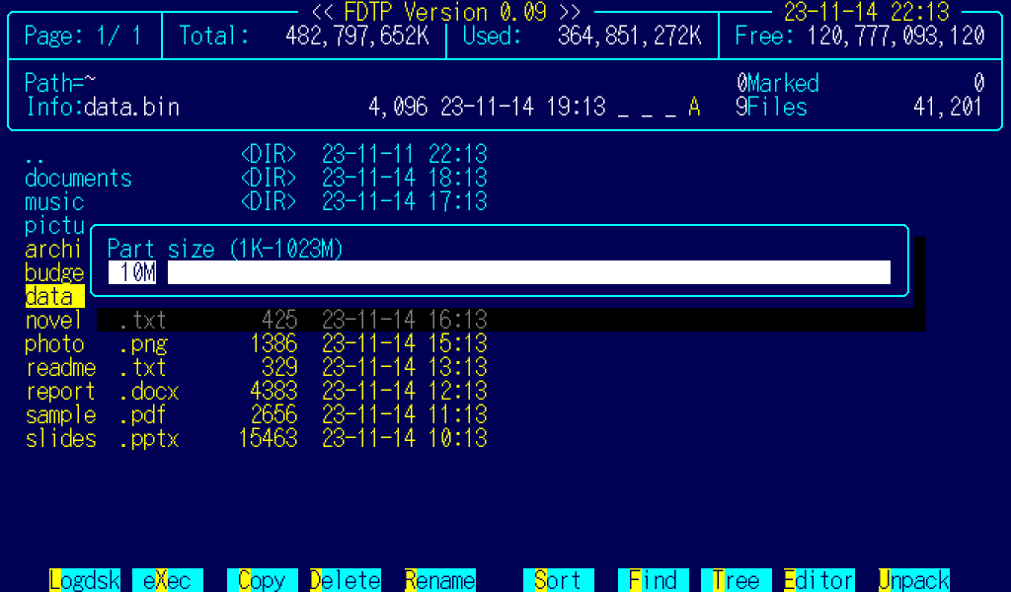
Figure 5. Split

4.7 Sharing with iPhone and Mac (LocalSend, Alt+l)
You can exchange files with an iPhone, iPad, Mac, Windows or Android device on the same Wi-Fi network. Install the free LocalSend app on the other device, from the App Store, Google Play or its official site. Transfers go directly over the local network, without the internet. They are encrypted, except when sharing with a browser.
Press Alt+l to choose what to do.
Key | Action
S | Send the marked items, or the item under the cursor if none are marked. Directories are sent as zip files
R | Receive into the current directory
B | Share with a browser. The other device can download with Safari or another browser, without LocalSend

Every screen shows this notice: "People on this network can see this device's name. Use a trusted LAN, such as at home, or your smartphone's personal hotspot (tethering)." Do not use it on public Wi-Fi.
Send
1. Mark the items to send, then press Alt+l and S.
2. LocalSend devices on the same network appear in a list. Choose one with Up and Down, then press Enter.
3. If the receiver has set a PIN, enter the PIN shown on its screen. It may contain more than digits.
4. When "Items sent" appears, press Esc to return.
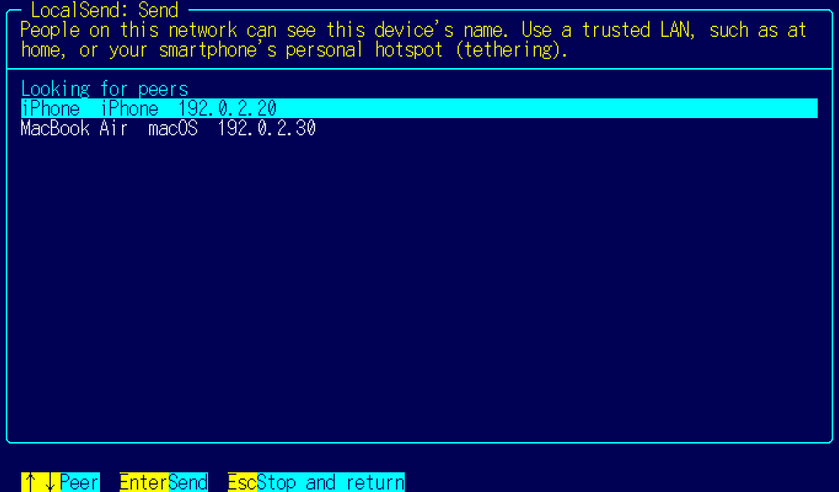
Figure 6. Peer list
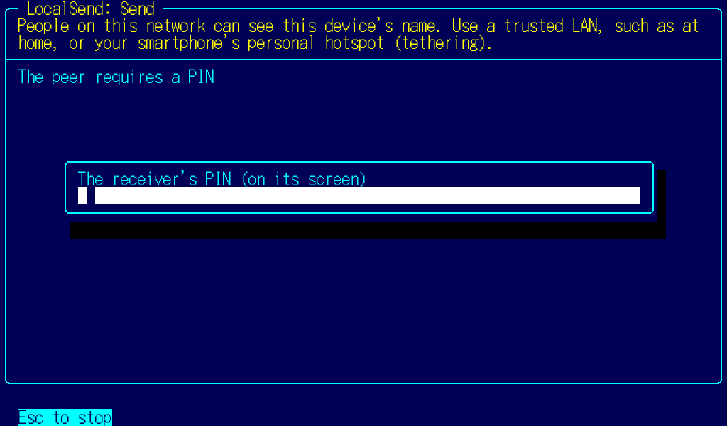
Figure 7. Entering the receiver's PIN
Receive
1. In the directory where you want the files, press Alt+l and R.
2. The screen shows this device's name, IP address and six-digit PIN. A new PIN is made each time you start receiving.
3. On the other device, choose the name in LocalSend and send the files. Enter the PIN when asked. The name defaults to the hostname; you can change it with LOCALSEND_ALIAS in ~/.fdtprc.
4. When asked "From ...: receive ... items (... MB)?", press y to accept, or n or Enter to refuse.
5. When "Received ... files" appears, you can receive from another device. Press Esc to stop.
If a file with the same name exists, the new file is saved under a different name, such as name (2).txt. If the sender stops or nothing arrives for 30 seconds, FDTP gives up the transfer and waits for the next one.
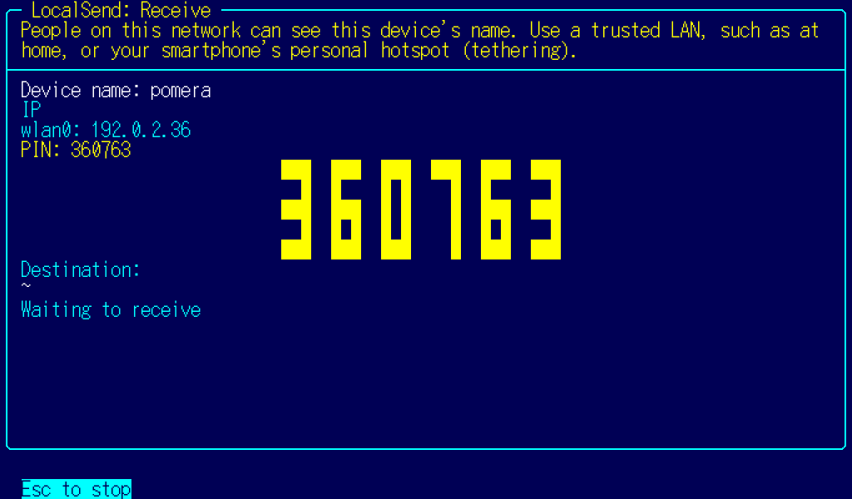
Figure 8. Receive screen
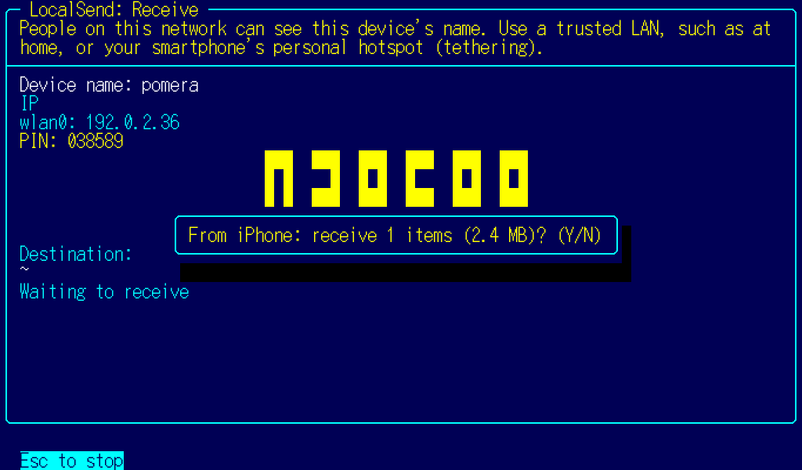
Figure 9. Receive confirmation
Share with a browser
1. Mark the items to share, then press Alt+l and B.
2. The screen shows a URL (http://device-IP:53317) and a PIN.
3. On the other device, open the URL in a browser and enter the PIN. A list of files appears. Use "Download" to receive them.
4. The bottom of the screen shows who downloaded what. Press Esc to stop.
This is not encrypted. Use only a trusted LAN, such as at home. Sharing stops after five incorrect PIN attempts.
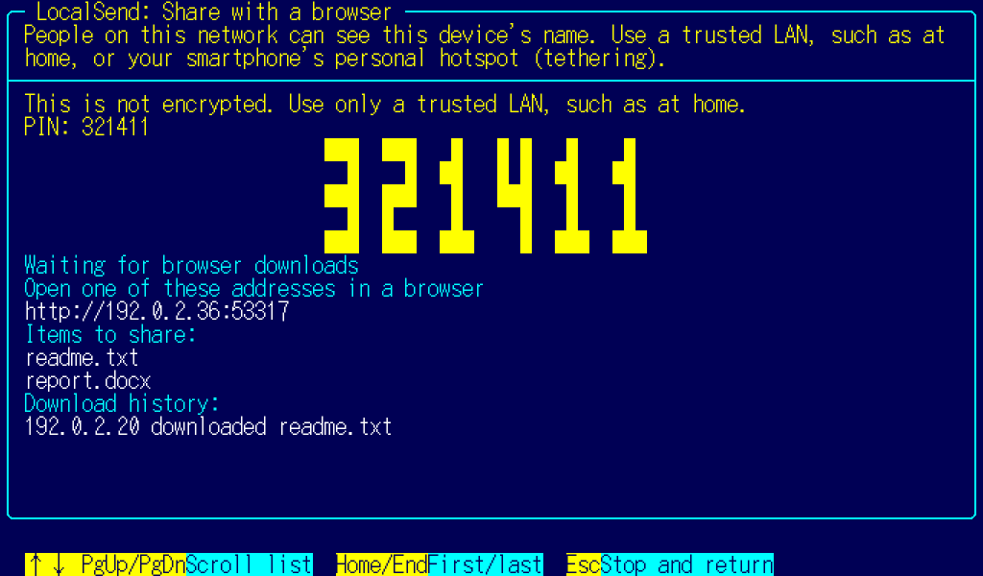
Figure 10. Browser sharing screen
Enter the PIN in a browser | File list
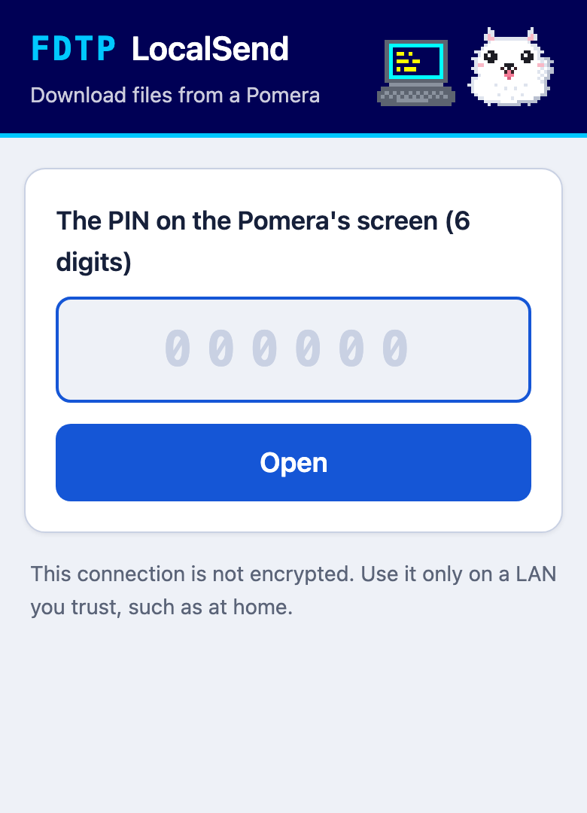  Figure 11. Browser PIN entry | 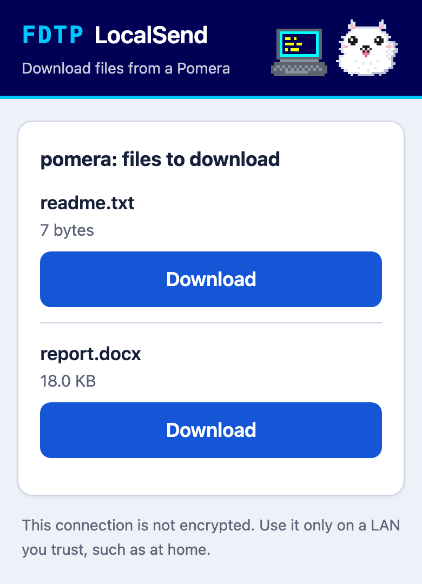  Figure 12. Browser file list

Preparing the other device and responding to prompts
• iPhone and iPad: Install LocalSend from the App Store. It lists in-app purchases, but these are donations; you can use all features without paying. The first time you open it, allow it to find devices on local networks. If you deny access, devices will not appear. You can change this later in Settings > Privacy & Security > Local Network > LocalSend.
• Using a PIN in LocalSend: After setting a PIN in LocalSend's receive settings, press OK on the PIN screen to activate it. Until then, receiving remains available without a PIN.
• Mac: When receiving with LocalSend, macOS may ask to allow incoming connections. Choose Allow. You can change this later in System Settings > Network > Firewall.
• Windows: The firewall asks for permission the first time you use it.
• Pomera (Debian): There is no firewall by default. If you have installed one such as ufw, open TCP and UDP port 53317 (for example, sudo ufw allow 53317).
• Photos from an iPhone camera arrive in HEIC format. FDTP's image viewer opens them (5.8).

5. Viewers
Press Enter or v on a file to open it in the viewer for its format.
Format | Opens in
Text | Text view (5.1)
PDF | PDF viewer (5.3)
docx | Document view (5.5)
xlsx, csv, tsv | Sheet view (5.6)
pptx | Slide view (5.7)
JPEG, PNG, GIF, BMP, WebP, MAG, Pi | Image view (5.8)
tar, zip, LHa | Archive list (4.5)
.mid, .rcp, .r36, .g36 | rmp-jukebox (chapter 7)

For a file in an unknown format that looks binary, FDTP asks whether to use "Text view (T)", "Binary view (B)" or "Cancel". b opens any file in the hex view.
All full-screen viewers share one layout. The file name is in the top line of the frame, and the status (line or page, encoding, and so on) is in the bottom line. Below the frame are the message line and the key band.

5.1 Text view
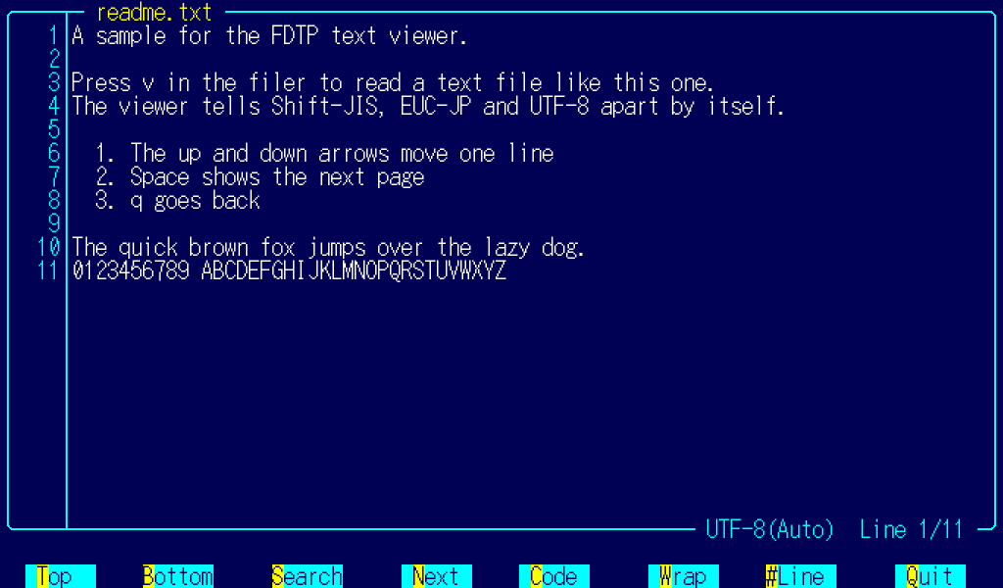
Figure 13. Text view
Key | Action
Up Down PgUp PgDn Space | Scroll
< > | Top or bottom
/ n N | Search, next match, previous match
c | Choose the encoding (auto, Shift_JIS, JIS, EUC-JP, UTF-8, UTF-16LE, UTF-16BE)
# | Show or hide line numbers (shown by default)
w | Turn line wrapping on or off
q Esc | Back

The bottom line shows the current encoding, with "(auto)" when FDTP chose it.

5.2 Hex view
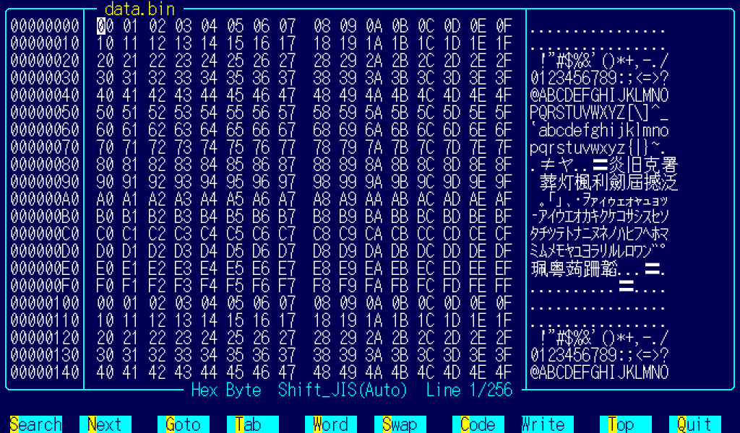
Figure 14. Hex view
From left to right: address, hex and characters. Each row shows 16 bytes.
Key | Action
Arrows PgUp PgDn Home End < > | Move the cursor
Tab | Switch between the hex column and the character column
0-9 a-f (hex column), characters (character column) | Change the byte at the cursor
Ctrl+s | Write (save)
g | Go to an address
/ n | Search, next match
w | Group by byte, word (2 bytes) or double word (4 bytes)
s | Swap the byte order (word or larger)
c | Encoding of the character column
q Esc | Back

The character column uses the encoding you chose, so characters that span several bytes, such as kanji in UTF-8, are shown correctly.

5.3 PDF
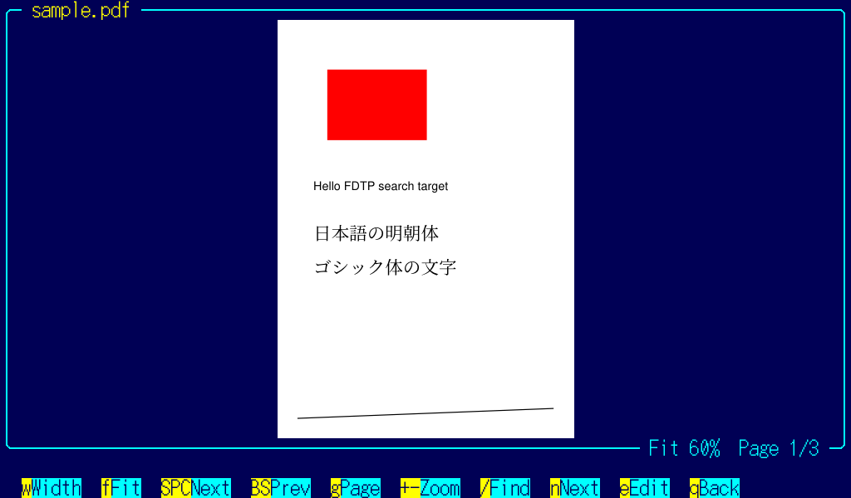
Figure 15. PDF viewer

Viewing
Key | Action
Space PgDn | Next page
BS PgUp | Previous page
Home End | First or last page
Up Down | Scroll up or down. At the edge, go to the previous or next page
Left Right | Scroll left or right
g | Go to a page number
w f | Fit the width, or fit the whole page
+ - | Zoom in or out
/ n | Search, next match
Alt+p | The PDF menu (5.4)
h ? | List of keys
q Esc | Back. If you have unsaved markup, FDTP asks whether to save it

For a password-protected PDF, FDTP asks for the password when opening it. What you type is shown as * and is not kept in the history.

Markup
Press e to start marking up. A text cursor appears on the text of the page.
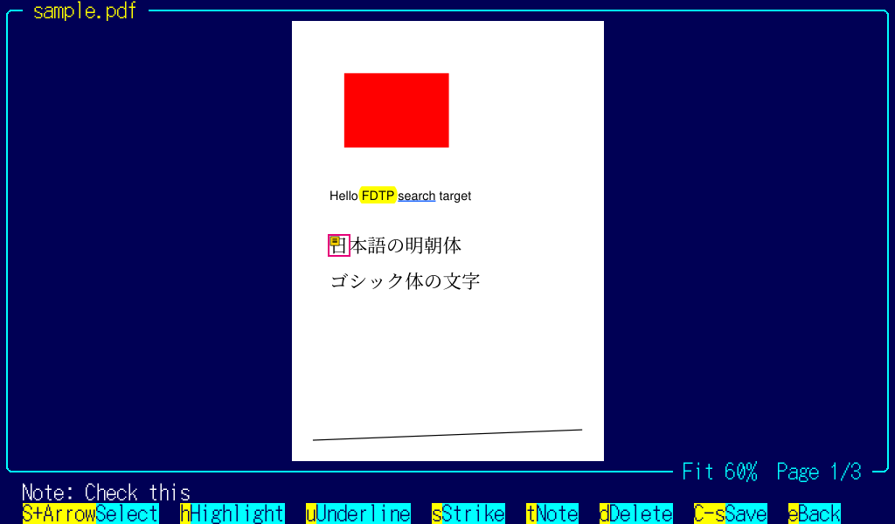
Figure 16. PDF markup
Key | Action
Arrows | Move the text cursor
Shift+arrows | Select text (across lines, but not across pages)
Home End | Start or end of the line
h | Highlight (yellow)
u | Underline (blue)
s | Strikethrough (red)
t | Add a sticky note, or edit the note at the cursor
d Del | Delete the markup at the cursor
Enter | Read the whole text of a sticky note
Tab | Next markup on the page
Ctrl+s | Save
e Esc | Stop marking up (Esc while selecting only cancels the selection)

Sticky notes can be written in Japanese too. Alt+Space or the Hankaku/Zenkaku key turns Japanese input on and off.
Markup is saved as standard PDF annotations, so other PDF readers, such as Preview on the Mac, show it and can delete it. The text of the page itself is never changed. Saving appends to the end of the original file, so the earlier contents stay as they were.
How the markup looks in Acrobat and Edge has not been checked.
On pages with no text (scanned pages, for example), you can add only sticky notes.

5.4 The PDF menu (Alt+p)
Press Alt+p in the file manager, with the cursor on a PDF or with PDFs marked, or in the PDF viewer. Everything runs on the Pomera; nothing is sent anywhere.
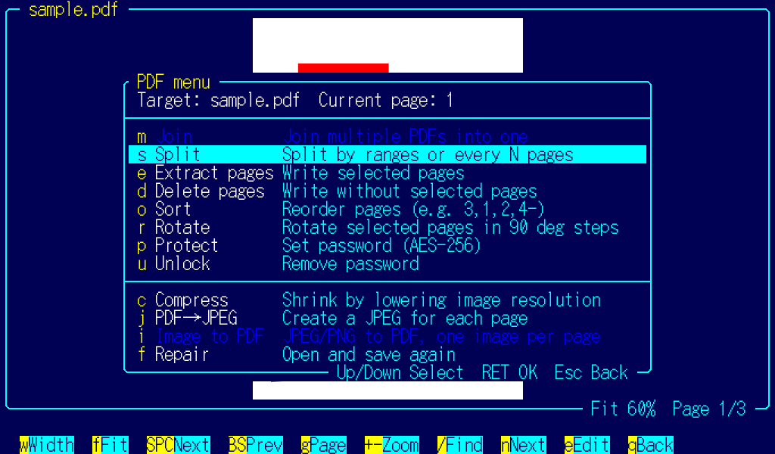
Figure 17. The PDF menu
Key | Item | For | What it does
m | Merge | Two or more PDFs | Joins the marked PDFs in the order you choose
s | Split | One PDF | Splits by page ranges or every N pages
e | Extract pages | One PDF | Makes a PDF of the pages you choose
d | Delete pages | One PDF | Makes a PDF without the pages you choose
o | Reorder | One PDF | Changes the order of the pages
r | Rotate | One PDF | Rotates the pages you choose by 90 degrees at a time
p | Protect | One PDF | Adds a password (AES-256)
u | Unlock | One PDF | Removes the password. You need the original password
c | Compress | One PDF | Makes the file smaller by lowering the resolution of its images
j | PDF to JPEG | One PDF | Saves each page as a JPEG
i | Image to PDF | JPEG or PNG files | Makes a PDF with one marked image per page
f | Repair | One PDF | Opens the PDF and saves it again

Write pages like 1-3,5,8-. 8- means page 8 to the end, and -3 means pages 1 to 3.
A suggested output name such as name_extract.pdf is filled in. You can also choose to replace the original file. If a file with the same name exists, FDTP asks before overwriting it. When it finishes, it shows the page count and size of each new file. If something fails, or you stop with Esc, FDTP deletes the unfinished output and leaves the original file as it was.

5.5 docx (Word documents)
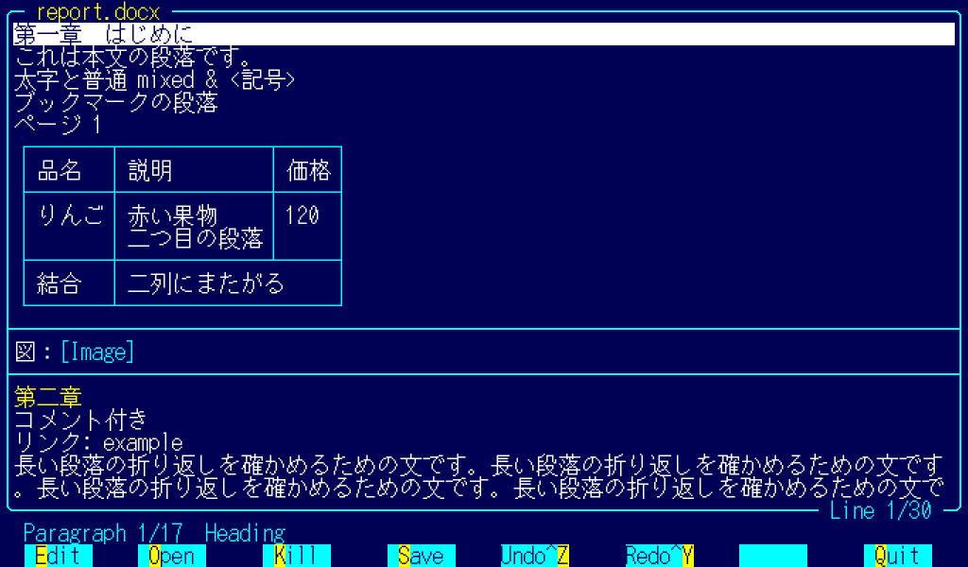
Figure 18. docx
Key | Action
Up Down PgUp PgDn | Choose a paragraph, scroll
Enter e | Edit the chosen paragraph (on the message line)
o | Add a paragraph
Ctrl+k | Delete the paragraph (asks first)
Ctrl+s | Save
Ctrl+z Ctrl+y | Undo, redo
q Esc | Back. Asks if there are unsaved changes

You can edit the text of paragraphs. An edited paragraph takes the formatting of its first character. Tables, images and heading styles stay as they were. Before the first save, FDTP always keeps the original file as .bak (no setting turns this off).

5.6 xlsx and csv (sheets)
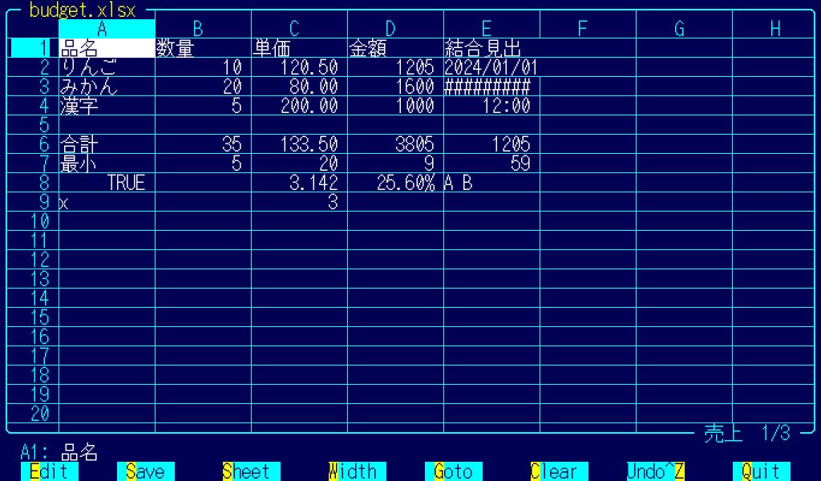
Figure 19. Sheet
Key | Action
Arrows PgUp PgDn | Move between cells
Home End | First cell, last cell with data
Enter, or start typing | Edit the cell. Start with = for a formula
Del | Clear the cell
Tab Shift+Tab | Next or previous sheet
< > | Narrow or widen the current column
Ctrl+g | Go to a cell address
Ctrl+s | Save
Ctrl+z Ctrl+y | Undo, redo
Esc | Back. Asks if there are unsaved changes

FDTP recalculates SUM, AVERAGE, MIN, MAX and COUNT, the four arithmetic operations, parentheses, cell references and ranges (A1:B3). Formulas with other functions keep their original results.
csv and tsv files are saved in the encoding they were read in. In xlsx files, only the changed cells are rewritten.

5.7 pptx (PowerPoint)
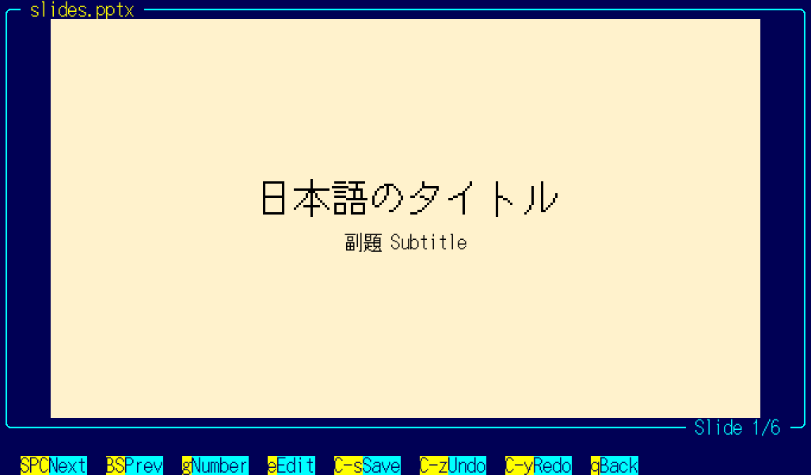
Figure 20. pptx
Key | Action
Space PgDn Down | Next slide
BS PgUp Up | Previous slide
g | Go to a slide number
e Enter | Start choosing a paragraph to edit
F5 | Slide show (full screen)
Ctrl+s | Save
Ctrl+z Ctrl+y | Undo, redo
q Esc | Back

While choosing, use the up and down arrows to choose a paragraph. The chosen paragraph has a purple frame around it. Press Enter or e to edit its text, and Esc to stop choosing. Pictures, positions and formatting stay as they were. You cannot add or delete slides.
In the slide show, Right, Down, PgDn, Space and Enter go to the next slide. Esc or F5 returns.
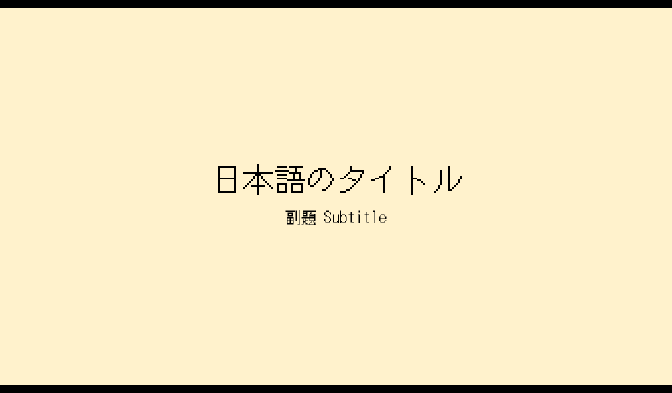
Figure 21. Slide show
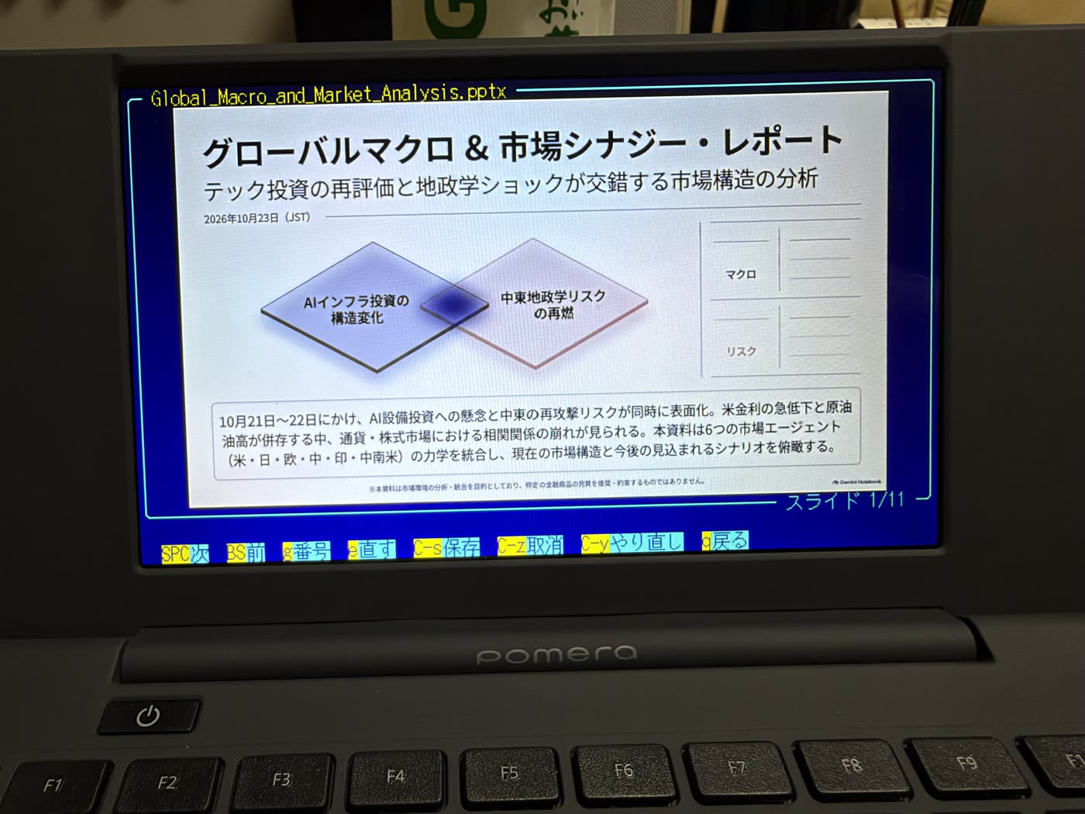
Figure 22. A pptx file on the Pomera

5.8 Images
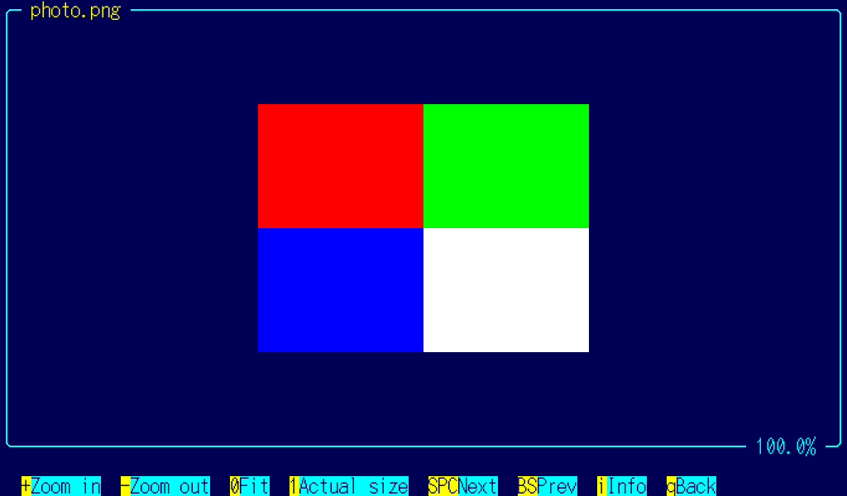
Figure 23. Image
Supported formats: JPEG, PNG, GIF, BMP, WebP, HEIC (iPhone photos), and the PC-98 formats MAG and Pi.
About HEIC
• Opening HEIC needs libheif1 and libheif-plugin-libde265 (the .deb usually brings them). When they are missing, FDTP shows the command to install them.
sudo apt install libheif1 libheif-plugin-libde265
• After installing them, HEIC opens without building FDTP again.
• Large photos take time to open. On the Pomera DM250, a 24-megapixel iPhone photo takes about 6 to 7 seconds.
• On the iPhone, Settings > Camera > Formats > Most Compatible takes photos as JPEG.
Key | Action
+ - | Zoom in or out
0 | Fit to the screen
1 | Actual size
Arrows | Scroll
Space BS | Next or previous image in the directory
i | Image information (size, format, colors)
q Esc | Back

6. The novel editor
This editor is made for writing Japanese manuscripts. Its special features (ruby, emphasis dots, vertical writing and publisher formatting) follow Japanese conventions. With English screens, all the features are still there; only the screen text is in English.
Press e or F9 in the file manager to open a file in the novel editor. Any file can be opened. Files that are not text are shown as they are (garbled), and FDTP warns before saving that the original bytes cannot be restored.
If the cursor is on .. or a directory, e asks for the name of a new file. The file is created when you save it.
To use an external editor (such as vi) instead, press Ctrl+e or Alt+e. FDTP uses $VISUAL, $EDITOR or vi, in that order.

6.1 The screen
Horizontal | Vertical
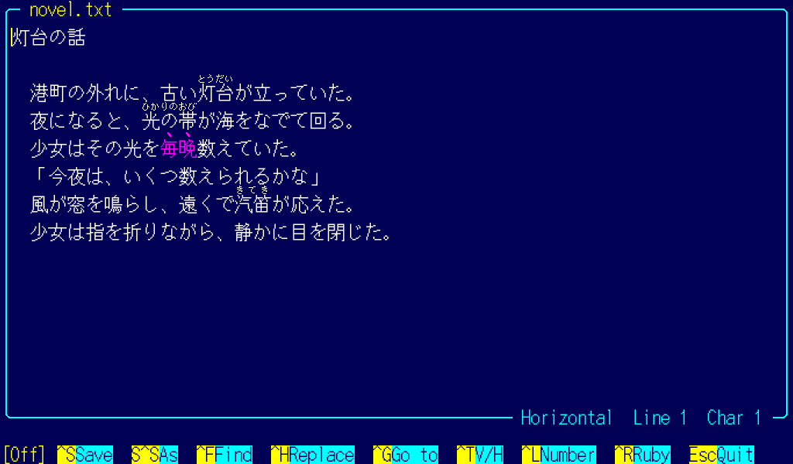  Figure 24. Horizontal | 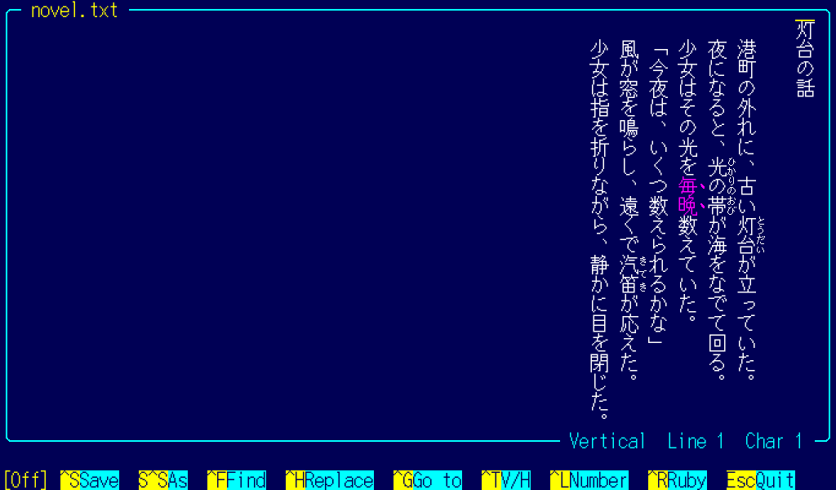  Figure 25. Vertical

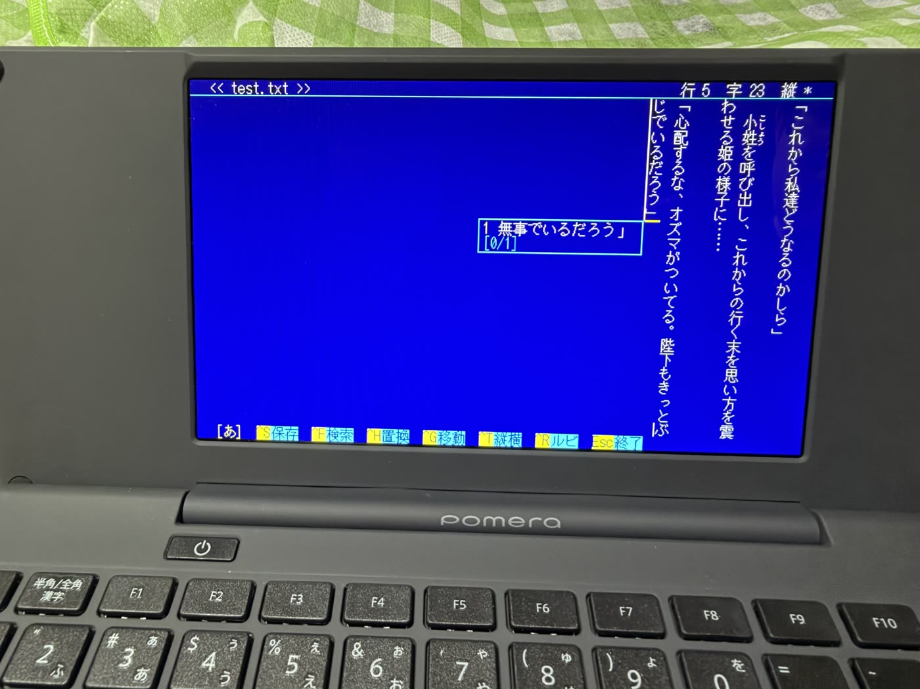
Figure 26. Writing a vertical manuscript on the Pomera
The file name is in the top line of the frame. The bottom line shows horizontal or vertical writing and the current line and character. Ctrl+t switches between vertical and horizontal writing. FDTP remembers the choice for each file.

6.2 Keys
F1 shows the list of the editor's keys.
Key | Action
Arrows | Move (in vertical writing, Up and Down move by character, Left and Right by column)
Ctrl+Home Ctrl+End | Beginning or end of the file
Shift+arrows | Select
Ctrl+a | Select all
Ctrl+c Ctrl+x Ctrl+v | Copy, cut, paste
Ctrl+z Ctrl+y | Undo, redo
Ctrl+f | Find
Ctrl+h | Replace (asks at each match)
Ctrl+g | Go to a line
Ctrl+r | Insert the ruby notation
Ctrl+t | Vertical or horizontal writing
Ctrl+l | Show or hide line numbers
Ctrl+s | Save
Ctrl+Shift+s | Save as
F2 | Convert (6.4)
F1 | List of keys
Esc | Close. Asks whether to save if there are changes

Files are saved in the encoding (UTF-8, Shift_JIS or EUC-JP) and line endings they were read with. If a character cannot be written in Shift_JIS, FDTP asks whether to save in UTF-8.
While there are changes, FDTP writes a copy to ~/.fdtp/autosave/ every 30 seconds and deletes it when the file is closed normally. If a copy is left when you open the file again, FDTP asks whether to open it.

6.3 Ruby and emphasis dots
Japanese web novel sites (Shosetsuka ni Naro and Kakuyomu) mark ruby (small reading aids, furigana) and emphasis dots with a plain-text notation. The editor shows that notation as real ruby and dots on the screen. The file keeps the notation as written.
Notation | On the screen
｜base《ruby》 | Ruby over "base"
漢字《かんじ》 | Ruby over the kanji just before 《
漢字（かんじ） | Ruby, when the parentheses hold only kana
《《text》》 | Dots over the characters (to the right in vertical writing)

Only while the cursor is on a ruby does the editor show the notation itself, so you can edit the ruby.
Notation that looks different on the two sites is shown in color: ruby in parentheses and emphasis dots in purple, and ruby longer than Naro allows in red.
Ctrl+r adds ｜…《》 around the selection (or the kanji just before the cursor) and puts the cursor between 《 and 》.

6.4 Convert (F2)
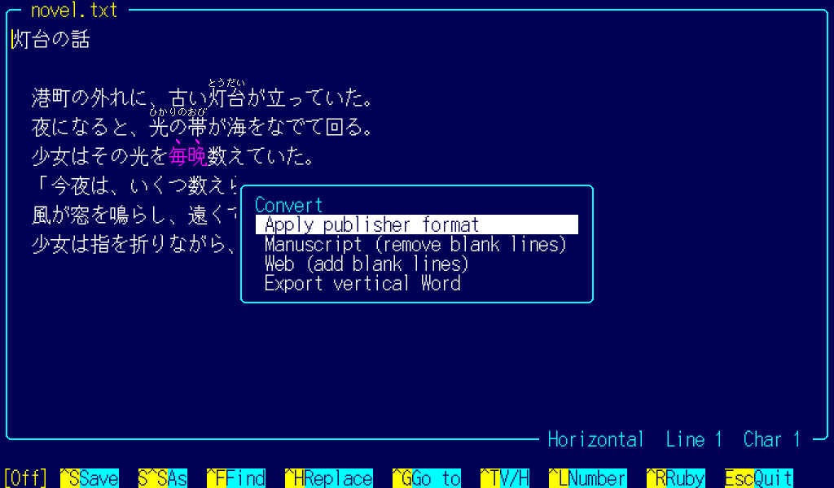
Figure 27. Conversion menu
F2 offers four conversions. Each one asks you to confirm with y or n first.
Item | What it does
Apply publisher format | Tidies the manuscript by the rules below. Also removes the blank lines of the web layout
Manuscript | Removes the blank lines of the web layout (a blank line after every line)
Web | Adds a blank line after each line that is not blank
Export vertical Word | Creates a .docx file with the same name in the same directory

One Ctrl+z undoes the whole of a format, manuscript or web conversion. The changes are listed in an information box and added to ~/.fdtp/format.log.
Scene break lines (lines of symbols only, such as ◇ or ＊＊＊) are kept as written, with one blank line before and after.

Formatting rules
Each rule can be turned on or off in the settings (z) or with NOVEL_FORMAT_NAME=0 or =1 in ~/.fdtprc. All are on by default.
Name | What it does
ZENKAKU | Turns half-width letters, digits and symbols into full-width ones
LEADER | Turns ・・・ into an ellipsis
EXCLAIM | Adds a full-width space after ！ and ？
EXCLAIM_KEEP | No space at the end of a line, within ！！ or ！？, or before 」』）
SPACES | Turns two full-width spaces in a row into one
LEADER2 | Turns ・・・ into …… (with 0, a single …)
HALFSPACE | Removes half-width spaces
INDENT | Indents the start of a paragraph by one character (not lines starting with 「『（)
PERIOD | Removes 。 from 。」 and 。』
DASH | Makes dashes ――
LEADER_EVEN | Makes runs of ellipses even
SCENE | Treats lines of symbols only as scene breaks
BLANK | Removes the blank lines of the web layout when formatting

Inside the 《》 of a ruby, only the full-width rule applies. The editor does not point out spelling variants or replace kanji. Formatting does not use generative AI.

Exporting a vertical Word document
FDTP writes a .docx with the same name in the same directory. Each line becomes one paragraph.
• Without a template of your own, FDTP uses its built-in default template: A4 portrait, vertical writing, the title (the first line) in 12 pt and the body in 10.5 pt, in the Yu Mincho typeface. The message after the export says the default template was used.
• With a template of your own, FDTP copies it and replaces only the body text. The paper, vertical writing, fonts and so on come from the template. FDTP looks for the template in this order:
1. The path in the environment variable FDTP_WORD_TEMPLATE
2. ~/.fdtp/template/本文フォーマット.docx
3. ~/.fdtp/template/本文フォ－マット.docx (with a full-width hyphen in the name)
• By default, the ruby notation goes into the body as plain text.
• With NOVEL_WORD_RUBY=1 in ~/.fdtprc, ruby and emphasis dots become Word's own ruby and emphasis marks.
• This export cannot be undone with Ctrl+z. If a .docx with the same name exists, FDTP asks before overwriting it.

6.5 Japanese input
Japanese input uses uim and Mozc (the packages uim and uim-mozc). The Hankaku/Zenkaku key or Alt+Space turns it on and off. It cannot be turned off in the middle of a conversion.
sudo apt install uim uim-mozc
In ~/.uim, write for example the following. The first line selects Mozc; the other two put Alt+Space and the Hankaku/Zenkaku key on turning input on and off.
(define default-im-name 'mozc)
(define-key generic-on-key? '("<Alt> " "zenkaku-hankaku"))
(define-key generic-off-key? '("<Alt> " "zenkaku-hankaku"))
Text being typed is underlined, and the candidates are listed below it. The same input works in the other input lines, such as rename and sticky notes.

7. Launching other programs
FDTP can also serve as a launcher. When it starts another program that draws on the DRM/KMS console, FDTP gives up the screen, and takes it back when the program exits. The two do not get in each other's way.
For example, the MIDI player rmp-jukebox (Retro MIDI Player) works like this:
• Enter or v on .mid, .rcp, .r36 and .g36 files starts rmp-jukebox.
• Ctrl+p or Alt+r opens any file with rmp-jukebox.
• If rmp-jukebox is not installed, FDTP only shows a message.
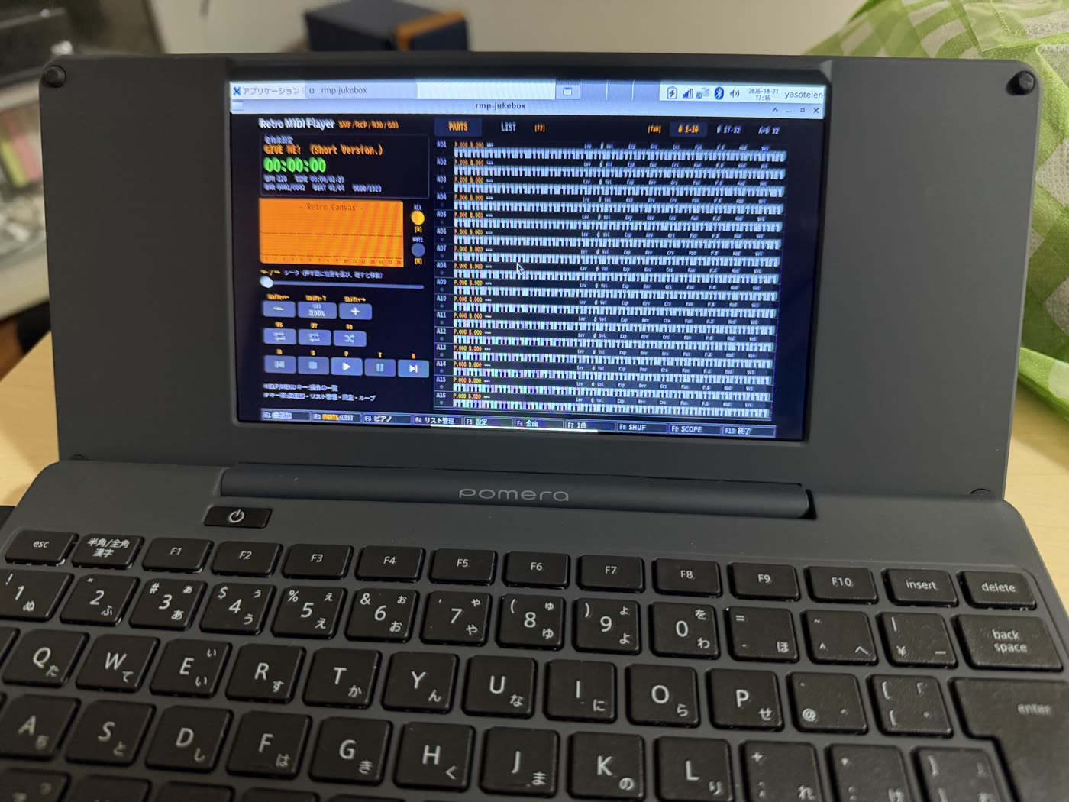
Figure 28. rmp-jukebox started from FDTP (an X11 window)
The iOS version is on the App Store as Retro MIDI Player Mobile. https://apps.apple.com/us/app/retro-midi-player-mobile/id6802171148
You can link other extensions to programs with launch lines in ~/.fdtprc (8.1).

8. Settings

8.1 Settings files
FDTP reads two files. The later one takes priority.
File | Contents
/etc/fdtprc | Settings for the whole machine. sudo make install writes the language here
~/.fdtprc | Your own settings

Write one setting per line. Everything after # is a comment.
# Variables
LANGUAGE=en
AWAKE_MINUTES=15
NOVEL_FORMAT_INDENT=0

# Key bindings (@ is Alt, ^ is Ctrl)
bind @d "df -h"

# Link an extension to a program (%C is the file)
launch .ext "command %C"
After bind, write the name of an internal command or a command in quotes. After launch, write a command in quotes or the name of a built-in viewer (textview, imageview, pdfview, sheetview, docview, slideview, noveledit, archive).

8.2 The customizer (z)
z opens the settings screen (the customizer). Choose variables, key bindings and launchers from the lists and change them. Changes are written to ~/.fdtprc, and the old file is kept as .bak first.
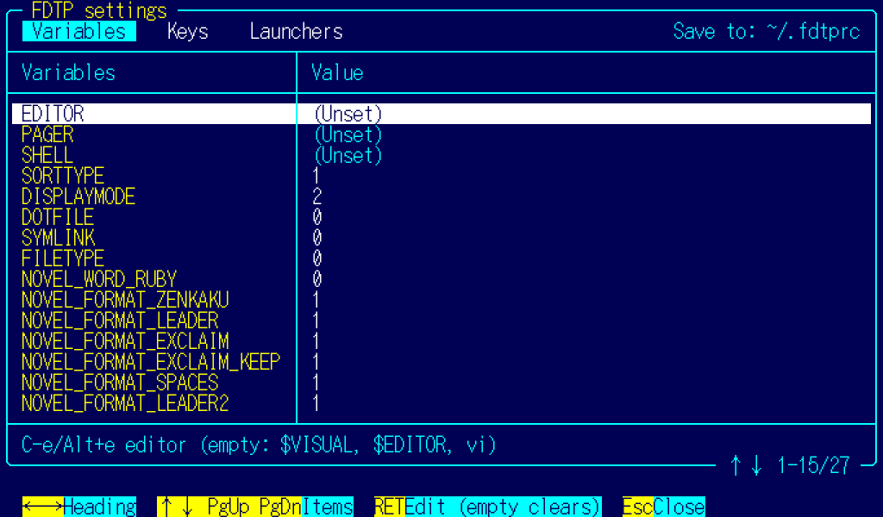
Figure 29. The customizer
The key binding list shows every key from the start: letters, Alt+letters, Ctrl+letters, F1 to F12, Shift+F1 to F12, and more. Keys that FDTP uses show the name of their command with "(Reserved)". Free keys are marked as free. The left Ctrl+c cannot be changed.

8.3 Main variables
Variable | Default | Meaning
LANGUAGE | auto | Screen language: auto, ja or en
SCREENSIZE | auto | Columns and rows: auto, or a size like 160x45 (80x25 to 320x90). On a 1024x600 screen, auto is 85x25
AWAKE_MINUTES | 15 | Minutes after the last key during which the screen stays awake (0 to 1440; 0 turns it off; chapter 9)
SPLIT_SIZE | 10M | Default piece size for Alt+n: a number followed by K or M
UNDO_LEVELS | 100 | Undo steps in docx, xlsx and pptx (1 to 1000)
EDITOR | empty | Editor for Ctrl+e and Alt+e. If empty, $VISUAL, $EDITOR, vi
SHELL | empty | Shell for Shift+F6 and x. If empty, $SHELL
SORTTYPE | 1 | Sort order: 0 to 5 are unsorted, name, extension, size, date, length. Add 100 for reverse order
DISPLAYMODE | 2 | Columns in the list (1, 2, 3 or 5)
DOTFILE | 0 | 1 hides names starting with .
SYMLINK | 0 | 1 shows where symbolic links point
FILETYPE | 0 | 1 adds a type symbol (/ * @ and so on) after each name
NOVEL_WORD_RUBY | 0 | 1 makes ruby in the vertical Word export into Word's own ruby
NOVEL_FORMAT_NAME | 1 | Turns a formatting rule on or off (6.4)
LOCALSEND_ALIAS | empty | Name shown to other LocalSend devices (4.7). If empty, the hostname

9. Battery and responsiveness

9.1 Battery
FDTP draws the screen with the GPU, so it uses more battery than King Jim's own editor (the Pomera mode). For long writing sessions, consider switching between FDTP and the Pomera mode.

9.2 Response after a pause
The Debian kernel lets the GPU sleep after 0.2 seconds without use. Because of this, the screen may respond late when you press a key after a pause. FDTP handles this in two ways.
AWAKE_MINUTES (default 15 minutes): for this many minutes after the last key, FDTP keeps the GPU and the screen awake on the DRM/KMS console. 0 turns this off. It does not work in an X11 window. Set it in ~/.fdtprc or in the settings (z).
The GPU sleep delay (optional, needs root): to change the 0.2 seconds to 15 minutes, put this line in /etc/udev/rules.d/91-pomera-gpu.rules and reboot:
ACTION=="add", SUBSYSTEM=="platform", KERNEL=="10090000.gpu", ATTR{power/autosuspend_delay_ms}="900000"
Both trade some battery life for a faster response.

9.3 System information (Alt+i)
Alt+i shows the system information. Press any key to return.
Group | Shows
Version | FDTP version, kernel, Debian version, uptime
Screen and input | Columns and rows, KMS or X. Whether the key devices can be read
Power | AWAKE_MINUTES and the time left. The GPU sleep delay
Resources | Memory, free disk space in the current directory, battery

If the GPU sleep delay is shorter than 15 minutes, it is shown in yellow with a note on how to change it. Values that cannot be read are shown with the reason, such as a permission problem.

10. Troubleshooting

10.1 The Pomera freezes
The SD card, the internal memory and Wi-Fi can stop at the same time (2.4). The Wi-Fi stabilization in ./configure, which adds the watchdog and Wi-Fi PIO, makes this less likely. If the Pomera freezes, turn it off and on again. It happens more often when you send large files quickly over Wi-Fi.

10.2 The internal memory is not there
• Check that you chose read-only or read-write for the internal memory mount in ./configure.
• The documents are under /mnt/pomera-internal. In the file manager, press l and type this path to go there.
• If the internal memory was not found, the question was skipped. On the DM250US, the location may be different.
• If you chose read-write but cannot write, the boot check may have found a problem and mounted it read-only (2.4). The check status is in /var/lib/pomera-internal/check.

10.3 Japanese input does not work
• Use the Hankaku/Zenkaku key or Alt+Space to turn it on and off. It cannot be turned off in the middle of a conversion.
• Check that Caps Lock is off.
• Check that uim and Mozc are installed.

10.4 Nothing appears on the screen
• Check that no other program is using the DRM display.
• Start fdtp from a terminal; the error output gives clues to the cause.

10.5 X11 window
• Alt+Enter or F11 switches between full screen and a window.
• fdtp --fullscreen starts in full screen.
• AWAKE_MINUTES does not work in an X11 window.

10.6 A PDF does not open
• For a password-protected PDF, FDTP asks for the password.
• A copy of FDTP built without the PDF library (MuPDF) cannot handle PDF files.

10.7 LocalSend cannot find a device or receive files
• Check that the Pomera and the other device are on the same Wi-Fi network (the same router). If using a smartphone hotspot, connect the Pomera to it.
• A router setting such as privacy separator or AP isolation prevents connected devices from seeing each other.
• Check that local network access is allowed on the iPhone (4.7).
• If "Another LocalSend (such as the official app) is using port 53317" appears, another LocalSend is running on the same machine. You can still send.
• If "fdtp-localsend is missing" appears, FDTP was built without OpenSSL (libssl-dev; 2.2).

11. License, acknowledgments and bug reports

11.1 License
FDTP is licensed under the GNU Affero General Public License v3.0 or later (AGPL-3.0-or-later). FDTP uses MuPDF and jbig2dec for PDF, which are AGPL-3.0-or-later, so FDTP uses a license that can be combined with them. The components FDTP uses and their licenses are listed in NOTICE.md.

11.2 Name and look
FDTP is a separate work by a different author. It follows the keys and screens of FD (by A. Idei), the file manager for MS-DOS and the PC-98. It is not related to FD or FDclone. No text or messages are copied from FD.
"Pomera" is a trademark of King Jim Co., Ltd. FDTP is unofficial and is not affiliated with King Jim.

11.3 Acknowledgments
• FD, by A. Idei, which FDTP follows. The FDclone manual page helped with the mapping of keys.
• The authors of the Shinonome fonts. Every character on the screen is drawn with them.
• The authors of MuPDF (Artifex), expat, zlib, libjpeg-turbo, libpng, giflib, libwebp, uim, lhasa, Info-ZIP and OpenSSL.
• Tien Do Nam and the LocalSend contributors. FDTP sends and receives using the published LocalSend protocol.
• The people who opened the way to running Debian on the Pomera DM250.

11.4 Reporting problems
Bug reports in GitHub Issues are welcome. The repository is https://github.com/yasoteien/fdtp. Please include:
• The machine (Japanese DM250, DM250US, PC, Raspberry Pi, ...) and the Debian version
• The output of fdtp -v
• The screen language, and whether you use DRM/KMS or X11
• The steps to reproduce, what you expected, and what happened
• A screenshot or photo, if you can
Pull requests are not accepted. If you want to change FDTP, please fork it and make your own version under the AGPL. The same goes for the wording of the English text.

