ITSU3018 - Information Technology Project
Progress Report 1
Event & Community Engagement Portal
Project-2026S1_32
Company: Jewish House
Team Members and Responsibilities
Team Member | Role/Specialization

Contents
1. Introduction 3
2. Project Overview 3
2.1 Background 3
2.2 Project Objectives 3
2.3 Project Scope 3
3. Status Summary 3
3.1 Current Project Phase 3
3.2 Completed Activities 4
3.2.1 Requirements Gathering and Analysis 4
3.2.2 Technology Stack Selection 5
3.2.3 System Architecture and Design 5
3.2.4 Testing Strategy 9
3.3 Current Work in Progress 9
4. Project Milestones 9
5. Risk and Constraint Analysis 10
5.1 Risk Matrix Summary 11
6. Conclusion and Next Steps 11
References 12

1. Introduction
This progress report provides an update on the progress of the Event and Community Engagement Portal project at Jewish House. This project aims to create a web-based system that will facilitate easier event management, community connection, and registration.
The team has accomplished valuable initial phases such as requirement-gathering, technology selection, and system design by Week 4, out of 12 weeks. In this report, the completed part of the project is described, the project milestones and their completion are provided, the potential risks and challenges are mentioned, and the chosen technology is outlined.
The project is running on schedule and all the work of Phase 1 is completed on time. Instead of Microsoft Power Platform, the team chose to build the application with the PHP Laravel [2] framework and MySQL database [5] due to its flexibility, lower cost and cost-effectiveness, and long-term maintenance.

2. Project Overview

2.1 Background
Jewish House now organizes numerous community activities such as JH Kids workshops, movement programs, SMART Recovery meetings, parent programs and other activities. At this moment, they are on the Funraisin platform and the process is not well linked.
The information related to the events, registrations and RSVPs are managed differently and this complicates matters and makes management more difficult. Due to this, employees experience additional work, users are provided with inconsistent experience, and it becomes hard to comprehend how individuals are interacting with events [1].

2.2 Project Objectives
The key aims of this project are:
- Develop a common event discovery and registration portal.
- Automate event-related communications such as confirmations, reminders and feedback collection.
- Introduce a full attendance tracking and analytics.
- Create event management and reporting administrative interfaces.
- Develop integration capabilities with Salesforce to have better community relationship management.

2.3 Project Scope
The project will be to develop a web-based event management portal having significant features. These are a public event calendar with filters, user registration and login, automatic email notifications, waitlist management and an admin dashboard to create and manage events.
It will also monitor attendance, review post event feedback and give reports and analytics.

3. Status Summary

3.1 Current Project Phase
The project is still at its development stage. The team is complete with all the planning and design of Weeks 1-4. Week 2 was used to complete requirements and Weeks 3-4 were used to do system design.
The project is now at the development stage and construction of the initial prototype will commence in Week 5.

3.2 Completed Activities

3.2.1 Requirements Gathering and Analysis
System requirements were obtained through discussion with the staff at Jewish House and reviewing existing workflows and all system requirements were documented and validated.
Table 1: Functional Requirements
Req. ID | Requirement | Description
FR-01 | Event Calendar Display | System shall display all upcoming events in a calendar view with filtering by category, date, and location
FR-02 | User Registration & Authentication | Users shall be able to create accounts, login securely, and manage their profiles and event registrations
FR-03 | Event Registration & RSVP | Registered users shall be able to RSVP for events, receive confirmation, and manage their registrations
FR-04 | Automated Email Notifications | System shall automatically send registration confirmations, event reminders, and post-event feedback requests via Gmail API
FR-05 | Waitlist Management | When events reach capacity, system shall enable users to join waitlist and automatically notify them of available spots
FR-06 | Admin Event Management | Administrators shall be able to create, edit, delete events, set capacity limits, and manage event categories
FR-07 | Attendance Tracking | System shall allow administrators to record actual attendance and track no-show rates for registered attendees
FR-08 | Post-Event Feedback Collection | System shall automatically send feedback surveys to attendees post-event and aggregate responses for review
FR-09 | Analytics & Reporting Dashboard | System shall provide visual analytics on registration trends, attendance patterns, popular event categories, and repeat attendees
FR-10 | Salesforce Integration Readiness | System architecture shall support future integration with Salesforce for contact enrichment and CRM capabilities

3.2.2 Technology Stack Selection
One of the critical areas in the planning was the selection of technology. The team has compared Microsoft Power Platform to the PHP Larval and chose the latter due to its better applicability to meet the requirements of the project. The comparison of the two options is presented in Table 2.
Table 2: Technology Stack Comparison
Aspect | Original (Power Platform) | Selected (PHP Laravel + MySQL)
Framework | Power Apps, Power Automate, SharePoint/Dataverse | Laravel 11.x (PHP 8.2+) with MVC architecture
Database | SharePoint Lists or Dataverse | MySQL 8.0+ with Eloquent ORM
Email Integration | Outlook via Power Automate | Gmail API with Laravel Mail
Frontend | Power Apps portals (limited customization) | Blade templates, Bootstrap 5, JavaScript/jQuery
Analytics | Power BI dashboards | Laravel analytics packages (Laravel Charts, Spatie Analytics)
Cost | Licensing fees per user/month (Microsoft 365, Power Apps licenses) | Hosting fees only (open-source framework), significantly lower operational cost
Customization | Limited to platform capabilities | Full customization possible
Scalability | Cloud-based, automatic scaling (with cost implications) | Highly scalable with proper hosting
Deployment | Microsoft cloud environment required | Flexible hosting options (shared hosting, VPS, cloud services)

3.2.3 System Architecture and Design
The frontend of the system is based on Blade templates, Bootstrap, and JavaScript to offer an easy-to-use interface. The backend is created with the help of Laravel (PHP framework) dealing with all application logic and processes. The information is stored in MySQL database, which provides an efficient and secure data management. To facilitate communication, the system incorporates the Gmail API [4] to send automated emails like confirmations, reminders and feedback requests.
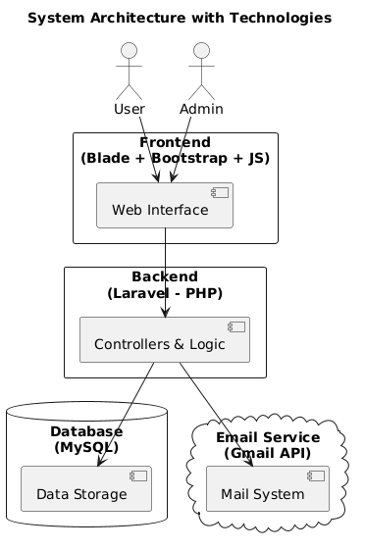
Figure 1 - System Architecture

User event registration
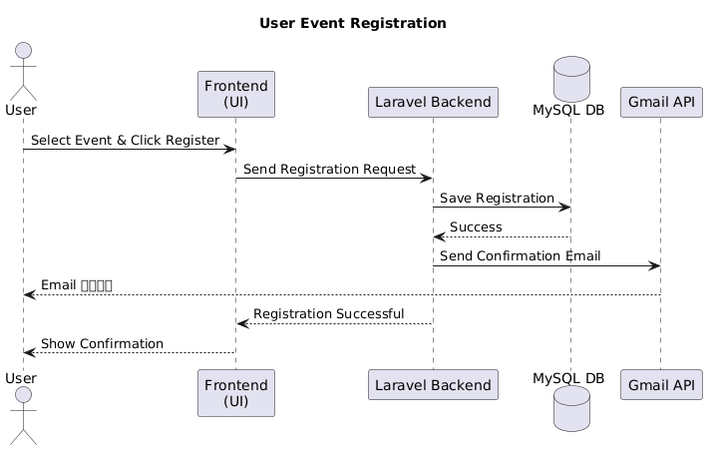
Figure 2 - User event registration sequence diagram
Admin Create Events
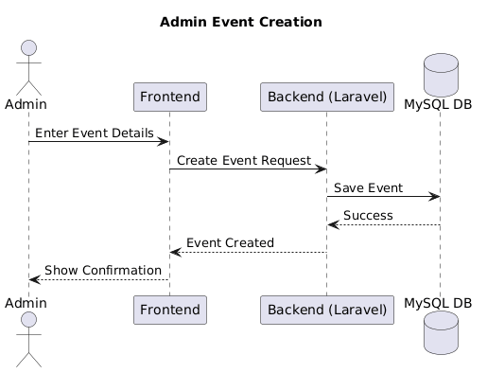
Figure 3 - Admin Create Events Sequence diagram

User Login
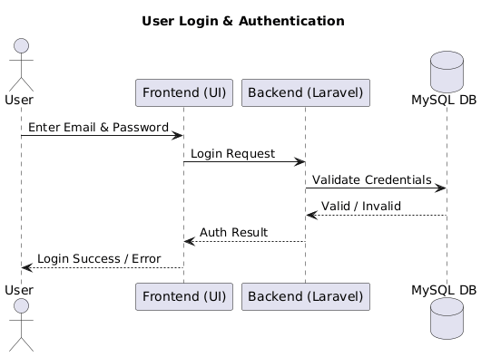
Figure 4 - User login sequence diagram
Event Feedback
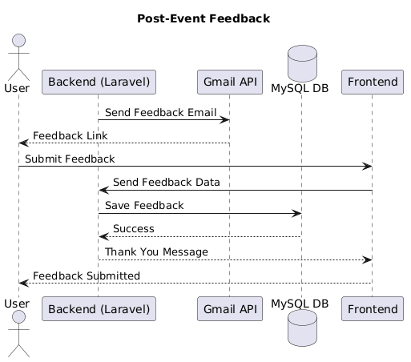
Figure 5 - Event Feedback Sequence diagram

3.2.4 Testing Strategy
Manual testing and TestRail have been used to develop a testing plan to manage test cases [6]. The team will test each part separately, test the interaction between modules, get users involved in acceptance testing, and test security to safeguard data. In TestRail, test cases are being created and associated with system requirements so that they can be easily tracked.

3.3 Current Work in Progress
The environment is still being developed, and Laravel 11.x is installed and configured with MySQL 8.0 database. The first database migrations are under development to build the underlying data structure. Gmail API integration credentials are being acquired and set up to the automated email notification system. In more complex integration projects, the team is taking advantage of AI-assisted development tools such as ChatGPT and GitHub Copilot to make the implementation process faster without sacrificing the quality of the codes [3].
The development of the prototype of the public event calendar interface will start in Week 5 and it will be the first component of the system that will interface with users.

4. Project Milestones
The project is organized into seven key milestones that are spread over the 12 weeks of development. The entire milestone breakdown with the current status indicators is provided in Table 3.
Table 3: Project Milestones and Status
# | Milestone | Deliverables | Timeline | Status
1 | Project Planning | Project charter, team formation, stakeholder identification, initial scope definition | Week 1-2 | Completed
2 | Requirements Analysis | Requirements document, user stories, functional and non-functional requirements | Week 2-3 | Completed
3 | System Design | System architecture, database schema, sequence diagrams, UI mockups, technology stack selection | Week 3-4 | Completed
4 | Prototype Development | Working prototype of event calendar, basic registration functionality, database implementation | Week 5-7 | In Progress
5 | Testing & Feedback | Comprehensive testing using TestRail, user acceptance testing, bug fixes, stakeholder feedback incorporation | Week 8-9 | Not Started
6 | Final Report Preparation | Final project documentation, user manuals, technical documentation, deployment guide | Week 10-11 | Not Started
7 | Presentation | Final presentation materials, live demonstration, Q&A preparation | Week 12 | Not Started
Figure 6 presents the project Gantt chart illustrating the timeline and dependencies among project tasks.
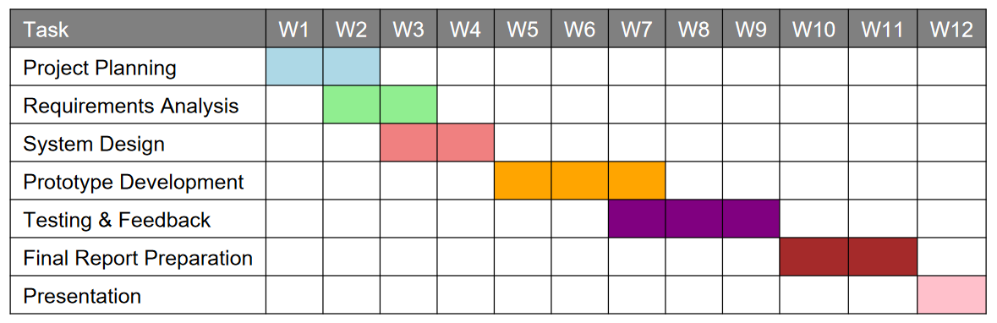
Figure 6 - Project Schedule Gantt Chart
The project is already ahead of schedule in a number of aspects. The thoroughness of the requirements analysis and system design phases has placed the team in a good position to undertake efficient development. The shift to the prototype development stage is going on well and all the preparatory work has been accomplished.

5. Risk and Constraint Analysis
Risk management of projects is a crucial element of effective project delivery. In this section, the possible risks to the project are identified, their effects on the project constraints (scope, time, cost and quality) are analyzed and mitigation measures are suggested.
Risk Area | Risk | Impact | Solution
Technical | Gmail API issues | Delay in development, email feature may fail | Test early, use SMTP backup, use AI tools
Technical | Database slow at scale | Slow system performance | Use indexing, optimize queries, add caching
Resource | Small team | Work delays, possible feature cuts | Good documentation, use Git, set priorities
Stakeholder | Changing requirements | Scope increase, time delay | Use change control, prioritize features, regular feedback
External | Third-party service issues | System may stop or slow down | Use backup options, error handling, reliable hosting

5.1 Risk Matrix Summary
Table 4 lists the risks identified, their probability, impact rating and a general priority that the management should consider.
Table 4: Risk Assessment Matrix
Risk | Probability | Impact | Priority
Gmail API Integration Complexity | Medium | High | High
Database Performance at Scale | Low | Medium | Medium
Limited Team Size and Availability | Medium | High | High
Changing Requirements | Medium | Medium | Medium
Third-Party Service Availability | Low | Medium | Medium

6. Conclusion and Next Steps
The project is progressing well and on schedule. Phase 1 activities are all done punctually. The team has very clear requirements and developed the system. The decision to use Laravel and MySQL will enable the system to be flexible, affordable, and maintainable.
Next steps (Week 5–7):
- Start building prototype
- Create event calendar page.
- Develop user registration and user login.
- Create databases functions in Laravel.
- Start Gmail API integration.
- Test features and results in TestRail.
Generally, the project is headed on the right path and is likely to be accomplished in 12 weeks. It will assist Jewish House to better manage events, minimize manual work and give valuable data analysis.

References
[1] K. Schwaber and J. Sutherland, The Scrum Guide: The Definitive Guide to Scrum, Scrum.org, 2020. [Online]. Available: https://scrumguides.org/
[2] M. Stauffer, Laravel: Up & Running: A Framework for Building Modern PHP Apps, 3rd ed. Sebastopol, CA: O'Reilly Media, 2023.
[3] S. Chen et al., "Evaluating Large Language Models Trained on Code," arXiv preprint arXiv:2107.03374, 2021.
[4] Google, "Gmail API Documentation," Google Developers, 2024. [Online]. Available: https://developers.google.com/gmail/api
[5] B. Schwartz, P. Zaitsev, and V. Tkachenko, High Performance MySQL: Optimization, Backups, and Replication, 4th ed. Sebastopol, CA: O'Reilly Media, 2021.
[6] TestRail, “TestRail Documentation – Test Case Management Tool,” Gurock Software GmbH, 2024. [Online]. Available: https://support.testrail.com

