**Movies Sentiment Analysis**

**NLP project '24**

*Team 80*

**Under Supervision of**

**DR. Sally Saad**

|  |  |  |
| --- | --- | --- |
| **Name** | **ID** | **Dep.** |
| يسى كميل عبد اللطيف | 20201700986 | SC |
| علي إبراهيم علي ابراهيم | 20201700500 | SC |
| كيرلس هلال ذكي سلطان | 20191700461 | SC |
| كيرلس وحيد كامل عبد المسيح | 20201700616 | SC |
| محمد عبد المحسن أحمد | 20191700836 | SC |

1. **Import necessary libraries:**
2. **A computer screen shot of a program code

   Description automatically generatedRead Data: Get the reviews from the "positive" and "negative" foldersA screen shot of a computer program

   Description automatically generated**
3. **A computer screen shot of text

   Description automatically generatedPreprocess Data: Clean up the text by making it lowercase, removing unnecessary characters like numbers and punctuation, and removing common words like "the", "is", etc.**
4. **A screen shot of a computer code

   Description automatically generatedConvert Text to Numbers: Use a technique called TF-IDF to turn the text into numbers. This helps the computer understand the words better:**
5. **Split Data: Split the data into two parts: one for training the model and one for testing the model.**
6. 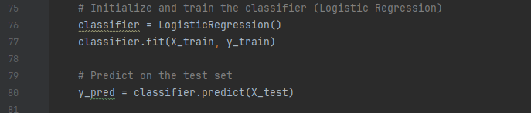**Train Model: Teach the computer to recognize positive and negative reviews by giving it the training data.**
7. **Evaluate Model: See how accurate the computer's predictions are by checking metrics like accuracy, precision, recall, and F1-score.**

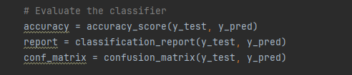

1. **A screen shot of a computer program

   Description automatically generatedVisualize Results: Make it easier to understand how the computer is performing by visualizing the confusion matrix, which shows how many predictions were correct and incorrect.**
2. **Show Results :**

