**HAPPY SHOOTS**

Submitted in partial fulfillment of the requirements

of the syllabus of

Android Apps Development Lab

in

Information Technology

by

AMEYASSH NAGARAJAN 118A3005

SIDDHESH IYER 118A3019

YASSAR MOHAMMED 118A3064

Under the Guidance of:

Ms. Bushra Shaikh



Department of Information Technology

SIES Graduate School of Technology

2021-22

**CERTIFICATE**

This is to certify that the project entitled **“**HAPPY SHOOTS” is a bonafide work of the following students, submitted to the University of Mumbai in partial fulfillment of the requirement of the syllabus of **Android Apps Development Lab** in **Information Technology.**

**AMEYASSH NAGARAJAN 118A3005**

**SIDDHESH IYER 118A3019**

**YASSAR MOHAMMED 118A3064**

Ms. Bushra Shaikh Dr. Lakshmi Sudha Dr. Atul N Kemkar

Internal Guide Head of Department Principal

**PROJECT REPORT APPROVAL**

This project report entitled ***(E-Stated) Real Estate App*** by following students is approved for the requirement of the syllabus of ***Android Apps Development Lab*** in ***Information Technology.***

**AMEYASSH NAGARAJAN 118A3005**

**SIDDHESH IYER 118A3019**

**YASSAR MOHAMMED 118A3064**

**Name of External Examiner: --------------------------------**

**Signature:--------------------------------**

**Name of Internal Examiner: --------------------------------**

**Signature:--------------------------------**

**Date:**

**Place:**

**DECLARATION**

I declare that this written submission represents my ideas in my own words and where others’ ideas or words have been included, I have adequately cited and referenced the original sources. I also declare that I have adhered to all principles of academic honesty and integrity and have not misrepresented or fabricated or falsified any idea/data/fact/source in my submission. I understand that any violation of the above will be cause for disciplinary action by the Institute and can also evoke penal action from the sources which have thus not been properly cited or from whom proper permission has not been taken when needed.

AMEYASSH NAGARAJAN 118A3005 _____________

SIDDHESH IYER 118A3019 _____________

YASSER MOHAMMMED 118A3064 _____________

Signature

Date:

**ACKNOWLEDGEMENT**

It gives us immense pleasure to thank Dr. Atul N Kemkar, our Principal for extending his support to carry out and develop the project. We also thank our Head of Department Dr. Lakshmi Sudha for her support in completing the project. We wish to express our deep sense of gratitude and thank to our Internal Guide, Ms. Bushra Shaikh for her guidance, help and useful suggestions, which helped in completing our project work in time.

We would like to thank the entire faculty of Information Technology Department for their valuable ideas and timely assistance in this project, last but not least, we would like to thank our non-teaching staff members of our college for their support, in facilitating timely completion of this project.

**Project Team**

**AMEYASSH NAGARAJAN**

**SIDDHESH IYER**

**YASSAR MOHAMMED**

**ABSTRACT**

As photography is a popular and growing career option for many people in today’s economy, the need to manage clients and understand them better is a very valuable asset in a business like photography. Clients have always booked appointments over the phone this can result in mismanagement and can cause a lot of panic and hassle for both the customers and the photographers.

The main objective of Happy Shoots is to bridge the gap between the customers and the photographers by providing a once stop platform to connect with each other. The clients can book appointments , they can leave a feedback and they can also look at the previous work of the photographer.

This app is a great way to help the photographers keep track of appointments and make sure that it is easy for the clients to book an appointment at any time of the day.

**Contents**

|  |  |  |
| --- | --- | --- |
|  |  | **Page No.** |
| **Chapter 1** | **Introduction** | **8** |
| **Chapter 2** | **Survey of Existing Apps** | **9-10** |
| **Chapter 3** | **Report on Present Investigation** | **10** |
|  | 3.1 Problem Statement | **10** |
|  | 3.2 Source of Problem Statement | **10** |
| **Chapter 4** | **Design and Implementation of Android Apps Components** | **11-16** |
|  | 4.1 Layouts | **11** |
|  | 4.2 Intents | **11-12** |
|  | 4.3 Activity | **12-13** |
|  | 4.4 SQLite | **13** |
|  | 4.5 Camera | **13-14** |
|  | 4.6 Location API | **14-15** |
|  | 4.7 Generate APK file | **15** |
|  |  |  |
|  |  |  |
| **Chapter 5** | **Report on Proposed System and its Implementation** | **16-18** |
|  | 5.1 Block Diagram | **16** |
|  | 5.2 Flowchart | **17** |
|  | 5.3 Hardware | **18** |
| **Chapter 6** | **Results and Discussions** | **19-27** |
|  | 6.1 Summary of Screenshots with Navigational Flow | **20-27** |
| **Chapter 7** | **Conclusions** | **28** |
| **References** |  | **29** |

**INTRODUCTION**

Android is a very popular operating system that is used in a majority of mobile phones, to be specific about 82% of smart phones use android as their operating system. There are a lot of applications designed for this operating system. There are endless possibilities to around which we can build an app. Even with these endless possibilities photo shoot apps are not very common and popular.

The demand for photography has increased exponentially in the recent years as a result of social media , photographers can find gigs for a variety of purposes ranging from gigs at corporate offices to gigs for personal purposes like weddings or a simple function. With photography becoming a high demanding job it is only sensible to make the lives of the customers and the photographers easier by connecting them on a single platform.

The application aims to help a photographer in a way that the customers can find one place to access everything , from their previous work to booking appointments and giving valuable feedback to the photographer.

**Survey On Existing Apps**

### ****Trafft****

### Trafft is a booking software for scheduling sessions. Clients can make bookings via the booking page with a few clicks. Keeping in touch with clients via Trafft’s automated SMS and email reminders.

### ****Bookedin****

Bookedin is for professional photographers looking to simplify the appointment booking process.

It helps to:

Schedule appointments

Change availability

Set prices for each package and event type

Collect payments (including deposits to confirm online bookings) and more.

**3. Picktime**

Picktime is a free appointment booking system for photographers of all kinds. This scheduling software requires no programming, installation, or contracts.

From the booking page, one can control staff schedules. Users can also decide which slots appear as busy or available to clients.

**Report on Present Investigation**

**3.1) Problem Statement:**

As smartphones have become common among the masses, old ways of booking a photo shoot by calling the photographer has become inefficient and obsolete , this method makes it very difficult to keep track of the appointments and keep track of clients. We need a fast paced all in one solution.

The user can login in the app after registering in the app. Once logged in they can book an appointment , look at the previous work of the photographer and finally provide feedback about their experience.

**3.2) Source of Problem Statement:**

Photography is a area of work which has gained a lot of attraction in the recent years , this boom in increased jobs for photographers can be attributed to social media. With the increasing demand for photographers it should be possible to connect with the photographer on a platform where it is easy and accessible to book appointments and understand the previous work of the photographer and also submit a honest feedback about the photographer.

There are not many applications that aim to give a solution to this problem. Thus we have decided to make this app to bridge the gap between the customers and the photographers.

**Design and Implementation of Android Apps Components**

**4.1) Layouts**

Layout basically refers to the arrangement of elements on a page these elements are likely to be images, texts or styles. These are a part of **Android Jetpack**. They define the structure of [android user interface](http://web.cs.wpi.edu/~emmanuel/courses/cs4518/C17/slides/lecture03.pdf) in the app, like in an activity. All elements in the layout are built with the help of Views and ViewGroups. These layouts can have various widgets like buttons, labels, textboxes, and many others.

Some of the Layouts in Android are

* Linear Layout
* Relative Layout
* Constraint Layout
* Table Layout
* Frame Layout
* Absolute Layout

You can declare a layout in two ways:

* **Declare UI elements in XML**. Android provides a straightforward XML vocabulary that corresponds to the View classes and subclasses, such as those for widgets and layouts.

You can also use Android Studio's [Layout Editor](https://developer.android.com/studio/write/layout-editor) to build your XML layout using a drag-and-drop interface.

* **Instantiate layout elements at runtime**. Your app can create View and ViewGroup objects (and manipulate their properties) programmatically.

**We have used Constraint Layout for the Login and registration page.**

**We have used Linear Layout for the profile page.**

**We have used Scroll view with Linear Layout for designing all the data structure and algorithm pages.**

**We have used Relative Layout and Card view in the quiz pag**e.

**We have used Card View for home pages of data structures and algorithms and also for the quiz.**

**4.2) Intents**

**Android Intent** is the *message* that is passed between components such as activities, content providers, broadcast receivers, services etc.

It is generally used with startActivity() method to invoke activity, broadcast receivers etc.

There are two types of intents:

* **Explicit intents** specify which application will satisfy the intent, by supplying either the target app's package name or a fully-qualified component class name. You'll typically use an explicit intent to start a component in your own app, because you know the class name of the activity or service you want to start. For example, you might start a new activity within your app in response to a user action, or start a service to download a file in the background.

**We have used Explicit intent to connect various activities like going to Login page fromRegister Page.**

*startActivity(new Intent(RegisterActivity.this,LoginActivity.class));*

* **Implicit intents** do not name a specific component, but instead declare a general action to perform, which allows a component from another app to handle it. For example, if you want to show the user a location on a map, you can use an implicit intent to request that another capable app show a specified location on a map.

**4.3) Activity**

To navigate transitions between stages of the activity lifecycle, the Activity class provides a core set of six callbacks: onCreate(), onStart(), onResume(), onPause(), onStop(), and onDestroy(). The system invokes each of these callbacks as an activity enters a new state.

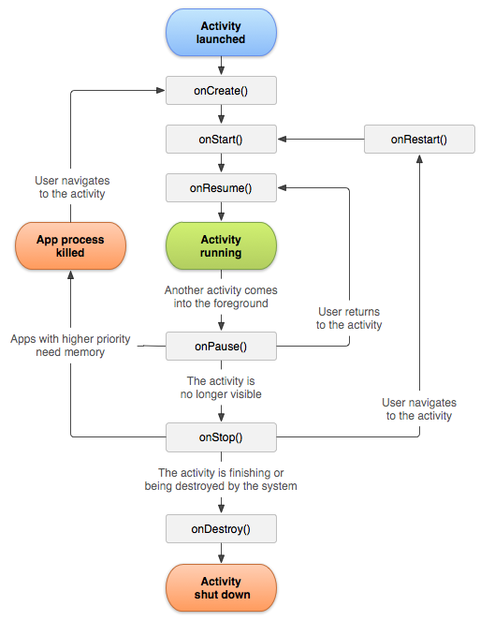

**Activities in our application are:**

**Login Page)**

**Sign In Page**

**Welcome Page**

**Add Properties**

**View Properties**

**Predict Price of the Properties**

**Maps**

**Detail Display Properties**

**4.4) SQLite**

**SQLite** is an **open-source relational database** i.e. used to perform database operations on android devices such as storing, manipulating or retrieving persistent data from the database.

It is embedded in android by default. So, there is no need to perform any database setup or administration task.

Here, we are going to see the example of sqlite to store and fetch the data. Data is displayed in the logcat. For displaying data on the spinner or listview, move to the next page.

**SQLiteOpenHelper** class provides the functionality to use the SQLite database

**We have used SQLite to store the user details entered at the time of registration and also the to store the property details provided by the user like image of the house Square foot,BHK, and description of the house.**

**4.5) Camera**

**Camera** is mainly used to capture picture of the house and we also added the functionality to crop the image of the house.

Android provides the facility to work on camera by 2 ways:

1. By Camera Intent
2. By Camera API

**We have used camera to allow user take a picture for the profile image. We used the Camera Intent**

Intent cameraIntent=new Intent(MediaStore.ACTION_IMAGE_CAPTURE);



**4.6) Location API**

The location APIs available in Google Play services facilitate **adding location awareness to** your app with automated location tracking.

**We have used location api to take the Current location of the user so he can sees the near by properties of which are listed.**

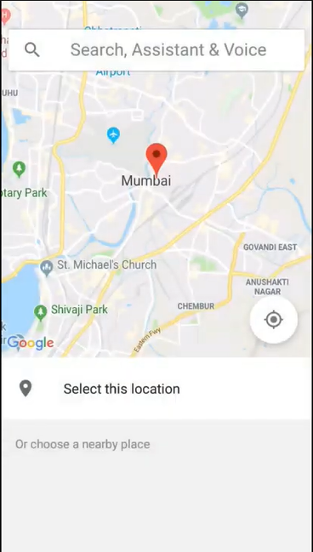

**4.7) Generate APK**

1. In the Android menu, go to Build > Build Bundle(s) / APK (s) > Build APK(s).
2. Android Studio will start building the APK for you. Once done, a pop-up on the bottom right will notify you of its completion. Click the ‘locate’ button in this dialog.
3. The ‘locate’ button should open File Explorer with the debug folder open that contains a file called “app-debug.apk”.
4. That’s it. Rename this file and share!

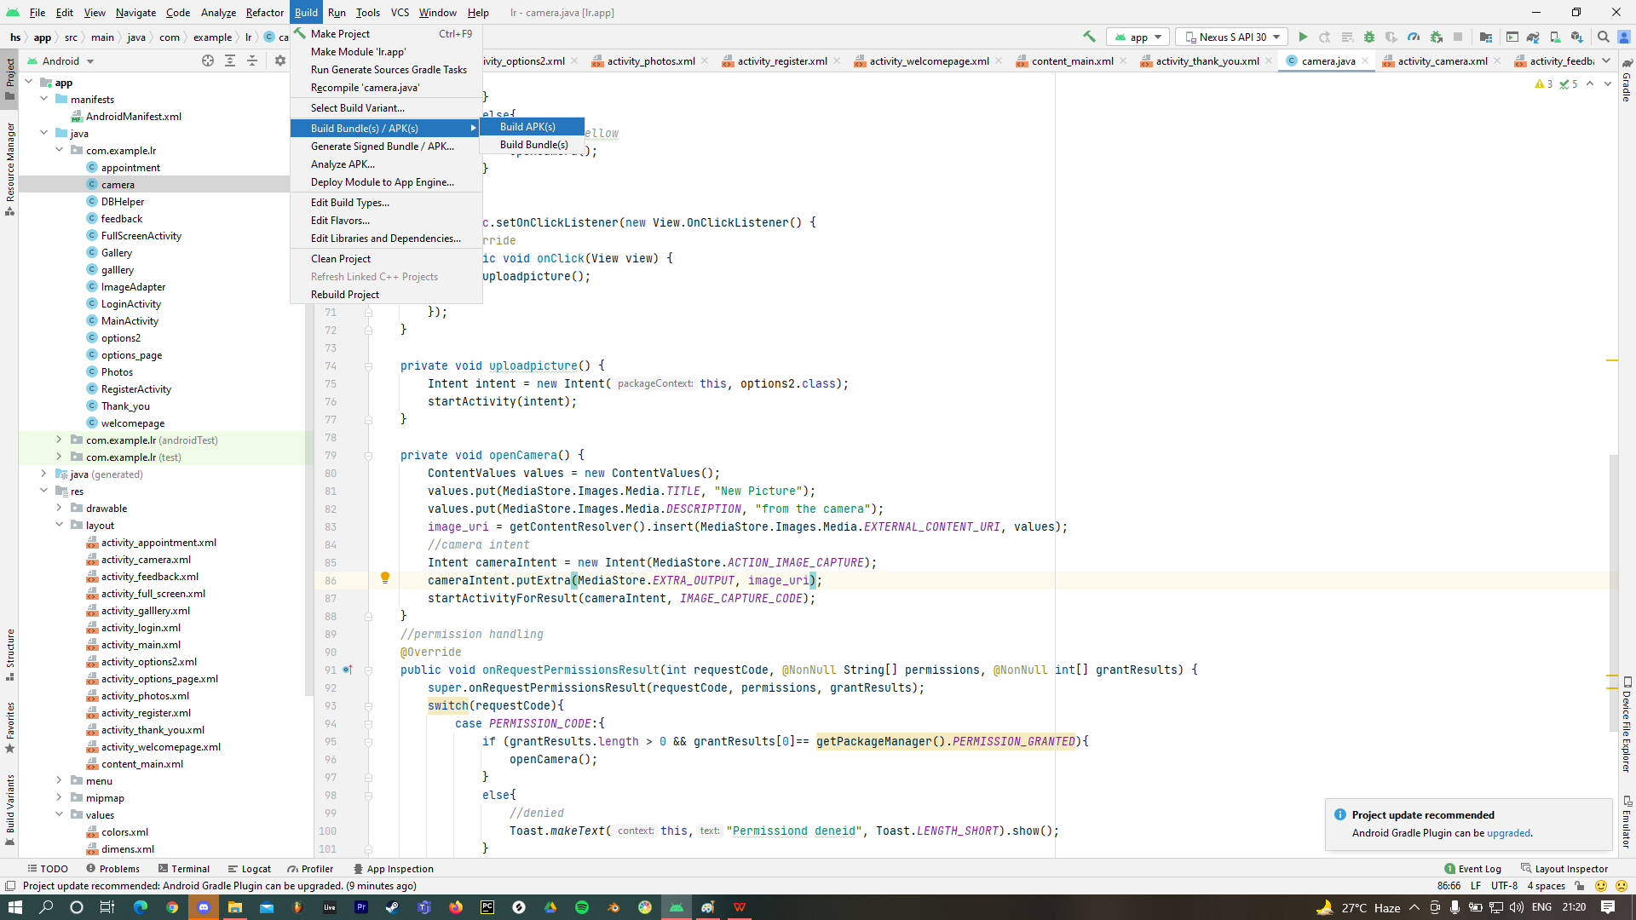

**Report on Proposed System and its Implementation**

**Block Diagram:-**

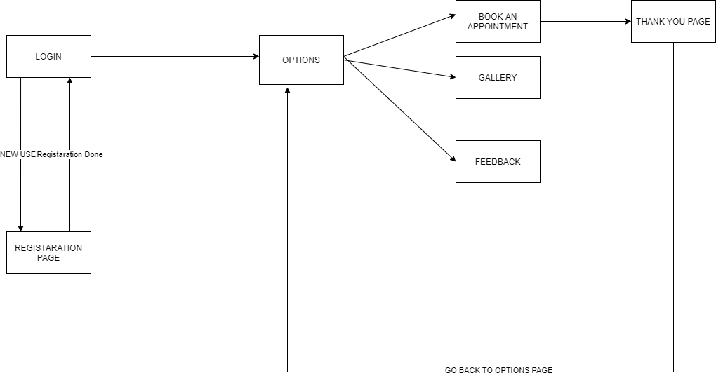

**Flowchart:**

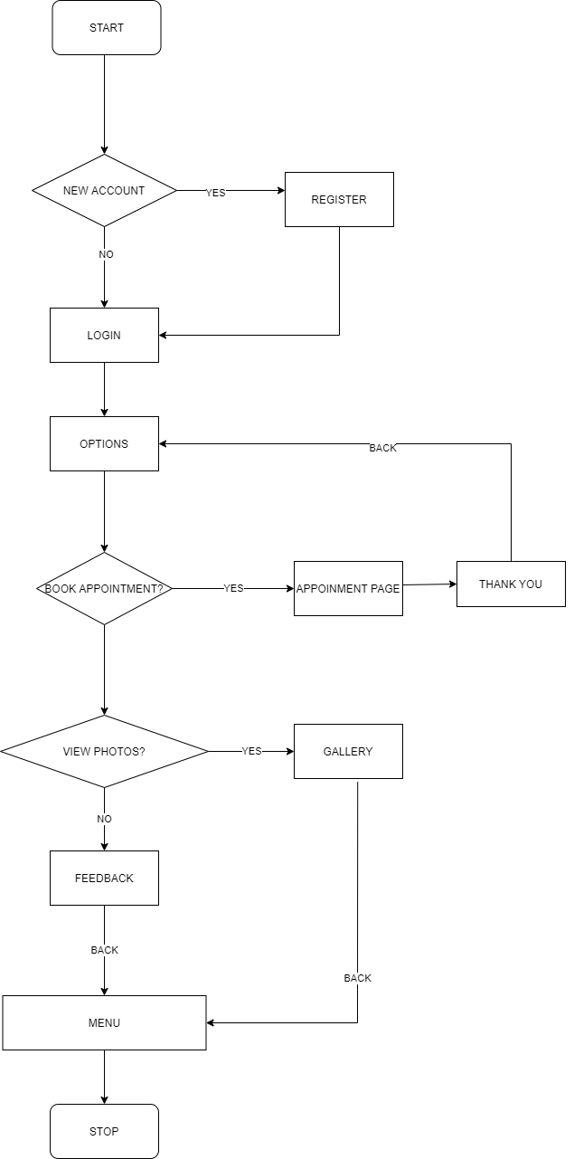

**Hardware –**

* Android Device
* GPS
* Internet
* Camera

**Software / External Libraries used with description –**

* Android Studio

Android Studio provides a unified environment where you can build apps for Android phones, tablets, Android Wear, Android TV, and Android Auto. Structured code modules allow you to divide your project into units of functionality that you can independently build, test, and debug.

**Results and Discussions:**

**Module A:**

**Login and Register :-**

The user needs to register filling basic details like name, email, phone number, address and create a password. Password must be 8 characters long. None of these fields can be kept blank. Once registered user can login using the registered email id and password anytime he/she wants to access the app.The user can also click and add a photo if needed.

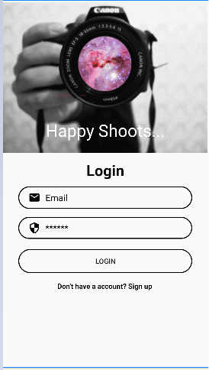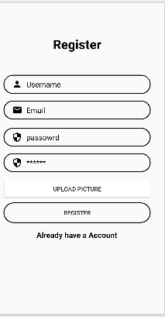

**Module B:**

**The Options Page:-**

The user can select between booking an appointment, looking at the previous images of the photographer and giving feedback.

T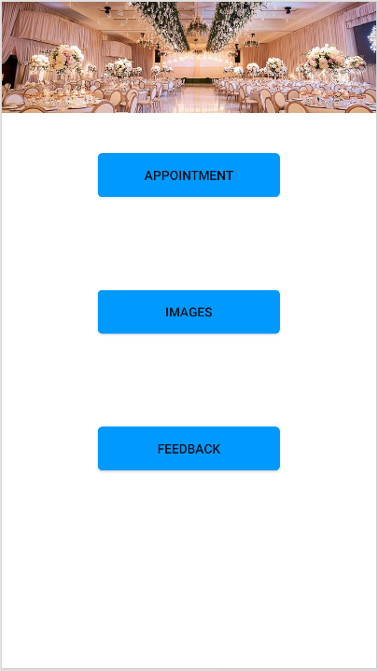

**Module C:**

**Book an Appointment:-**

The user can book an appointment in this module and can pin point the exact location with the help of google places API.

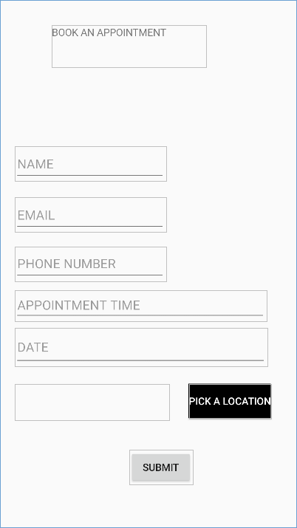



**Module D:**

**Gallery:-**

The user can look at the previous photos taken by the photographer.

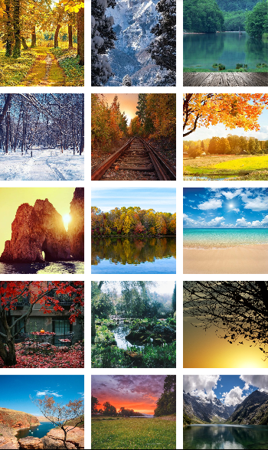

**Module E:**

**Feedback Page**

The user can give feedback on the service they have received , the user can also leave a star rating.

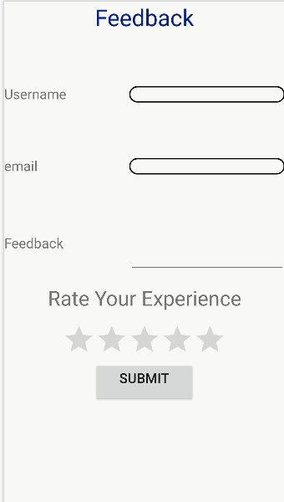

**Module F:**

**Thank You Page:-**

After booking of the appointment the user is redirected to the thank you page where the user can go back to the options page or simply quit the application.



**Conclusion**

In conclusion we can say that Happy Shoots is an application that can help customers and the yo book an appointment, get a better idea about the photographers work and helps the customer give feedback. The app mainly also focuses on keeping all the data and appointments of the user at one place with the help of this application.

**References**

1. https://developer.android.com/training/data-storage/sqlite
2. https://developers.google.com/maps/documentation/android-sdk/start

[3] https://developer.android.com/guide/topics/media/camera