Qatar University
College of Engineering
Department of Computer Science & Engineering

Shell Scripting, System Administration & System Programming

Project Report

Course: CMPS405 - Operating Systems
Fall 2026
Section: B03
Instructor: Dr. Heba Dawoud

Date of Submission: 31/10/2026

Group Members
Name | Student ID
Yasser ElMokadem | 202309012
Mohammed Alhusali | 202212621
Khaled Elrefaey | 202309917
Huthaifa Rajha | 202308103

Task Distribution:
Student Name | Student ID | Tasks Assigned | Contribution %
Yasser ElMokadem | 202309012 | Users.sh, Install.sh (ALPHA)  Connectivity.sh (BETA)  Repo, VMs & network setup | 25%
Mohammed Alhusali | 202212621 | Search.sh, Network.sh (ALPHA)  SysInfo.sh (BETA)  QA, Word report, submission | 25%
Khaled Elrefaey | 202309917 | FileSystem.sh (ALPHA)  C program (Part 2) | 25%
Huthaifa Rajha | 202308103 | LogServer.sh (ALPHA)  LogClient.sh, Remote.sh (BETA) | 25%

Project Overview:
This project uses two Ubuntu virtual machines. ALPHA is the server: it creates the user accounts, installs the services, audits and backs up the file system, and collects the logs of the whole lab. BETA is the client: it keeps testing the connection to ALPHA, connects to it remotely, reports its own system information, and sends its system messages to ALPHA’s log server. A C program on ALPHA shows how a parent process creates child processes to do different file tasks and reports the results in a log file.
Script | VM | What it does
Users.sh | ALPHA | Creates 10 users in a loop with sudo rights, and says “already exists” instead of failing.
Install.sh | ALPHA | Installs MySQL, SSH, FTP and Apache, starts them at boot, shows their status, and saves errors in a log file.
Search.sh | ALPHA | Finds files larger than 1M, saves them in bigfile, and emails the result to the administrator if any are found.
Network.sh | ALPHA | Shows network settings, routes and hostname, tests DNS, traceroute and ping, and saves everything in network.log.
FileSystem.sh | ALPHA | Saves system information, backs up selected files into a time-named folder, then checks that the backup is correct.
LogServer.sh | ALPHA | Turns ALPHA into a central log server that receives BETA’s messages on port 514 and rotates the logs.
Connectivity.sh | BETA | Pings ALPHA every 5 minutes (using cron) and records the result with the time.
Remote.sh | BETA | Logs in to ALPHA by SSH without a password, downloads its web page, and uploads a report by SFTP.
SysInfo.sh | BETA | Collects disk, CPU, memory, applications and network card information into one timestamped report.
LogClient.sh | BETA | Checks that ALPHA is reachable, then forwards BETA’s system messages to ALPHA’s log server.
part-2.c | ALPHA | Creates child processes (half the CPU cores), gives each a random file task, and the parent prints their log.

Environment Setup:
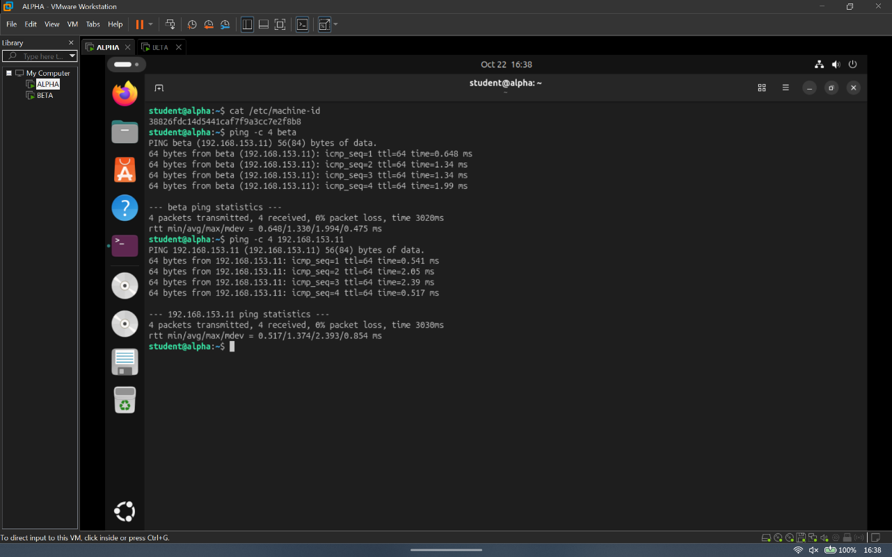
Figure 1: ALPHA | Environment | Setup – hostname, IP address and ping to beta (by IP and by hostname)
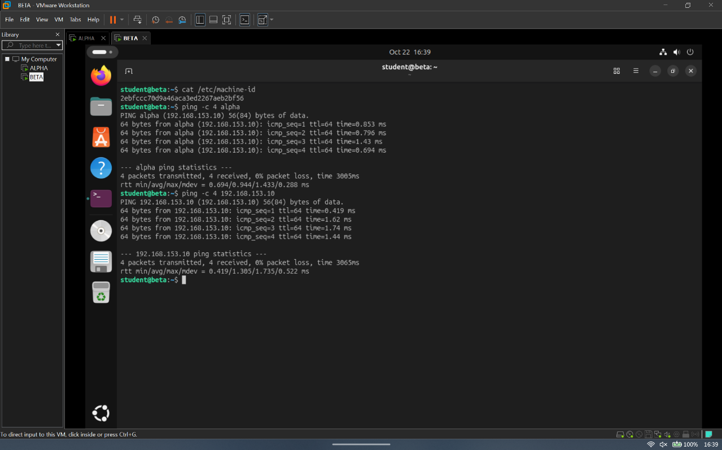
Figure 2: BETA | Environment | Setup – hostname, IP address and ping to alpha (by IP and by hostname)

Part 1: Shell Scripting – ALPHA VM (Server)

Task 1: User and Group Management (Users.sh)
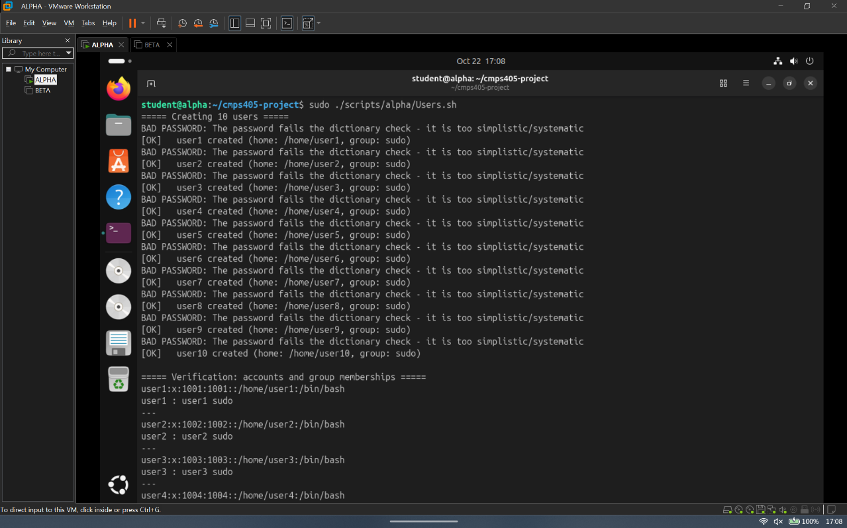
Figure 3: ALPHA | Users.sh | Task 1 – first run, 10 users created in a loop
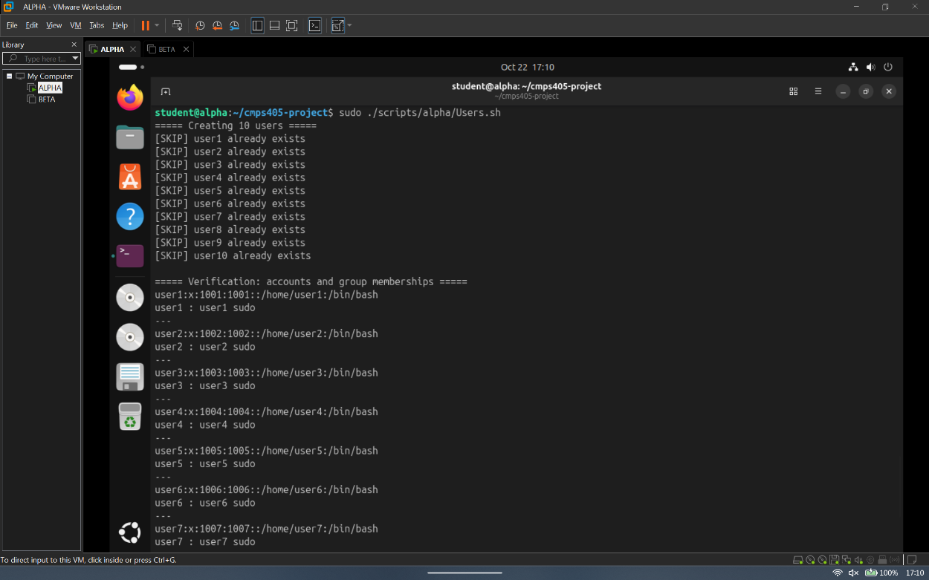
Figure 4: ALPHA | Users.sh | Task 1 – second run, existing users reported instead of failing
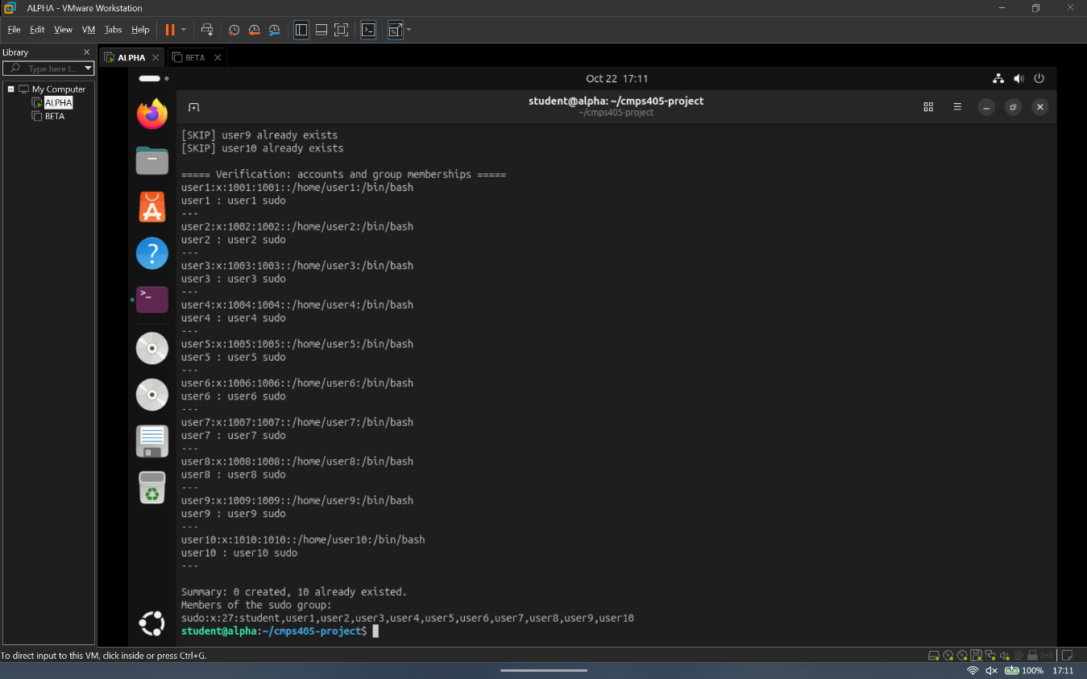
Figure 5: ALPHA | Users.sh | Task 1 – verification: accounts and sudo group memberships

Task 2: Service Installation and Error Logging (Install.sh)
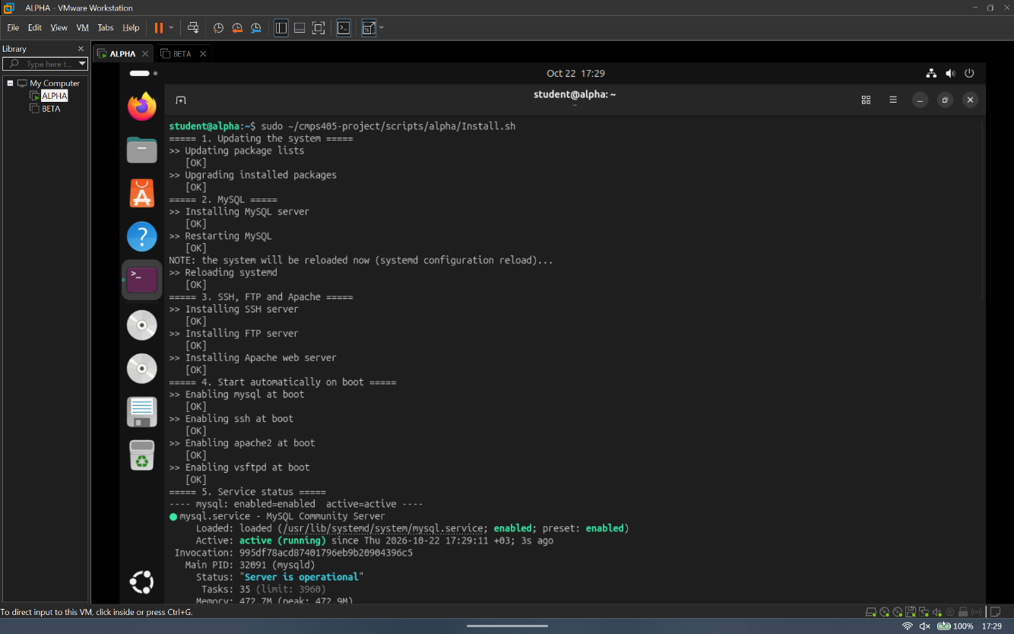
Figure 6: ALPHA | Install.sh | Task 2 – first run: update, MySQL install and restart, reload message
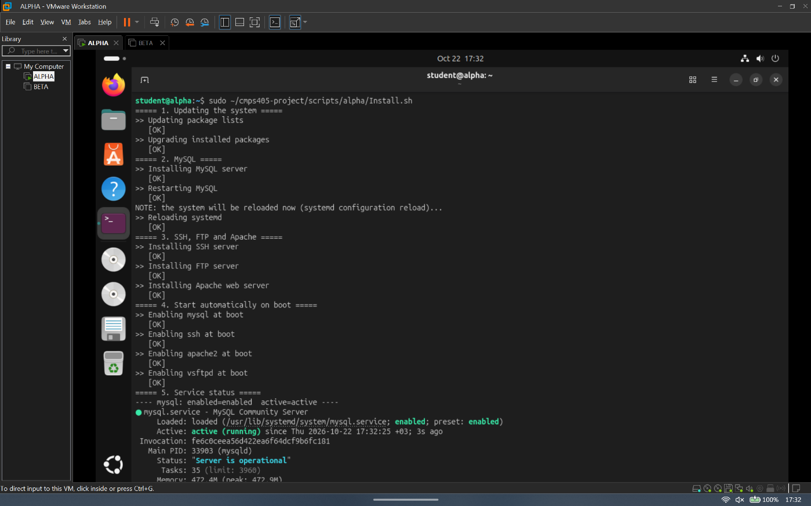
Figure 7: ALPHA | Install.sh | Task 2 – SSH, FTP and Apache installation
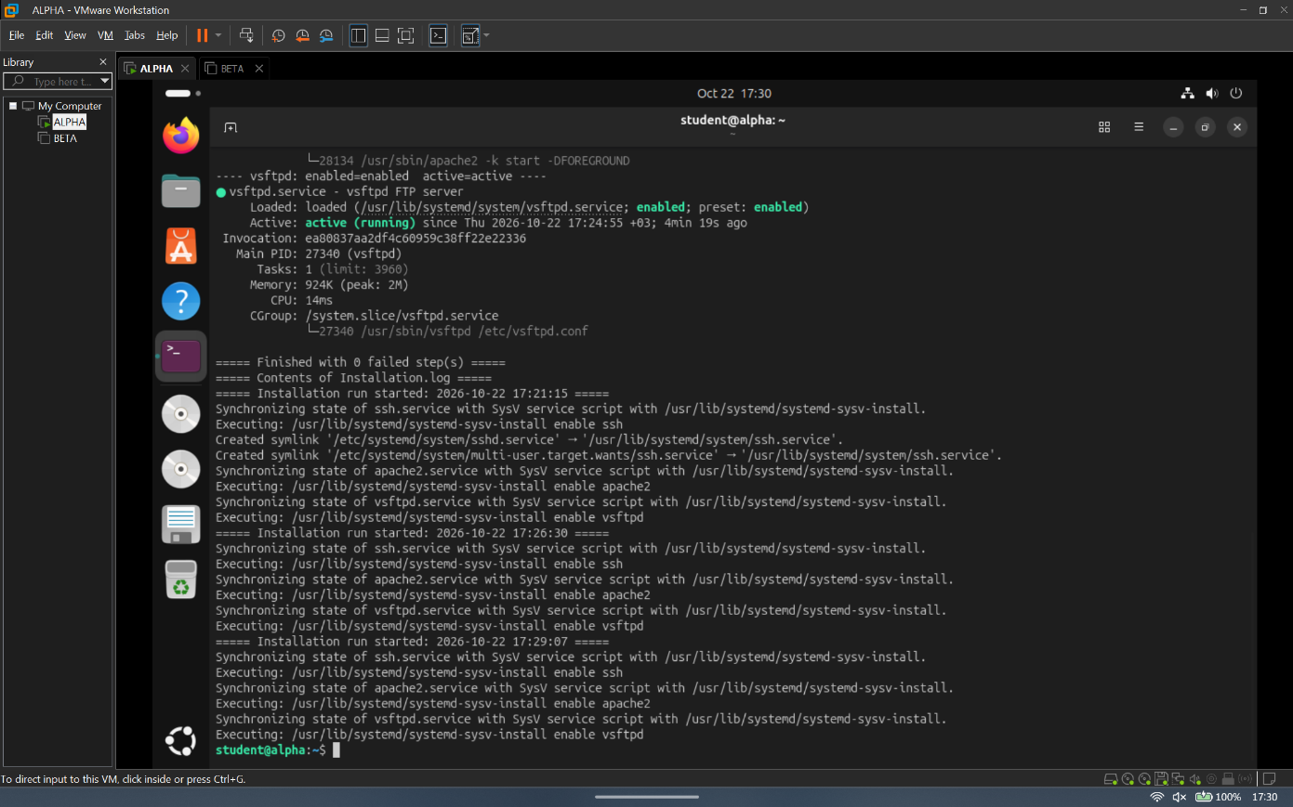
Figure 8: ALPHA | Install.sh | Task 2 – services enabled at boot and status of MySQL, SSH, Apache
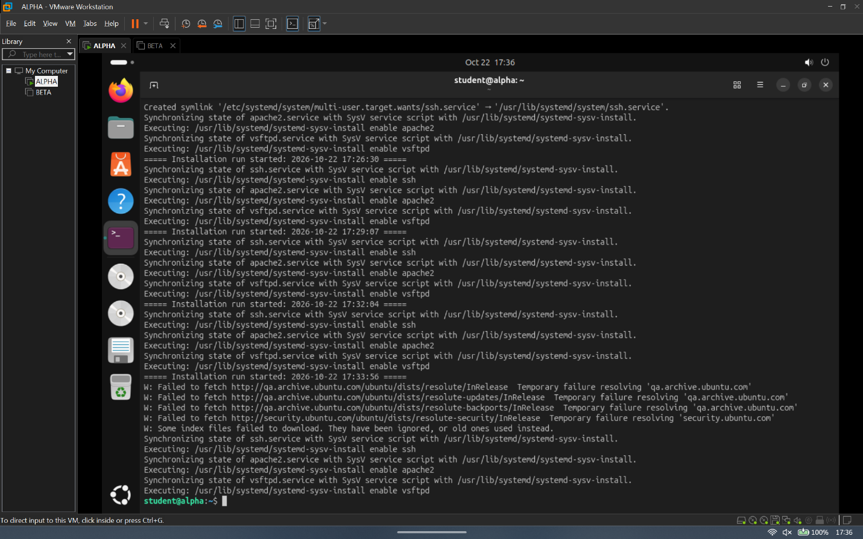
Figure 9: ALPHA | Install.sh | Task 2 – errors captured in Installation.log

Task 3: File Search and Administrator Notification (Search.sh)
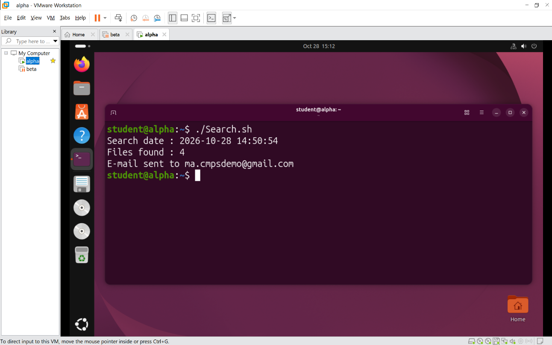
Figure 10: ALPHA | Search.sh | Task 3 – script run, files larger than 1M found
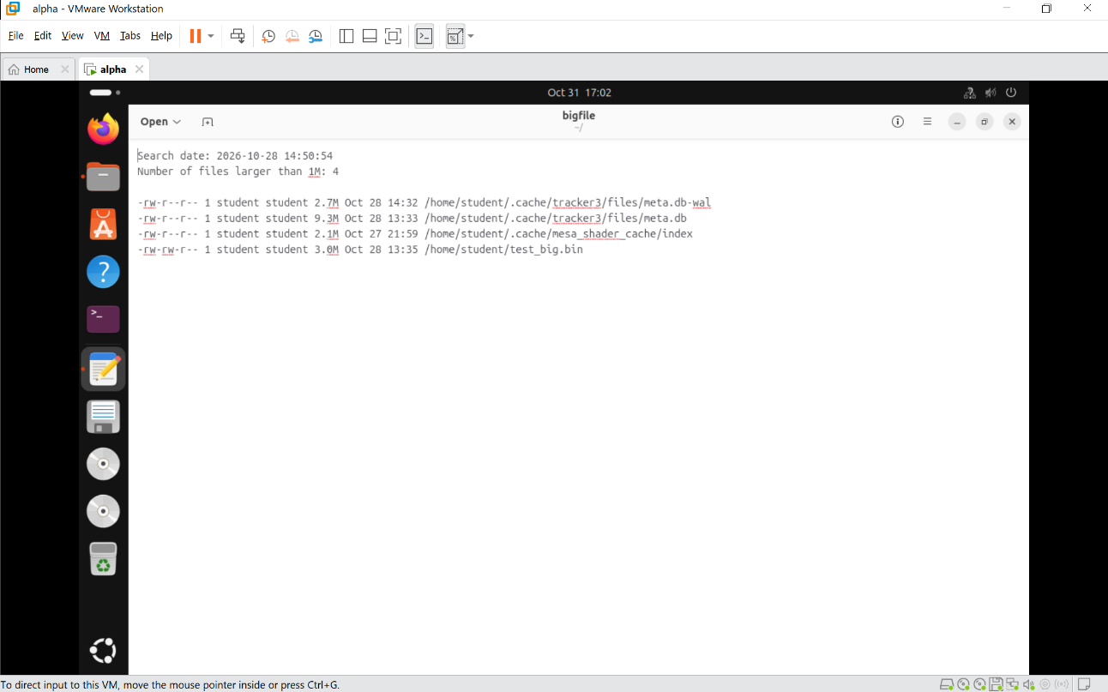
Figure 11: ALPHA | Search.sh | Task 3 – contents of bigfile (search date and number of files)
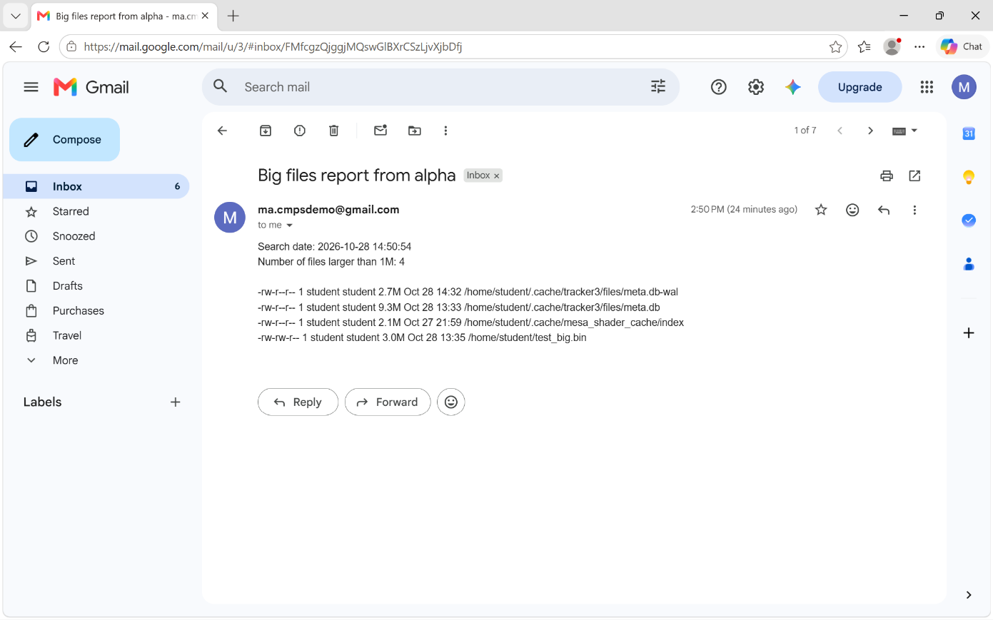
Figure 12: ALPHA | Search.sh | Task 3 – email received in the administrator’s personal mailbox

Task 4: Network Configuration and Diagnostics (Network.sh)
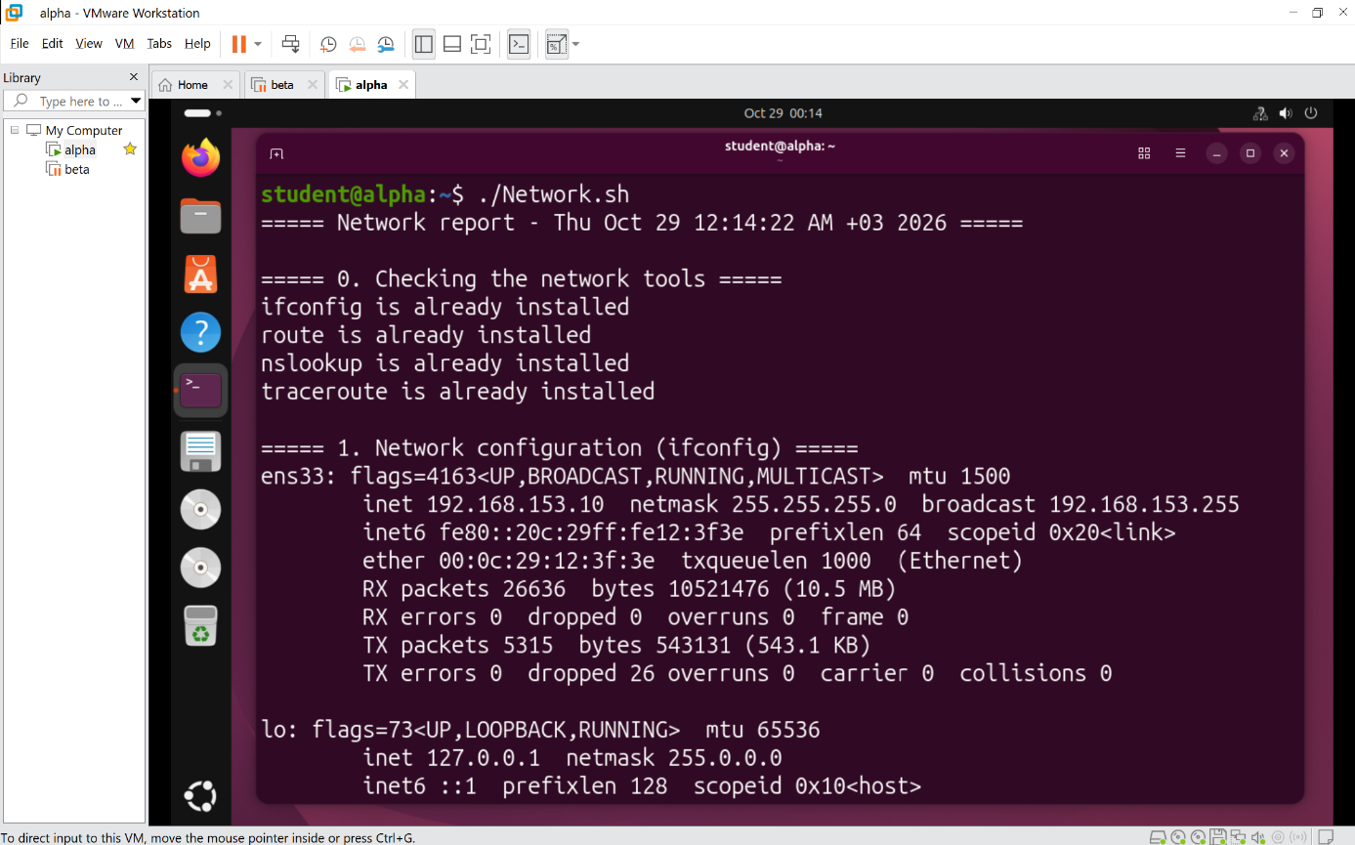
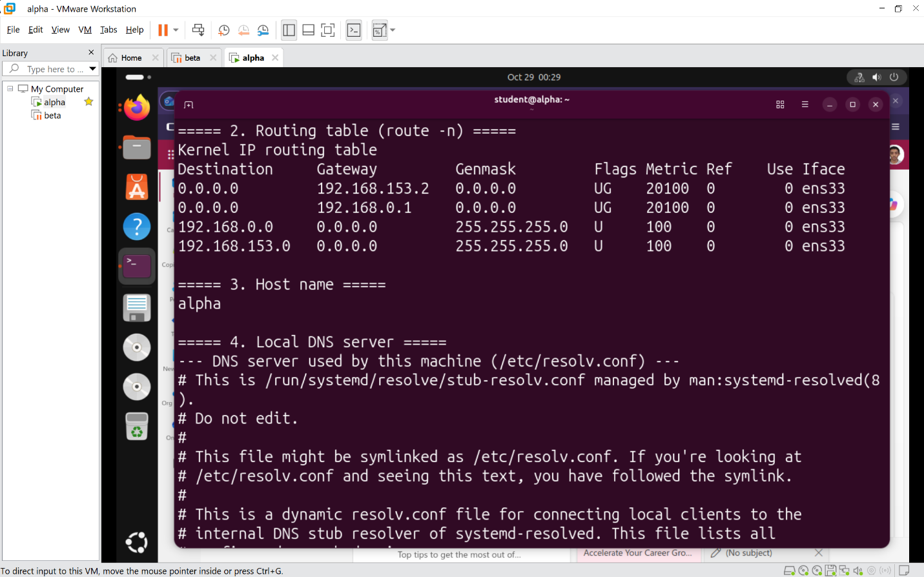
Figure 13: ALPHA | Network.sh | Task 4 – network configuration, routing table and hostname
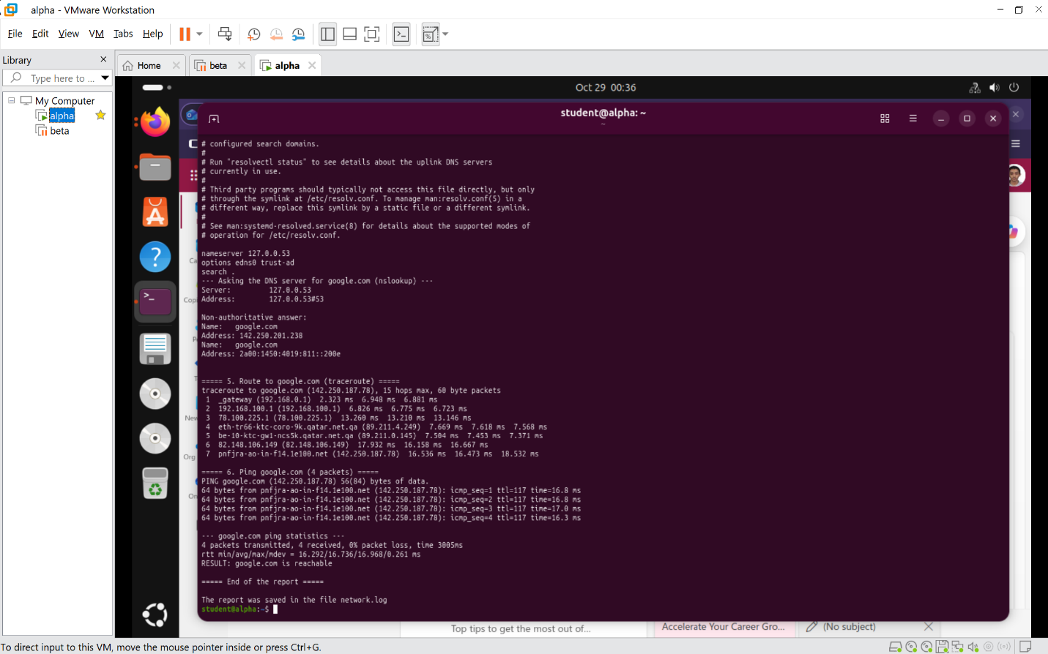
Figure 14: ALPHA | Network.sh | Task 4 – DNS test, traceroute to google.com and ping google
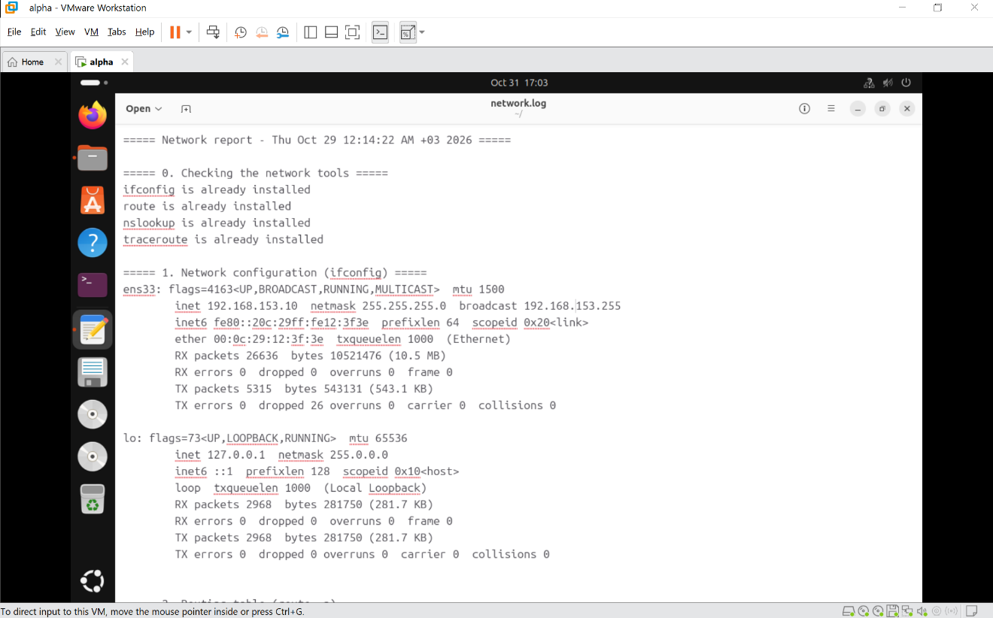
Figure 15: ALPHA | Network.sh | Task 4 – contents of network.log

Task 5: File System Auditing and Backup (FileSystem.sh)
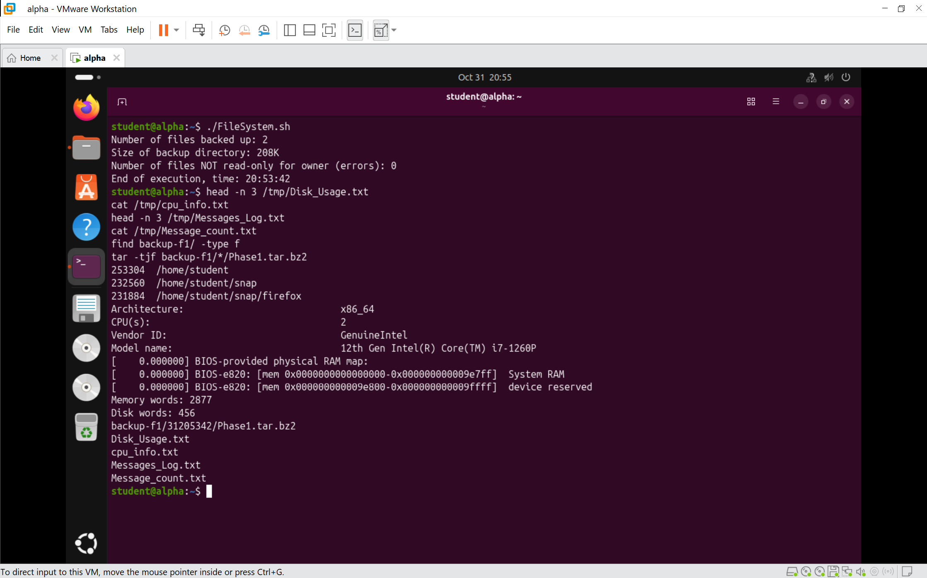
Figure 16: ALPHA | FileSystem.sh | Task 5 – first subroutine: Disk_Usage.txt, cpu_info.txt, Messages_Log.txt, Message_count.txt, and Phase1.tar.bz2 in the time-named directory
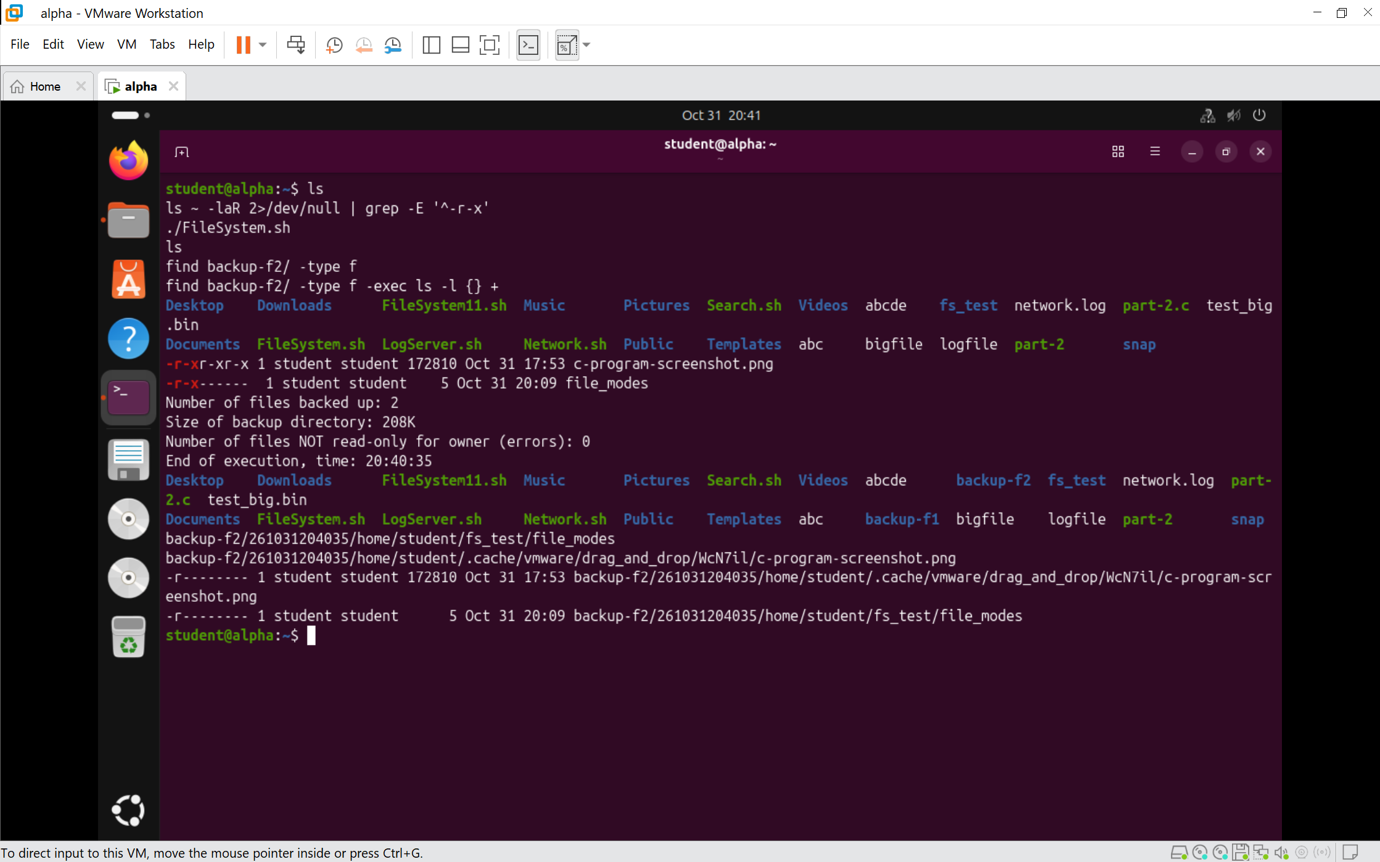
Figure 17: ALPHA | FileSystem.sh | Task 5 – second subroutine: copy of the owner-only r-x files into the date-time backup directory with read-only permissions
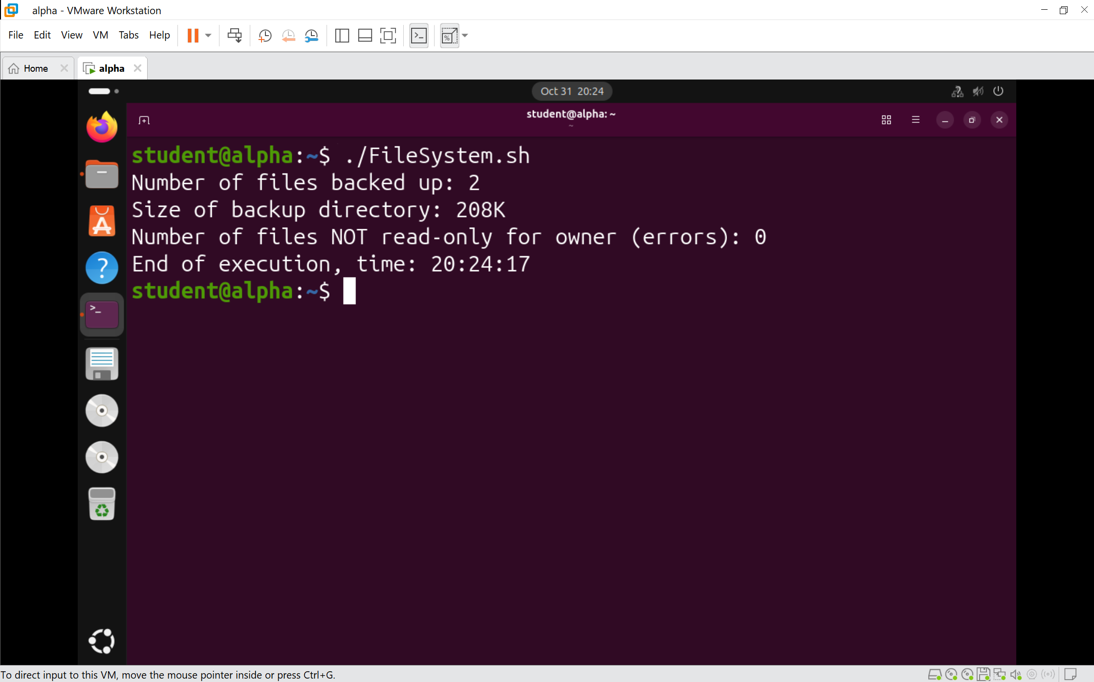
Figure 18: ALPHA | FileSystem.sh | Task 5 – third subroutine: verification (error count = 0), total files, directory size, end message with time

Task 6: Centralized Log (Syslog) Server (LogServer.sh)
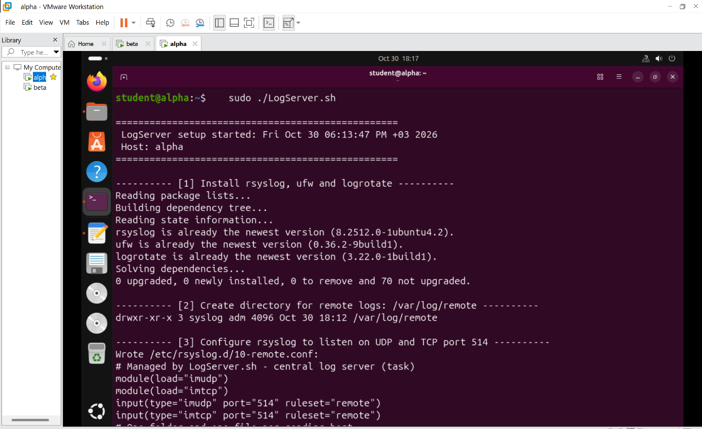
Figure 19: ALPHA | LogServer.sh | Task 6 – script run: rsyslog install, UDP/TCP 514 configuration
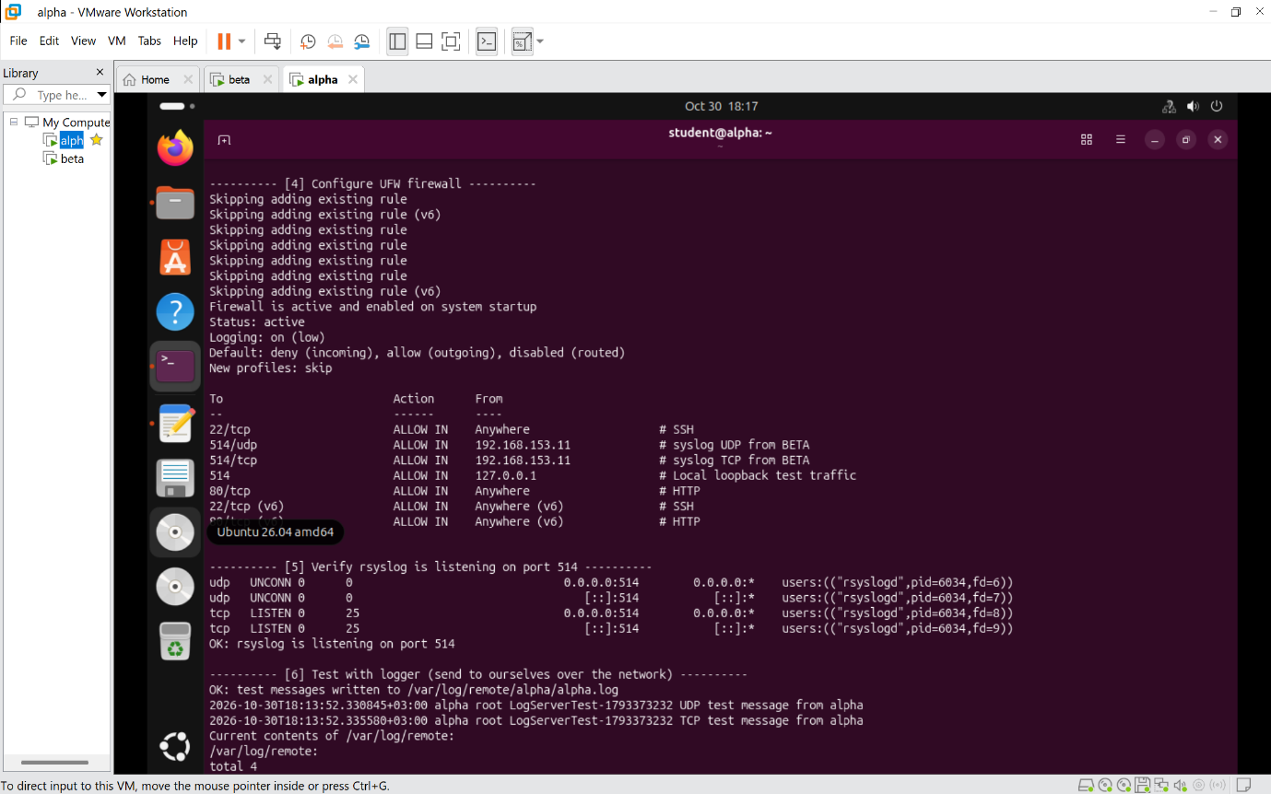
Figure 20: ALPHA | LogServer.sh | Task 6 – firewall rules (SSH allowed first, port 514 from BETA only)
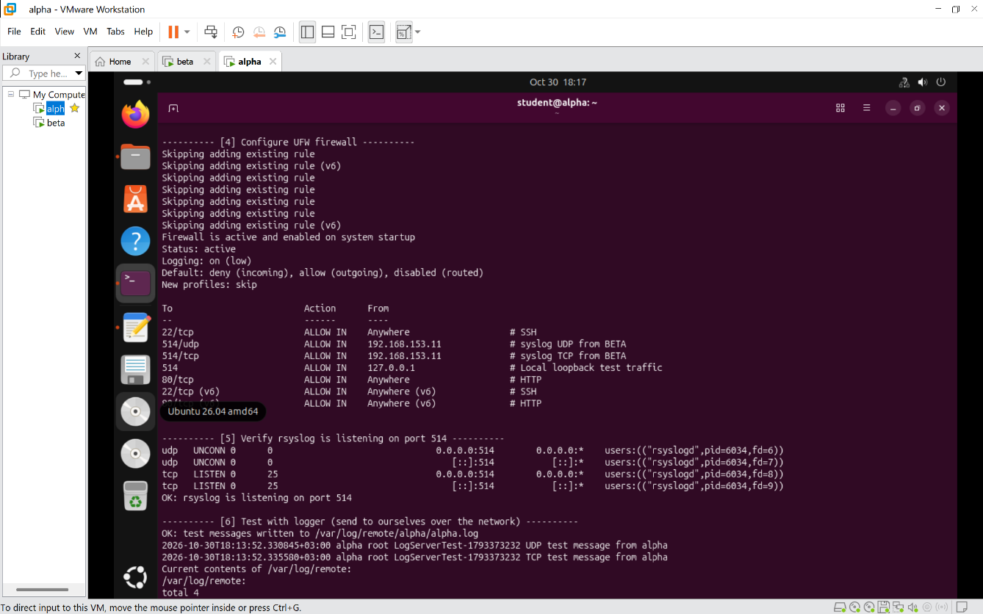
Figure 21: ALPHA | LogServer.sh | Task 6 – service restarted and listening on port 514
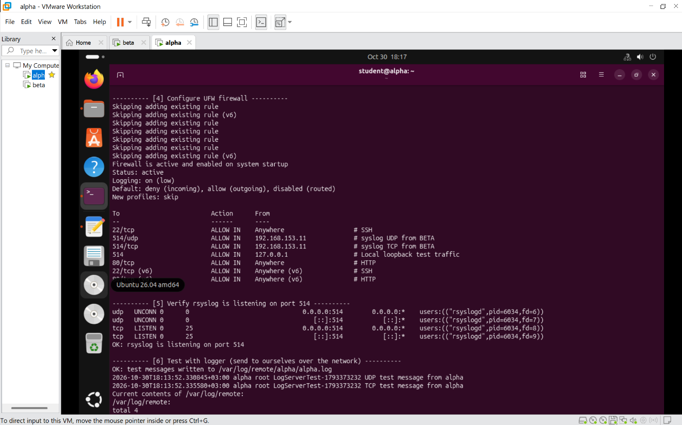
Figure 22: ALPHA | LogServer.sh | Task 6 – logger test message recorded
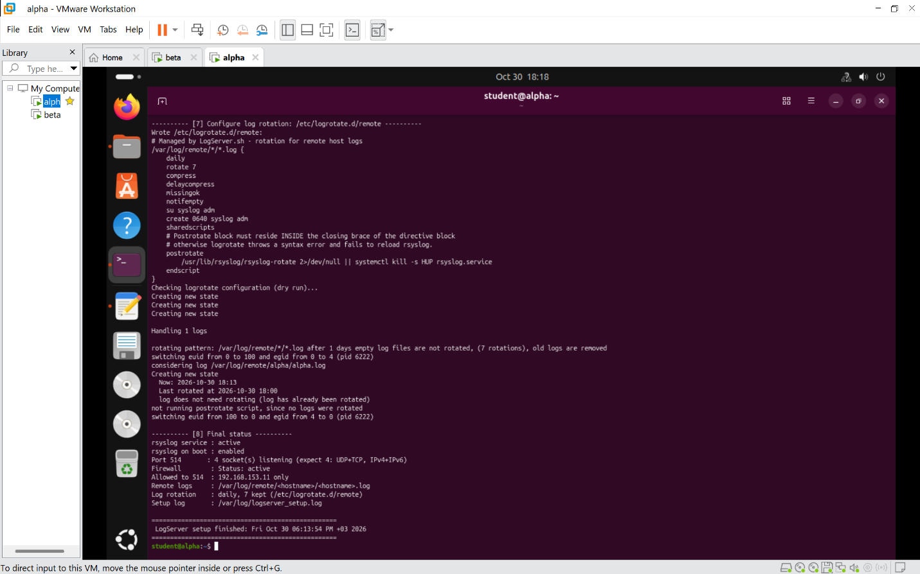
Figure 23: ALPHA | LogServer.sh | Task 6 – log rotation configuration (daily, 7 kept)
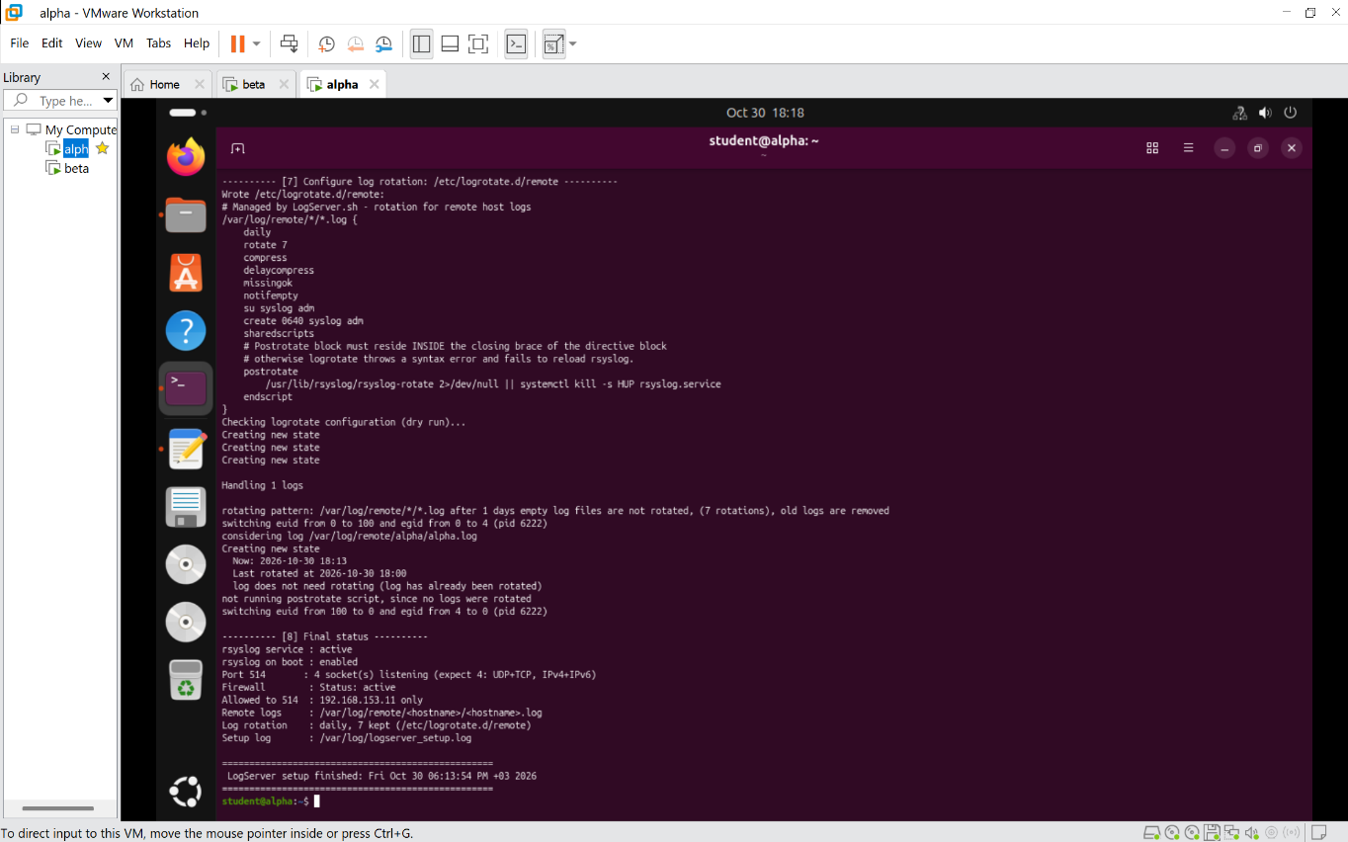
Figure 24: ALPHA | LogServer.sh | Task 6 – logserver_setup.log and final service status

Part 1: Shell Scripting – BETA VM (Client)

Task 1: Continuous Connectivity Testing (Connectivity.sh)
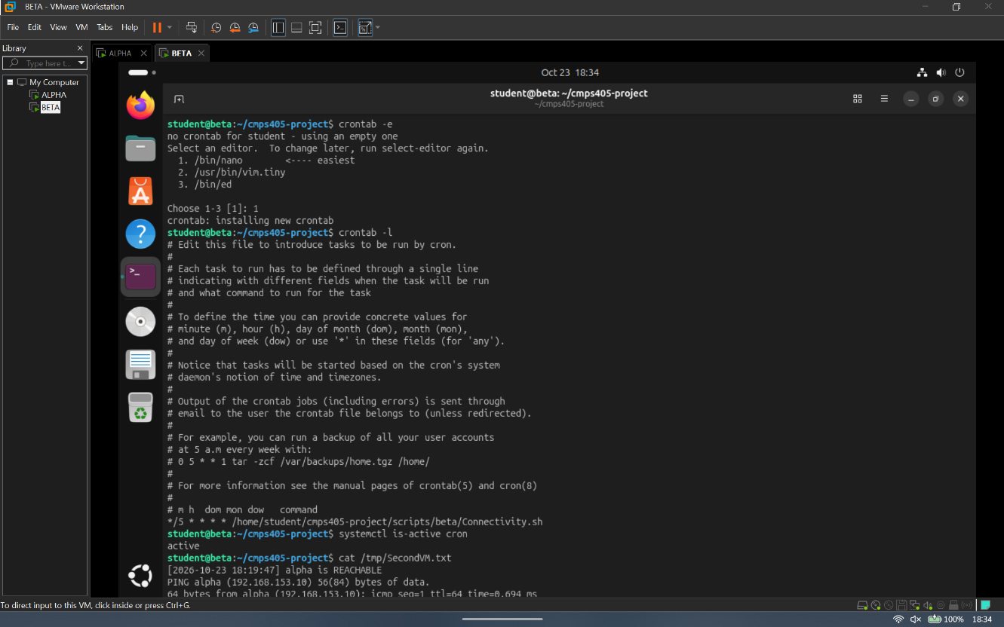
Figure 25: BETA | Connectivity.sh | Task 1 – script run and cron schedule (crontab -l)
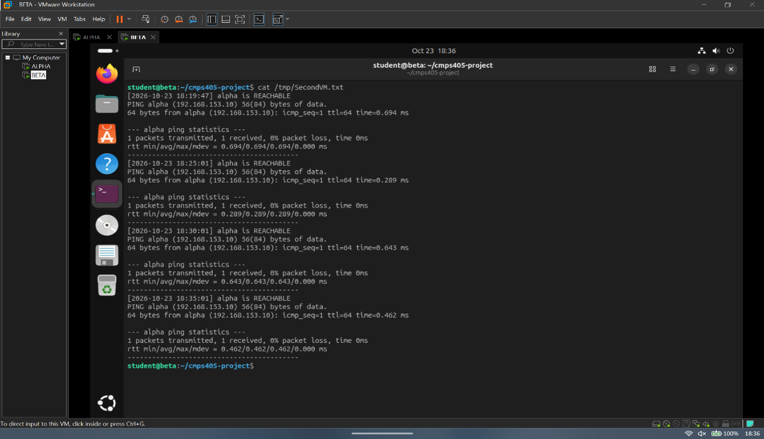
Figure 26: BETA | Connectivity.sh | Task 1 – /tmp/SecondVM.txt with timestamped ping results every 5 minutes

Task 2: Remote Access and Web Verification (Remote.sh)
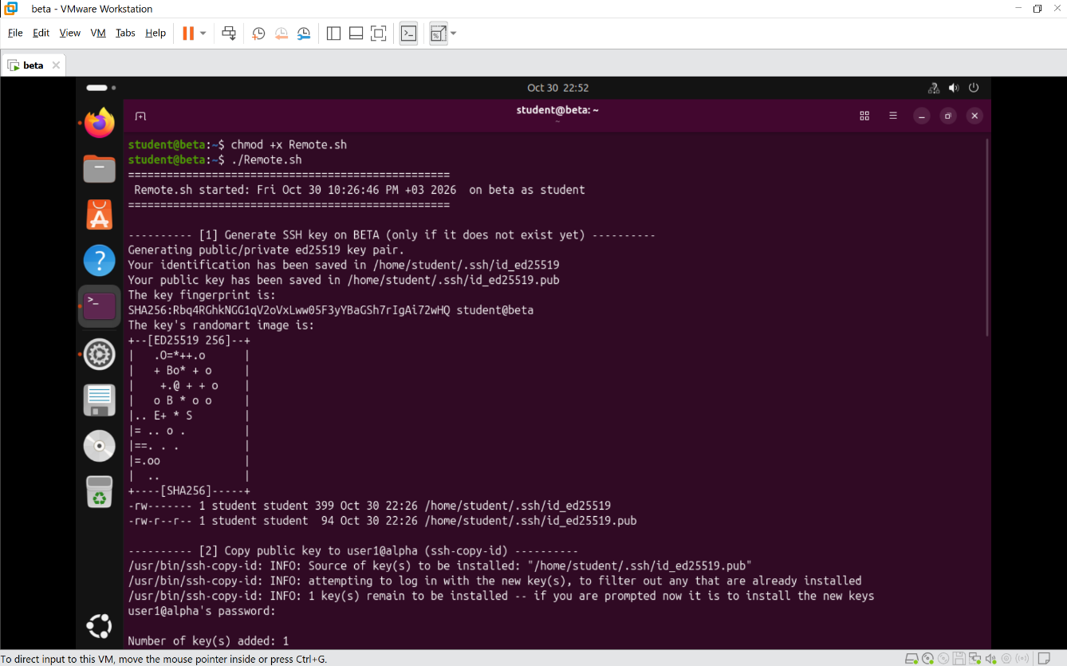
Figure 27: BETA | Remote.sh | Task 2 – SSH key pair generated and public key installed on ALPHA
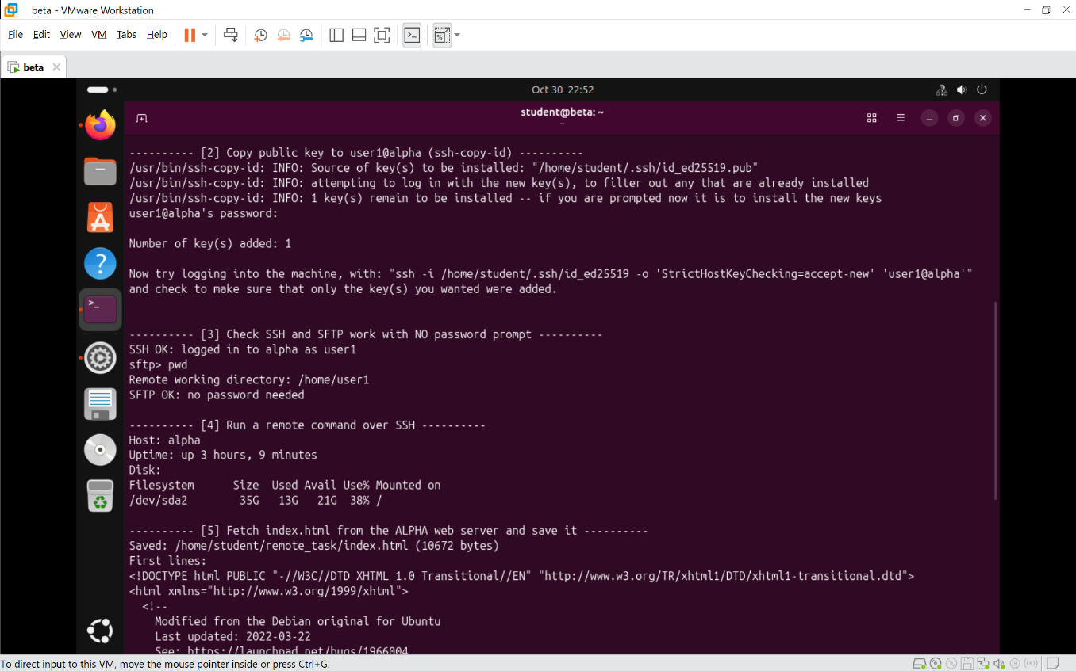
Figure 28: BETA | Remote.sh | Task 2 – script run: SSH to ALPHA without password prompt
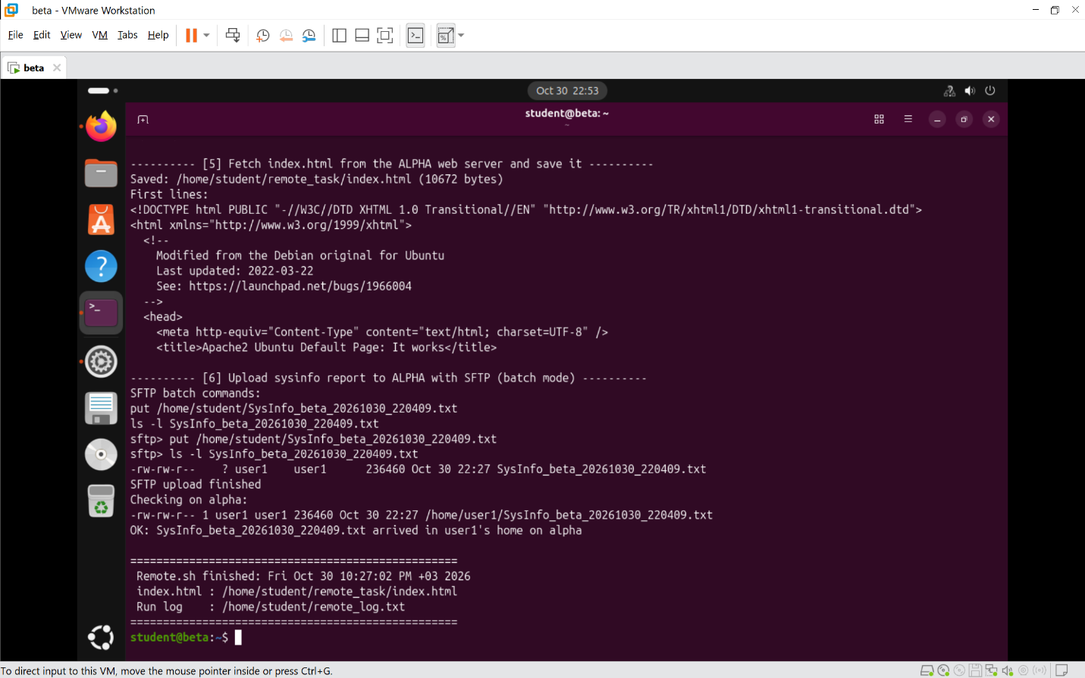
Figure 29: BETA | Remote.sh | Task 2 – index.html fetched from the ALPHA web server and saved
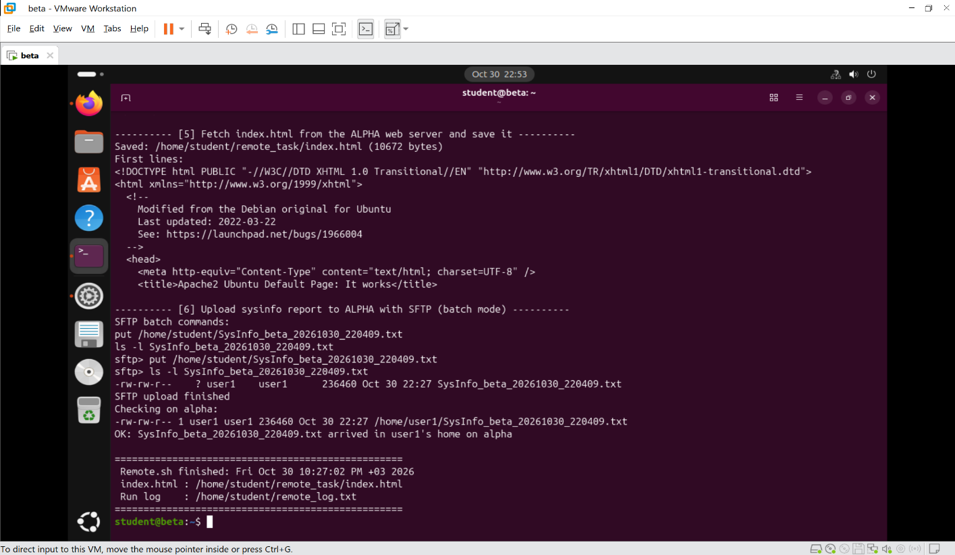
Figure 30: BETA | Remote.sh | Task 2 – SFTP upload of the system information file
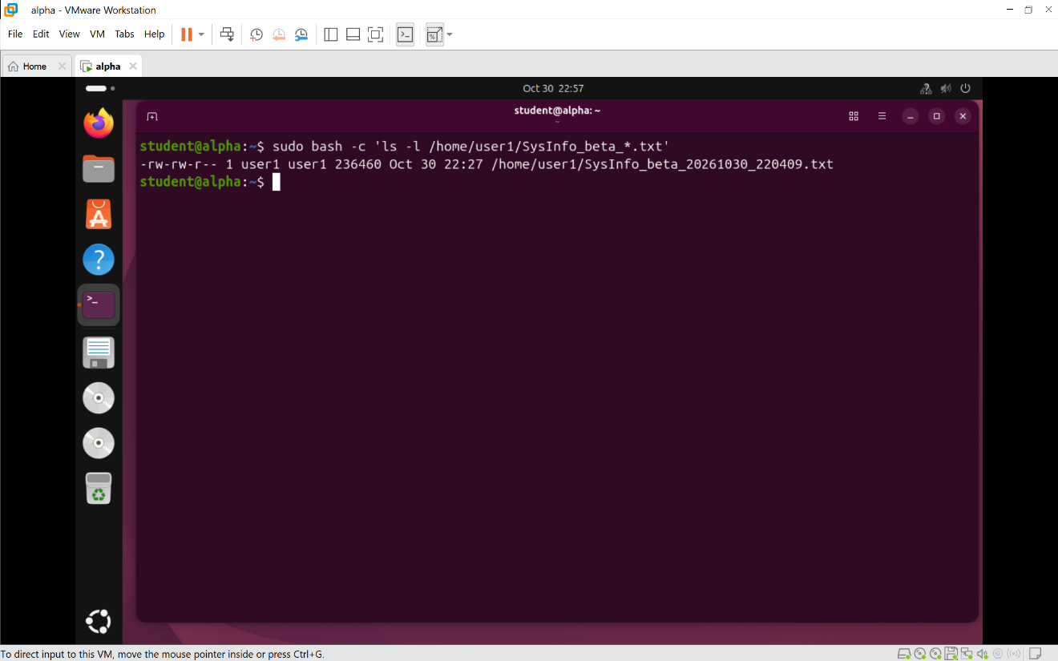
Figure 31: BETA | Remote.sh | Task 2 – uploaded file received on ALPHA

Task 3: System Information Report (SysInfo.sh)
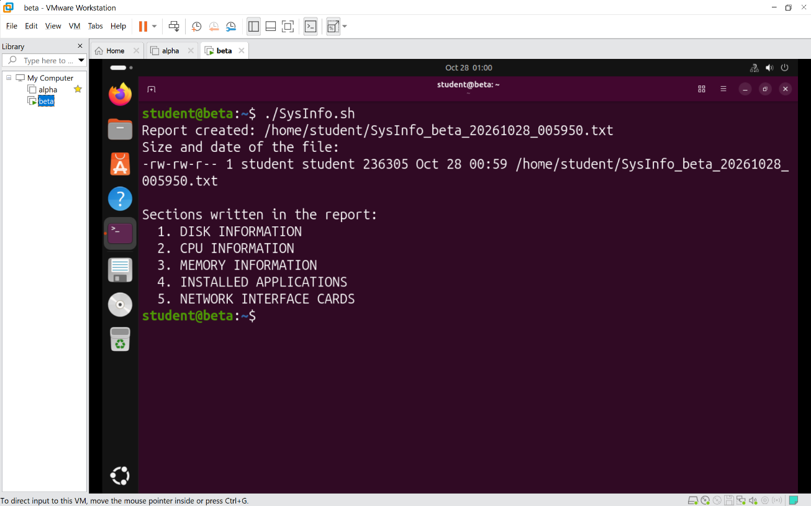
Figure 32: BETA | SysInfo.sh | Task 3 – script run
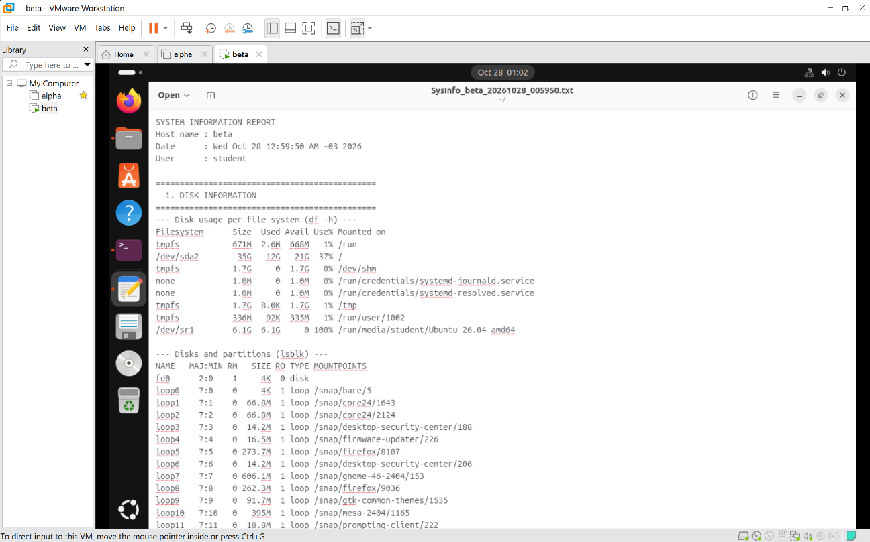
Figure 33: BETA | SysInfo.sh | Task 3 – contents of the timestamped report (disk, CPU, memory, applications, NIC)

Task 4: Log Forwarding Client (LogClient.sh)
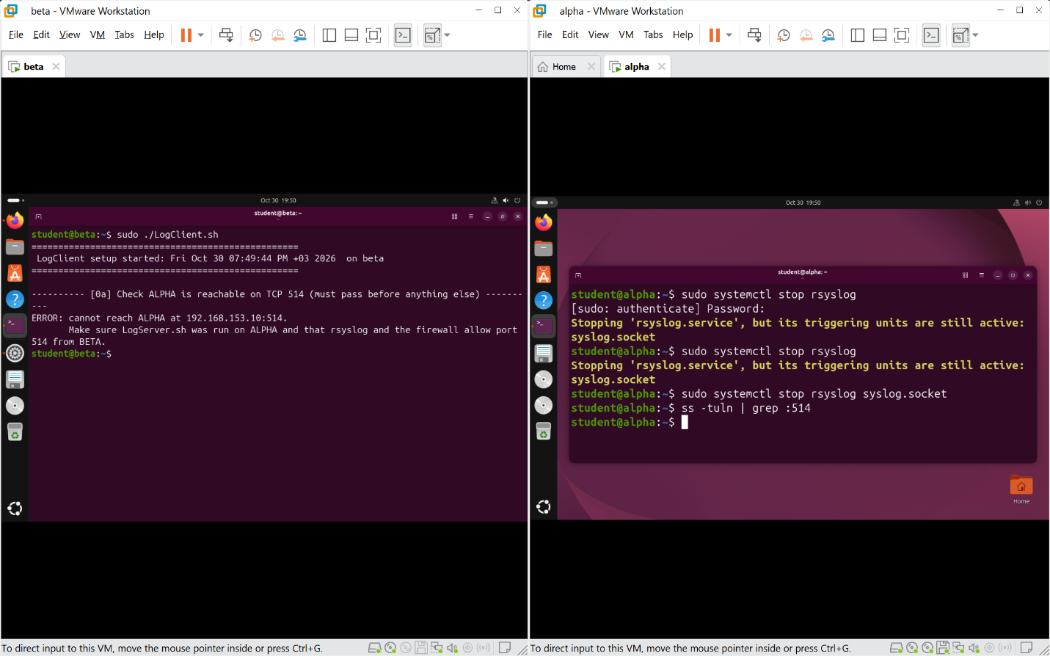
Figure 34: BETA | LogClient.sh | Task 4 – reachability check on ALPHA port 514 (clear error when unreachable)
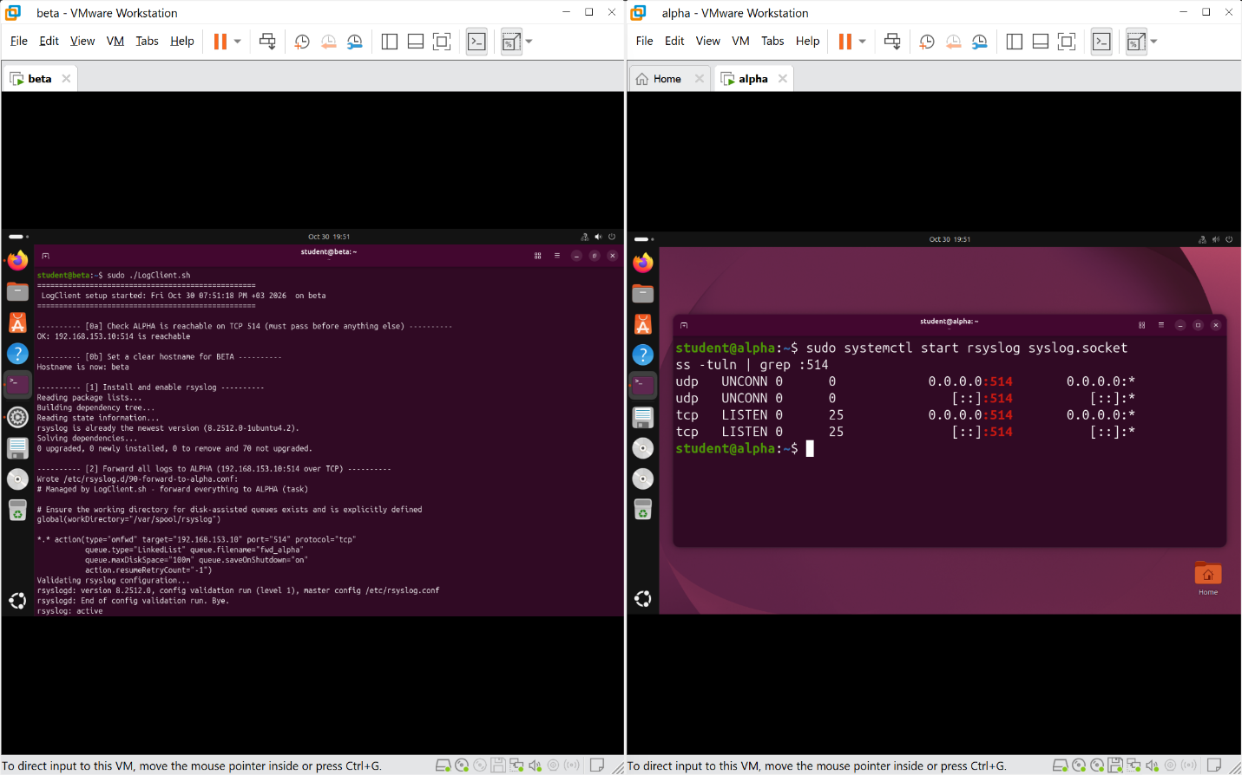
Figure 35: BETA | LogClient.sh | Task 4 – script run: hostname, rsyslog installed and forwarding configured, service restarted
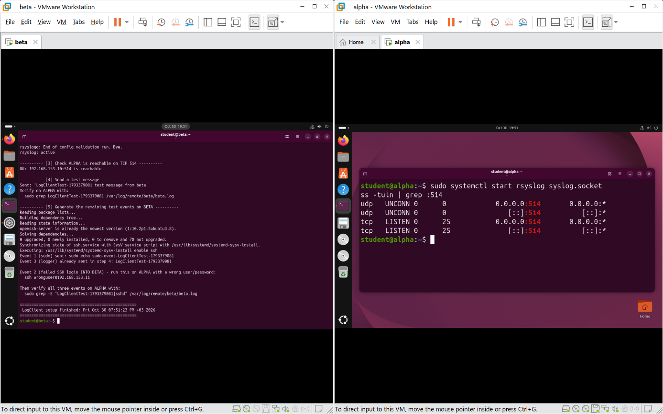
Figure 36: BETA | LogClient.sh | Task 4 – test events on BETA: sudo command and logger message
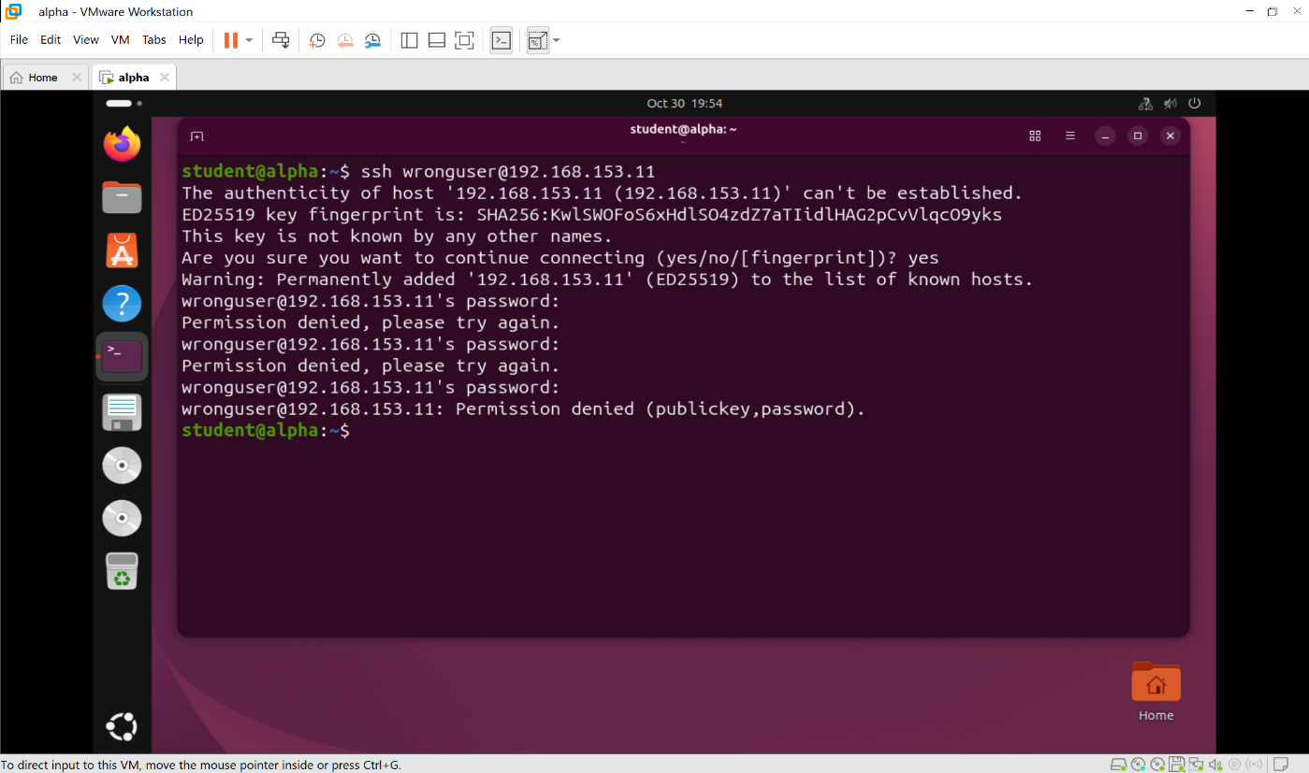
Figure 37: BETA | LogClient.sh | Task 4 – failed SSH login attempt into BETA (from ALPHA)
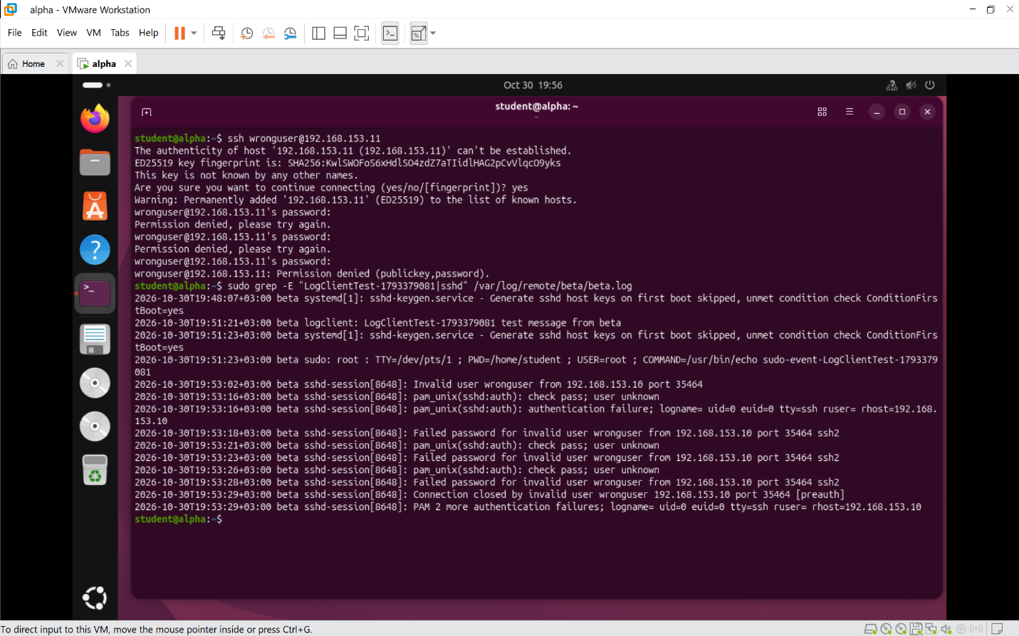
Figure 38: BETA | LogClient.sh | Task 4 – three events visible inside /var/log/remote/ on ALPHA

Part 2: System Programming in C (ALPHA)

Task 1: Parallel Task Execution with Sibling Processes (part-2.c)
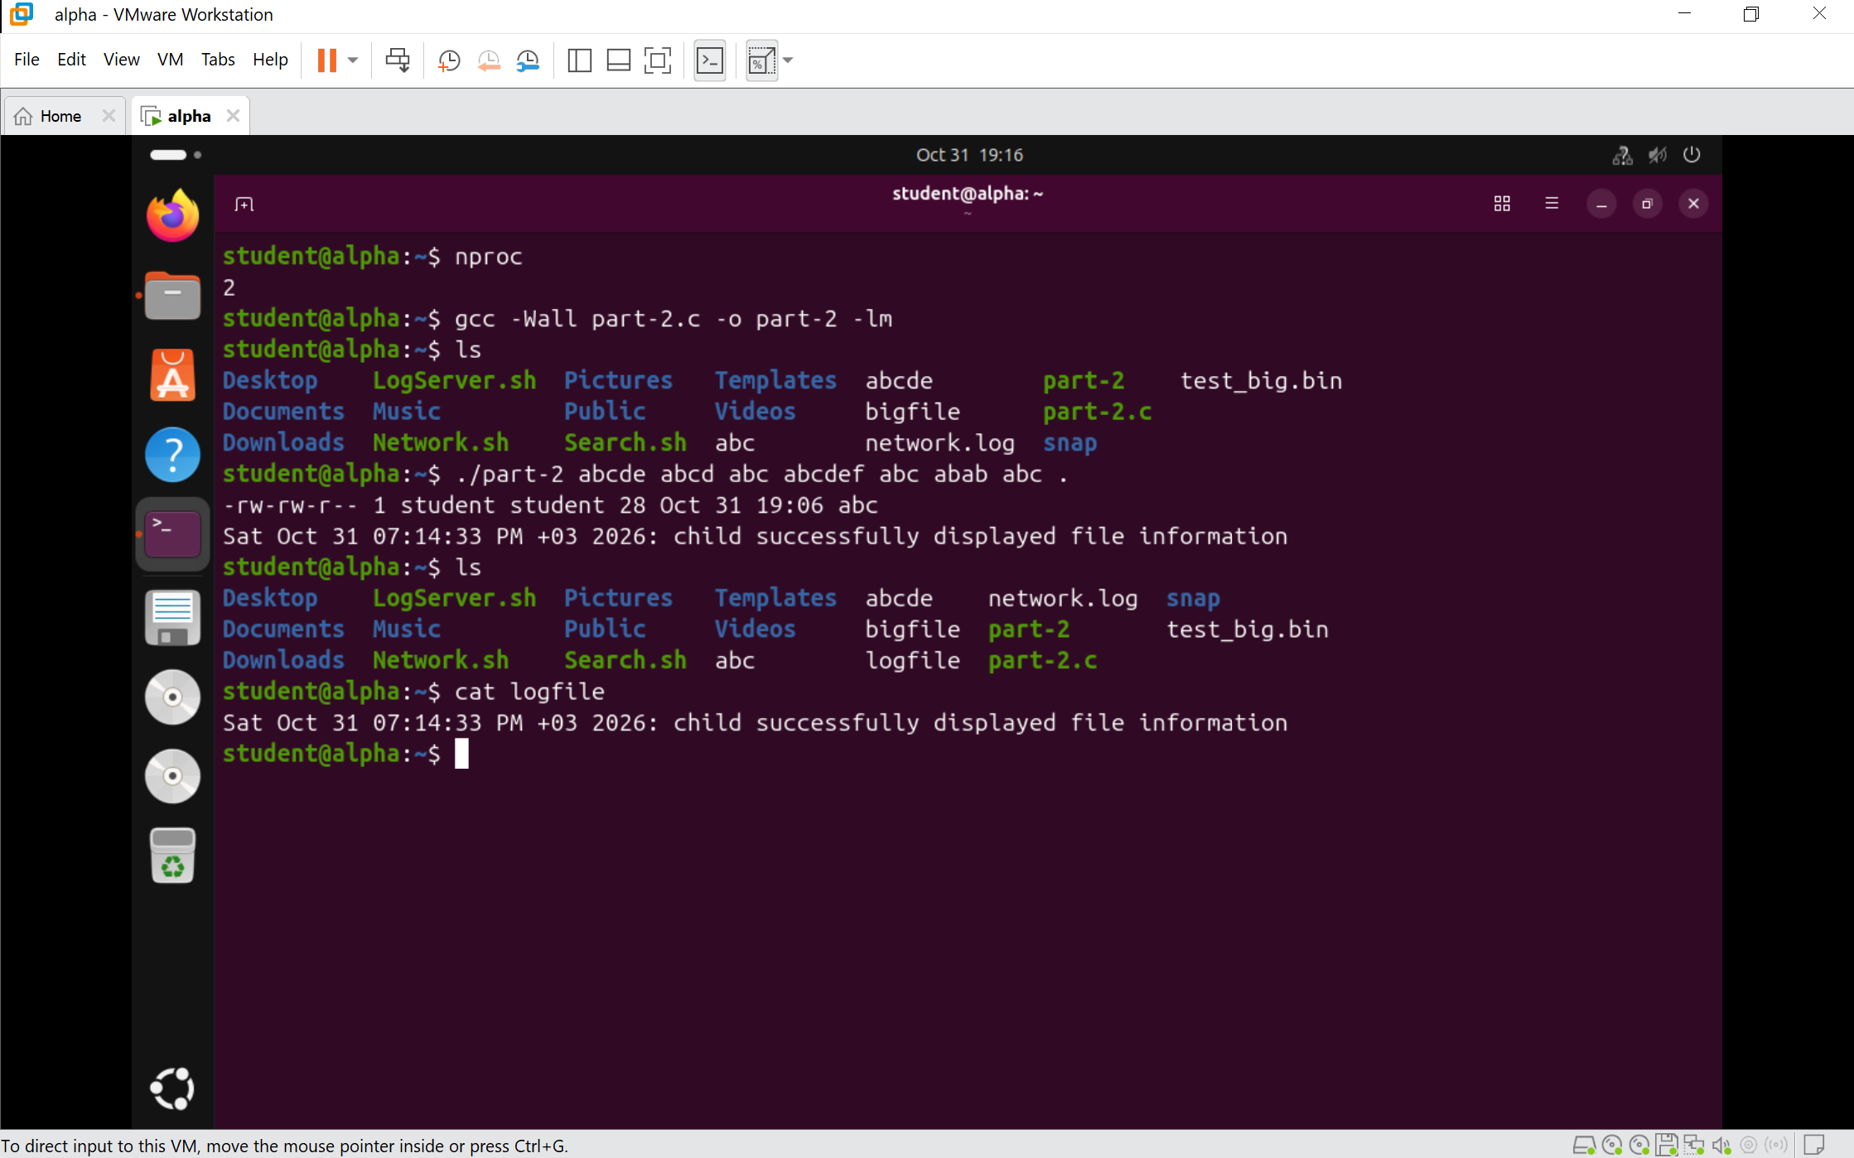
Figure 39: ALPHA | part-2.c | Task 1 – core count, compilation with -Wall, running with CLI arguments, and the parent printing the log file

