**BGP Lab**

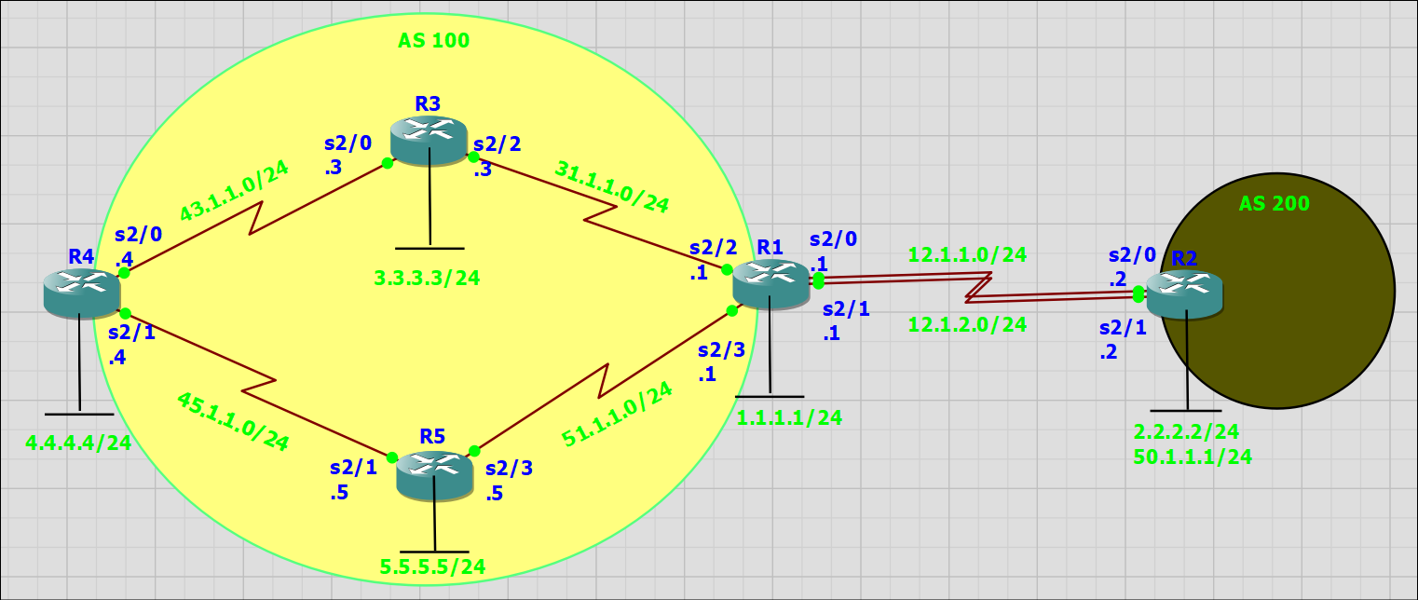

R1(config)#interface serial 2/2

R1(config-if)#no shutdown

R1(config-if)#ip address 31.1.1.1 255.255.255.0

R1(config-if)#ex

R1(config)#interface serial 2/3

R1(config-if)#no shutdown

R1(config-if)#ip address 51.1.1.1 255.255.255.0

R1(config-if)#ex

R1(config)#interface loopback 1

R1(config-if)#no shutdown

R1(config-if)#ip address 1.1.1.1 255.255.255.0

R1(config-if)#ex

R1(config)#router ospf 1

R1(config-router)#network 0.0.0.0 255.255.255.255 area 0

R1(config-router)#passive-interface serial 2/0

R1(config-router)#passive-interface serial 2/1

R1(config-router)#ex

R1(config)#router bgp 100

R1(config-router)#no auto-summary

R1(config-router)#no synchronization

R1(config-router)#neighbor 3.3.3.3 remote-as 100

R1(config-router)#neighbor 3.3.3.3 update-source loopback 1

R1(config-router)#neighbor 4.4.4.4 remote-as 100

R1(config-router)#neighbor 4.4.4.4 update-source loopback 1

R1(config-router)#neighbor 5.5.5.5 remote-as 100

R1(config-router)#neighbor 5.5.5.5 update-source loopback 1

R1(config-router)#neighbor 3.3.3.3 next-hop-self

R1(config-router)#neighbor 4.4.4.4 next-hop-self

R1(config-router)#neighbor 5.5.5.5 next-hop-self

R1#show ip bgp summary

R1(config)#interface serial 2/0

R1(config-if)#no shutdown

R1(config-if)#ip address 12.1.1.1 255.255.255.0

R1(config-if)#ex

R1(config)#interface serial 2/1

R1(config-if)#no shutdown

R1(config-if)#ip address 12.1.2.1 255.255.255.0

R1(config-if)#ex

R1(config)#router bgp 100

R1(config-router)#neighbor 2.2.2.2 remote-as 200

R1(config-router)#neighbor 2.2.2.2 update-source loopback 1

R1(config-router)#neighbor 2.2.2.2 ebgp-multihop 2

R1(config-router)#ex

R1(config)#ip route 2.2.2.0 255.255.255.0 12.1.1.2

R1(config)#ip route 2.2.2.0 255.255.255.0 12.1.2.2

R1#write memory

R2(config)#interface serial 2/0

R2(config-if)#no shutdown

R2(config-if)#ip address 12.1.1.2 255.255.255.0

R2(config-if)#ex

R2(config)#interface serial 2/1

R2(config-if)#no shutdown

R2(config-if)#ip address 12.1.2.2 255.255.255.0

R2(config-if)#ex

R2(config)#interface loopback 2

R2(config-if)#no shutdown

R2(config-if)#ip address 2.2.2.2 255.255.255.0

R2(config)#router bgp 200

R2(config-router)#no auto-summary

R2(config-router)#neighbor 1.1.1.1 remote-as 100

R2(config-router)#neighbor 1.1.1.1 ebgp-multihop 2

R2(config-router)#neighbor 1.1.1.1 update-source loopback 2

R2(config-router)#ex

R2(config)#ip route 1.1.1.0 255.255.255.0 12.1.1.1

R2(config)#ip route 1.1.1.0 255.255.255.0 12.1.2.1

R2# write memory

R2(config)#interface loopback 50

R2(config-if)#no shutdown

R2(config-if)#ip address 50.1.1.1 255.255.255.0

R2(config-if)#ex

R2(config)#router bgp 200

R2(config-router)#network 50.1.1.0 mask 255.255.255.0

R2# write memory

R3(config)#interface serial 2/2

R3(config-if)#no shutdown

R3(config-if)#ip address 31.1.1.3 255.255.255.0

R3(config-if)#ex

R3(config)#interface serial 2/0

R3(config-if)#no shutdown

R3(config-if)#ip address 43.1.1.3 255.255.255.0

R3(config-if)#ex

R3(config)#interface loopback 3

R3(config-if)#no shutdown

R3(config-if)#ip address 3.3.3.3 255.255.255.0

R3(config-if)#ex

R3(config)#router ospf 1

R3(config-router)#network 0.0.0.0 255.255.255.255 area 0

R3(config-router)#ex

R3(config)#router bgp 100

R3(config-router)#no auto-summary

R3(config-router)#no synchronization

R3(config-router)#neighbor 1.1.1.1 remote-as 100

R3(config-router)#neighbor 1.1.1.1 update-source loopback 3

R3(config-router)#neighbor 4.4.4.4 remote-as 100

R3(config-router)#neighbor 4.4.4.4 update-source loopback 3

R3(config-router)#neighbor 5.5.5.5 remote-as 100

R3(config-router)#neighbor 5.5.5.5 update-source loopback 3

R3(config-router)#neighbor 1.1.1.1 next-hop-self

R3(config-router)#neighbor 4.4.4.4 next-hop-self

R3(config-router)#neighbor 5.5.5.5 next-hop-self

R3# write memory

R4(config)#interface serial 2/0

R4(config-if)#no shutdown

R4(config-if)#ip address 43.1.1.4 255.255.255.0

R4(config-if)#ex

R4(config)#interface serial 2/1

R4(config-if)#no shutdown

R4(config-if)#ip address 45.1.1.4 255.255.255.0

R4(config-if)#ex

R4(config)#interface loopback 4

R4(config-if)#no shutdown

R4(config-if)#ip address 4.4.4.4 255.255.255.0

R4(config-if)#ex

R4(config)#router ospf 1

R4(config-router)#network 0.0.0.0 255.255.255.255 area 0

R4(config-router)#ex

R4(config)#router bgp 100

R4(config-router)#no auto-summary

R4(config-router)#no synchronization

R4(config-router)#neighbor 1.1.1.1 remote-as 100

R4(config-router)#neighbor 1.1.1.1 update-source loopback 4

R4(config-router)#neighbor 3.3.3.3 remote-as 100

R4(config-router)#neighbor 3.3.3.3 update-source loopback 4

R4(config-router)#neighbor 5.5.5.5 remote-as 100

R4(config-router)#neighbor 5.5.5.5 update-source loopback 4

R4(config-router)#neighbor 1.1.1.1 next-hop-self

R4(config-router)#neighbor 3.3.3.3 next-hop-self

R4(config-router)#neighbor 5.5.5.5 next-hop-self

R4#write memory

R5(config)#interface serial 2/1

R5(config-if)#no shutdown

R5(config-if)#ip address 45.1.1.5 255.255.255.0

R5(config-if)#ex

R5(config)#interface serial 2/3

R5(config-if)#no shutdown

R5(config-if)#ip address 51.1.1.5 255.255.255.0

R5(config-if)#ex

R5(config)#interface loopback 5

R5(config-if)#no shutdown

R5(config-if)#ip address 5.5.5.5 255.255.255.0

R5(config-if)#ex

R5(config)#router ospf 1

R5(config-router)#network 0.0.0.0 255.255.255.255 area 0

R5(config-router)#ex

R5(config)#router bgp 100

R5(config-router)#no auto-summary

R5(config-router)#no synchronization

R5(config-router)#neighbor 1.1.1.1 remote-as 100

R5(config-router)#neighbor 1.1.1.1 update-source loopback 5

R5(config-router)#neighbor 3.3.3.3 remote-as 100

R5(config-router)#neighbor 3.3.3.3 update-source loopback 5

R5(config-router)#neighbor 4.4.4.4 remote-as 100

R5(config-router)#neighbor 4.4.4.4 update-source loopback 5

R5(config-router)#neighbor 1.1.1.1 next-hop-self

R5(config-router)#neighbor 3.3.3.3 next-hop-self

R5(config-router)#neighbor 4.4.4.4 next-hop-self

R5# write memory