**EIGRP Lab**

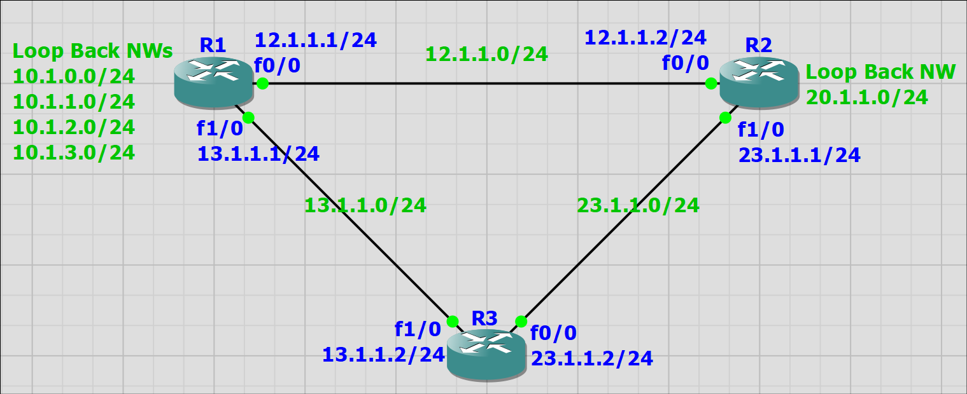

**R1**

R1(config)#interface fastEthernet 0/0

R1(config-if)#no shutdown

R1(config-if)#ip address 12.1.1.1 255.255.255.0

R1(config-if)#ex

R1(config)#interface fastEthernet 1/0

R1(config-if)#no shutdown

R1(config-if)#ip address 13.1.1.1 255.255.255.0

R1(config-if)#ex

R1 (config)#interface loopback 0

R1 (config-if)#no shutdown

R1 (config-if)#ip address 10.1.0.1 255.255.255.0

R1 (config-if)#ex

R1 (config)#interface loopback 1

R1 (config-if)#no shutdown

R1 (config-if)#ip address 10.1.1.1 255.255.255.0

R1 (config-if)#ex

R1 (config)#interface loopback 2

R1 (config-if)#no shutdown

R1 (config-if)#ip address 10.1.2.1 255.255.255.0

R1 (config-if)#ex

R1 (config)#interface loopback 3

R1 (config-if)#no shutdown

R1 (config-if)#ip address 10.1.3.1 255.255.255.0

R1 (config-if)#ex

R1#show ip interface brief

R1#show ip route

R1(config)#router eigrp 100

R1(config-router)#no auto-summary

R1(config-router)#network 0.0.0.0 255.255.255.255

R1#show ip eigrp neighbors

R1#show ip eigrp topology

R1(config-router)#passive-interface loopback 0

R1(config-router)#passive-interface loopback 1

R1(config-router)#passive-interface loopback 2

R1(config-router)#passive-interface loopback 3

Or it is better

R1(config-router)#passive-interface default

R1(config-router)#no passive-interface fa 0/0

R1(config-router)#no passive-interface fa 1/0

R1(config)#interface fastEthernet 0/0

R1(config-if)#ip summary-address eigrp 100 10.1.0.0 255.255.252.0

R1(config-if)#interface fastEthernet 1/0

R1(config-if)#ip summary-address eigrp 100 10.1.0.0 255.255.252.0

R1(config)#key chain Transistor

R1(config-keychain)#key 10

R1(config-keychain-key)#key-string epic

R1(config-keychain-key)#ex

R1(config-keychain)#ex

R1(config)#interface fastEthernet 0/0

R1(config-if)#ip authentication mode eigrp 100 md5

R1(config-if)#ip authentication key-chain eigrp 100 Transistor

R1(config-if)#interface fastEthernet 1/0

R1(config-if)#ip authentication mode eigrp 100 md5

R1(config-if)#ip authentication key-chain eigrp 100 Transistor

**R2**

R2(config)#interface fastEthernet 0/0

R2(config-if)#no shutdown

R2(config-if)#ip address 12.1.1.2 255.255.255.0

R2(config-if)#ex

R2(config)#interface fastEthernet 1/0

R2(config-if)#no shutdown

R2(config-if)#ip address 23.1.1.1 255.255.255.0

R2(config-if)#ex

R2(config)#interface loopback 0

R2(config-if)#ip address 20.1.1.1 255.255.255.0

R2(config)#router eigrp 100

R2(config-router)#no auto-summary

R2(config-router)#network 0.0.0.0 255.255.255.255

R2(config)#key chain Transistor

R2(config-keychain)#key 10

R2(config-keychain-key)#key-string epic

R2(config-keychain-key)#ex

R2(config-keychain)#ex

R2(config)#interface fastEthernet 0/0

R2(config-if)#ip authentication mode eigrp 100 md5

R2(config-if)#ip authentication key-chain eigrp 100 Transistor

R2(config-if)#interface fastEthernet 1/0

R2(config-if)#ip authentication mode eigrp 100 md5

R2(config-if)#ip authentication key-chain eigrp 100 Transistor

**R3**

R3(config)#interface fastEthernet 0/0

R3(config-if)#no shutdown

R3(config-if)#ip address 23.1.1.2 255.255.255.0

R3(config-if)#ex

R3(config)#interface fastEthernet 1/0

R3(config-if)#no shutdown

R3(config-if)#ip address 13.1.1.2 255.255.255.0

R3(config-if)#ex

R3(config)#router eigrp 100

R3(config-router)#no auto-summary

R3(config-router)#network 0.0.0.0 255.255.255.255

R3(config-if)#key chain Transistor

R3(config-keychain)#key 10

R3(config-keychain-key)#key-string epic

R3(config-keychain-key)#ex

R3(config-keychain)#ex

R3(config)#interface fastEthernet 0/0

R3(config-if)#ip authentication mode eigrp 100 md5

R3(config-if)#ip authentication key-chain eigrp 100 Transistor

R3(config-if)#interface fastEthernet 1/0

R3(config-if)#ip authentication mode eigrp 100 md5

R3(config-if)#ip authentication key-chain eigrp 100 Transistor

**The full configuration as script**

**==============================================================================**

**============================= R1 =================================**

**==============================================================================**

config t

interface fastEthernet 0/0

no shutdown

ip address 12.1.1.1 255.255.255.0

ex

interface fastEthernet 1/0

no shutdown

ip address 13.1.1.1 255.255.255.0

ex

interface loopback 0

no shutdown

ip address 10.1.0.1 255.255.255.0

ex

interface loopback 1

no shutdown

ip address 10.1.1.1 255.255.255.0

ex

interface loopback 2

no shutdown

ip address 10.1.2.1 255.255.255.0

ex

interface loopback 3

no shutdown

ip address 10.1.3.1 255.255.255.0

ex

router eigrp 100

no auto-summary

network 0.0.0.0 255.255.255.255

passive-interface default

no passive-interface fa 0/0

no passive-interface fa 1/0

ex

interface fastEthernet 0/0

ip summary-address eigrp 100 10.1.0.0 255.255.252.0

ex

interface fastEthernet 1/0

ip summary-address eigrp 100 10.1.0.0 255.255.252.0

ex

key chain Transistor

key 10

key-string epic

ex

ex

interface fastEthernet 0/0

ip authentication mode eigrp 100 md5

ip authentication key-chain eigrp 100 Transistor

ex

interface fastEthernet 1/0

ip authentication mode eigrp 100 md5

ip authentication key-chain eigrp 100 Transistor

ex

**==============================================================================**

**============================= R2 =================================**

**==============================================================================**

config t

interface fastEthernet 0/0

no shutdown

ip address 12.1.1.2 255.255.255.0

ex

interface fastEthernet 1/0

no shutdown

ip address 23.1.1.1 255.255.255.0

ex

interface loopback 0

ip address 20.1.1.1 255.255.255.0

ex

router eigrp 100

no auto-summary

network 0.0.0.0 255.255.255.255

ex

key chain Transistor

key 10

key-string epic

ex

ex

interface fastEthernet 0/0

ip authentication mode eigrp 100 md5

ip authentication key-chain eigrp 100 Transistor

interface fastEthernet 1/0

ip authentication mode eigrp 100 md5

ip authentication key-chain eigrp 100 Transistor

**==============================================================================**

**============================= R3 =================================**

**==============================================================================**

config t

interface fastEthernet 0/0

no shutdown

ip address 23.1.1.2 255.255.255.0

ex

interface fastEthernet 1/0

no shutdown

ip address 13.1.1.2 255.255.255.0

ex

router eigrp 100

no auto-summary

network 0.0.0.0 255.255.255.255

ex

key chain Transistor

key 10

key-string epic

ex

ex

interface fastEthernet 0/0

ip authentication mode eigrp 100 md5

ip authentication key-chain eigrp 100 Transistor

interface fastEthernet 1/0

ip authentication mode eigrp 100 md5

ip authentication key-chain eigrp 100 Transistor