**L3 VPN**

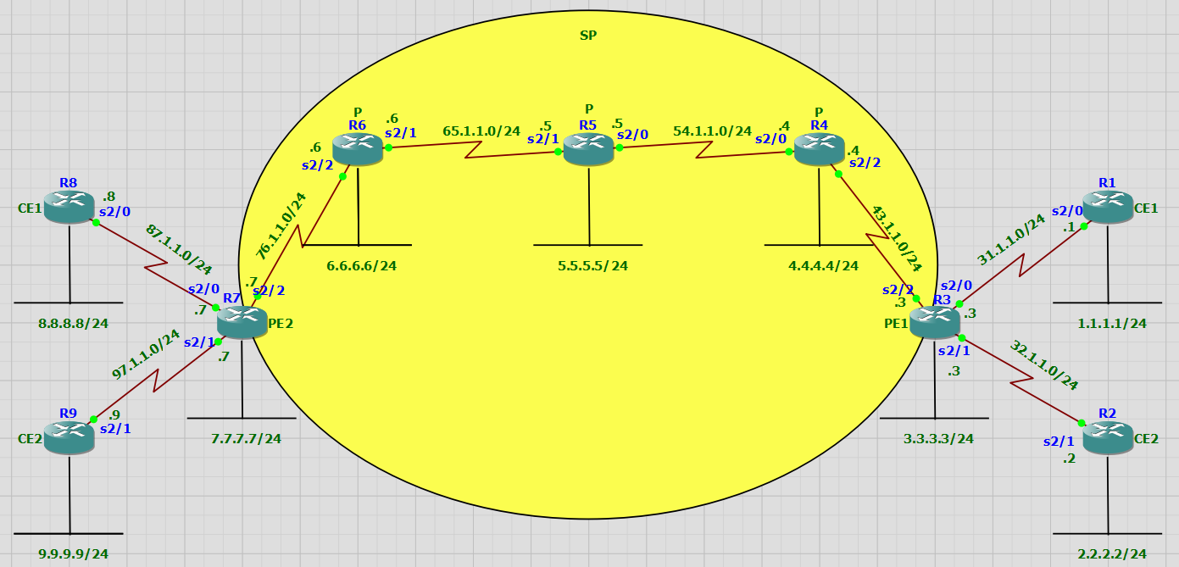

**R1**

R1(config)#interface serial 2/0

R1(config-if)#no shutdown

R1(config-if)#ip address 31.1.1.1 255.255.255.0

R1(config-if)#ex

R1(config)#interface loopback 1

R1(config-if)#ip address 1.1.1.1 255.255.255.0

R1(config-if)#ex

R1(config)#router ospf 1

R1(config-router)#network 0.0.0.0 255.255.255.255 area 1

**R2**

R2(config)#interface serial 2/1

R2(config-if)#no shutdown

R2(config-if)#ip address 32.1.1.2 255.255.255.0

R2(config-if)#ex

R2(config)#interface loopback 2

R2(config-if)#no shutdown

R2(config-if)#ip address 2.2.2.2 255.255.255.0

R2(config-if)#ex

R2(config)#router ospf 2

R2(config-router)#network 0.0.0.0 255.255.255.255 area 2

**R3**

R3(config)#interface serial 2/0

R3(config-if)#no shutdown

R3(config-if)#ip address 31.1.1.3 255.255.255.0

R3(config-if)#ex

R3(config)#interface serial 2/1

R3(config-if)#no shutdown

R3(config-if)#ip address 32.1.1.3 255.255.255.0

R3(config-if)#ex

R3(config)#interface loopback 3

R3(config-if)#no shutdown

R3(config-if)#ip address 3.3.3.3 255.255.255.0

R3(config-if)#ex

R3(config)#interface serial 2/2

R3(config-if)#no shutdown

R3(config-if)#ip address 43.1.1.3 255.255.255.0

R3(config-if)#ex

R3(config)#router eigrp 100

R3(config-router)#no auto-summary

R3(config-router)#network 0.0.0.0 255.255.255.255

R3(config-router)#passive-interface default

R3(config-router)#no passive-interface serial 2/2

R3(config)#mpls ip

R3(config)#interface serial 2/2

R3(config-if)#mpls ip

R3(config)#router bgp 100

R3(config-router)#neighbor 7.7.7.7 remote-as 100

R3(config-router)#neighbor 7.7.7.7 update-source loopback 3

R3(config-router)#address-family vpnv4

R3(config-router-af)#neighbor 7.7.7.7 activate

R3(config-router-af)#neighbor 7.7.7.7 send-community extended

R3(config-router-af)#

R3(config)#ip vrf CE1

R3(config-vrf)#route-target both 1:1

R3(config-vrf)#rd 1:1

R3(config-vrf)#exit

R3(config)#interface serial 2/0

R3(config-if)#ip vrf forwarding CE1

% Interface Serial2/0 IP address 31.1.1.3 removed due to enabling VRF CE1

R3(config-if)#ip address 31.1.1.3 255.255.255.0

R3(config-if)#ex

R3(config)#ip vrf CE2

R3(config-vrf)#route-target both 2:2

R3(config-vrf)#rd 2:2

R3(config-vrf)#exit

R3(config)#interface serial 2/1

R3(config-if)#ip vrf forwarding CE2

% Interface Serial2/1 IP address 32.1.1.3 removed due to enabling VRF CE2

R3(config-if)#ip address 32.1.1.3 255.255.255.0

R3(config-if)#ex

R3(config)#router ospf 1 vrf CE1

R3(config-router)#network 0.0.0.0 255.255.255.255 area 1

R3(config)#router ospf 2 vrf CE2

R3(config-router)#network 0.0.0.0 255.255.255.255 area 2

R3(config)#router bgp 100

R3(config-router)#address-family ipv4

R3(config-router-af)#redistribute ospf 1 vrf CE1

R3(config-router-af)#redistribute ospf 2 vrf CE2

R3(config-router-af)#ex

R3(config-router)#ex

R3(config)#router ospf 1 vrf CE1

R3(config-router)#redistribute bgp 100 subnets

R3(config-router)#ex

R3(config)#router ospf 2 vrf CE2

R3(config-router)#redistribute bgp 100 subnets

R3(config-router)#ex

**R4**

R4(config)#interface serial 2/2

R4(config-if)#no shutdown

R4(config-if)#ip address 43.1.1.4 255.255.255.0

R4(config-if)#ex

R4(config)#interface loopback 4

R4(config-if)#no shutdown

R4(config-if)#ip address 4.4.4.4 255.255.255.0

R4(config-if)#ex

R4(config)#interface serial 2/0

R4(config-if)#no shutdown

R4(config-if)#ip address 54.1.1.4 255.255.255.0

R4(config-if)#ex

R4(config)#router eigrp 100

R4(config-router)#no auto-summary

R4(config-router)#network 0.0.0.0 255.255.255.255

R4(config)#mpls ip

R4(config)#interface serial 2/2

R4(config-if)#mpls ip

R4(config-if)#ex

R4(config)#interface serial 2/0

R4(config-if)#mpls ip

**R5**

R5(config)#interface serial 2/0

R5(config-if)#no shutdown

R5(config-if)#ip address 54.1.1.5 255.255.255.0

R5(config-if)#ex

R5(config)#interface loopback 5

R5(config-if)#no shutdown

R5(config-if)#ip address 5.5.5.5 255.255.255.0

R5(config-if)#ex

R5(config)#interface serial 2/1

R5(config-if)#no shutdown

R5(config-if)#ip address 65.1.1.5 255.255.255.0

R5(config-if)#ex

R5(config)#router eigrp 100

R5(config-router)#no auto-summary

R5(config-router)#network 0.0.0.0 255.255.255.255

R5(config)#mpls ip

R5(config)#interface serial 2/0

R5(config-if)#mpls ip

R5(config)#interface serial 2/1

R5(config-if)#mpls ip

**R6**

R6(config)#interface serial 2/1

R6(config-if)#no shutdown

R6(config-if)#ip address 65.1.1.6 255.255.255.0

R6(config-if)#ex

R6(config)#interface loopback 6

R6(config-if)#ip address 6.6.6.6 255.255.255.0

R6(config-if)#ex

R6(config)#interface serial 2/2

R6(config-if)#ip address 76.1.1.6 255.255.255.0

R6(config-if)#ex

R6(config)#router eigrp 100

R6(config-router)#no auto-summary

R6(config-router)#network 0.0.0.0 255.255.255.255

R6(config)#mpls ip

R6(config)#interface serial 2/1

R6(config-if)#mpls ip

R6(config)#interface serial 2/2

R6(config-if)#mpls ip

**R7**

R7(config)#interface serial 2/2

R7(config-if)#ip address 76.1.1.7 255.255.255.0

R7(config-if)#ex

R7(config)#interface loopback 7

R7(config-if)#ip address 7.7.7.7 255.255.255.0

R7(config-if)#ex

R7(config)#interface serial 2/0

R7(config-if)#no shutdown

R7(config-if)#ip address 87.1.1.7 255.255.255.0

R7(config-if)#ex

R7(config)#interface serial 2/1

R7(config-if)#no shutdown

R7(config-if)#ip address 97.1.1.7 255.255.255.0

R7(config-if)#ex

R7(config)#router eigrp 100

R7(config-router)#no auto-summary

R7(config-router)#network 0.0.0.0 255.255.255.255

R7(config-router)#passive-interface default

R7(config-router)#no passive-interface serial 2/2

R7(config-router)#

R7(config)#mpls ip

R7(config)#interface serial 2/2

R7(config-if)#mpls ip

R7(config)#router bgp 100

R7(config-router)#neighbor 3.3.3.3 remote-as 100

R7(config-router)#neighbor 3.3.3.3 update-source loopback 7

R7(config-router)#address-family vpnv4

R7(config-router-af)#neighbor 3.3.3.3 activate

R7(config-router-af)#neighbor 3.3.3.3 send-community extended

R7(config)#ip vrf CE1

R7(config-vrf)#route-target both 1:1

R7(config-vrf)#rd 1:1

R7(config-vrf)#exit

R7(config)#interface serial 2/0

R7(config-if)#ip vrf forwarding CE1

% Interface Serial2/0 IP address 87.1.1.7 removed due to enabling VRF CE1

R7(config-if)#ip address 87.1.1.7 255.255.255.0

R7(config-if)#ex

R7(config)#ip vrf CE2

R7(config-vrf)#route-target both 2:2

R7(config-vrf)#rd 2:2

R7(config-vrf)#exit

R7(config)#interface serial 2/1

R7(config-if)#ip vrf forwarding CE2

% Interface Serial2/1 IP address 97.1.1.7 removed due to enabling VRF CE2

R7(config-if)#ip address 97.1.1.7 255.255.255.0

R7(config-if)#ex

R7(config)#router ospf 1 vrf CE1

R7(config-router)#network 0.0.0.0 255.255.255.255 area 1

R7(config)#router ospf 2 vrf CE2

R7(config-router)#network 0.0.0.0 255.255.255.255 area 2

R7(config)#router bgp 100

R7(config-router)#address-family ipv4

R7(config-router-af)#redistribute ospf 1 vrf CE1

R7(config-router-af)#redistribute ospf 2 vrf CE2

R7(config)#router ospf 1 vrf CE1

R7(config-router)#redistribute bgp 100 subnets

R7(config)#router ospf 2 vrf CE2

R7(config-router)#redistribute bgp 100 subnets

**R8**

R8(config)#interface serial 2/0

R8(config-if)#no shutdown

R8(config-if)#ip address 87.1.1.8 255.255.255.0

R8(config-if)#ex

R8(config)#interface loopback 8

R8(config-if)#ip address 8.8.8.8 255.255.255.0

R8(config-if)#ex

R8(config)#router ospf 1

R8(config-router)#network 0.0.0.0 255.255.255.255 area 1

**R9**

R9(config)#interface serial 2/1

R9(config-if)#no shutdown

R9(config-if)#ip address 97.1.1.9 255.255.255.0

R9(config-if)#ex

R9(config)#interface loopback 9

R9(config-if)#ip address 9.9.9.9 255.255.255.0

R9(config-if)#ex

R9(config)#router ospf 2

R9(config-router)#network 0.0.0.0 255.255.255.255 area 2