**OSPF Lab**

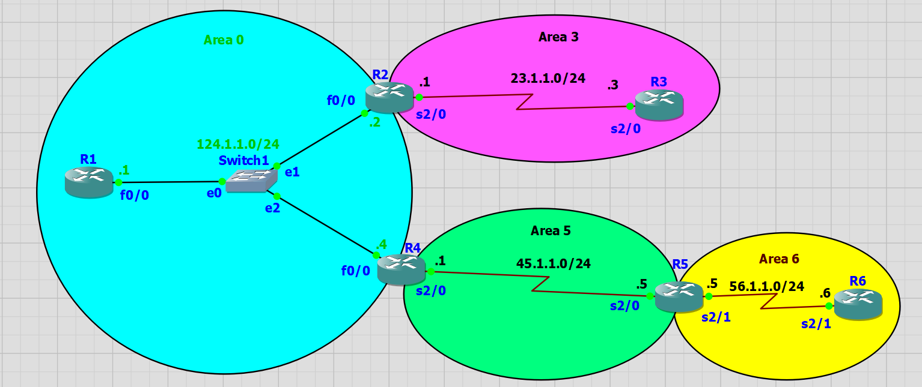

R1(config)#interface fastEthernet 0/0

R1(config-if)#no shutdown

R1(config-if)#ip address 124.1.1.1 255.255.255.0

R1(config)#router ospf 1

R1(config-router)#router-id 1.1.1.1

R1(config-router)#network 0.0.0.0 255.255.255.255 area 0

R1#show ip ospf neighbor

R1#show ip route

R1#show ip ospf database

R1(config)#ip route 10.1.1.0 255.255.255.0 null 0

R1(config)#ip route 10.1.2.0 255.255.255.0 null 0

R1(config)#ip route 10.1.3.0 255.255.255.0 null 0

R1(config-router)#redistribute static subnets

R1(config-router)#default-information originate always

R2(config)#interface fastEthernet 0/0

R2(config-if)#no shutdown

R2(config-if)#ip address 124.1.1.2 255.255.255.0

R2(config)#interface serial 2/0

R2(config-if)#no shutdown

R2(config-if)#ip address 23.1.1.1 255.255.255.0

R2(config)#interface fastEthernet 0/0

R2(config-if)#ip ospf priority 0

R2(config)#router ospf 1

R2(config-router)#router-id 2.2.2.2

R2(config-router)#network 124.1.1.0 0.0.0.255 area 0

R2(config-router)#network 23.1.1.0 0.0.0.255 area 3

R2#show ip ospf neighbor

R2(config)#access-list 10 permit 10.30.2.0 0.0.0.255

R2(config)#access-list 10 permit 10.30.3.0 0.0.0.255

R2(config)#router ospf 1

R2(config-router)#distribute-list 10 out

R2 (config)#interface serial 2/0

R2 (config-if)#ip ospf hello-interval 1

R2 (config-if)#ip ospf authentication message-digest

R2 (config-if)# ip ospf message-digest-key 1 md5 1234

R2(config-router)#area 3 stub no-summary

R3(config)#interface serial 2/0

R3(config-if)#no shutdown

R3(config-if)#ip address 23.1.1.3 255.255.255.0

R3(config)#interface loopback 1

R3(config-if)#ip address 30.30.30.30 255.255.255.0

R3(config)#router ospf 1

R3(config-router)#router-id 3.3.3.3

R3(config-router)#network 0.0.0.0 255.255.255.255 area 3

R3(config)#interface loopback 3

R3(config-if)#ip address 10.30.3.1 255.255.255.0

R3(config-if)#ex

R3(config)#interface loopback 2

R3(config-if)#ip address 10.30.2.1 255.255.255.0

R3(config-if)#ex

R3(config)#interface loopback 4

R3(config-if)#ip address 10.30.4.1 255.255.255.0

R3(config)#interface serial 2/0

R3(config-if)#ip ospf hello-interval 1

R3(config-if)#ip ospf authentication message-digest

R3(config-if)# ip ospf message-digest-key 1 md5 1234

R3(config-if)#

R3(config)#router ospf 1

R3(config-router)#area 3 stub

R3(config-router)#area 3 stub

R3(config-router)#do show ip route

After “R2(config-router)#area 3 stub no-summary”

R3(config-router)#do show ip route

R4(config)#interface fastEthernet 0/0

R4(config-if)#no shutdown

R4(config-if)#ip address 124.1.1.4 255.255.255.0

R4(config)#interface serial 2/0

R4(config-if)#no shutdown

R4(config-if)#ip address 45.1.1.1 255.255.255.0

R4(config)#interface fastEthernet 0/0

R4(config-if)#ip ospf priority 0

R4(config)#router ospf 1

R4(config-router)#router-id 4.4.4.4

R4(config-router)#network 124.1.1.0 0.0.0.255 area 0

R4(config-router)#network 45.1.1.0 0.0.0.255 area 5

R4(config)#router ospf 1

R4(config-router)#area 5 virtual-link 5.5.5.5

R5(config)#interface serial 2/0

R5(config-if)#no shutdown

R5(config-if)#ip address 45.1.1.5 255.255.255.0

R5(config-if)#interface serial 2/1

R5(config-if)#no shutdown

R5(config-if)#ip address 56.1.1.5 255.255.255.0

R5(config-if)#interface loopback 1

R5(config-if)#no shutdown

R5(config-if)#ip address 50.50.50.50 255.255.255.0

R5(config)#router ospf 1

R5(config-router)#router-id 5.5.5.5

R5(config-router)#network 45.1.1.0 0.0.0.255 area 5

R5(config-router)#network 56.1.1.0 0.0.0.255 area 6

R5(config-router)#network 50.50.50.0 0.0.0.255 area 5

R5(config)#router ospf 1

R5(config-router)#area 5 virtual-link 4.4.4.4

R6(config)#interface serial 2/1

R6(config-if)#no shutdown

R6(config-if)#ip address 56.1.1.6 255.255.255.0

R6(config)#interface loopback 1

R6(config-if)#ip address 60.60.60.60 255.255.255.0

R6(config)#router ospf 1

R6(config-router)#router-id 6.6.6.6

R6(config-router)#network 0.0.0.0 255.255.255.255 area 6