**Sudanese License Plate Recognition System**

**By**

**Hazim Naiem Abdulaal Basheer**

**INDEX NO.124038**

**Supervisor**

**Prof. Sharif Fadul Babikir**

A REPORT SUBMITTED TO

University Of Khartoum

In partial fulfillment for the degree of

B.Sc. (HONS) Electrical and Electronics Engineering

(INSTRUMANTATION AND CONTROL ENGINEERING)

Faculty of Engineering

Department of Electrical and Electronic Engineering

October 2017

**DECLARATION OF ORGINALITY**

*I declare this report entitled* “**Sudanese License Plate Recognition System**” *is my own work except as cited in references*. *The report has been not accepted for any degree and it is not being submitted currently in candidature for any degree or other reward.*

Signature: ____________________

Name: _______________________

Date: ________________________

**ACKNOWLEDGEMENT**

**Abstract**

**المستخلص**

**Table of Contents**

1 CHAPTER 1: Introduction 1

1.1 Overview 1

1.2 Problem Statement 1

1.3 Objectives 1

1.4 Methodology 1

1.5 Thesis Layout 1

2 CHAPTER 2: Literature Review 2

2.1 Digital Images 2

2.1.1 Advantages 2

2.1.2 Disadvantages 2

2.2 Digital Image Processing 3

2.2.1 Difference between Digital Image Processing and Computer Vision 3

2.2.2 Applications 4

2.2.3 Fundamental Steps for Digital Image Processing 5

2.3 Python 6

2.3.1 Features 6

2.3.2 Applications 7

2.4 OpenCV 8

2.4.1 Features 8

2.4.2 OpenCV vs Matlab 8

2.5 Sudanese License Plate 10

2.6 License Plate Recognition System 11

2.6.1 Components 11

2.6.2 Algorithm 11

2.6.3 Difficulties 12

2.6.4 Applications 13

2.7 Machine Learning 13

2.7.1 Types of Learning 14

2.7.2 Applications 14

2.7.3 Some Approaches 15

2.7.4 Support Vector Machine 15

2.8 Related Work 16

2.8.1 License Plate Detection 16

2.8.2 Characters Segmentation 17

2.8.3 Characters Recognition 18

3 CHAPTER 3: Methodology 19

3.1 Filters 19

3.1.1 Neighborhood Operations 19

3.1.2 Masks 19

3.1.3 Smoothing Filters 20

3.1.4 Sharpening Filters 21

3.2 Histogram 21

3.2.1 Grayscale Image Histogram 21

3.2.2 Histogram Equalization 22

3.3 Geometric Perspective Transformation 23

3.4 Thresholding 24

3.4.1 Global Thresholding 24

3.4.2 Adaptive Thresholding 24

3.4.3 Otsu’s Thresholding 25

3.5 Morphological Processing 25

3.5.1 Dilation 26

3.5.2 Erosion 26

3.5.3 Opening and Closing 27

3.6 Canny Edge Detection 28

3.6.1 Edge Detection 28

3.6.2 Steps of Canny Edge Detector 28

3.7 Contours 29

3.8 Connected Components 29

3.9 Image Correlation 30

3.9.1 Cross-Correlation 30

3.9.2 Normalized Cross-Correlation 31

3.10 Histogram of Oriented Gradient 31

3.10.1 Feature Descriptor 31

3.10.2 Calculating the Histogram of Oriented Gradient 32

3.11 Support Vector Machine 33

3.11.1 Inputs and Outputs 33

3.11.2 Hyper-Plane 33

3.11.3 Support Vectors 33

3.11.4 Support Vector Machine for Multi-Classes Classification 34

3.12 Implementation 35

3.12.1 License Plate Detection 35

3.12.2 Characters Segmentation 35

3.12.3 Character Recognition 36

4 CHAPTER 4: Results and Discussion 39

5 CHAPTER 5: Conclusions and Future Work 40

No table of figures entries found.

No table of figures entries found.

# CHAPTER 1: Introduction

## Overview

## Problem Statement

## Objectives

## Methodology

## Thesis Layout

# CHAPTER 2: Literature Review

## Digital Images

Human vision is the strongest and the most advanced sense of human senses. It is the source of most of the information provided to the brain about the outside environment. Because of this, humans try to save memories in form of photos. The first successful photo taken by Nicéphore Niépce in 1826 or 1827. The photo was a view from Niépce’s window and it was taken using the exposure of light on some substances for several hours.

Later, digital images are invented by Harry G. Bartholomew and Maynard D. McFarlane in 1920 for the purpose of image transmission at [Bartlane cable picture transmission system](https://en.wikipedia.org/wiki/Bartlane_cable_picture_transmission_system). And now they are used in many popular applications, for example, in the field of education they are used in projectors and graphics, and in the medical field they are used as an assistant in diseases diagnoses. Many other daily activities use digital images.

### Advantages

* The ability to be accessed, edited and processed using digital computer.
* Minimize the effort used to be done by photographers to obtain the image.
* Digital cameras are very small and portable. This make it possible to be used in mobile phones and other electronic devices.

### Disadvantages

Digital images make it easy to manipulate images which can be used for illegal purposes. Also copying and stealing images can waste the effort made by photographers. Legal constrains are made to ensure copyrights, also, images may not be considered as a legal evidence in courts because they can be edited.

## Digital Image Processing

Digital image processing is the processing of digital images using digital computer. It has two main applications area, improving pictures for human interpretation (eg. Image enhancement) and processing of image for storing, transmitting and representing it for machine autonomous tasks.

Humans and machines deal with images in different ways. Human prefer images to be sharp and highly detailed. While machines prefer images to be simple and uncluttered. This is caused by the variation between their purposes of using images.

### Difference between Digital Image Processing and Computer Vision

The difference between image processing and computer vision is not clear, since both two have much in common. An idea of differentiation between them based on the input and output of the process is proposed by Rafael Gonzalez and Richard Woods [4]. It categorizes the computerized processes to three types.

First, low-level processing which is characterized by the fact that the inputs and the outputs are all images. It contains all the primitive operations on images. For example image filtering where the input is the noisy image and the output is clear enhanced image.

Second, mid-level processing which is characterized by the fact the inputs are images and the outputs are attributes extracted from these images. For example image segmentation where the input is an image containing both desired and desired information and the output is image containing only the desired data.

Finally, high-level processing which is performing functions associated with the vision. For example optical character recognition where the input is an image containing a character the output is that character.

These types can be considered as stages in the path from image processing at the low-processing to computer vision at the high-level.

### Applications

* Medical applications

Some of medical activities that is based on human vision of an acquired images can be replaced by autonomous image processing and computer vision algorithms to give the final results. For example diagnosis of skin diseases, detecting broken bones using X-ray images and tumor extraction from MRI images.

* Photography

Digital cameras and smartphones use digital image processing to enhance taken images and increase its quality to make them look better.

* Communications

The time and bandwidth required to transmit an image from one place to another may be significantly reduced using image processing. Images are coded to reduce its size the reconstructed in the receiver. That is the early use of image processing by newspapers, and now it is used to use images over the internet.

* Security cameras

Security cameras are powered by image processing hardware and software to do some tasks like detecting motion and facial recognition.

* Robotics

Robots are designed by artificial intelligence algorithms which simulate the human being behavior. Computer vision is a part of artificial intelligence specialized in simulate the human vision.

* Pattern recognition

A lot of daily used applications use image processing and computer vision to recognize a special patterns. For example fingerprint reader, object detectors and images search engines.

* Optical character recognition

The ability of a computer to read and understand characters is used in license plate recognition, documents auto reader and a lot of other applications.

### Fundamental Steps for Digital Image Processing

* Image acquisition

It’s the process of acquiring and image and convert it to digital form and other preprocessing operations done to the image.

* Image enhancement:

It’s the process of improving image quality to highlight more details. It deals with making images looking good for human vision, this make it very subjective operation.

* Image restoration:

It’s the process of removing defects which degrade an image. It is objective operation since it is based on mathematical and probabilistic models.

* Color image processing:

It’s the processes deals with colors models and color processing in digital form.

* Wavelets and multi-resolution processing:

It’s the processes where source image is processed at multiple resolutions and the filtering is applied and combined at all these resolutions

* Compression:

It’s the process of minimizing the storage required to save the image (image size).

* Morphological processing:

It’s the processes of digital images related to the shape of the image and the relative positions of its pixels.

* Segmentation:

It’s the process of extracting the region of interests from an image. It is one of the most difficult tasks in image processing, but also the most important one since further operations success can depend on the accuracy of segmentation.

* Representation and description:

It’s the process is converting the image data to a form suitable for computer processing.

* Recognition:

It’s the process of extracting information from the input image (eg. Assigning labels to objects in an image)

Not all of these steps are required for all image processing applications, some applications use some steps and others use other steps.

## Python

Python is a high-level general purpose programming language, created by [Guido van Rossum](https://en.wikipedia.org/wiki/Guido_van_Rossum) and released in 1991.

Since early days it was designed based on two features, code readability and the ability to program in fewer lines of codes. This design philosophy makes python very popular in short period. Since 2003 python has been ranked on top 10 most popular programming language by [TIOBE Programming Community Index](https://en.wikipedia.org/wiki/TIOBE_Programming_Community_Index), and the top programming language by IEEE Spectrum ranking as posted on 18 July 2017.

### Features

* Python provides a dynamic type system which allow a variable data type to be changed during the execution of the program and doesn’t require a variable to be declared and initialized before using it.
* Python provides an automatic memory management using both reference counting and cycle garage collector.
* Python supports many programming paradigms. It is meant to be object oriented programming and structured programming language, but also it supports other paradigms like functional programming and aspect-oriented programming. Also, other paradigms can be supported using extensions.
* Python is available in all major operating systems, and many other operating systems.
* Python was built so that the core of the language doesn’t contains all of its functionality. Extensibility of Python provides a small language core with very large library can be used when needed.
* Python simplicity in programming appear on the philosophy that anything in Python can be done in one preferable way, making code choices not available. This make it easy to learn python rather than other languages since there is few limited options to do any certain task.

### Applications

[Python Package Index](https://en.wikipedia.org/wiki/Python_Package_Index) is the official repository for python third-party software and it contains over one hundred thousand packages which can be used for a large number of applications.

Some of Python’s applications are:

* Graphical user interface.
* Web frameworks.
* Multimedia.
* Databases.
* Networking and communications.
* Scripting and automation.
* System administration.
* Scientific purposes.
* Test processing.
* Image processing.

## OpenCV

OpenCV is a programming library which is used for image processing, computer vision and machine learning applications.

OpenCV was initially developed by Intel in 1999, and the first alpha version was released in 2000 at [IEEE Conference on Computer Vision and Pattern Recognition](https://en.wikipedia.org/wiki/Conference_on_Computer_Vision_and_Pattern_Recognition).

### Features

* OpenCV is a cross-platform library. It supports many operating systems which are  [Windows](https://en.wikipedia.org/wiki/Microsoft_Windows), [Linux](https://en.wikipedia.org/wiki/Linux), [macOS](https://en.wikipedia.org/wiki/MacOS), [FreeBSD](https://en.wikipedia.org/wiki/FreeBSD), [NetBSD](https://en.wikipedia.org/wiki/NetBSD) and [OpenBSD](https://en.wikipedia.org/wiki/OpenBSD) for desktop operating systems and  [Android](https://en.wikipedia.org/wiki/Android_(operating_system)), [iOS](https://en.wikipedia.org/wiki/IOS), [Maemo](https://en.wikipedia.org/wiki/Maemo) and [BlackBerry 10](https://en.wikipedia.org/wiki/BlackBerry_10) for mobile operating systems.
* OpenCV is open source and free to use under [open-source](https://en.wikipedia.org/wiki/Open-source) [BSD license](https://en.wikipedia.org/wiki/BSD_license).
* OpenCV supports three of the most popular programming language which are C++, Python and Java.

### OpenCV vs Matlab

OpenCV and Matlab are both from the most popular tools used in image processing and computer vision. However, the comparison between the two has always been a subject of discussion. Here advantages of each over the other is discussed.

OpenCV has advantages over Matlab which are:

* Speed

Since Matlab is written in Java and Java is built on C, Matlab code is interpreted to Java then to C to generate machine language code. This long path of language conversions make OpenCV much faster since it is written in C/C++ directly.

* Resources

Matlab take over a gigabyte of ram to process a videos, while OpenCV can take only about 70 megabyte for the same operation.

* Cost

Matlab is very costly since its base only costs over two thousand dollars. OpenCV on the other hand is open source and free to use.

* Portability

Matlab has to be imported specifically to the operating system to be able to run on it. While OpenCV can be downloaded and used in any device can run C language.

Matlab also has advantages over OpenCV which are:

* Easiness

Matlab is considered more easy to use, since it is high-level language there is no need to do lower level languages task (eg. Memory management). However, OpenCV supports programming languages other than C/C++. This can make OpenCV even easier to use than Matlab, but this will decrease the speed of execution discussed earlier.

* Memory management

Again Matlab has automatic memory management system because it is a high level language. And OpenCV require a manual memory management when it is used by C/C++ and this can be avoid using other languages like Python.

* Great matrix library

Digital images are treated as a matrices which is the main theory of operation of Matlab and a lot of built-in functions are available

* Integration with OpenCV

Matlab can interface with OpenCV, a thing can’t be done using OpenCV.

* Great documentation

OpenCV require a prior knowledge of C++ or python to work with. While Matlab documentation can make it easier for beginners to understand it and start with.

The decision of choosing either OpenCV or Matlab is based on the desired application and the specification and resources available.

## Sudanese License Plate

License plate is an identifier for a vehicle. It is invented in France in 1893 at Paris Police Ordinance.

All countries require license plates to uniquely identify any vehicle. The government is the only manufacturer of the plates and it is not allowed for other to do it because it is equivalent to [forging](https://en.wikipedia.org/wiki/Forgery) an official document.

Sudanese license plates are categorized into number of groups which are different in color and contents of the plate. This categorization is based on the use of the vehicle itself. There are private vehicles with white plates, commercial passengers’ vehicles with green plates, commercial goods vehicles with black plates, police vehicles with blue plates and many others like governmental vehicles, United Nations vehicles, embassies vehicles and others.

Here, the area of interest is private vehicles’ plates. Its size is 0.3m×0.15m without the outer black frame and 0.31m×0.16m with the frame. And it can be divided to three regions containing the information of the plate.

The first region is on the upper part of the plate, and it contains the name of the country in English “Sudan” and in Arabic “السودان”.

The second region is on the left part of the plate, and it contains one letter or more representing an abbreviation of the state the car is licensed in and one digit number. The abbreviation on this region is represented in Arabic letters and in English letters right below it. Also the number is written in Indian form and Arabic form below it.

The third region is on the right part of the plate, and it contains one to five digits number in Indian form and the same number in Arabic form below it but in smaller size.

The border between the second and third regions is a silver colored bar in in the old version of the plate or a text in Arabic “جمهورية السودان”, which mean “The Republic of Sudan” in the newer version of the plate. Both versions are currently used.

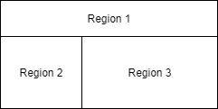

Figure .

## License Plate Recognition System

License plate recognition system is a system designed with the ability to read cars’ license plates. It is invented in 1976 at Police Scientific Development Branch in the UK. These types of systems didn’t become popular until the 90’s when they became accurate, fast and cheap.

There are two types of license plate recognition systems. The first type has the required hardware to acquire the image and process it to read the license plate all in one place and this type is used for real time applications. The second type use servers, the system only contain hardware capable for acquiring the image and send it to server to process it later.

### Components

* Hardware

The hardware of license plate recognition system is different Depending on the type of the system and the purpose of using it. It may only be a camera and connections hardware in case of servers system or a full system of camera and microprocessor or other electronic chips in case of real time systems.

* Software

Optical character recognition is the main technology used in license plate recognition systems. Optical character recognition is an application of image processing and computer vision and designed to identify characters.

### Algorithm

Most of license plate recognition systems use the same steps of operation. Some systems use less or more of these steps to get the results depending on the result desired by the system.

The main algorithm used by most of license plate recognition systems consist of three steps:

* License plate detection.
* Characters segmentation.
* Characters recognition.

If an image of the car is considered to be provided to the system the first step will be to detect the location of the license plate and determine its coordinates. After the extraction of the plate the resulted image is segmented so that each image segment contain one character or one digit number. Finally optical character recognition is used to identify each character on the plate and produce the output of the system which is the number of the plate.

Other steps may be required, image acquisition is required for a full end-to-end systems using a camera to capture the image of the car. Preprocessing is also very helpful for captured images to increase quality and make the next operations very easy and accurate. License plate correction of angle and orientation is usually done after detecting the location of the plate. Other post-processing is sometimes used for further need of the image.

### Difficulties

License plate recognition systems are facing a lot of difficulties and challenges. Software and sometimes hardware are used to avoid these difficulties. Some of them are:

* Low quality and poor resolution of the image due to limited hardware capabilities and the images are taken from a long distance.
* Blurred images can’t usually been recognized by humans, and computer vision is not yet more powerful than human vision. Blurred images are produced by a camera trying to capture a moving object.
* Poor lighting and low contrast due to exposure of light and shadows. Image processing is used to overcome these problems using algorithms like histogram equalization.
* License plates are not always clean and ready to get captured. Also, sometimes decorative items might be used in the cars and this limits the ability of the system.
* Systems are usually designed locally because license plates design can be different from countries and sometimes between states.

### Applications

* Law enforcement

License plate recognition systems are used in many countries like Australia, Canada, Germany, United Kingdom and United States to detect black listed cars. Black listed cars may be stolen cars, unregistered cars, unlicensed cars or the cars with no insurance.

* Average speed limit enforcement

A license plate recognition system consisting from two cameras located in proper distance can be used to calculate the average speed of a certain vehicle along that distance. This is the case in Australia, Austria, Belgium, France, Italy, Netherlands, Spain, South Africa, UK, Kuwait and Dubai city in UAE.

* Enterprises

Private sector companies and facilities may not be able to access to governmental databases and information, but they can build license plate recognition systems using their own databases of customers, vendors, VIP’s and specific banned people.

* Traffic control

License plate recognition systems may also be used to monitor the flow of vehicles to get information about number of vehicle crossing a certain road in a certain amount of time, the periods and areas of low and high congestions and the locations and causes of traffic jams.

## Machine Learning

Machine learning is a set of algorithms designed to give the computer the ability to learn how to perform a specific tasks without being explicitly programmed. Learning is done by providing a set of data used as a training data so that the system adapted to obtain the desired output by adjusting system parameters.

Another definition of machine learning is provided by [Tom M. Mitchell](https://en.wikipedia.org/wiki/Tom_M._Mitchell), it state that machine learning is that set of algorithms in which its performance will improve with respect to increasing in experience.

### Types of Learning

* Supervised learning

In supervised learning, training data is provided with a desired output and a teacher to determine if the results are correct or not. Error is calculated using the difference between the actual output and the desired one, and then the system adapt toward minimizing the error.

* Unsupervised learning

In unsupervised learning, no desired outputs are given making the system free to obtain structures and patterns in the input data. These types of algorithms are usually used in classification problems, where the system analyze the data, find similiraties and difference and then labeling the data into classes.

* Reinforcement learning

In reinforcement learning, there is no desired output but there is a teacher. The teacher make sure that the objectives and goals of the system is achieved using rewards in the case of success and punishments in the case of failure.

### Applications

* Classification

Classification is assigning labels to input data from predefined labels corresponding to classes. For example, machine learning can be used in diagnosing skin diseases and tumors

* Clustering

Clustering is assigning labels to input data to classify them to classes which are not known beforehand. This make clustering is a task achieved by unsupervised learning algorithms

* Prediction and forecasting

Data regression is used to analyze the input data and gives an approximated predicted outputs for inputs that are not within the training data. For example, predication and forecasting is used to predict sales and revenues to use them in marketing.

### Some Approaches

* Decision tree learning.
* Association rule learning.
* Artificial neural networks.
* Deep learning.
* Support vector machine.

### Support Vector Machine

Support vector machine is a supervised learning algorithm used in data classification by mapping the given data to n-dimensional features space and find the optimum hyper-plane that classify the data with minimum error.

Support vector machine has many advantages over other algorithms, some of them are:

* It give the best results in classification where the result is more general and can be used for newly arrived data, and that increase the generalization and robustness of the system.
* By using the kernel transformation the hyper-plane of non-linearly separable data can be obtained by finding the linear separation plane in higher coordinates.
* The uniqueness of solution is also one of the advantages of support vector machine, which ensure that the obtained solution is the optimum among all the available solutions.
* Support Vector Machine is a very powerful memory efficient algorithm since all data required to obtain the support vectors is in the training data itself.

Also, some limitation of the algorithm are:

* Since it seeks to identify the optimum hyper-plane, for fewer training data supplied to the system the result become less accurate because it is biased by error data.
* The algorithm is not time efficient. The time required for training the system using training data is long. So that the performance decrease. Resulting from computational complexity and seeking to generate the perfect solution.
* It can be used to classify data of two classes only.

## Related Work

### License Plate Detection

License plate detection is the process of locating the region in the image that contain the license plate and the process of extraction and normalization of the plate. This considered the most difficult task in license plate recognition systems since plates can be different in size, shapes and colors, also the angle of the image and the orientation of the plate make it even more difficult.

Usually, the detection process is designed only to work in certain conditions. For example, most of the systems are designed to obtain the plate of specific country or region where all plates has the same size and colors, others also constraint the image of the vehicle to be in certain distance and angle.

Edge detection is one of the most popular algorithms used in locating the license plates. In [1] work, vertical edge detection by Sobel operator is used to obtain vertical edges of the image. Then prior knowledge of the local plate dimensions (width to height ratio) is used to find candidate regions where higher probabilities of license plate exist. If there are more than one candidates, black to white ratio is used to choose the best candidate. In [3] work, double edge detection is used vertically and horizontally. Since license plates usually contains a lot of black and white variation, the highest density region of edges is considered to be the best license plate candidate.

Color processing can also be uses when the plates have a specific color. In [2] work, projection of the blue color which is the color of Beijing’s plates is done vertically and horizontally. Peaks of blue colors are used to find an accurate rectangle containing the license plate. Also, in [4] work, the colors of the plate is mainly used to detect its location in the image.

In [6] work, projection of the binary image is used to obtain the license plate location by calculating the peak of the projection.

In [5] paper, many algorithms are proposed. Vertical edge detection with Sobel operator and a threshold value of density of vertical lines is used to detect the plate. Fuzzy logic uses red, green and blue edges. Hue, Saturation and Intensity HSI is obtained to generate the fuzzy map and obtain the license plate location using colors values. . Hough transform combined with contour analysis is also proposed. Contours analysis is used to detect closed loop lines and then Hough transform is used to detect parallel lines which have higher probability to be the license plate. This technique considered one of the most accurate and robust techniques but the fact that it requires a lot of computations make it less time efficient and not suitable for real time systems.

In other approaches, frequency domain is used rather than the spatial domain to process the image. In [7] work, the detection of the plate is based on the extraction of areas having a high density of mono-oriented gradient.

### Characters Segmentation

Character segmentation is the process of partitioning the image of the license plate into individual characters that can be recognized by the system. The segmentation importance comes from the fact that a more efficient and accurate segmentation will result easier and more accurate character recognition.

One of the most popular image segmentation algorithms is vertical projection. It is used in [1][2][3][5] by obtaining the image vertical projection and then analyzing it to segment the characters, that is done by looking for a peak-to-valley in the projection which gives higher probability of the border between characters.

In [9] work, connected components algorithm is used to segment the characters based on thresholded binary image. This algorithm is accurate in case of characters that are constructed from one components and free of dots and dashes. Also this can take more computations than the projection techniques but will produce a better result in case of noisy images.

A more alternative solution is presented by [10] to avoid the segmentation process at all and jump to recognize all letters at once, this solution might take more computations and more time to complete. Also, in case the letters doesn’t construct any meaningful word which is the case in license plate recognition systems, it make it harder to use artificial intelligence and machine learning techniques to obtain correct results.

### Characters Recognition

Character recognition is the process of assigning a label to a character image representing that character. It is a sort of classification, where the input character image is classified to the best matching character.

Most of license plates systems use template matching algorithm to classify images to correct labels. This is the case in [1][2][3][4][5]. It depends of using a template images of a predefined characters and test the input image to all the templates and find the closest result.

In [6] classification is done by minimum distance measure using differ-weight average method of template image and Euclidean distance.

Modifications to template matching technique is done to increase the efficacy and make it more robust to noisy and distorted input images. That is done in [2] work, where neural networks used to train the system for better and faster results. In [5] work, a combination of template matching and machine learning algorithms is used. Support vector machine by using one versus others is used with descriptors to classify characters.

# CHAPTER 3: Methodology

## Filters

Filtering is the process of removing noise in the image. This is accomplished by using neighborhood operations to calculate the new pixel value of the filtered image.

### Neighborhood Operations

Neighborhood processing is using the pixel value and its predefined neighbor’s values to calculate the new pixel value. The neighborhood of a pixel is usually a rectangle centered on that pixel.

Some basic neighborhood operations are order statistics operations. Some of them are:

* Maximum

Where the value of the center pixel will be equal to the maximum value of a pixel in that neighbor.

* Minimum

Where the value of the center pixel will be equal to the minimum value of a pixel in that neighbor.

* Median

Where the value of the center pixel will be equal to the median value of a pixel in that neighbor.

### Masks

Masks or kernels are sub-images used to perform neighborhood operations on images with neighbors equal to their size.

For an image A and a kernel k, the mask iterate over all image’s pixels where each pixel be at the center of the mask and calculate the new value of that pixel in the output image B using the formula:

$$B\left(i , j\right)= \sum_{s=-a}^{a}{\sum_{t=-b}^{b}{A\left(i+s, j+t\right)*k(s , t)}}$$

For example, using image A and kernel k as the following:

$A= \left[\begin{matrix}a1 & a2 & a3 \\ a4 & a5 & a6 \\ a7 & a8 & a9\end{matrix}\right]$ $k= \left[\begin{matrix}k1 & k2 & k3 \\ k4 & k5 & k6 \\ k7 & k8 & k9\end{matrix}\right]$

The output of the center pixel is given by:

$$a5=a1k1+a2k2+a3k3+a4k4+a5k6+a6k6+a7k7+a8k8+a9k9$$

### Smoothing Filters

Smoothing filters are used in image blurring and noise reduction. Some of smoothing filters are:

* Averaging filter

Corresponds to using the kernel k:

$$k=\frac{1}{9}\left[\begin{matrix}1 & 1 & 1 \\ 1 & 1 & 1 \\ 1 & 1 & 1\end{matrix}\right]$$

These filters are used to minimize the noise in the image but it has a drawback of minimizing the details in the image also by blurring its edges.

* Weighted average filter

Corresponds to using the kernel k:

$$k=\frac{1}{16}\left[\begin{matrix}1 & 2 & 1 \\ 2 & 4 & 2 \\ 1 & 2 & 1\end{matrix}\right]$$

These filters have an advantage over the averaging filter in making the near pixels have a greater effect than the far ones.

* Median filter

Median filters is obtaining the median value of pixels in specific neighborhood. It is used in removing salt and pepper noises because they have very extreme values.

### Sharpening Filters

Sharpening filters are used to highlight the details in the image. Derivative of the image obtain the edges of that image where the values of the pixels are changing in higher rates.

Sobel operator is used to obtain image derivative. It is given by:

$$G=\sqrt{{Gx}^{2}+ {Gy}^{2}}$$

$$θ=arctan⁡(\frac{Gy}{Gx})$$

Where Gx and Gy can be obtained using the following masks:

$Gx=\left[\begin{matrix}-1 & 0 & +1 \\ -2 & 0 & +2 \\ -1 & 0 & +1\end{matrix}\right]$ $Gy=\left[\begin{matrix}-1 & -2 & -1 \\ 0 & 0 & 0 \\ +1 & +2 & +1\end{matrix}\right]$

## Histogram

### Grayscale Image Histogram

Grayscale image histogram is a vector representation of gray level distribution over the image. It represent the frequency of each gray level in the image.

Histogram of an image A of M rows and N columns is defined as:

$$h\left(l\right)=\# \left\{\left(i , j\right) \right|A\left(i , j\right)=l, i=0, 1,.., M-1, j=0, 1,.., N-1$$

Where # S denotes the number of elements in S.

In other words, histogram of a grayscale image with gray levels of 0 to 255 is a 256 elements vector where the first element is the number of pixels in the image that has a gray level of 0 and the second element is the number of pixels in the image that has a gray level of 1 and so on. Figure [[[[[[[[[]]]]]]]]]] is a representation of the histogram.

Histogram is used in image enhancement using histogram equalization to ensure that all gray levels are equally distributed in the image and hence a good dynamic color range.

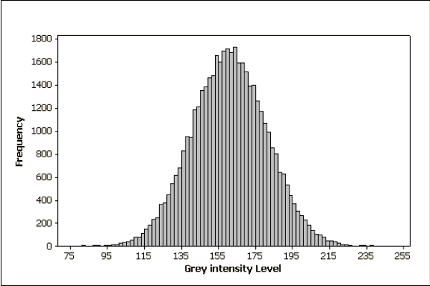

Figure .

Also, it is used in image segmentation by obtaining the valley in the histogram that usually separate the object from the background.

Histogram of colored images can be obtained by the same method as grayscale image. But rather that plotting the gray levels intensities, three plots are produced using the red, green and blue intensities in the image.

### Histogram Equalization

Histogram equalization is a method used to enhance an image and increase its contrast by manipulating its histogram in order to stretch out the intensity range.

The goal of this method is to map the original image histogram to another one closer to the uniform distribution. This is accomplished by changing all pixels values in an M by N image by:

$$s=\frac{L-1}{MN} \sum{p}$$

Where p is the original gray level and s is the modified one, L is the number of gray levels and MN represents the number of pixels in the image.

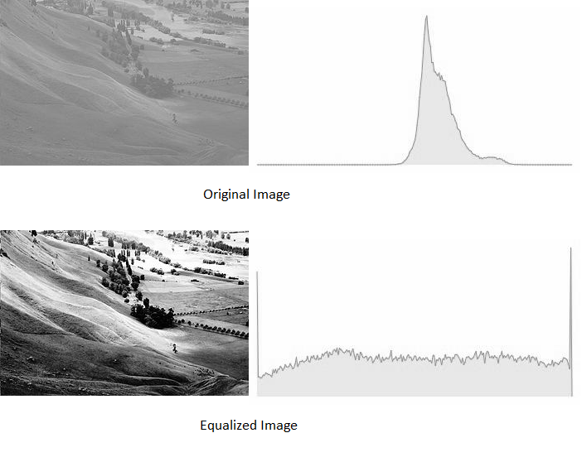

Figure .

Most of the time, the histogram equalization formula produces rational numbers. So, rounding of the result to the nearest value is important in order to be able to represent that image.

An example of histogram equalization and its effeteness in the images is presented in figure [[[[[[[[[[]]]]]]]]].

## Geometric Perspective Transformation

Geometric transformation of an image is mapping the image to another image after deforming the pixels grid but without changing the image contents. This is achieved by filling the pixels of the output image with the values of pixels in the input image after calculating the coordinates of them using the desired transform formula.

Problems facing geometric transformations are:

* The result from the transform formula is non-existing pixels, this is solved using extrapolation.
* The result from the transform formula is between two pixels, this is solved using interpolation.

Geometric perspective transformation is a projection of an image to another image changing the viewing angle of that image. This produce an image has the property that any straight line in the input image remains straight in the output image.

## Thresholding

Image thresholding is the process of converting grayscale image to binary image. It scans all pixels in a given grayscale image, and decide whether each pixel should be converted to black or white.

Image thresholding could be divided into two categories, global thresholding and local thresholding. If the decision of pixel color depends only on the pixel value, it is called global thresholding. And if the decision of pixel color depends on the pixel value and other local properties (eg. The values of neighbor pixels), it is called adaptive thresholding.

### Global Thresholding

Global thresholding is the simplest method of thresholding and image segmentation. It scans all image pixels, for each pixel if the pixel value is greater than or equal to the threshold value the pixel is labeled as white pixel, and if the pixel value is less than the threshold value the pixel is labeled as black pixel.

### Adaptive Thresholding

Adaptive thresholding can be very useful in case of non-uniform lighting, where a global threshold value may not be the perfect choice in all image parts.

Adaptive thresholding find a threshold value for each pixel using its neighbor pixels. Two popular algorithms are finding the threshold value using the mean of neighbor pixels values and finding the threshold value using the weighted sum of neighbor pixels value where weights are a Gaussian window.

### Otsu’s Thresholding

Otsu’s thresholding algorithm is a global thresholding algorithm used to automatically calculate the best threshold value especially in bimodal images (which have two peaks in their histogram).

Since the image histogram contains two peaks, Otsu’s thresholding scans all gray level values and find the value which minimize the weighted within-class variance which is the optimum threshold value.

The variance within the class defined as:

$$σ^{2}= ω_{0}\left(t\right){σ_{0}}^{2}\left(t\right)+ ω_{1}\left(t\right){σ_{0}}^{2}\left(t\right)$$

Which is the weighted sum of variances of the two classes separated by threshold value. Where ω is the probability and σ is the variance of each class and t is the threshold value.

Otsu’s method can be very inaccurate in case of non-bimodal image. For example in case of small object in big background, or in the case when the object and background peaks in histogram are close to each other, so image enhancement techniques like histogram equalization is used before thresholding to minimize this issue.

## Morphological Processing

Morphological operations are an image processing techniques related to the shape of image performed for the better representation of an image.

Morphological operations manipulate an image using another image called structuring element (or kernel).

Set theory is the language used by mathematical morphology to represent and manipulate images. A set contains tuples each represent one pixel, and the tuple contents are different for each image type. For example in binary images objects are represented by white in black background, the set contains tuples of pixels of the white object and each tuple contains x and y coordinates of the pixel. Also in grayscale images the tuple contains a third element for the value of the pixel.

There are two basic morphological operation, dilation and erosion. Other operations can be performed using these basic operations combined with other set’s operations like union, intersection, complement and difference.

Additional two set’s operations are reflections and translation.

Reflection of a set A denoted by Â is defined as:

$$Â =\left\{ b \right|b=-a for a ∈A\}$$

Translation of a set A by point z denoted by (A)z is defined as:

$${(A)}_{z} =\left\{ b \right|b=a+z for a ∈A\}$$

### Dilation

Dilation of a set A by another set B as a structuring element denoted by A ⊕ B is defined as:

$$A ⊕B=\left\{ z \right| \left[{\left(\hat{B}\right)}_{z}∩A\right] ⊆ A \}$$

It is obtained by reflecting B about the origin and translate it by z then find the points z in which the reflected translated B is contained in A.

In other words, the dilation of A by B is the points covered by B when the center of B moves inside A.

### Erosion

Erosion of a set A by another set B as a structuring element denoted by A ⊖ B is defined as:

$$A ⊖B=\{ z {\left(B\right)}_{z } ⊆ A \}$$

It is obtained by translating B by z then find the points z in which the translated B is contained in A.

In other words, the erosion of A by B is the points covered by the center of B when B moves inside A.

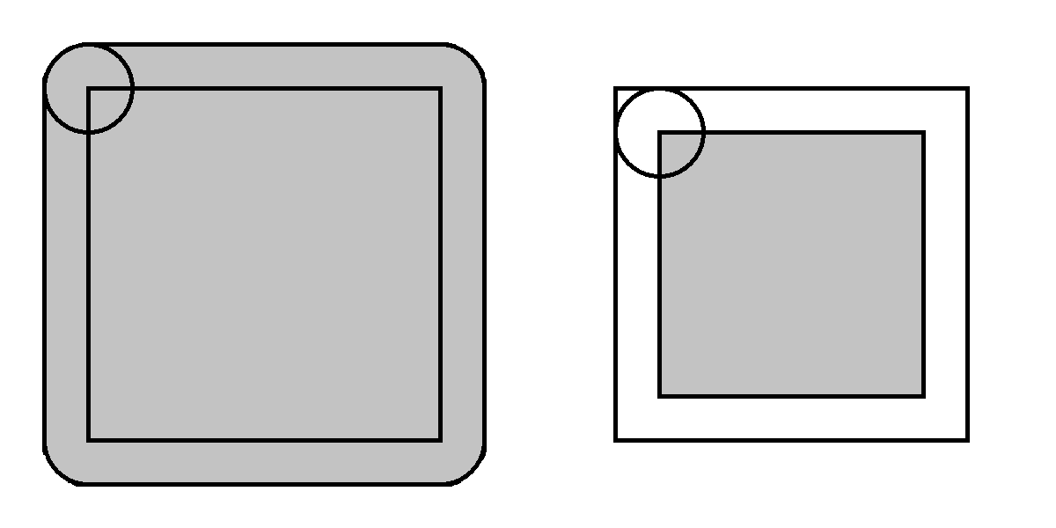

Figure .

Figure [[[[[[[]]]]]]]]]] shows the dilation and erosion of a square object by a circular kernel.

### Opening and Closing

Opening of a set A by another set B as a structuring element denoted by A ∘ B is defined as:

$$A ∘B=\left(A ⊖ B\right) ⊕ B$$

It is obtained by erosion of A by B then dilate the result by B.

Since dilation expands the image and erosion shrinks the image, opening can be used for filtering small objects in black background.

Closing of a set A by another set B as a structuring element denoted by A • B is defined as:

$$A •B=\left(A ⊕ B\right) ⊖ B$$

It is obtained by dilation of A by B then erode the result by B.

Since dilation expands the image and erosion shrinks the image, opening can be used for filtering black holes inside white objects.

## Canny Edge Detection

### Edge Detection

Edges in images are described by the points in which the difference between colors in both side of the point is very sharp. These changes is created by the discontinuities of the object’s boundaries or internal corners in the object where the brightness is different.

Canny edge detector is a multi-stages process used to detect edges and have the following criteria:

* Detection of edges with minimum error rate.
* Detected point should be at the center of the edge.
* Detect any edge just once and resist image noises from creating edges.

### Steps of Canny Edge Detector

First, the image is filtered using Gaussian filter to remove noise. Gaussian filtering with a filter of size 5 is equivalent to use the following mask:

$$K=\frac{1}{159}\left[\begin{matrix}2 & 4 & 5 & 4 & 2 \\ 4 & 9 & 12 & 9 & 4 \\ 5 & 12 & 15 & 12 & 5 \\ 4 & 9 & 12 & 9 & 4 \\ 2 & 4 & 5 & 4 & 2\end{matrix}\right]$$

Second, the gradient of the image is calculated to find the points where the higher rate changes occur in the image. Gradient of an image is defined as:

$$G=\sqrt{{Gx}^{2}+ {Gy}^{2}}$$

$$θ=arctan⁡(\frac{Gy}{Gx})$$

Where Gx and Gy can be obtained using the following masks:

Gx = $\left[\begin{matrix}-1 & 0 & +1 \\ -2 & 0 & +2 \\ -1 & 0 & +1\end{matrix}\right]$ Gy = $\left[\begin{matrix}-1 & -2 & -1 \\ 0 & 0 & 0 \\ +1 & +2 & +1\end{matrix}\right]$

Then, Non-maximum suppression is applied. To obtain an image only contains edges and remove other points. This is done by comparing each pixel edge strength to its neighbors and the pixels with greater values will remain.

The next step is to perform a double threshold of the obtained image, upper and lower. If the pixel gradient is greater than the upper threshold value, the pixel will be used as an edge pixel. . If the pixel gradient is less than the upper threshold value, the pixel will not be used as an edge pixel. If the pixel gradient is between the upper and lower threshold value, it will be used as an edge pixel only if it is connected to a pixel that is above the upper threshold.

## Contours

A contour is a closed curve of connected points having the same value. In the context of image processing, these values is the colors pixels.

A typical contour in a grayscale image will be a closed path of pixels having the same gray level. Noisy images and the slight variation of pixels gray levels make it very difficult to obtain a contour in grayscale images. To overcome this problem, thresholding and edge detection techniques are used to convert the image into binary image. Since binary images only take two pixels values, obtaining a closed path of pixels with the same values is possible.

Contours mainly used in objects extraction and segmentation by finding contours of edge image to extract the boundaries of that object.

## Connected Components

Connected components is one of the most accurate algorithms used in image segmentation. A connected components is a group of pixels have the same value and connected to each other using 4-pixels or 8-pixels connections. Image is required thresholding before using this algorithm, because grayscale image of an object can’t be all in same gray level.

Connected components algorithm make use of morphological dilation and set’s intersection given a known pixel inside the object to be extracted. It can be described as:

$X_{k}=\left(X_{k-1}⊕ B\right)∩ A$

Where A is the original image that it is desired to extract a component from, B is suitable structuring element and X is the new image containing only the extracted component.

It starts with the known pixel, a dilation is done to expand the component and intersection to eliminate parts of the component which is not exists in the original image. This operation is repeated until Xk is equal to Xk-1, and the result is an image with only one connected component.

Connected components algorithms is very useful in extracting an object in an image containing nested objects but not overlapping ones. But it is considered as time consumer due to high number of iterations in dilations and intersections. More knowledge about the object to be extracted can increase the speed of the algorithm, for example if objects in an image are not close to each other, then a larger structuring element can be used and that decrease the number of iterations required.

## Image Correlation

Image correlation is a numeric representation of the similarity between two images. It describes how much an image A is similar to other image B.

The method of image correlation is the core concept of template matching algorithm. In template matching, a template image is moved across the original image while calculating the similarity in each point. This measure of similarity usually done using image correlation techniques.

### Cross-Correlation

Image cross-correlation is a numeric representation of the similarity between two images, and it is obtained by the sum of pairwise multiplications of corresponding pixel values of the images.

This can be described by:

$$Cross-Correlation \left(img1 , img2\right)=\sum_{y=0}^{N}{\sum_{x=0}^{M}{img1\left(x,y\right)*img2\left(x,y\right)}}$$

This is the fundamental concept of image correlation, and it is not practically efficient due to lack of robustness. For example, the difference between image brightness may cause a bright image produce high value of correlation although the difference of the template to the original image.

### Normalized Cross-Correlation

Normalized cross-correlation is modified version of cross-correlation that overcomes some of the classical cross-correlation problems.

Normalized cross-correlation is obtained by the sum of pairwise multiplications of corresponding pixel values of the images after subtracting the mean value of each image from each pixel in that image. Then, the result is normalized by dividing by the multiplication of the standard deviation of each image and the number of pixels in them.

This is described by:

$$NCC\left(img1 , img2\right)=\frac{1}{MNσ1σ2} \sum_{y=0}^{N}{\sum_{x=0}^{M}{\left(img1\left(x , y\right)- \overline{img1}\right)* \left(img2\left(x , y\right)- \overline{img2}\right)}}$$

This produce a more robust method that resists the changes in brightness to obtain more accurate results of the similarity between images.

The improvement of normalized cross-correlation over the classical cross-correlation can be viewed in two main points:

* The result is invariant to the global brightness of images.
* The result is normalized so that the output is within the interval [-1.0 , 1.0]. Where 1.0 is the result when comparing the image with itself, and -1.0 is the result when comparing the image with its negative.

## Histogram of Oriented Gradient

### Feature Descriptor

Feature descriptor is a vector representation of the useful information in the image. These useful information can’t be used to reconstruct the image, but they are useful in the process of recognition and object detection.

Histogram of oriented gradient is a feature descriptor that use the distribution of the gradient magnitudes and directions in the image.

### 3.10.2 Calculating the Histogram of Oriented Gradient

First, the gradient of the image is calculated vertically and horizontally. Gradient of an image is defined as:

$$G=\sqrt{{Gx}^{2}+ {Gy}^{2}}$$

$$θ=arctan⁡(\frac{Gy}{Gx})$$

Where Gx and Gy can be obtained using the following masks:

$Gx=\left[\begin{matrix}-1 & 0 & 1\end{matrix}\right]$ $Gy=\left[\begin{matrix}-1 \\ 0 \\ 1\end{matrix}\right]$

This produce gradient matrix, where each element corresponds to one pixel, and each element contains two values, magnitude and direction.

The second step is dividing the image into portions of equal areas and the histogram of the gradient is obtained. This is done by mapping the gradient magnitudes over a vector representing a discrete values of gradient direction angles. For example a 9 pins histogram will correspond to angle values of 0, 20, 40, …, 160. The magnitudes of gradients will be distributed over the angles. If one magnitude value correspond to an angle that is not in the histogram vector, the value of the magnitude is divided between the two nearest angles with respect to the distances to them.

Then, normalization is done to each image partition histogram to avoid the effects of image brightness. This is the purpose of the partitioning described earlier. Normalization of the histogram is done by dividing all its value by the largest value in it. That will each histogram largest value to be equal to 1.

The histogram of oriented gradient vector is then obtained by concatenating all partitions histograms in one vector.

## Support Vector Machine

Traditional learning approaches suffer from difficulties in over-fitting of training data, and hence less generalization.

In techniques that use mapping of data in n-dimensional features space and uses boundaries to classify the input data, many decision boundaries can be used to perfectly classify the input data, but there is one optimum decision boundary that classify data with minimum error. To find that optimum decision boundary support vector machine algorithm is used.

Support vector machine is a supervised learning method used in data classification and regression for a linearly separable data by obtaining the optimum hyper-plane that classify the data.

In addition to performing linear classification, support vector machine can efficiently perform a non-linear classification using what is called the Kernel function, which maps inputs into high-dimensional feature spaces.

### Inputs and Outputs

Inputs are sets of input-output training pairs, these represent a pair of features and result. The output is values of weights that describe how much each feature effects the result.

### Hyper-Plane

A hyper-plane of data that are mapped in two dimensional features space is a line that separate these data into given classes.

The further from the hyper-plane the data points lie, the more confident that they have been correctly classified. Therefore data points are desired to be as far away from the hyper-plane as possible, while still being on the correct side of it.

### Support Vectors

Support vectors are the data points nearest to the hyper-plane, the points of a data set that, if removed, would alter the position of the dividing hyper-plane.

These are the data used to identify the hyper-plane since it must maximize the distance to both support vectors.

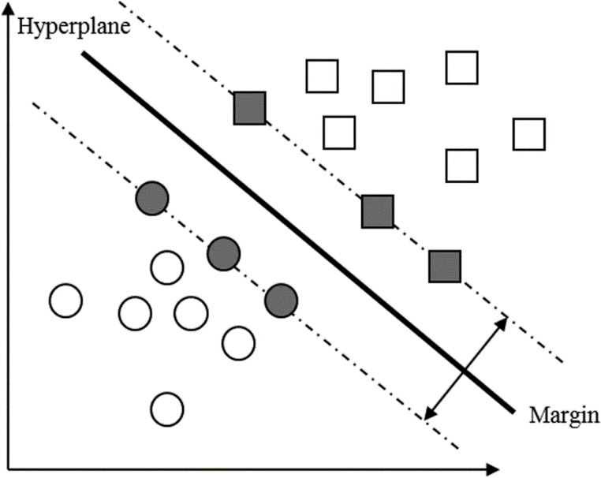

Figure .

If the training data are linearly separable, two parallel hyper-planes can be selected to separate two classes of data, so that the distance between them is as large as possible. The region bounded by these two hyper-planes is called the margin, and the maximum-margin hyper-plane is the hyper-plane that lies halfway between them.

### Support Vector Machine for Multi-Classes Classification

An extension to use SVM to classify multi-classes data is provided in many ways. The most common algorithm is to use (One vs the rest) where the hyper-plane separates the specific class from others in each iteration. By repeating this operation by the number of classes (n), a full classification of n-classes is resulted.

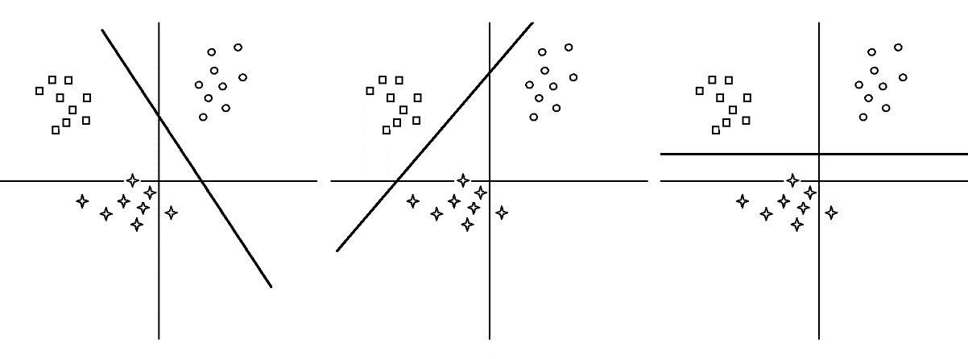

Figure .

## Implementation

### License Plate Detection

The first step of the system is to locate and extract the license plate from a given input image. This is done using the following procedure:

* The system first filter the image to remove noise and then perform histogram equalization.
* Morphological opening is done using rectangular structural element and subtract the result from the original image.
* Image is then transformed to binary image using Otsu’s thresholding algorithm.
* Edges of the image is extracted using Canny edge detector and then apply morphological closing to the output image.
* The largest 20 contours in area in the image is extracted and approximated to the nearest geometric shape.
* Contours is filtered to obtain only rectangular shaped contours.
* A reference image of the license plate is read to be used as a template.
* For every candidate contour, geometric perspective transformation is used to extract and fix skewed candidate plate.
* Normalized cross-correlation is calculated for each candidate and the candidate with the highest correlation value is extracted as the license plate.

### Characters Segmentation

The output of the detection process is the license plate. Segmentation is then used to separate each character in individual image using the following procedure:

* The first step is preprocess the image to make it suitable for segmentation using:
  + Resizing the plate image to a predefined size so that the plate content’s positions will be known.
  + Cropping is used to extract the region of interest that contains the license plate characters.
  + The image is thresholded using Otsu’s method to transform it to inverse binary image.
  + Morphological opening followed by closing is used to filter remove noise inside and outside the objects.
* Connected components algorithm is used to extract one object from the image.
* The extracted object is subtracted from the image. This process is repeated until the extraction of all components.
* Extracted components are filtered using their dimensions to eliminate undesired objects.\

This whole segmentation process is performed for both Arabic and English numbers.

### Character Recognition

Segmented images of the characters is classified to assign labels for each character using the following procedure:

* A trained Support Vector Machine model is loaded to be used for characters prediction.
* Histogram of Oriented Gradient descriptor is calculated for each image and used as an input vector to the classifier.
* The classifier use the Histogram of Oriented Gradient of the input image to obtain the output numbers.

Arabic and English numbers are recognized and their results is compared to obtain the final output.

# CHAPTER 4: Results and Discussion

# CHAPTER 5: Conclusions and Future Work