Genius – Quick Start

Koen Hindriks, Catholijn Jonker, Dmytro Tykhonov

Introduction
This QuickStart presents software for bilateral multi-issue closed negotiations. The software implements an open architecture for heterogeneous agents proposed in [3]. This negotiation environment, user manuals, and a number of implemented negotiation agents can be downloaded from http://mmi.tudelft.nl/negotiation.
The environment is designed as a research tool to help designing negotiation strategies and algorithms. The open architecture [3] used in the design of the environments allows organizing tournaments between heterogeneous automated agents in the various negotiation setups. The environment provides a graphical user interface (GUI) for a human negotiator and, therefore, it can be used as a training tool for humans.
The core functionality of the system includes:
- specification of negotiation domains and preference profiles;
- simulation of bilateral negotiation between agents;
- analysis of the negotiation outcomes [4] and negotiation dynamics [1];
The software has been developed using widely-accepted standards such as design patterns to integrate various components of the architecture. The software allows integration of new negotiating agents as well as integration of the existing agents’ implementations through a simple API. In [3], examples of how an existing agent can be integrated into the system using the Adaptor design pattern. Such approach minimizes programming efforts required to (re-)integrate and maintain code of a negotiation agent.
Interaction protocols are implemented in the negotiation environment as a separate component to allow the use of a variety of protocols. The current version of the negotiation environment supports the alternating offer protocol, which allows a generic communication between the agents.
The XML file format is used system-wide to specify the negotiation ontology (negation domain, preference profiles) and export results of simulations for detailed analysis. The use of XML simplifies task of maintaining the persistent information in the system, allows extending the original information structures of the system with new concepts with no impact on the existing code, and integration with other systems. The system includes a simple XML parser.
The software environment consists of two main executable packages:
- NegoEditor, a GUI-based editor that allows to create, store, and modify a negotiation domain and preferences of the negotiating parties;
- NegoSimulator, a tool used to simulate and analyze negotiation between the software and/or human agents.
In addition, the system is supplied with a number of examples of negotiation domains and preference profiles.
The software is implemented in Java language version 5.0. It can be run on the most of the platforms that support Java Runtime Environment 1.5. The current version of the system is used as a stand-alone application that runs on a single computer.

Negotiation Domain and Preferences Profile Editor
NegoEditor is used to create and modify negotiation domain and preference profiles. Figure 1 shows a structure of the “Laptop domain”, an example included in the software. The left column shows the laptop domain, with the issues "Laptop", "Harddisk", and "External Monitor". The second column shows the type of the issue and the third column shows the values that are available for the issue. Issues can be grouped into a hierarchical structure using the Objective. Negotiation domain starts with a single root objective. The objective branches into sub-objectives and issues providing an additional structure to the domain. Every branch of the objective/issues tree ends up with an issue.
By selecting an issues and clicking the “Edit” button user can specify possible values for the issue. Figure 2 shows an example of the values for the “Laptop” issues. User can enter associate a cost and a short description with every value. For real, integer and price types of issues use should input the minimal and maximal values.
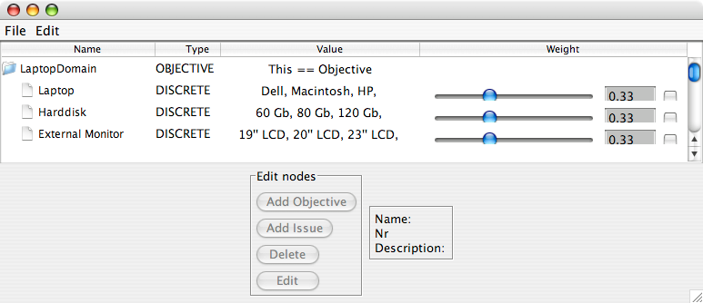 | 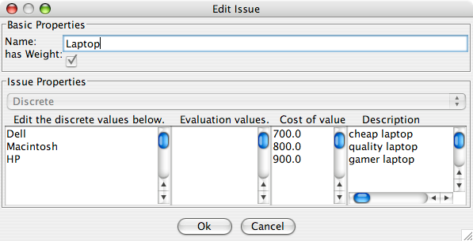
Figure 1. The NegoEditor. | Figure 2. The discrete-issue editor.
The next step is to define preferences profile. The profile describes personal preferences of an agent for a negotiation in a given domain. The current version supports linear additive utility functions [4]. The profile is used to convert any bid in that domain to a value indicating how you would rate that bid. This is also called utility of that bid. A profile is also often called a utility space.
The "Weight" column on the Figure 1 shows the importance associated with every issue. User can move the sliders to change the weights or enter their values by hand. The weights are automatically normalized by the editor. To edit preferences over values of a given issue users should select an issue and click edit. In the issue editor (see Figure 2) user can give every value and evaluation (second column). The evaluation values are positive integers starting with one. The evaluation values are normalized within one issue into the real in the range of [0;1].

Negotiation Simulator and Analytical Toolbox
NegoSimulator is used to run negotiation sessions. Figure 3 shows the main window of the NegoSimulator. The main window is used to setup parameters of a negotiation session.
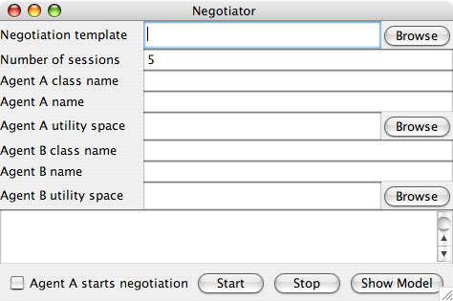
Figure 3. Main window of the NegoSimulator
To set up the following items are required:
- The negotiation template. This is an XML file with a description of the domain created with the NegoEditor, plus the default values for all other fields in the set-up screen. The xml file can be edited by hand to change the default values.
- Number of sessions: the number of negotiation sessions that user wants to run.
- Agent A/B class name: the name of the negotiation agent that party A/B wants to use in the negotiation. User can use agents from the repository that is included in the package or use own agent (see the user guide for instructions on how to program own agents for the negotiation environment). Here the UIAgent can be used to allow participation of a human negotiator.
- Agent A/B name: the plain name of the agent, used mainly when printing information about the progress and asking input.
- Agent A/B utility space: the XML file containing the utility space of agent A/B created with the NegoEditor.
- The Agent A starts Negotiation checkbox. Used to force the system to start the negotiation with the agent A (instead of at random).
The text field just above the start button will show real-time feedback on the ongoing negotiation. After these fields have been set appropriately, the Start can be pressed button to run the negotiation sessions.
The results of the negotiation are shown in the Negotiation Results screen (see Figure 4). This screen shows four columns: the session number, the final utility for agent A and B, and the Protocol ErrorRemarks column. The utilities are the utilities of the final, accepted bid, as measured in the corresponding utility spaces of agent A and B. The Protocol ErrorRemarks column shows extra information in case one of the agents ignored the negotiation protocol, causing a non-standard scoring of the result.
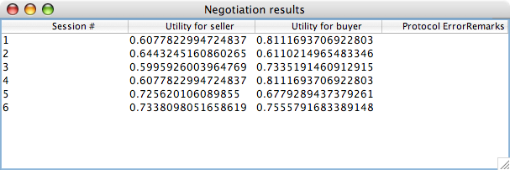
Figure 4. Example of Negotiation score window. Here Agent A is the seller, agent B the buyer.
If the analysis of the negotiation is enabled, a utility plot will be provided after each negotiation session. An example of a plot is shown in Figure 5. The plot shows points corresponding to all possible bids, the Pareto Frontier, the Nash product, the Kalai-Smorodinsky solution, and the bidding progress plot.
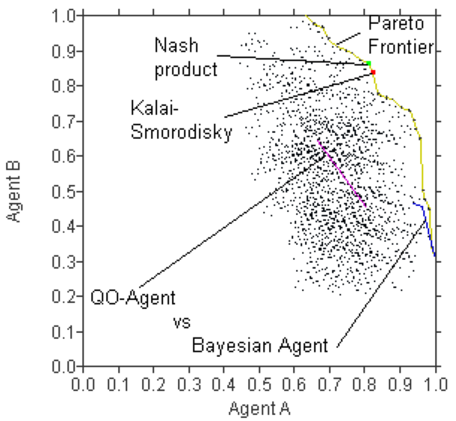 | 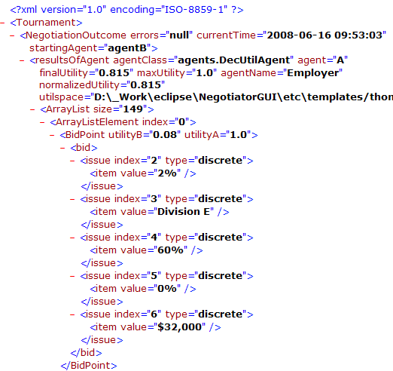
Figure 5. Utility plot. The plot shows the Pareto Frontier, Nash product, Kalai-Smorodinsky solution, and the bidding sequence of agent A and agent B | Figure 6. Negotiation trace in XML format.
The NegoSimulator save the details of the negotiation session in an XML file. The transcript contains the following information:
- details of the negotiation session setup, names of the agents, negotiation domain and preference profiles, which agent started the negotiation;
- negotiation outcome and utilities of the agents;
- all bids exchanged in the negotiation and their utilities wrt the preferences of the agents.
The XML transcript of the negotiations can be imported into the software such as MS Excel, Mathematica for further analysis. It can be transformed in any other representation languages, such as HTML using a XSL template included in the package.

GUI of a Human Negotiator
If the agents.UIAgent is selected for Agent A/B class name, the window as shown in Figure 7 will pop up every time input from negotiation agent A/B is needed.
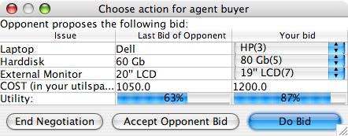 | 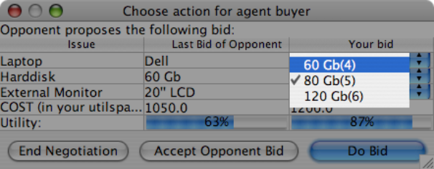
Figure 7. The GUI of UIAgent. | Figure 8. Combo box opens after clicking on a field, allowing change of the picked values for the next bid.
This GUI has three main components: the text field at the top level, the table showing the last bid and a possible next bid, and a row of buttons at the bottom. The table has three columns:
- the left column shows the names of the issues in the domain
- the center column shows the values for the issues as proposed in the last bid of the opponent (or "-" if this is the first round)
- the right column shows the current picked values for the issues. User can edit the current bid by clicking on the fields, which will open the combo boxes in the fields (Figure 8).
The last two rows of the table show the cost and utility of the last opponent's bid and your current bid. The cost field will turn red if the bid exceeds the maximum cost. The utility is shown as a percentage, and also as a bar of matching size. These values are computed according to the user’s utility space. User has no access to the opponent's utility space.
The lower three buttons allow user to submit the next bid as set in the right column, or to accept the opponent's last bid.

References
[1] K. Hindriks, C. M. Jonker, and D. Tykhonov. Negotiation dynamics: Analysis, concession tactics, and outcomes. In Proceedings of the IEEE/WIC/ACM International Conference on Intelligent Agent Technology, pages 427–433, 2007.
[2] K. Hindriks and D. Tykhonov. Opponent modelling in automated multi-issue negotiation using bayesian learning. In Proceedings of the AAMAS 2008, 2008.
[3] K. Hindriks, C. M. Jonker, and D. Tykhonov. Towards an Open Negotiation Architecture for Heterogeneous Agents. In Proceeding of the CIA 2008. 2008.
[4] H. Raiffa. The Art and Science of Negotiation. Harvard University Press, 1982.

