Tactile sense

reeham mohamed

reehammohamedhelmy@yahoo.com

sarah alaa elden

sarahalaa888@gmail.com

assuit university

facuilty of education

meachatronics and robotics

Abstract
This report is an outlook about tactile sense and it’s existing around us in our life. We talked about tactile sense specially in humans and robots. We begin with its general definition, and an overview of tactile technology. Next, we talked about human tactile sense. Then we made a conversation between tactile sensors in human and tactile sensors in robots. After that we talked about tactile sense in robots widely. we mentioned types of tactile sense in robots. After that we talked about tactile sensors in industry. Finally we talked about two applications using tactile sensors .



INTRODUCTION
The term tactile sensor usually refers to a transducer that is sensitive to touch, force, or pressure. Tactile sensors are employed where ever interactions between a contact surface and the environment are to be measured and registered. Tactile sensors are useful in a wide variety of applications for robotics and computer hardware.
A sensor's sensitivity indicates how much the sensor's output changes when the measured quantity changes. The term tactile refers to the somatosensory system or more commonly the sense of touch. A tactile sensor is a device which receives and responds to a signal or stimulus having to do with force.

Tactile sensors are generally known and can be grouped into a number of different types depending upon their construction; the most common groups are piezoresistive, piezoelectric, capacitive and elastoresistive sensors. [1]

Tactile Sensors are used all the time in everyday objects such as elevator buttons and lamps which dim or brighten by touching the base. There are also innumerable applications for tactile sensors of which most people are never aware.
Sensors that measure very small changes must have very high sensitivities. Sensors need to be designed to have a small effect on what is measured; making the sensor smaller often improves this and may introduce other advantages. Tactile Sensors can be used to test the performance of all types of applications. For example these sensors have been noted to be used in the manufacturing of automobiles (brakes, clutches, door seals, gasket), battery lamination, bolted joints, fuel cell, etc.[1]

AN OVERVIEW OF TACTILE TECHNOLOGY

The different applications for tactile sense are listed below:
1. Teleportation and telepresence.
2. Laboratory prototypes to study the different tactile parameters.
3. Sensory substitution.
4. 3D surface generation.
5. Braille systems.
6. Games. [2]

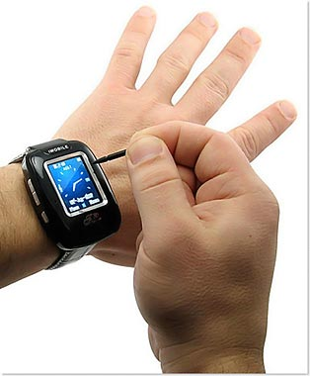
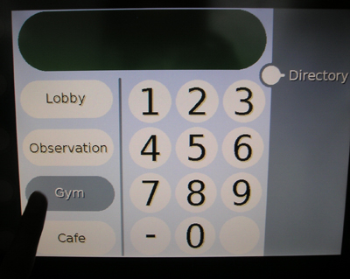


human tactile sensing
How many of us say: “Let me see!” and then stretch out our hands to touch an object? We are all dependent on our tactile sense to interpret and engage with the world around us and to respond appropriately to touch sensations.
The tactile system is the first sensory system to develop in the womb and develops from the same embryonic layer as the nervous system. It is able to function effectively when the visual and auditory systems are just beginning to develop. The skin thus plays an important role in regulating our nervous system, i.e. making us more alert or calming us down. It affects our ability to learn as well as our emotional and social well-being. This stresses the fact that without a great deal of tactile stimulation of the body, the system tends to become unbalanced. [3]

Why People Can Pick Up Objects with Their Fingers??!!
There are two ways we grip things. One way is by applying strong pressure,
While, the other way is by tenderly fondling an object.[4]

Tactile sensor in human vs. in robots

As the figure shown below the mechanism of sensing needs controller .it is the brain in human and computer or any controller (microcontroller, Pic) in robots. In human, when you touch anything cold or hot your hand feel it and send a signal with the Nervous system to the brain then the brain react with this signal.in robot, the sensor in the gripper sense the object and send a signal to the controller and it reacts with this signal according to the program installed on it.

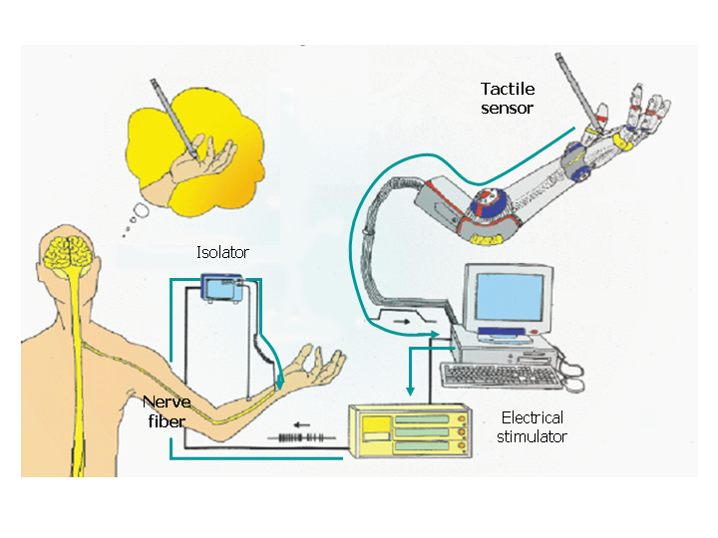

Tactile Sensors in the Robotics
A transducer, usually associated with a robot end effectors, that is sensitive to touch; comprises stress and touch sensors. As we mentioned tactile sensors are generally known and can be grouped into a number of different types depending upon their construction; the most common groups are resistive based sensor, piezoelectric, capacitive and strain gauge sensors.[1]

Its specifications:
- A touch sensor should ideally be a single-point contact; through the sensory area can be any size. In practice, an area of 1-2 mm2 is considered a satisfactory compromise between the difficulty of fabricating a sub-miniature sensing element and the coarseness of a large sensing element.
- The sensitivity of the touch sensor is dependent on a number of variables determined by the sensor's basic physical characteristic. In addition the sensitivity may also be the application, in particular any physical barrier between the sensor and the object. Sensitivity within the range 0.4 to 10N, together with an allowance for accidental mechanical overload, is considered satisfactory for most industrial applications.
- A minimum sensor bandwidth of 100 Hz.
- The sensor’s characteristics must be stable and repeatable with low hysteresis. A linear response is not absolutely necessary, as information processing techniques can be used to compensate for any moderate non-linearities.
- As the touch sensor will be used in an industrial application, it will need to be robust and protected from environmental damage. [5]

Types of tactile sensors in robots :
- Resistive based sensors
The uses of compliant materials that have defined force-resistance characteristics have received considerable attention in touch and tactile sensor research. The basic principle of this type of sensor is the measurement of the resistance of a conductive elastomer or foam between two points. The majority of the sensors use an elastomer that consists of a carbon doped rubber.
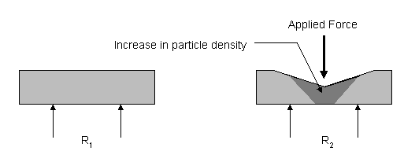
In the above sensor the resistance of the elastomer changes with the application of force, resulting from the deformation of the elastomer altering the particle density.

- Piezoelectric sensors
Polymeric materials that exhibit piezoelectric properties are suitable for use as a touch or tactile sensors, while quartz and some ceramics have piezoelectric properties, polymers such as polyvinylidene fluoride (PVDF) are normally used in sensors.
Polyvinylidene fluoride is not piezoelectric in its raw state, but can be made piezoelectric by heating the PVDF within an electric field.PVDF is supplied sheets between as 5 microns and 2 mm thick, and has good mechanical properties. A thin layer of metallization is applied to both sides of the sheet to collect the charge and permit electrical connections being made.so we use it in artifitial skin
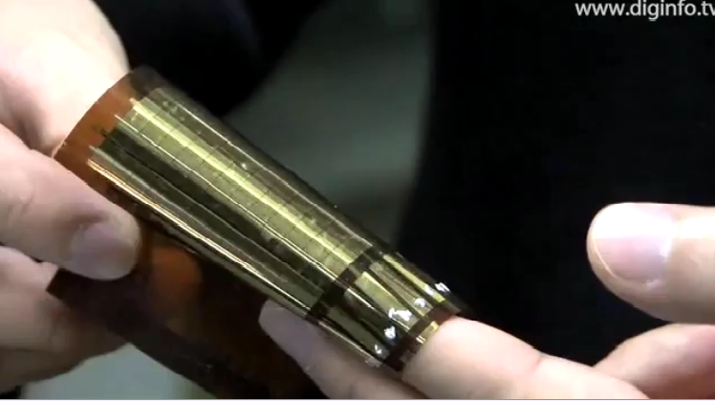
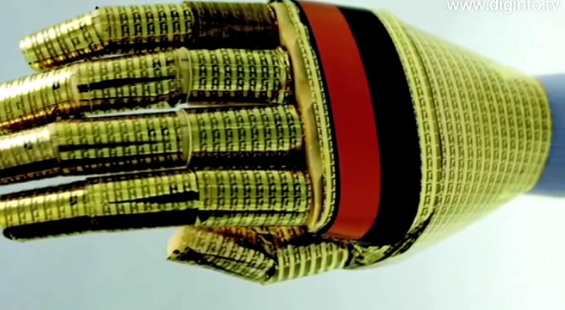

- Strain gauges in tactile sensors
A strain gauge when attached to a surface will detect the change in length of the material as it is subjected to external forces. The strain gauge is manufactured from either resistive elements (foil, wire, or resistive ink) or from semiconducting material. A typical resistive gauge consists of the resistive grid being bonded to an epoxy backing film. If the strain gauge is pre-stressed prior to the application of the backing medium, it is possible to measure both tensile and compressive stresses. The semi-conducting strain gauge is fabricated from a suitable doped piece of silicone; in this case the mechanism used for the resistance change is the piezoresistive effect.
When applied to robotic touch applications, the strain gauge is normally used in two configurations: as a load cell, where the stress is measured directly at the point of contact, or with the strain gauge positioned within the structure of the end effector. [5]

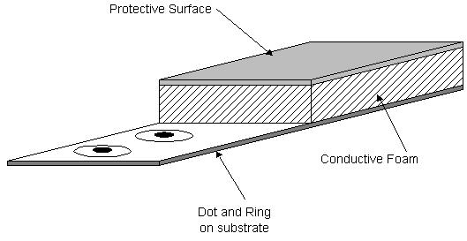

- Capacitive Touch Sensing

What is Touch Capacitive Touch Sensing??
Main components:
- Touch Sensor
- Relaxation Oscillator Circuit
- Frequency Measurement
- Software

What is Touch Capacitive Touch Sensing?

-Alternative to traditional push-button user interfaces.
- No mechanical movement.
-Completely sealed.
-Modern-looking design.

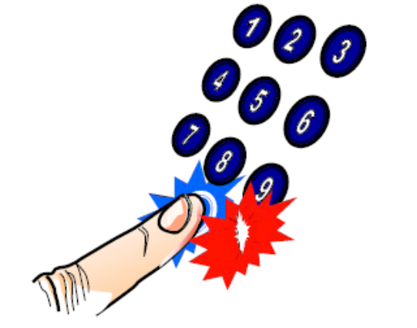

Overview of Touch Capacitive Touch Sensing
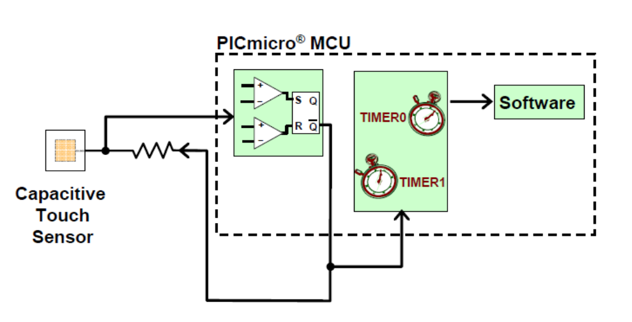

Relaxation Oscillator Circuit
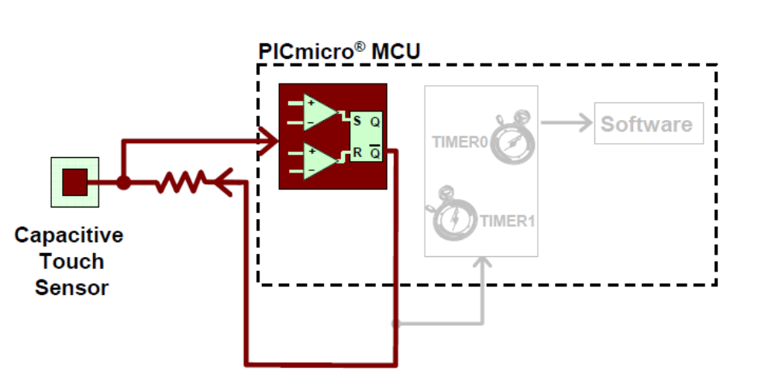 First, we have the touch sensor itself. As the Capacitive Touch Sensing name implies, this sensor will produce a varying capacitance that will interact with a relaxation oscillator circuit. When the capacitance from the sensor changes, for example when touched by a finger, the oscillator’s frequency will change.

Frequency Measurement
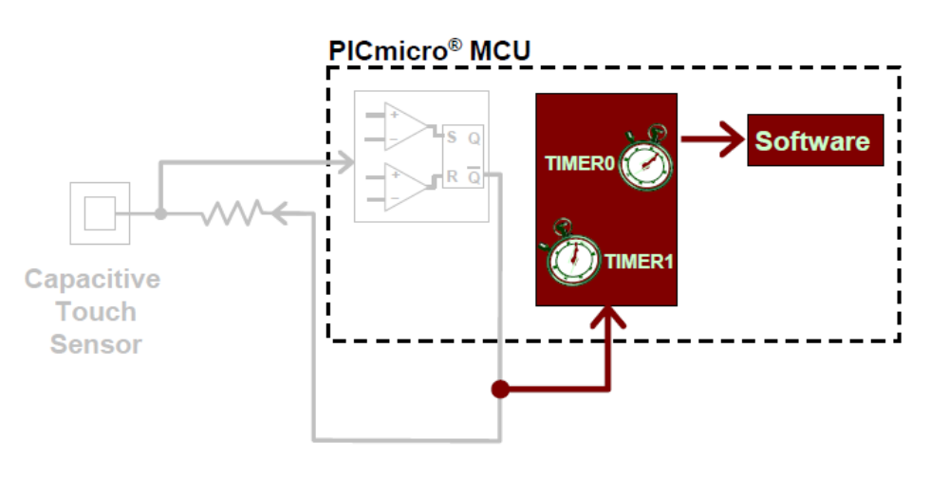
In order to interpret this change in oscillator frequency, a frequency measurement component is required in our system. This component will interface hardware and software to accurately determine if and when a sensor has been touched.

Capacitance
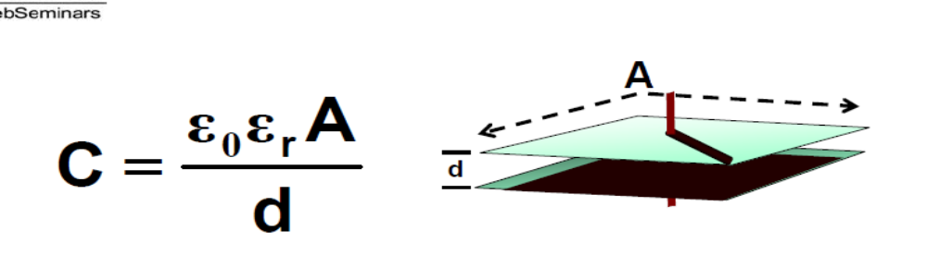

ε0 Permittivity of Free Space (8.854 Pico-Farad/meter)
εr Relative Dielectric Constant (unit-less)
A Area of Plates (meters)
C Capacitance (Farads)
d Distance between plates (meters)

Recalling the equation for capacitance, we can see that there are a number of variables that could change the capacitance produced by our touch sensors. As we will see, the most important variables that we will be concerned with is Area and distance. From this equation we can see that the greater the Area, the greater the capacitance. As the distance becomes larger, the capacitance drops. Keep this in mind as we proceed through this presentation. So…how do we build a sensor?

Touch Sensor Construction

- Fiberglass (FR- 4) Printed Circuit Board (PCB)
Laminate made from woven glass fiber impregnated with epoxy resin.

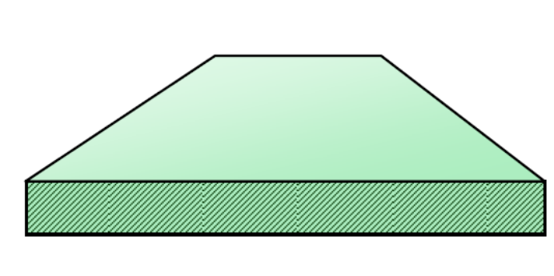

We begin with a simple printed circuit board. Constructed of FR-4, a composite of laminated woven glass fiber and epoxy, the PCB will enable us to produce a natural capacitance for our application.

- Copper (Cu) pads (thickness exaggerated)
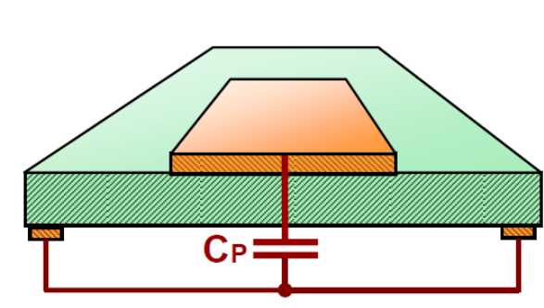

A copper pad is next introduced. The shape of this pad is not very important. Therefore, we have the freedom to shape the sensor aesthetically to suit a particular design. However, the area of the pad is very important. The larger the pad, the better the sensitivity and a sensor touch will be more easily detected by the rest of the system. As you can see in the slide above, a natural parasitic capacitance to grounds elsewhere in the system has been introduced here which I have labeled Pad Capacitance or Cp

- Glass or Plexiglas
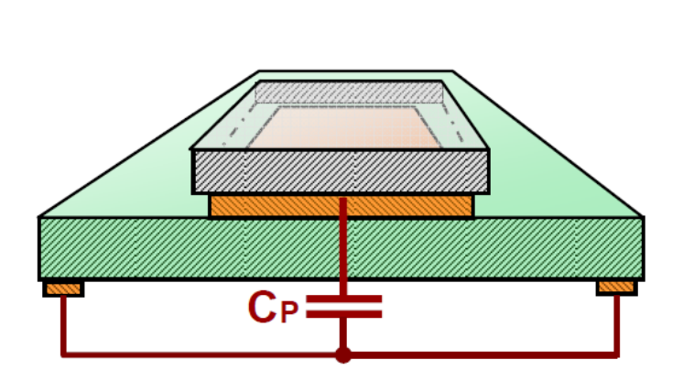
2 to 5mm thick
Next, a touch surface is applied in the form of either Window glass or Plexiglas. Other materials could be used as long as the dielectric constant of the material is evaluated for functionality. Typically it is best to design a thin touch surface. Remember back to the capacitance equation, as distance increases, the capacitance will effectively decrease. Therefore, using a surface that is very thin produces a more sensitive system.

How does it work?
Introduction of finger produces a parallel capacitance
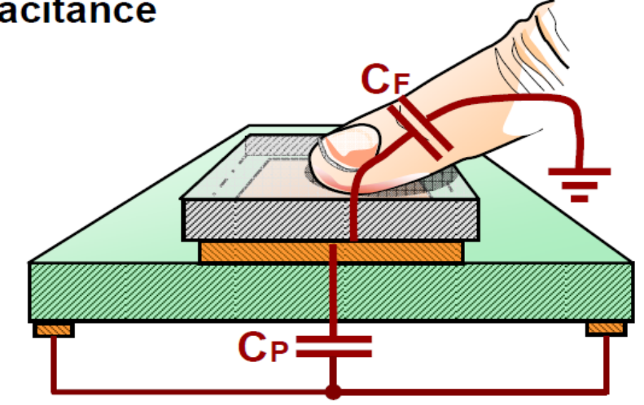

A finger touch will add a second capacitance in parallel with the pad’s capacitance. The iron in an individual’s blood creates strings of capacitors between every surface of their body. So, when someone creates a capacitance by moving his or her hand into close proximity of another conductor, it creates a capacitance essentially coupled to ground.

Equivalent Circuit

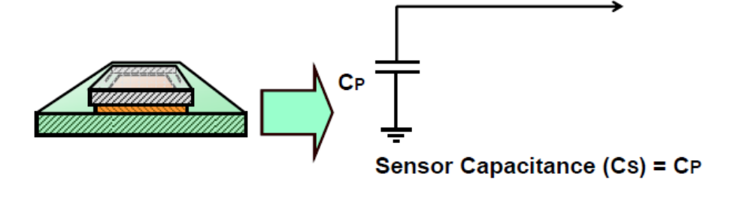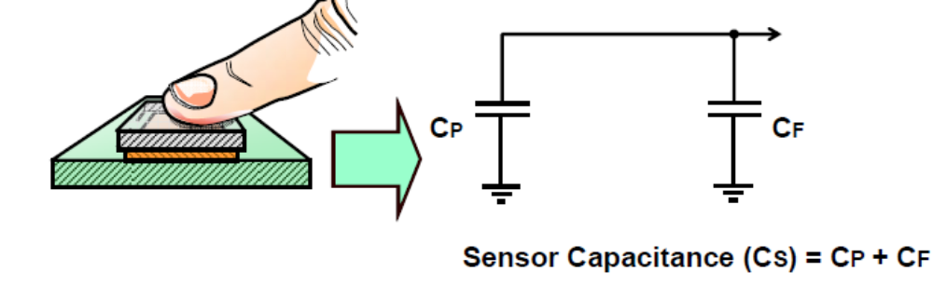

Looking at equivalent circuits, we have the capacitance from the pad alone and then a parallel combination of pad capacitance and the finger capacitance which add together to form a total sensor capacitance labeled Cs. We should mention here that the capacitance introduced by the finger is known to be very small in the area of 5-15pF. Therefore, we will want to ensure that the capacitance created by our pad is small as well to ensure that a touch is sensed.[6]

Tactile Sensors in the Robotics Industry

Research and development has been grown on industrial robots, intended to replace human workers in a variety of assembly tasks. In order for robots to effectively perform increasingly more delicate and detailed tasks, it becomes necessary to provide sensory apparatus which is functionally equivalent to the various sensors which human workers are naturally endowed touch. Sensors enable a robot to respond to changes in its environment. Tactile sensors have been developed for use with industrial robots. Tactile sensors can complement visual systems by becoming the controlling system at the time contact is made between a gripper of the robot and an object or objects being gripped, this being a time when vision is often obscured. Typical tactile sensors have force-sensitive deflection-responsive sensor members associated with the sensor surface and electrical circuitry which connects the members to an analyzer for determining a physical parameter of the object being sensed. In robotics, tactile sensors provide useful information about the state of contact between a robot hand and an object in pretension. Sensors can indicate the presence or shape of an object, its location in the hand, and the force of contact.[1]

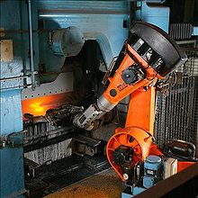

a pick and place robot in a factory.

Robots using tactile sense

James the robot

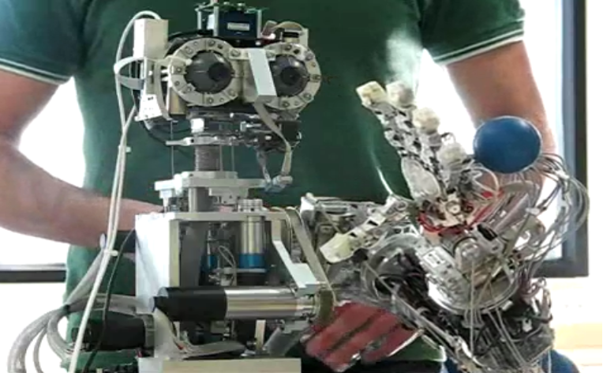

James the robot moves its arm randomly. When something touches its hand James moves its wrist to avoid the object. Admittance control is showed (the velocity of the wrist is proportional to the sensed force on the touch sensors of the hand). [7]

The Curious Robot

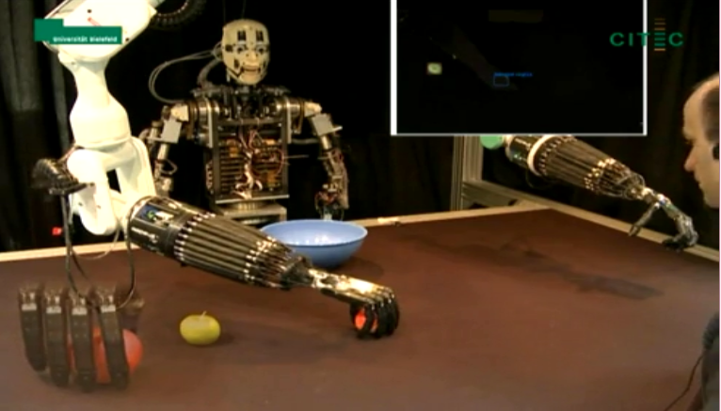

In Bielefeld, work is carried out on a bimanual anthropomorphic platform including the torso BARTHOC as a communication partner. We study interactive robot learning within a object learning scenario, i.e. labeling, grasping, and removing objects, aiming at a more natural human-robot cooperation. In particular, our research focuses on: bimanual action, representation and execution, tactile sensors and manipulation based on tactile feedback, online-learning object detection, integration and coordination of perception and action and principles of human-robot dialog, including non-verbal communication, combination of exploratory and guided learning.[8]

Conclutuin

In the last few years the scientists were searching about tactile sense mechanism to make simulation for it in the robots.

With tactile sensors the robot could interact with the objects in its environment and take the suitable reaction.so they noticed that without this
Sensing mechanism in robots many manufactures will use human instead of robots in many hard tasks.

Although, the researches proves that robot dealing with its environment reaches high levels it will never reaches the human level.

So they dream to reaches human accuracy.

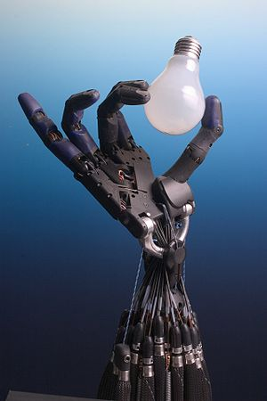

References:

  - Wikipedia

  - “Tactile interfaces: a state-of-the-art survey”
Mohamed Benali-Khoudja1, Moustapha Hafez1Jean-Marc Alexandre1and
Abderrahmane Kheddar

  - How messy play NOW can clean up his act LATER! Toddlers Workshop.mht

  - “The world of tactile sensation”
Michitaka Hirose

  - “R M Crowder” January 1988

  - “Introduction to mTouch”
Marc McComb

  - YouTube - James the robot - tactile based motor control.

  - YouTube - The Curious Robot.

