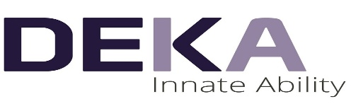


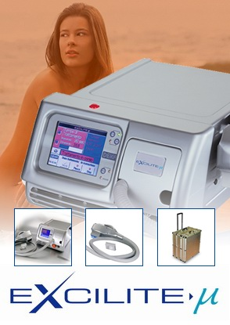
Quotation {{EMP_CODE}}#{{SERIAL}}#

Date: Tuesday, 20 January 2026

Name: {{ACCOUNT}}
Attention: {{CITY}}

Dear Sir(s),
We are glad to offer you our products and services
please find herewith our quotation for Excilite-μ

DEKA Laser – Made in ITALY

S/N | Item Description | Qty | Unit Price | Total Price
1 | Technical Features of Excilite-μ  Light Source MEL@308, Excimer XeCl  Wavelength 308 ± nanometers  Power density 50 mW/cm2  Treatment surface Up to 30 cm 2 (6x5)  Cooling Air cooled  Electric supply 230 V single phase, 50/60 Hz, 2.6 A max  LCD screen Included  Dimensions 24 cm (H), 38 cm (D), 50 cm (W)  Weight 19 Kg | {{QTY}} | {{PRICE}} SR | {{TOTAL_PRICE}} SR
Price in Words: {{TOTAL_PRICE_WORDS}} |  |  |  | {{TOTAL_PRICE}} SR

This Machine SFDA Approved

Excilite-μ
is a monochromatic source able to emit a non-coherent light with a narrow band centered around 308 nm in the UVB band?
This particular source is exclusive of Deka and it is called MEL@308nm.
The emission is continuous wave and is uniform on the area where the treatment can take place, 30 cm2 at maximum (5x6 cm).

Applications:

This system is used mainly in dermatology for treating autoimmune-diseases as:
- Dermatology
- Psoriasis
- Vitiligo
- Atopic Dermatitis
- Alopecia Areata

Consumables:
Handpiece can work until 300 hours
Cost of replacement is 35.000 SR

Manufacturer: DEKA . ITALY
Terms & Conditions:
- Offer Validity is for only 6 months from the quotation date
- Delivery Time 6 (Six) weeks Maximum from the date of the confirmed Purchase Order and down payment
- Training will be by our specialist in your location
- Warranty 2 (Two) years from the date of delivery including spare parts (not including consumables & not including miss use)
Payment Details:
  - {{DOWN_PAYMENT}} on confirmation of the order
  - {{REMAINING_PERCENT}} will be paid on {{INSTALLMENTS}} months (PDC needed)

DEKA Laser Specialist DEKA Area Manager
{{EMP_NAME}} Eng. Yaseen Ayyash
Mobile:{{EMP_PHONE}} Mobile: 0507274963

