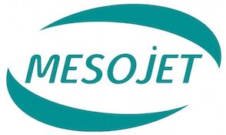
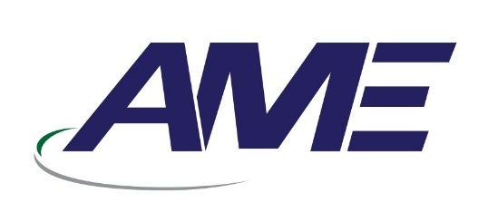

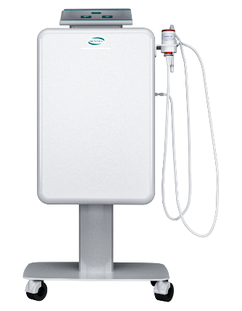
Quotation {{EMP_CODE}}# {{SERIAL}}#Credit Offer

Date: Wednesday, 21 January 2026

Name: {{ACCOUNT}}
Adress: {{CITY}}

Dear Sir(s),
We are glad to offer you our products and services
please find herewith our quotation for

Meso Jet Hy-Po device
Hydroporation Technology for Superior Results

Meso Jet- Made in Italy
S/N | Item Description | Qty | Unit Price | Total Price
1 | Meo Jet Hy-Po device  Accessories and products included in the offer:  - Premium 2.0 Hp  - Triple nozzles Hp box of 5  - Anti-aging Complex 1  - Argir Elisir  - Jet Detox Water bag  - Renewal Complex 2  - Renewal Complex 4  - MesoJet Towel  - MesoJet Hair Band  - Tablet touch-screen console with Bluetooth technology  Weight: 23,5 Kg  Power supply: 230V:50-60Hz  Size: 52 x 30 x 102 cm  Consumption: 550W | {{QTY}} | {{PRICE}} SR | {{TOTAL_PRICE}} SR
Price in Words: {{TOTAL_PRICE_WORDS}} |  |  |  | {{TOTAL_PRICE}} SR

Applications:
- Hydra dermabrasion
- Chemical Peeling
- Transdermal Infusion
- Scalp & Hair Care
- Acne & Hyperpigmentation

Manufacturer: NOVA VISION GROUP . ITALY
Terms & Conditions:
- Offer Validity is for only 3 months from the quotation date
- Delivery Time 6 (Six) weeks Maximum from the date of the confirmed Purchase Order and down payment
- Training will be by our specialist in your location
- Warranty 2 (Two) years from the date of delivery including spare parts (not including consumables & not including miss use)
Payment Details:
  - {{DOWN_PAYMENT}} on confirmation of the order
  - {{REMAINING_PERCENT}} will be paid on {{INSTALLMENTS}} months (PDC needed)

DEKA Laser Specialist DEKA Area Manager
{{EMP_NAME}} Eng.Yaseen Ayyash
Mobile : {{EMP_PHONE}} Mobile : 0507274963

