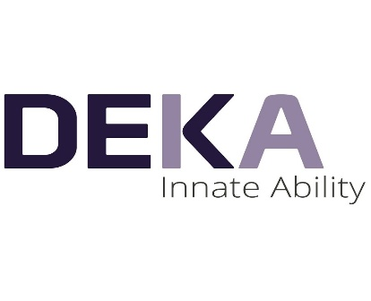


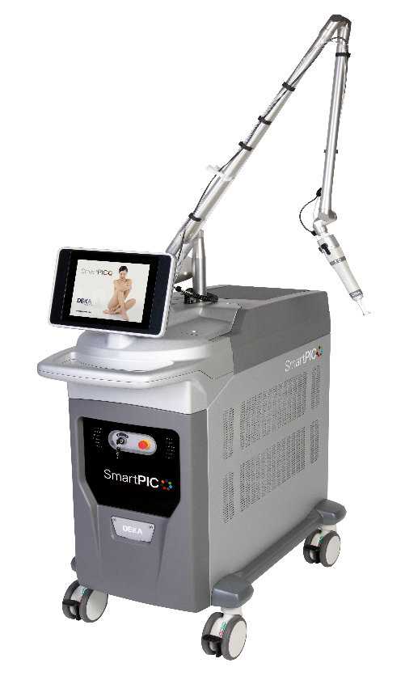

Quotation {{EMP_CODE}}#{{SERIAL}}# Credit Offer

Date: {{DATE}}
Name: {{ACCOUNT}}
Adress: {{CITY}}

Dear Sir(s),
We are glad to offer you our products and services
please find herewith our quotation for

DEKA Smart PICO

DEKA Laser - Made in Italy

S/N | Item Description | Qty | Unit Price | Total Price
1 | DEKA Smart PICO  Control Panel Colour LCD Touch Screen  Mains Supply 200 - 240 VAC, 50-60Hz  Size and Weight 548(L)-1118(D)–1230 (H)–150 Kg  Nd:YAG 1064 nm  PICO:  Pulse duration : 450 ps  Energy (max0 : 800 mJ  Q-SWITCHED:  Pulse duration : QS – 6 ns  Energy (max0 : 800 mJ  OPTI-PULSE:  Pulse duration : OP – 6 ns + 6ns  Energy (max0 : 1200 mJ  PHOTO-THERMAL:  Pulse duration : PT – 300 µs  Energy (max0 : 2 J  Nd:YAG 532 nm  PICO:  Pulse duration : 370 ps  Energy (max0 : 300 mJ  Q-SWITCHED:  Pulse duration : QS – 6 ns  Energy (max0 : 400 mJ  OPTI-PULSE:  Pulse duration : OP – 6 ns + 6ns  Energy (max0 : 450 mJ  Repetition Rate:  UP to 10 HZ  Laser Emission:  Articulated Arm with removable handpieces  Available Handpieces (optional):  2×2 ; 3×3 ; 4×4 ; 5×5 mm square  3 ; 4.5 ; 6 ; 7.5 ; 9 ; 10.5 mm round  8 ; 9 mm fractional square  Deka Peel treatment handpiece | {{QTY}} | {{PRICE}} SR | {{TOTAL_PRICE}} SR
Price In Words: {{TOTAL_PRICE_WORDS}} |  |  |  | {{TOTAL_PRICE}} SR

This Machine SFDA Approved

Applications:
- Removal of Tattoos
- Pigmented Lesions
- Wide pores, acne, toning and vitalization treatment
- Hair bleaching
- Fine hair removal
- freckles treatment
- Post acne redness

Manufacturer: DEKA. ITALY
Terms & Conditions:
- Offer Validity is for only 3 months from the quotation date
- Delivery Time 6 (Six) weeks Maximum from the date of the confirmed Purchase Order and down payment
- Training will be by our specialist in your location
- Warranty 2 (Two) years from the date of delivery including spare parts (not including consumables & not including miss use)
Payment Details:
  - {{DOWN_PAYMENT}} confirmation of the order
  - {{REMAINING_PERCENT}} will be paid on {{INSTALLMENTS}} months (PDC needed)

{{NOTES}}

DEKA Laser Specialist DEKA Area Manager
{{EMP_NAME}} Eng. Yaseen Ayyash
Mobile: {{EMP_PHONE}} Mobile : 0507274963

