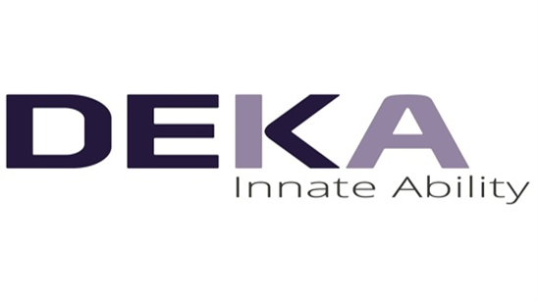
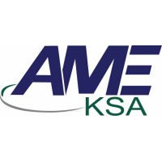


Certificate of attendance

LASER TRAINING COURSES & WORKSHOPS DEPARTMENT (AME-KSA)
THIS IS TO CERTIFY THAT
{{NAME}}

Has attended a One Month Laser Training & Workshop for the use of Hair Removal, Non-Ablative Skin Rejuvenation & Vascular Treatment
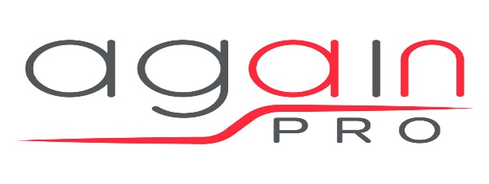

Held From Dr.Ali Eed
{{DATE}} – {{CITY}} General Manager (GM)

