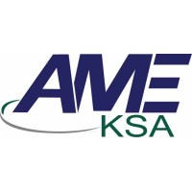
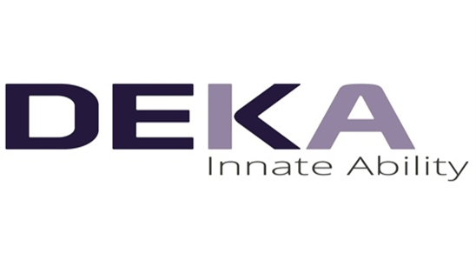
Certificate of attendance



LASER TRAINING COURSES & WORKSHOPS DEPARTMENT (AME-KSA)
THIS IS TO CERTIFY THAT
{{NAME}}


Has attended a One Month Laser Training & Workshop for the use of Hair Removal, Non-Ablative Skin Rejuvenation & Vascular Treatment
{{STAMP_HERE}}

Held From Dr.Ali Eed
{{DATE}} – {{CITY}} General Manager (GM)

