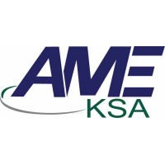
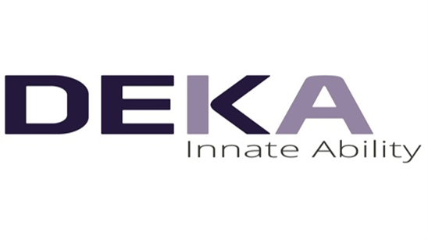
Certificate of attendance



LASER TRAINING COURSES & WORKSHOPS DEPARTMENT (AME-KSA)
THIS IS TO CERTIFY THAT
{{NAME}}
Has attended a One Month Laser Training & Workshop for the use of the
Multicolored Tattoos Removal & Dermal and Epidermal Benign Pigmented Lesion


Held From Dr.Ali Eed
{{DATE}} – {{CITY}} General Manager (GM)

