TEST-DRIVEN DEVELOPMENT (TDD)
SALAF
BY YOUSIF ALBALUSHI & HUSAIN DESMAL

Table of Contents
1. TDD Goals and Scope 3
2. TDD Methodology 3
2.1 Red–Green–Refactor 3
2.2 Test Levels and Ratios 3
3. Mapping Requirements to Tests 4
3.1 Authentication (FR-1 to FR-4) 4
3.2 Contact Management (FR-5 to FR-7) 5
3.3 Lending Workflow (FR-8 to FR-16, Business Rules) 5
3.4 Dashboard & Lend Details (FR-17 to FR-21) 7
3.5 PDF Receipt (FR-22, FR-23) 7
3.6 Optional Intelligence Features (FR-24 to FR-26) 8
4. Non-Functional TDD Aspects 8
4.1 Performance Tests 8
4.2 Security-Focused Tests 8
5. Frontend (React Native) Test Plan under TDD 8
6. TDD Execution Order (Recommended) 9

1. TDD Goals and Scope
- Ensure every functional requirement FR-1 to FR-26 has at least one automated test (unit, integration, or E2E).
- Drive implementation through tests for core flows: Auth, Contacts, Lending & Repayments, Dashboard, PDF Receipts.​
- Focus TDD mainly on backend business logic and REST APIs, with light component tests on React Native UI.
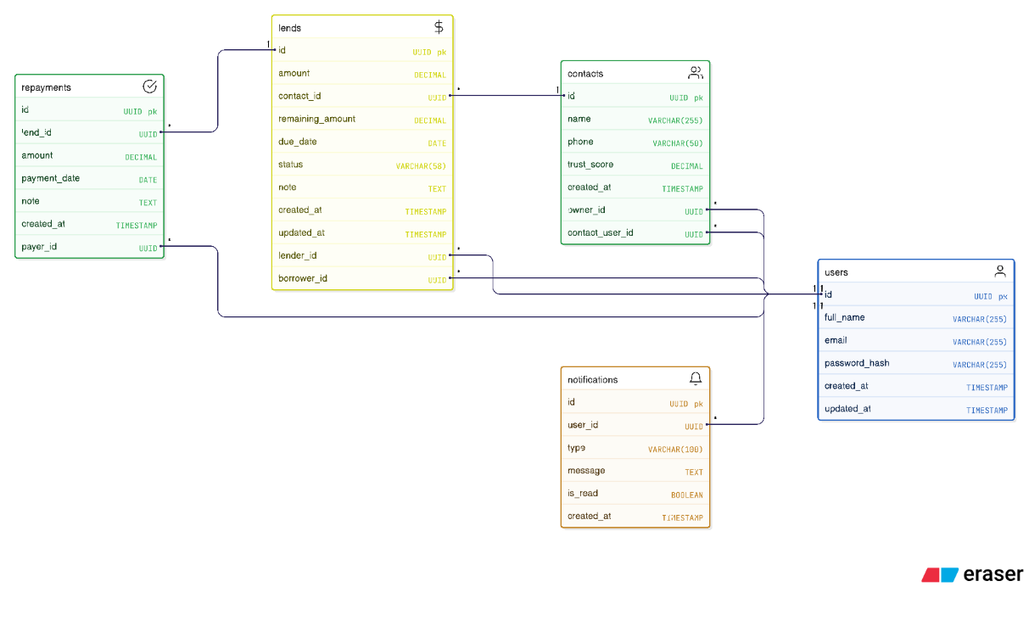
Figure 1 - Entity Requirements Diagram (ERD)

2. TDD Methodology

2.1 Red–Green–Refactor
For each requirement or user story:
- Red: Write a failing unit or integration test that encodes the acceptance criteria (e.g., “repayment cannot exceed remaining balance”).
- Green: Implement minimal code in Spring Boot (service, controller, repository) to pass the test.​
- Refactor: Clean up code, extract methods, improve naming while keeping all tests green.​
Repeat in small increments per feature (e.g., “create lend request”, then “accept lend”, then “add repayment”).

2.2 Test Levels and Ratios
Align with a test pyramid:
- Unit tests (~70%): Services, domain logic, validators, utility classes (e.g., status transitions, balance calculations).​
- Integration tests (~20%): REST controllers + database (PostgreSQL) for main endpoints: auth, contacts, lends, repayments, dashboard, PDF.
- End-to-End tests (~10%): Key mobile flows using mocks/fake backend or staging environment.​
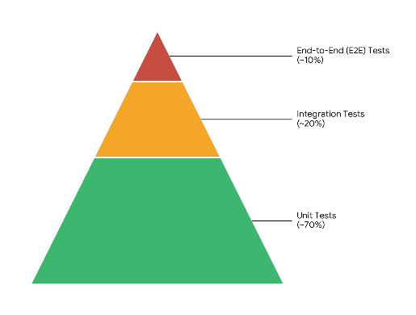
Figure 2 - Test Pyramid Structure

3. Mapping Requirements to Tests

3.1 Authentication (FR-1 to FR-4)
Key rules: register, login, JWT, protected routes.
Unit Tests (Spring Boot)
- AuthService.register()
  - Valid registration with unique email → user persists, password hashed (BCrypt).​
  - Duplicate email → throws DuplicateUserException.
  - Invalid email / weak password / missing fields → validation errors.
- AuthService.login()
  - Correct email + password → returns JWT token string.
  - Wrong password or non-existing user → authentication exception.
- JwtService
  - Generate token for valid user, includes user id and expiry.
  - Validate valid token → returns principal.
  - Expired or malformed token → throws validation error.
Integration Tests (REST)
- POST /api/auth/register
  - 201/200 on valid data, 400 on invalid, 409/400 on duplicate email.
- POST /api/auth/login
  - 200 + token for valid credentials, 401 for invalid.
- Protected sample endpoint (e.g., /api/contacts)
  - 401 without token, 403 for invalid/expired token, 200 with valid token.

3.2 Contact Management (FR-5 to FR-7)
Key rules: contacts are owned per user; must exist before lend.
Unit Tests
- ContactService.createContact(ownerId, dto)
  - Creates contact with valid data, linked to owner.
  - Rejects invalid email / missing name.
  - Prevents duplicate contact name/email per owner.
- ContactService.listContacts(ownerId)
  - Returns only contacts for that owner.
Integration Tests
- POST /api/contacts (auth required)
  - 201 on valid contact, body contains id and ownerId.
  - 400 on invalid payload, 409/400 on duplicate.
- GET /api/contacts
  - Returns list of contacts for logged-in user only.

3.3 Lending Workflow (FR-8 to FR-16, Business Rules)
Key rules:
- New lend → Pending.
- Borrower must accept before repayments can be added.
- Status transitions and balance rules.
Domain / Unit Tests
- LendService.createLend(lenderId, borrowerContactId, amount, dueDate, note)
  - Valid → status PENDING, remaining = amount.
  - Negative amount or past due date → validation error.
  - Non-existing contact → not found.
- LendService.acceptLend(borrowerUserId, lendId)
  - Pending & borrower is correct user → status ACCEPTED.
  - Already accepted/rejected → invalid state exception.
  - Non-borrower attempts → authorization exception.
- LendService.rejectLend(borrowerUserId, lendId)
  - Pending → REJECTED.
  - Already accepted/rejected → invalid state.
- RepaymentService.addRepayment(borrowerUserId, lendId, amount)
  - Only allowed if lend is ACCEPTED or PARTIALLY_PAID.
  - Amount > 0, and amount <= remainingBalance; else validation error.
  - After applying payment:
    - If remaining > 0 → status PARTIALLY_PAID.
    - If remaining = 0 → status PAID.
  - Test a scenario with multiple repayments to ensure no rounding or logic bug (e.g., 100 → 30 + 30 leaves 40).
- LendStatusCalculator / helper methods
  - Given due date and remaining balance, calculates OVERDUE when now > dueDate and remaining > 0.
Integration Tests
- POST /api/lends
  - Auth lender, valid body → 201, status PENDING, correct borrower contact.
- GET /api/lends?role=lender/borrower
  - Returns only lends related to user.
- PATCH /api/lends/{id}/accept
  - Borrower logged in, pending → 200, status ACCEPTED.
  - Non-borrower or wrong user → 403.
  - Non-existent lend → 404.
- PATCH /api/lends/{id}/reject
  - Similar cases as accept.
- POST /api/lends/{id}/repayments
  - Borrower adds valid repayment → 201, remaining updated, status updated.
  - Exceeding remaining balance → 400.
  - Status not accepted/partially_paid → 400.

3.4 Dashboard & Lend Details (FR-17 to FR-21)
Unit Tests
- DashboardService.getSummary(userId)
  - Computes:
    - “Total owed to me”: sum of active lends where user is lender and remaining > 0.
    - “Total I owe”: sum where user is borrower and remaining > 0.
  - Correct grouping for: due today, due this week, overdue.
- LendDetailsService.getDetails(lendId, userId)
  - Returns lend info, repayments timeline ordered by date, remaining balance, status, and progress %.
Integration Tests
- GET /api/dashboard
  - Needs auth; returns totalOwedToMe, totalIOwe, dueToday, dueThisWeek, overdue arrays.
- GET /api/lends/{id}
  - Returns full lend details only if user is lender or borrower; 403 otherwise.

3.5 PDF Receipt (FR-22, FR-23)
Unit Tests
- PdfService.generateReceipt(lendId, requesterUserId)
  - Works only for lends with status PAID (completed).
  - Includes lender, borrower, amount, list of repayments, dates, final status.
  - Throws error if lend doesn’t exist or user not involved in the lend.
Integration Tests
- GET /api/pdf/receipt/{id}
  - 200, Content-Type: application/pdf, non-empty body, only when lend is paid and user is lender/borrower.
  - 403 if user not related, 404 if lend doesn’t exist.

3.6 Optional Intelligence Features (FR-24 to FR-26)
These are “may” requirements; implement TDD only if you implement the features:
- Debt priority ranking: unit tests for ranking algorithm given multiple lends.
- Repayment suggestion engine: tests for suggested amounts/dates based on rules.
- Trust score: test score calculation based on history (on-time vs overdue).

4. Non-Functional TDD Aspects

4.1 Performance Tests
- For key APIs (/api/dashboard, /api/lends, /api/pdf/receipt/{id}), define performance checks in a tool like JMeter or Gatling:
  - ≤ 500ms response time under nominal load, ≤ 2s dashboard load.
- For PDF generation, ensure receipts for normal-sized lends are built under 5s.​

4.2 Security-Focused Tests
- Unit tests for validators (input validation).
- Integration tests to confirm:
  - Passwords stored hashed (never plain text).
  - All business endpoints return 401/403 without valid JWT.
  - User A cannot see or mutate User B’s loans or contacts.

5. Frontend (React Native) Test Plan under TDD
Even if backend is the primary TDD target, you can still apply it at UI level:
- Use Jest + React Native Testing Library.​
- For each critical screen:
  - Write test first asserting presence of key elements and flows (e.g., “when user enters valid credentials and taps Login, calls /api/auth/login and navigates to dashboard”).
  - Mock API responses, then implement UI logic to satisfy tests.​
Key screens to cover:
- Login/Register screen (validation, error messages).
- Contacts screen (list, add contact form).
- Lending screen (create request, validation).
- Borrower requests screen (accept/reject).
- Repayment screen (prevent invalid amounts).
- Dashboard summary screen.

6. TDD Execution Order (Recommended)
- Start with core domain logic (pure Java classes, no HTTP):
  - Balance calculation, status transitions, overdue calculation.
- Add service-level tests for Auth, Contacts, Lends, Repayments.
- Expose controllers and write integration tests for main endpoints.
- Implement dashboard + PDF with tests guiding behavior.
- Wire React Native screens, writing Jest tests first for the most critical flows.
This way, each new requirement from your BRD becomes:
- 1–3 new tests → minimal implementation → refactor, instead of writing big chunks of code without safety nets.

