LANGKAWI TOUR25

Day 1

* Cruise Dinner

- Sunset

- Dinner:

- Sate

- Nasi Goreng

- Roti Bakar + Spaghetti Sauce

- Ayam Masak Merah

- Udang Bakar

- Acar Buah

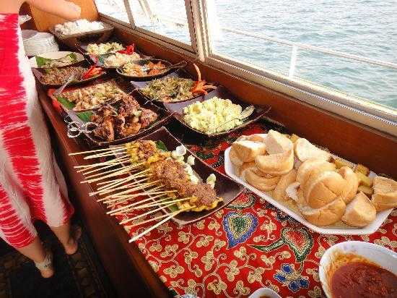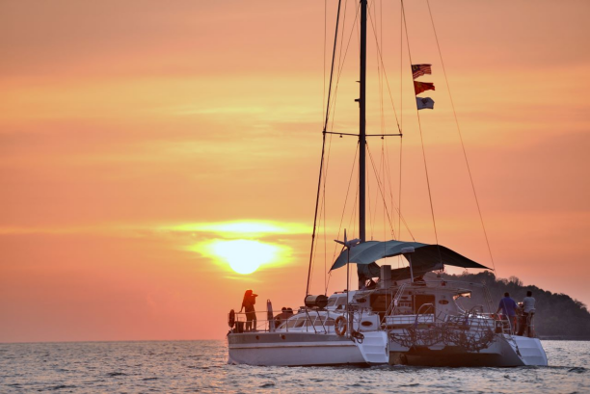

**LANGKAWI ACCOMODATION**

**A Rock Resort Langkawi**

**(Coral Reefs)**

Deluxe King Pool View

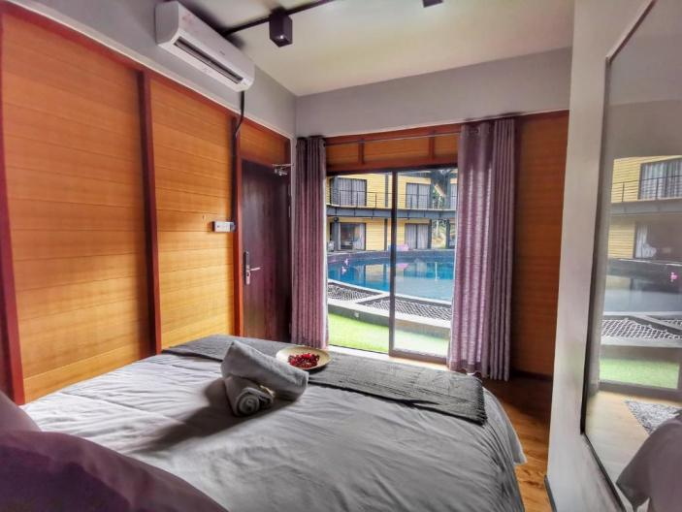

**Location:**

PT 3167, Jalan Beringin, Kampung Penarak, Kuah, Langkawi, Malaysia

**Facilities:**

- Breakfast Include

- Swimming Pool

- Free Parking

- Restaurant

- Bar

- Coffee Shop

- BBQ Facilities

- Balcony