LANGKAWI TOUR25

Day 1

* Cruise Dinner

- Sunset

- Dinner:

- Sate

- Nasi Goreng

- Roti Bakar + Spaghetti Sauce

- Ayam Masak Merah

- Udang Bakar

- Acar Buah

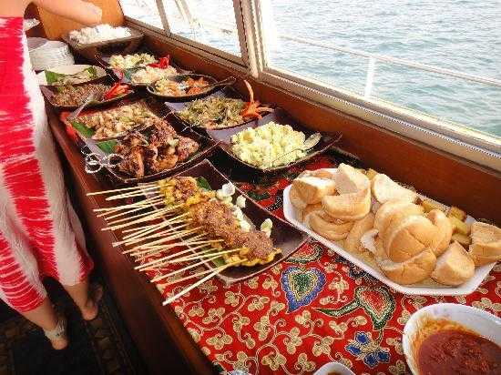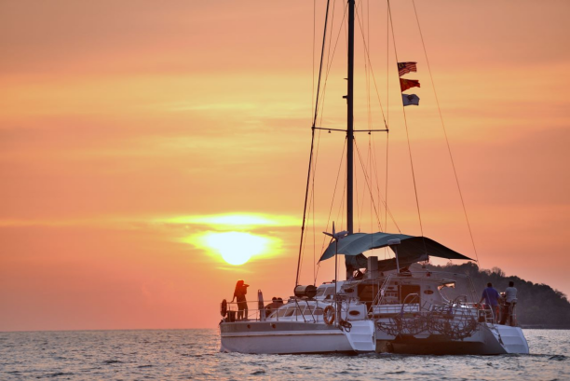

**LANGKAWI ACCOMODATION**

**A Rock Resort Langkawi**

**(Coral Reefs)**

Deluxe King Pool View

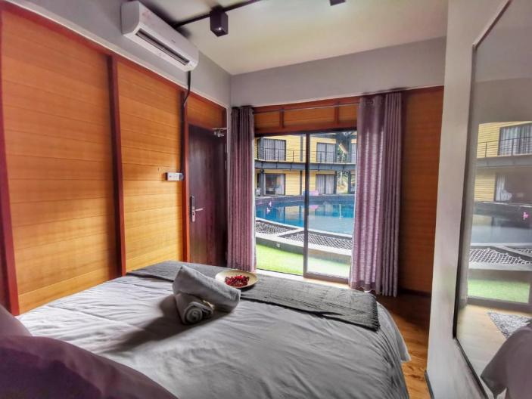

**Location:**

PT 3167, Jalan Beringin, Kampung Penarak, Kuah, Langkawi, Malaysia

**Facilities:**

- Breakfast Include

- Swimming Pool

- Free Parking

- Restaurant

- Bar

- Coffee Shop

- BBQ Facilities

- Balcony

**Add Place and transportation in Langkawi**

**Places to Visit in Langkawi**

1. **Langkawi Sky Bridge**  
   A curved pedestrian bridge offering panoramic views of the island and the Andaman Sea.
2. **Langkawi Cable Car (Panorama Langkawi)**  
   A thrilling ride to the peak of Gunung Mat Cincang, showcasing breathtaking views of the rainforest and islands.

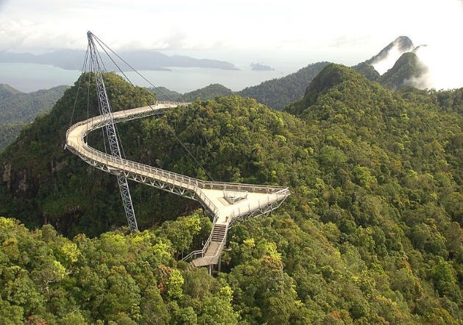 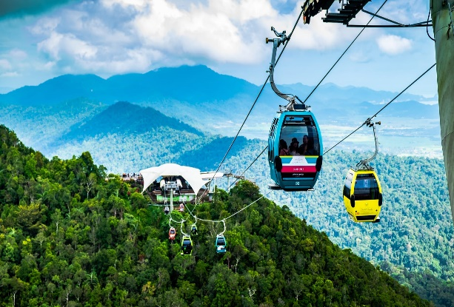

**Transportation in Langkawi**

**Boats and Ferries**

* **Used for island hopping tours or traveling to nearby islands like Pulau Payar.**
* **Ferries connect Langkawi to the mainland (Kuala Kedah, Kuala Perlis, and Penang).**

**Rental Cars and Motorbikes**

* **Most popular and convenient mode of transport for tourists.**
* **Affordable rental rates with options for self-drive.**

**Tour Buses**

* **Many attractions offer organized tours with transportation included**