BRACT’s
Vishwakarma Institute of Technology, Pune
Practical Implementation Sheet
Department: CSE-AI Semester: 5 Academic Year: 2026-27
Division: C Batch: 2 Practical No: 1
Roll no: 31 PRN No: 12414723 Name of Student: Yash Karia
Subject Name : Deep Learning

Problem Statement : Install and configure TensorFlow/Keras in Google Colab. Perform data preprocessing, normalization, train-test splitting, and data visualization on a sample dataset

Algorithm :
• Open Google Colab and create a new notebook.
• Import the required libraries such as TensorFlow, Keras, NumPy, Matplotlib, and Scikit-learn.
• Verify that TensorFlow and Keras are installed and configured in the Colab environment.
• Load the MNIST dataset into the notebook.
• Separate the dataset into training images, training labels, testing images, and testing labels.
• Examine the dataset by checking its shape, dimensions, and labels.
• Perform data preprocessing by converting the image data into an appropriate numerical format.
• Normalize the pixel values by dividing each pixel value by 255, scaling the range from 0–255 to 0–1.
• If required, split the dataset into training and testing sets using an appropriate train-test split ratio.
• Visualize sample images from the dataset using Matplotlib to verify that the data has been loaded correctly.
• Display the corresponding labels for the visualized images.
• Confirm that the dataset is successfully preprocessed and ready for training a deep learning model.

Code :
import tensorflow as tf
import matplotlib.pyplot as plt
(train_images, train_labels), (test_images, test_labels) = tf.keras.datasets.fashion_mnist.load_data()
train_images = train_images /255.0
test_images = test_images / 255.0
print(train_images.shape)
print(test_images.shape)
print(train_labels)
plt.imshow(train_images[0], cmap='gray')
plt.show()
my_model = tf.keras.models.Sequential()
my_model.add(tf.keras.layers.Flatten(input_shape=(28, 28)))
my_model.add(tf.keras.layers.Dense(128, activation='relu'))
my_model.add(tf.keras.layers.Dense(10, activation='softmax'))

my_model.compile(optimizer='adam', loss='sparse_categorical_crossentropy', metrics=['accuracy'])

my_model.fit(train_images, train_labels, epochs=3)
val_loss, val_acc = my_model.evaluate(test_images, test_labels)
print('Test accuracy: ', val_acc)
my_model.save("my_mnist_model.keras")

Output :

- Dataset Loaded Successfully :
- Downloading data from https://storage.googleapis.com/tensorflow/tf-keras-datasets/train-labels-idx1-ubyte.gz
- 29515/29515 ━━━━━━━━━━━━━━━━━━━━ 0s 0us/step
- Downloading data from https://storage.googleapis.com/tensorflow/tf-keras-datasets/train-images-idx3-ubyte.gz
- 26421880/26421880 ━━━━━━━━━━━━━━━━━━━━ 0s 0us/step
- Downloading data from https://storage.googleapis.com/tensorflow/tf-keras-datasets/t10k-labels-idx1-ubyte.gz
- 5148/5148 ━━━━━━━━━━━━━━━━━━━━ 0s 0us/step
- Downloading data from https://storage.googleapis.com/tensorflow/tf-keras-datasets/t10k-images-idx3-ubyte.gz4422102/4422102 ━━━━━━━━━━━━━━━━━━━━ 0s 0us/step
2. Maximum Pixel Value Before Normalization : 255.0
3. Dataset Shape :
Training Images Shape : (60000, 28, 28)
Testing Images Shape : (10000, 28, 28)
4. Sample Image :
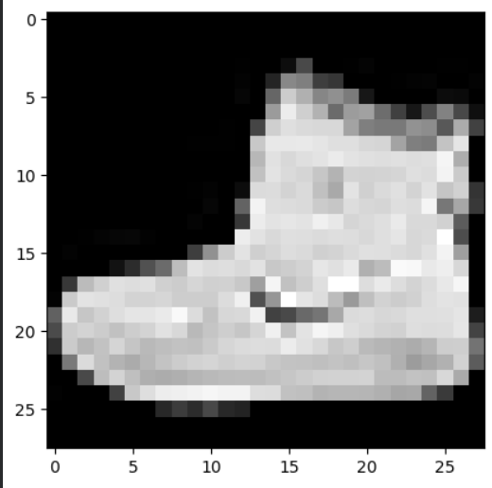
5. Model Training :
Epoch 1/3
1875/1875 ━━━━━━━━━━━━━━━━━━━━ 8s 4ms/step - accuracy: 0.8261 - loss: 0.4957
Epoch 2/3
1875/1875 ━━━━━━━━━━━━━━━━━━━━ 8s 4ms/step - accuracy: 0.8648 - loss: 0.3751
Epoch 3/3
1875/1875 ━━━━━━━━━━━━━━━━━━━━ 7s 4ms/step - accuracy: 0.8768 - loss: 0.3374
<keras.src.callbacks.history.History at 0x7d34250a25d0>

6. Test Accuracy :
313/313 ━━━━━━━━━━━━━━━━━━━━ 1s 2ms/step - accuracy: 0.8668 - loss: 0.3794
Test accuracy: 0.8668000102043152

