https://github.com/yassienE4/OS-VM/commit/3846ae8b48fa572486c9cc3fb142f36fbf4de522
How to run
- cd deadlock
- change /input.txt (with ur input)
- ./run.sh main.cpp

I created a data structure called system state that stores the required data
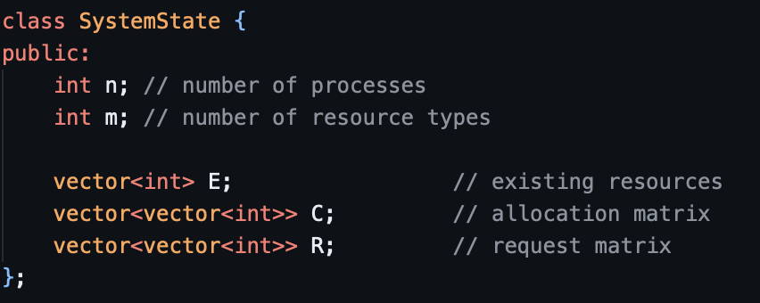

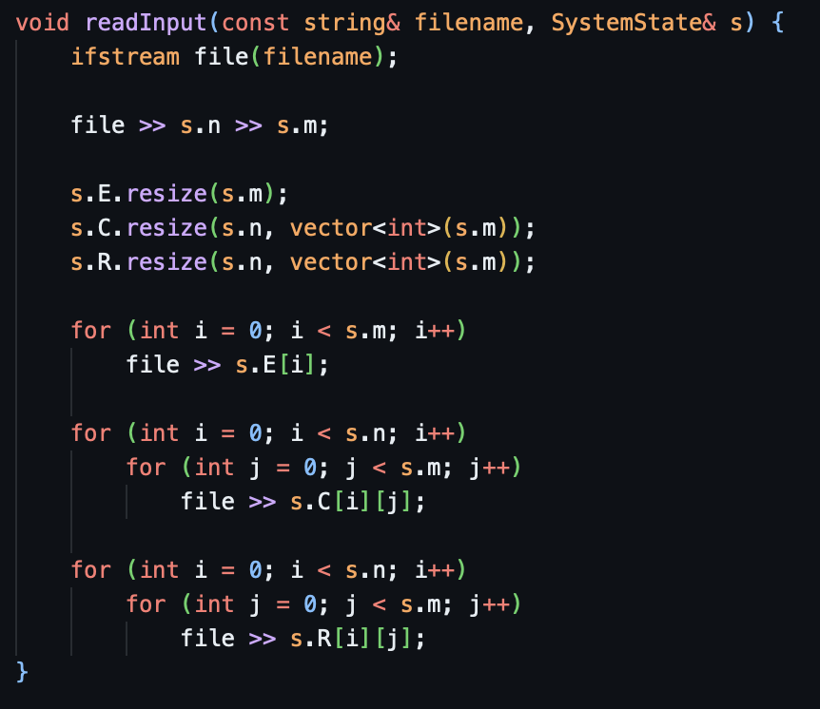

This parses a txt file in this format
Example
2 2
1 1
1 0
0 1
0 1
1 0

Becomes
N = 2 (number of processes)
M = 2 (number of resource types)
E = [1,1]
C = [1 0] [0 1]
R = [0 1] [1 0]
The actual algorithm
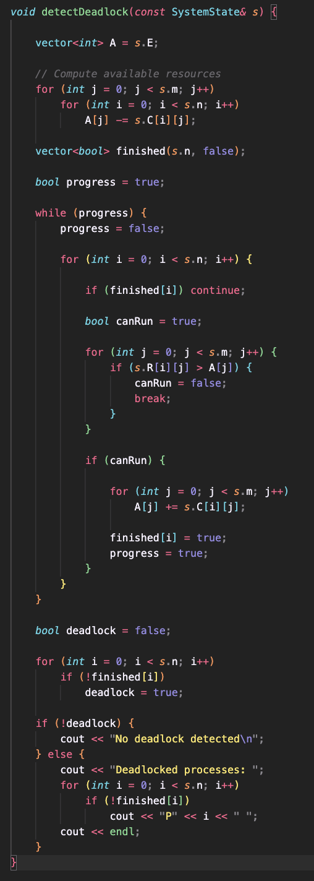

The algorithm works by first computing the available resource vector. We do this by subtracting the currently allocated resources for every process and every resource type in a new vector called A.
We then create another vector, size n with default value false, used to represent whether a process can eventually complete.
We then check for every process Pi that is not finished whether its remaining request can be satisfied. We check that via the condition R[i][j] <= A[j] for all resource types j.
If the condition holds then the process can be completed.
If it runs, we simulate completion, release the allocation back to the system and mark the process as finished, and also set progress = true.
If no process can run during a full iteration, progress becomes false and the loop stops.
At this point the algorithm has determined the final state.

Finally we check if any processes remain unfinished.
if finished[i] == false
These processes are considered deadlocked, because none of them could obtain the resources required to finish.

