https://github.com/yassienE4/OS-VM/commit/b7e12deff3fbcc65242c960350334ebbc79c81e6

How to run
- First make sure the python env is activated
- “source /workspaces/OS-VM/venv/bin/activate”
- Second move to working directory
- cd /workspaces/OS-VM/scheduling
- ./run.sh main.cpp
- The c++ code should automatically call the python plot script

How the code works:

First i created a DS to store each process, storing arrival time, burst time, and a unique id
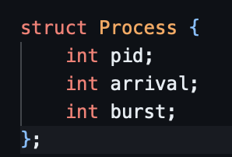

In main, we read each process from the text file, and then call the respective function for each algorithm
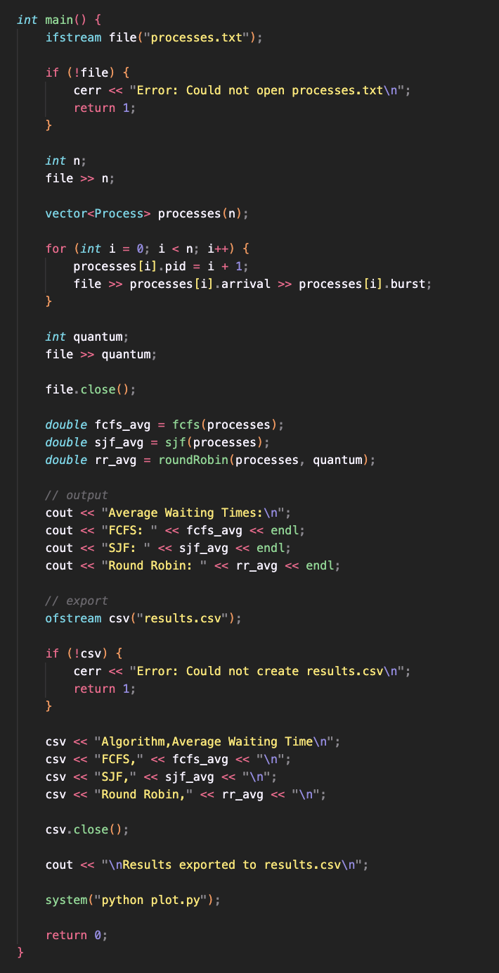

For first come first serve
- We first sort our processes by arrival time
- We simulate each process by
  - First if its “idle”, we simulate time passing
  - We then compute waiting time by Waiting time = start time − arrival time
  - Then “execute” the process by running the process for the full burst time
  - Then return average waiting time
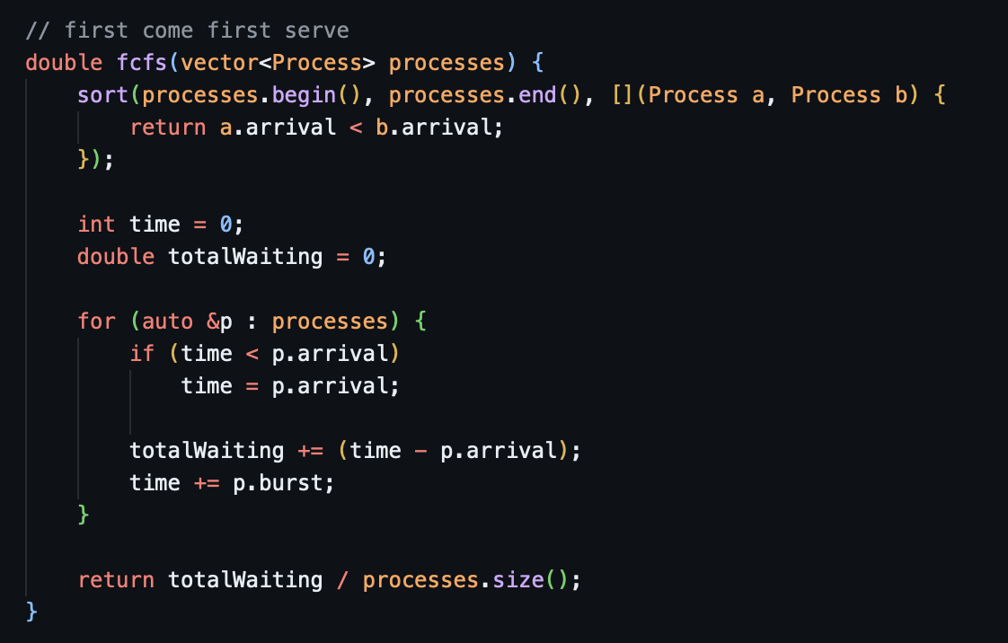

For SJF
- We find the shortest available process by
- Scanning all processes and picking the unfinished process with:
  - arrival <= current time
  - smallest burst time
- If none is found we set index to -1, which is handled by simulating idle time
- We then execute the process
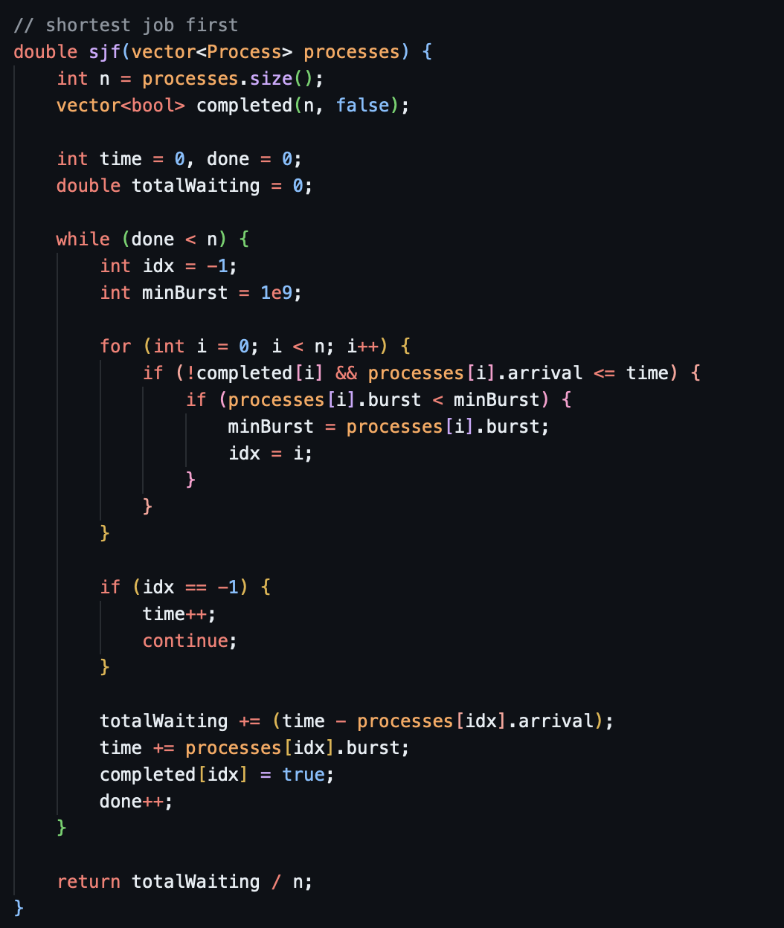

For round Robin
- We initialize the queue, with ready processes
- And an array with remaining burst time
- We add process to queue if they meet arrival <= current time
- If queue is empty = all current processes are executed, so we simulate time until we reach a process
- We then choose the next process by taking the front of the queue
- We then execute the process only for the chosen quantum time,
- We then add newly arrived processes
- We then handle the executed process
- If it still has remaining time, we push it back to the queue
- If not, we increment completed counter and update waiting time
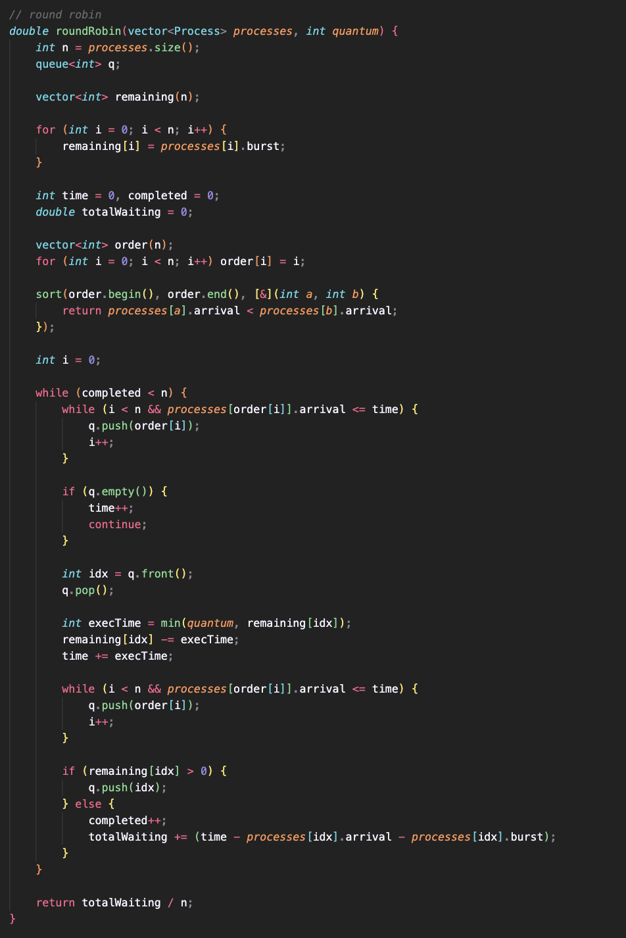
Back in the main function:
- We output the average waiting times
- And export as CSV
- We then call a python script


In the python script, we parse the csv file and use matplotlib to create a bar chart
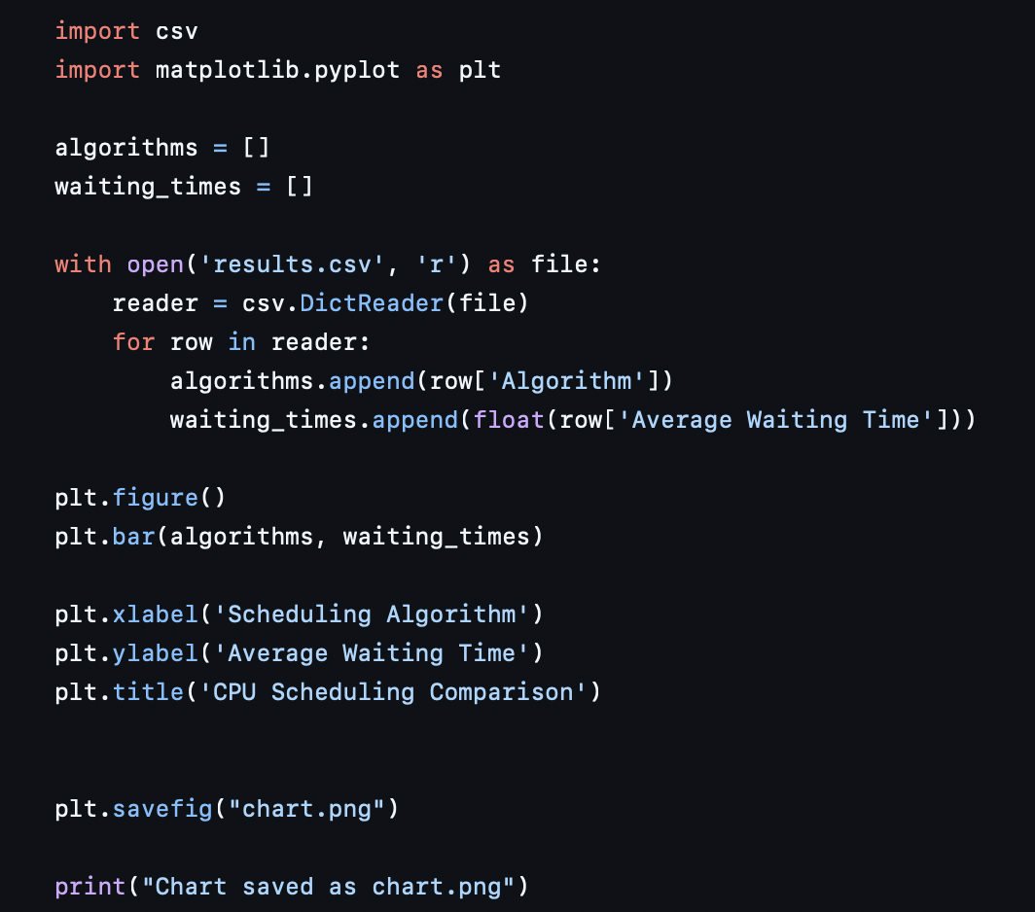

Findings:
With this text file setup
4 (number of processes)
0 5 ( arrival / burst)
1 3 ( arrival / burst)
2 8 ( arrival / burst)
3 6 ( arrival / burst)
2 (quantum time)

We get this output

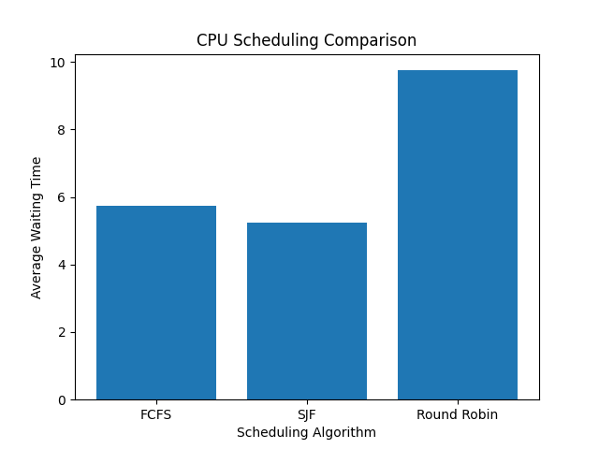

Shortest job first has the lowest waiting time, as it focuses on minimizing it
Round Robin maximizes fairness but as a result processes get interrupted and waiting time goes up
FCFS is in between, but leans towards SJF more, as the processes are not interrupted.

