https://github.com/yassienE4/OS-VM/commit/9393c5952a805470bed9c5e1555c3382bce53cc0
How to run
- First make sure the python env is activated
- “source /workspaces/OS-VM/venv/bin/activate”
- Second move to working directory
- cd /workspaces/OS-VM/scheduling
- ./run.sh main.cpp
- ./main <directory> <bin_width>
- The c++ code should automatically call the python plot script

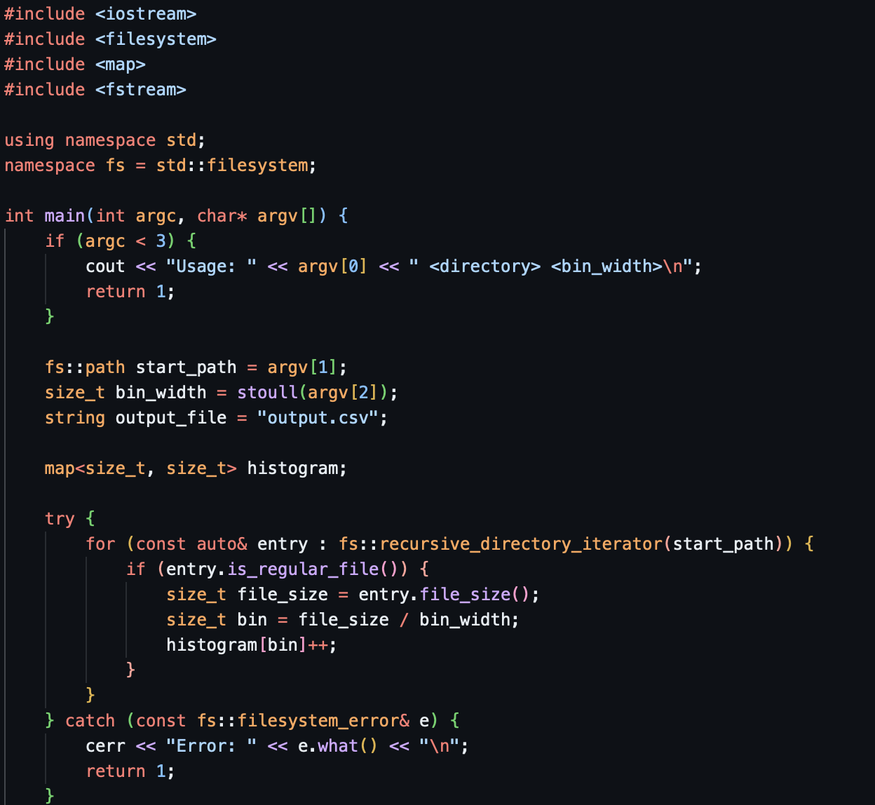

I represented the histogram as a map, Key = bin index, Value = number of files in that bin
I used the library function recursive_directory_iterator to traverse the file tree, calculated the filesize of each file and added it to the map
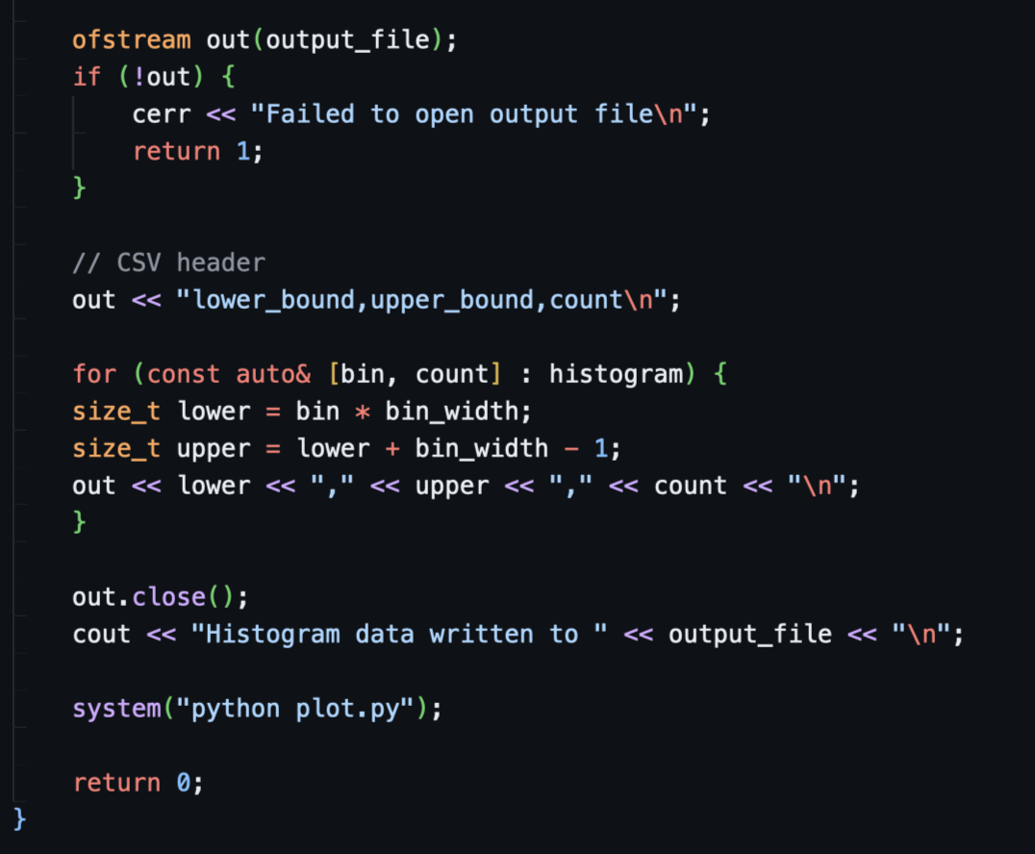
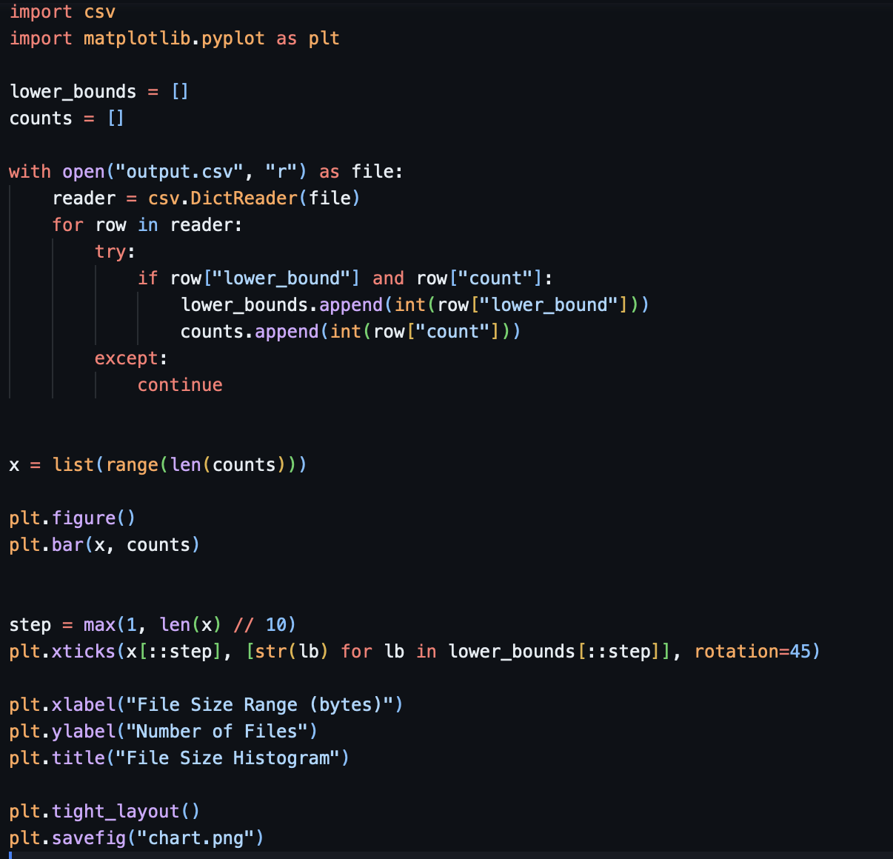
To plot the histogram I first export the map as a CSV file which is then read by a python file and using matplotlib I created a histogram and saved it as a PNG.

Findings:
I ran ./main .. 1024
To look at the entire codespaces directory, with 1024 bin sizes
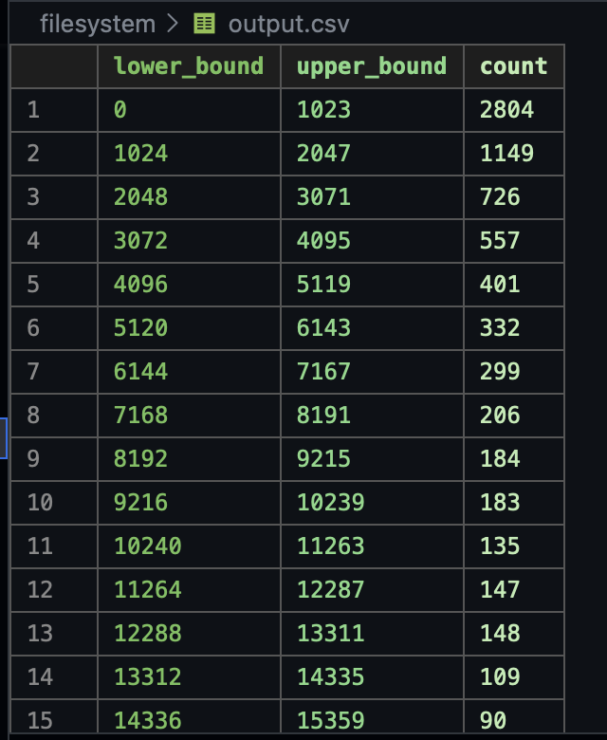
As you can see there was a greater amount of smaller files then larger
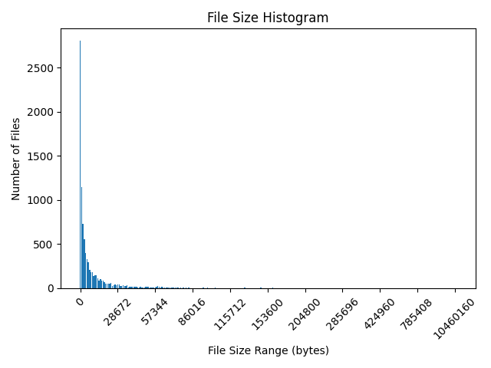
Which is also represented in the histogram

